Image: https://www.shutterstock.com/image-photo/young-couple-visiting-potential-new-home-2222205237?trackingId=e6d4ec55-a6d5-4d77-8687-0eb3b9436a7f&listId=searchResults

SL: Our Team's Watchlist For A 5% World
SSL: The 10-year hasn't been this high since 2007…
Headline: Rates Top 5%, Berkshire Buys Housing, And Our Experts Get Defensive
Tags: Stephen Prior, Monument Traders Alliance, Stocks to Watch, CJ Johnson, Bryan Bottarelli, Nate Bear, SPY, QQQ, VIX, Lennar, Berkshire Hathaway, Amphastar Pharmaceuticals, Costco, Micron earnings, interest rates, watchlist
Slug: what-were-watching-rates-top-5-percent
Author: Stephen Prior
Mobile Tag: Active Trading
Push HL: Rates Just Topped 5%. Here's What Our Team Is Watching.
Push Body: A Berkshire bet on housing, a 6,854-to-4 options skew, and CJ's lines in the sand.
TD Quote: "The market will tell you which way the 5% fight is going before the headlines do." Stephen Prior

The 10-year Treasury yield pushed above 5.2% last week. Mortgage rates just hit their highest level since January 2025. And Micron (MU) reports earnings on Wednesday.
So, I asked the team what they're watching. Just about every answer came back to the same number: 5%.
I know... interest rates aren't the most exciting thing to build a week around.
But right now, everything else is reacting to them.
Some stocks are getting crushed, some are getting bought, and some of our experts are getting defensive.
Their picks are below.
CHRIS "CJ" JOHNSON | SPDR S&P 500 ETF (SPY)
"This week is all about inflation and interest rates. Last week's surge above 5.2% sent a warning shot across the market's bow.
"At risk is the already slow housing and real estate market, which is often the canary in the coal mine for the economy. Investors will need to see rates pull back below 5% before we consider sending an all-clear."
There's a reason CJ looks at housing first. The last time the 10-year yield was this high, the first iPhone hadn't gone on sale yet. It was June 2007, and we witnessed the first crack in the housing bust. Today's market isn't 2007's, but housing is still where the stress shows up first.
CJ is also watching breadth, which measures how many stocks are taking part in a move. More than half of the Nasdaq 100 is now trading below its 50-day moving average, the weakest reading since March.
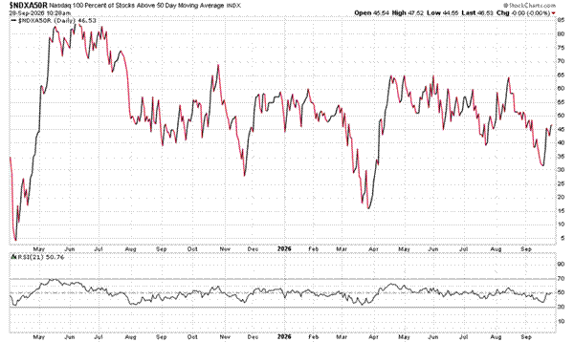
His lines in the sand are $725 on the SPY, $725 on the QQQ, and 17.50 on the VIX. A VIX break above that level would add selling pressure. He'll also be trading Micron's earnings on Wednesday, looking for signs that AI spending is still on track.
BRYAN BOTTARELLI | Lennar (LEN)
"Lennar is down 20% this year, making it one of the worst performers in the homebuilding sector. But Berkshire Hathaway purchased more than $200 million in stock over a 3-day span, which means it now controls 10% of the country's second-largest homebuilder."
Berkshire did that buying with the average 30-year mortgage rate at 6.95%, according to CNBC. One of the most patient investors in the world is buying housing right when rates are hurting it most.
Bryan also flagged Amphastar Pharmaceuticals (AMPH). Last week, 6,854 call options traded on the stock versus only 4 puts. Calls are bets on a stock going up and puts are bets on it going down, so a week that lopsided can mean someone is positioning for a move.
It's a strange place for that kind of bet. Amphastar has picked up four analyst downgrades since April and an FDA warning letter at one of its subsidiaries. Somebody’s betting against the crowd.
NATE BEAR | Costco (COST)
"Inflation is up, and I'm thinking defensive sectors like consumer staples. My favorite name in the group is Costco, and it just had a solid reaction to earnings late last week. It's not the best chart from a technical perspective, but it's oversold, and it will work if the market gets more defensive in October."
Costco's hot dog-and-soda combo has cost $1.50 since 1985. Adjusted for inflation, it'd be more than $4 today. When former CEO Craig Jelinek told co-founder Jim Sinegal they were losing money on it, Sinegal's answer was: "If you raise the f---ing hot dog, I will kill you." Members pay for that kind of stubbornness, and they keep paying. U.S. and Canada renewal rates improved to 92.3% last quarter.
Consumer staples are the things people keep buying no matter what the economy does, like groceries and household goods. When rates squeeze everything else, that's often where money hides.

Your Action Plan
If the 10-year slips back under 5%, CJ calls that the all-clear. If it stays above, the team looks first to the defensive names on this list.
Either way, put CJ's levels on your chart this week. The market will tell you which way the 5% fight is going before the headlines do.
P.S. AI is moving fast, and everyone from Wall Street to the talking heads on TV has an opinion about where it goes next. But we want to hear from YOU.
CJ put together a quick survey to find out how YOU view AI, both as an investor and as a person watching this technology reshape the world.
Your answers could directly shape upcoming Trade of the Day material, and your input will help us provide you the best AI opportunities, trends, and risks for our experts to focus on.
Take the AI survey right here.

