Image: https://www.shutterstock.com/image-photo/tornado-wray-colorado-may-2016-rated-1007786833?trackingId=f8223648-e92d-4617-8d19-137c24f32dc2&listId=searchResults

SL: The Market's Tornado Siren Is Blaring
SSL: Here’s where I’m taking shelter…
HL: This Is My Storm Shelter as Market Breadth Collapses

EX: New lows are outnumbering new highs 3 to 4 times over. One stock is holding up anyway.
TAG: market breadth, new highs new lows, SharkNinja, consumer stocks, household products, market sentiment
SLUG: markets-tornado-siren
AUT: BB
Objective: Stocks, active trading
Mobile Tags: Consumer Goods
Psychology: Caution
Sector: Consumer discretionary
Push Notification HL: The Market's Tornado Siren Is Blaring
Push Text Body: Why I'm staying cautious, and the one name I still like right now.
TD Quote: "Despite the market flashing warning signs, there are always pockets of opportunity." MTA Co-Founder Bryan Bottarelli

=====================================

I went to school in Indiana and cut my teeth trading in Chicago, so I know the sound of a tornado siren.
It's a low, rising wail that cuts through everything. It doesn't tell you exactly where the storm will touch down, but it tells you the conditions are ripe, and it's time to know where your shelter is.
The stock market has its own version of that siren. And right now, it's blaring.
One metric I track every week is the number of companies setting new 52-week highs versus the number setting new 52-week lows.
Tracking this list offers a clear view of market sentiment.
If more stocks are hitting new highs than new lows, market sentiment is bullish. If more stocks are hitting new lows than new highs, sentiment is bearish.
I first saw why this matters back in 1999 and 2000, when I was trading in the Apple pit on the CBOE floor. The Nasdaq was grabbing every headline on its way to record highs. But underneath, fewer and fewer stocks were doing the heavy lifting.
The generals kept charging while the troops quietly deserted. We all know how that story ended.
Two weeks ago, I noted how this skew moved decidedly into "new low" territory, which (to me) serves as a warning that more selling may be on the horizon.
This past week, the siren got louder:
- NYSE: 115 new highs vs. 554 new lows
- Nasdaq: 255 new highs vs. 803 new lows

With new lows outnumbering new highs more than three to one on the Nasdaq and nearly five to one on the NYSE, it reinforces my feeling that market sentiment is shifting to bearish, which is why I'll stay cautious in our trading and positioning.
I’m not Bill Paxton. I'm not about to go storm chasing.
That said, a tornado siren doesn't mean every house gets flattened. It means you'd better know which ones are built to last.
And there’s one stock that I think can withstand market pressure, making it a buy candidate right now.
That company is SharkNinja (SN).
You may not know the ticker, but you almost certainly know the products. Odds are there's a Ninja air fryer on a kitchen counter or a Shark vacuum in a hallway closet somewhere on your street.
Yes, inflation is cutting into consumers' buying power. But for SharkNinja, it doesn't seem to be a problem.
The household-products company just posted its fastest sales growth since 2024. Net sales jumped 22.2% in the second quarter to $1.77 billion, and management raised its full-year sales growth outlook to 16%-17%, up from 11.5%-12.5%.
That marked its 13th straight quarter of double-digit sales growth. Tariffs, inflation, a squeezed consumer… none of it has knocked SharkNinja off course. It keeps making products people want badly enough to buy even when money's tight. In August, search volume climbed 38% across its 100 trademarked products.
Analysts at Jefferies value the shares at $240, which is about 40% above where the stock trades now. The daily chart shows support around $160, and a bounce from there could carry the stock up to $190.
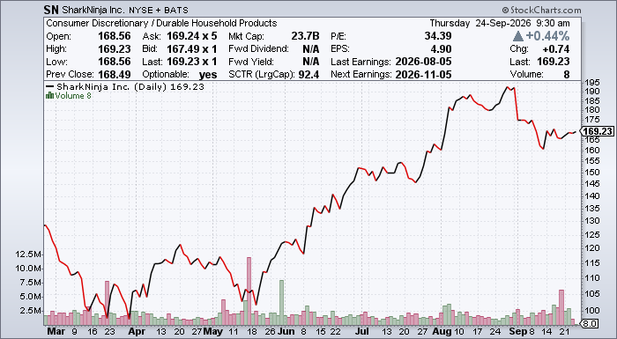

Your Action Plan
Despite the market flashing warning signs, pockets of opportunity always exist. You just need to know where to find them.
Right now, SN represents one of those pockets, and it's a name we're currently trading inside The War Room.
[nonWAR]
But SN isn't the only storm shelter we're building in there.
My War Room partner Karim Rahemtulla has spent 46 years waiting for the gold setup he's seeing right now. Countries like Iran are hoarding gold at a furious clip, and investors are paying up to get in on the move. Karim’s found a way to target the world's top gold assets at 30% to 50% less than what everyone else is paying.
He calls it the Gold Heist. He walked through the whole playbook at Thursday's watch party, and inside The War Room, he's putting it to work in real time.
So, here's my advice: While the rest of the market scrambles for cover, come trade alongside us. You'll get my SharkNinja trade, Karim's Gold Heist plays, and a front-row seat as two very different traders navigate the same storm.
The siren's blaring, The War Room is your shelter.
Come join us inside.

