Image: https://www.shutterstock.com/image-photo/thoroughbred-horses-racing-race-2337962037?trackingId=62391061-2717-48c4-9e06-421edac37847&listId=searchResults

SL: The Horse Nobody's Betting On

SSL: Wall Street is braced for impact, but history favors a different finish…
Headline: From Fear to FOMO: The Huge Contrarian Setup Taking Shape
Excerpt: Traders have piled into QQQ puts at the $700 strike and stacked VIX calls well above current volatility levels. Chris Johnson reads Wall Street's betting board, explains why a market this hedged is less likely to panic, and shows why post-midterm seasonality may favor the long shot.
Tags: Chris Johnson, Trade of the Day, Monument Traders Alliance, QQQ, Nasdaq 100, VIX, open interest, options market, market sentiment, contrarian investing, midterm elections, stock market seasonality, S&P 500, FOMO
Slug: from-fear-to-fomo-contrarian-setup
Author: Chris Johnson
Push HL: Everyone's Betting on the Same Horse
Push Body: Traders have loaded up on QQQ puts and VIX calls. Here's what happens if the favorite stumbles.
TD Quote: "The board isn't telling us where the market will go. It's telling us where a lot of money is positioned for it to go." — Chris Johnson

There are certain places that just feel different the moment you walk through the gates.
For me, Keeneland is one of them.
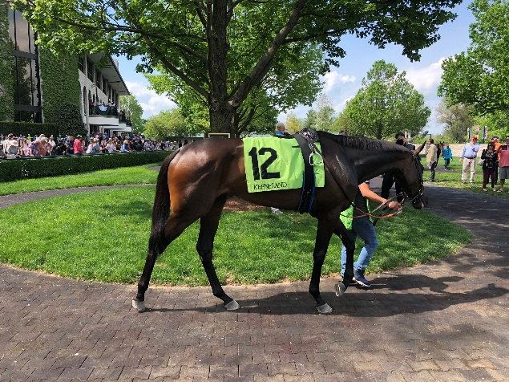
I try to make it down to Lexington every spring and fall. The limestone buildings, enormous trees, paddock, and rolling Kentucky landscape give the place lasting generational character.
It’s the perfect place to grab a drink, find some friends, and watch some of the best thoroughbreds in the world walk through the paddock just a few feet away. Serious horsemen rub elbows with greenhorns who don’t know the difference between a furlong and a trifecta.
But eventually, everyone starts paying attention to two things.
The Racing Form and the betting board.
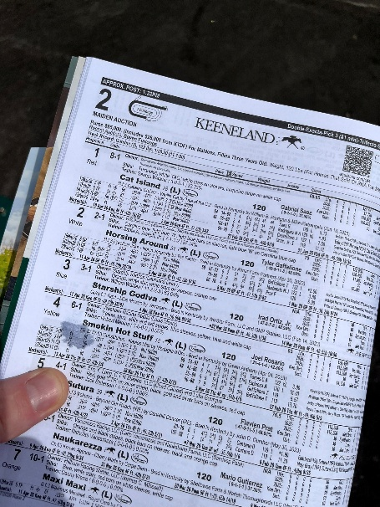
The Racing Form tells you what’s already happened. Past performances, track conditions, and how each horse has performed under similar circumstances.
The betting board tells you what people think happens next.
As money comes in on a horse, its odds shorten. An 8-to-1 horse moves to 5-to-1, then maybe 3-to-1. Before long, it becomes obvious where the crowd is betting.
But the favorite doesn’t always win.
Sometimes the money is telling you something important. Other times, it simply tells you everyone has crowded onto the same side of the bet.
That’s exactly how I want you to think about the options market right now.

Wall Street’s Betting Board
When I look at the open interest configuration of the QQQ or VIX, I’m essentially looking at Wall Street’s betting board.
Instead of horses and odds, we have strikes, calls, puts, and thousands of contracts showing us where traders have placed their money.

Heading into the October expiration, there’s a massive (almost historic) concentration of QQQ put open interest around the $700 strike.
In racetrack terms, the QQQ crashing below $700 has become the odds-on favorite.
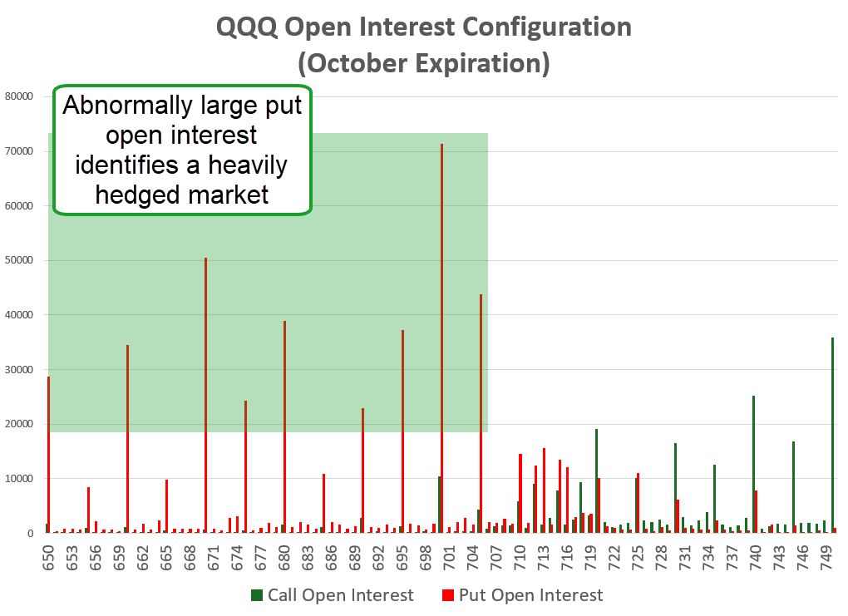
We saw a similar setup with the August and September expirations. Through the summer, traders built significant put positioning around $700.
Instead, QQQ held above the strike and began moving higher.
Now the board is loading up again.
The board isn’t telling us where the market will go. It’s telling us where a lot of money is positioned for it to go.

Betting On Fear
VIX options are heavily used to hedge volatility exposure or bet directly on it, which makes open interest a useful gauge of how aggressively traders are preparing for turbulence.

Large concentrations of October and November VIX call open interest have developed well above current volatility levels.
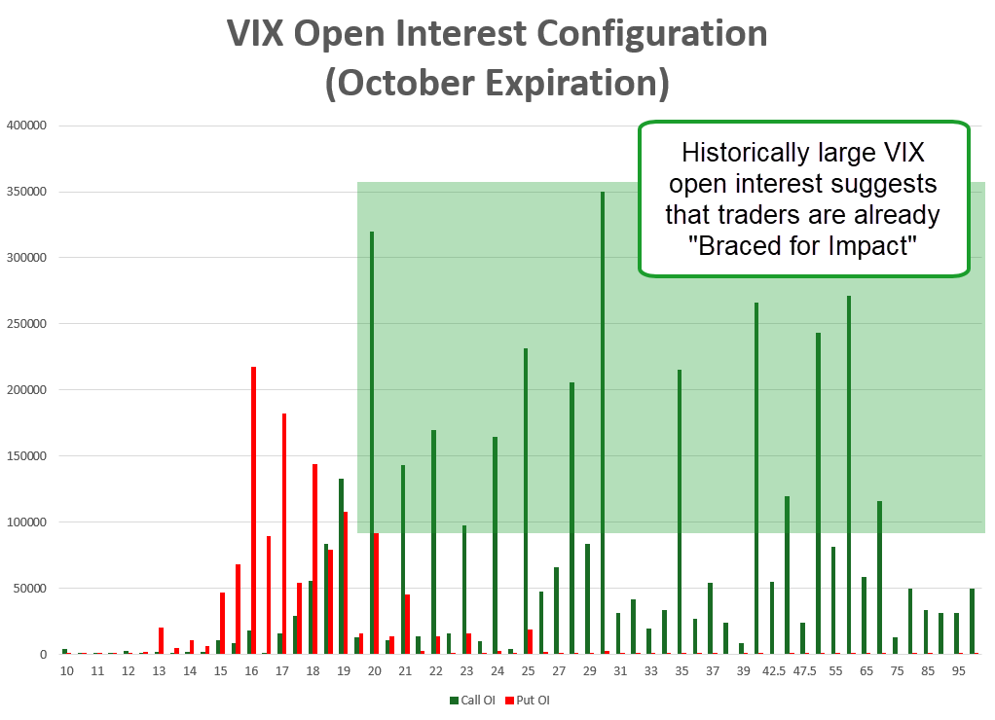
Put the QQQ and VIX configurations together and you see the same wager expressed two different ways.
QQQ puts are positioned for stocks to move lower.
VIX calls are positioned for volatility to move higher.
Wall Street appears to be braced for impact.

A Hedged Herd Doesn't Stampede
If volatility arrives, a significant amount of protection is already sitting in the market.
QQQ puts increase in value as the underlying falls. VIX calls can benefit as volatility rises. Investors who already own protection have less reason to suddenly panic and dump stocks when the market moves against them.
That doesn’t prevent a correction, but it can change the character of one.

Enter The Dark Horse

QQQ and VIX traders appear to be betting on the same horse…
Volatility higher. Stocks lower.
But when everyone at the track is standing at the same window betting the favorite, sometimes it’s worth looking at the horse nobody is talking about.
It reminds me of the old Camptown Races line:
“I’ll bet my money on the bob-tail nag, somebody bet on the bay.”
Because there’s another piece of information sitting in our Racing Form right now.
Seasonality.

Since 1980, the S&P 500 has averaged an 8% gain during the three months following a midterm election, with 10 of 11 periods finishing higher. Stretch that window to six months and the average return increases to 12.4%, with all 11 periods positive.
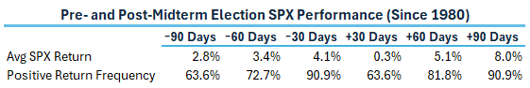
Fidelity’s research shows that since 1938, the S&P 500 has produced a positive price return during the 12 months following a midterm election 95% of the time, with an average gain of roughly 14%.
Of course, past performance doesn’t guarantee 2026 will follow the same script. Earnings, interest rates, inflation, and economic growth still matter.
But look at the setup.
The betting board shows an enormous amount of money preparing for volatility.
The Racing Form shows we’re approaching a stretch of the calendar that has historically favored stocks once midterm uncertainty is removed.
And the Nasdaq 100 is already rallying.

And Down the Stretch They Come
Maybe the favorite wins. Maybe QQQ moves toward $700 and volatility explodes higher. If that happens, plenty of traders already have their tickets.
But if it doesn’t?
That’s the scenario I find much more interesting.
When a crowded trade moves the wrong way, hedges come off. Shorts get covered. Money starts chasing price.
This creates a fast and aggressive FOMO trade.
Suddenly, everyone who was betting on the favorite is trying to get a ticket on the horse that’s already running away from the field.

Keep in mind, we’re not even factoring in the possibility that the war in the Middle East could end, sending oil prices tumbling, truly a bullish catalyst.
Bottom Line: I’m keeping my eye on the bob-tail nag.
[nonWAR]
P.S. Gold's got its own crowded trade right now, everybody chasing the same horse at record premiums. Karim's working the other side of that board.
Instead of buying shares outright, he sells puts, collects the premium up front, and lets the market pay him to wait for his price. In nearly 200 of those trades, he’s sitting on a 95% win rate. And so far in 2026, not a single trade has lost.
Tomorrow, he's opening up that exact method at his Gold Heist watch party, showing you how to buy the world's top gold assets at half price.
Register here.

