Image: https://www.shutterstock.com/image-photo/oil-barrel-us-dollars-cost-sale-2752123537?trackingId=4220becc-f8ba-4f99-a862-bcc3385bb9a3&listId=searchResults

SL: 5 Trades We’re Watching This Week
SSL: Only one of them is already in the trade…
Headline: Five Setups, One Live Trade, And A Market About To Move
Tags: Stephen Prior, Monument Traders Alliance, Stocks to Watch, Karim Rahemtulla, Nate Bear, Bryan Bottarelli, CJ Johnson, USO, BitMine, SharkNinja, Oracle, QQQ, VIX, UN General Assembly, watchlist
Slug: 5-trades-were-watching-this-week
Author: Stephen Prior
Mobile Tag: Active Trading
Push HL: One Trade Is Already Live, Four More Are Loaded
Push Body: Oil, crypto, a $7.5 billion stock sale that never happened, and the quietest chart in a year.
TD Quote: "When everybody's waiting on the same week, the waiting is the trade." — Stephen Prior

World leaders are landing in New York this week for the UN General Assembly. The U.S. and Denmark are set to sign their Greenland security deal there. Bitcoin just cleared $80,000 for the first time in weeks.
And with all of that on the calendar, I asked the team what they're watching. Four out of five gave me the same one-word answer: waiting.

I know… it’s not sexy.
But there’s a good reason for waiting.
Not because nothing's happening. Because too much is happening at once, and none of it has broken yet. Markets that go this quiet don't stay quiet. They coil.

Only one of our experts is already in a trade. Here's what came back from the rest:
KARIM RAHEMTULLA | United States Oil Fund (USO)
"I'm looking for developments from the UN conference and any escalation by the Houthis. Both would be near-term catalysts, up or down."
USO tracks crude oil, so it moves with whatever comes out of New York this week and whatever the Houthis do next.
NATE BEAR | BitMine Immersion Technologies (BMNR)
"It's an Ethereum play, should do well if Republicans win the midterms, but either way it's a chart play for me. It will go up with crypto, and it also has a great daily TPS setup. We are long the October $20 calls and it's ripping today. Looking for at least $30 here."
BitMine holds Ether on its balance sheet, so it trades with crypto. TPS is Nate's system: Trend, Pattern and Squeeze, read in that order.
BRYAN BOTTARELLI | SharkNinja (SN)
"Inflation is cutting into the buying power of the consumer, but for SharkNinja, it doesn't seem to be a problem. August saw search volume climb 38% for their more than 100 trademarked products. Analysts at Jefferies value the shares at $240. A 'W' on the daily chart could offer support at $160 and trigger a bounce up to $190."
SharkNinja's August quarter showed revenue up 22% to $1.77 billion, and management raised its full-year outlook on the strength of it. A "W" is a double bottom, two dips to the same level with a bounce between them.
Bryan also flagged Oracle (ORCL). In June, Larry Ellison set up a plan to sell up to 50 million shares, about $7.5 billion worth. It became public on September 11, and he cancelled it the next day without selling a share.
CHRIS “CJ” JOHNSON | Invesco QQQ Trust (QQQ)
"The QQQ is trading with its tightest Bollinger Bands in the last year, and that tells us we're going to see a surge in volatility. It's been too quiet too long. A VIX close below 15 will see further unwinding of uncertainty in the form of broader buying."
Bollinger Bands are lines drawn above and below price. They pinch in when a stock goes quiet and blow apart when it doesn't.
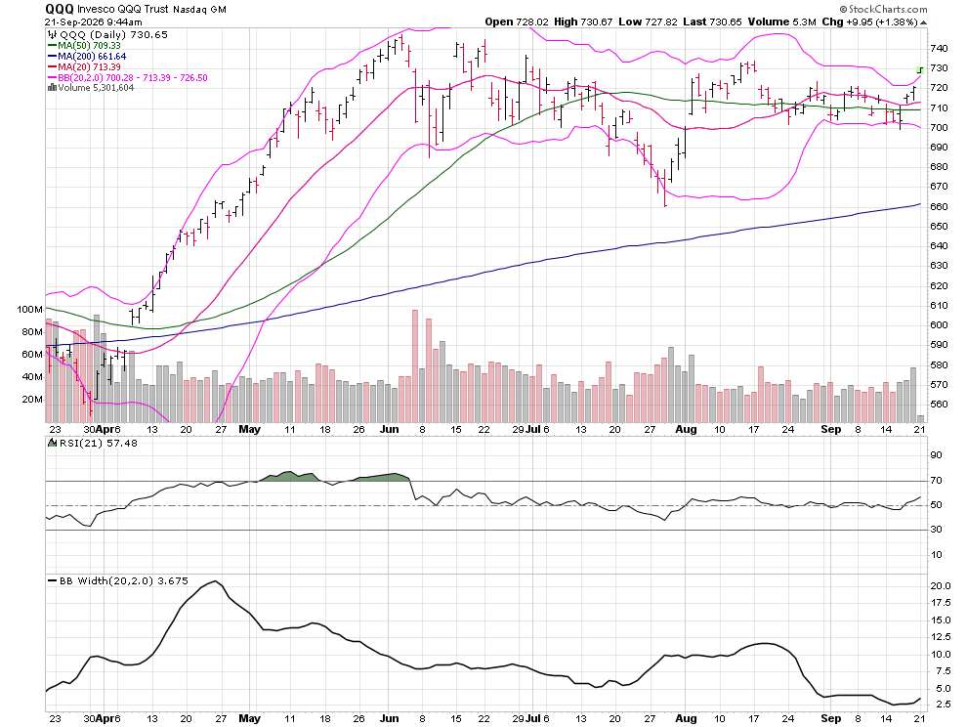
CJ is watching $725 on the QQQ and 15 on the VIX, and the stock he likes is Corning (GLW), squeezed between its 50-day and 200-day moving averages.
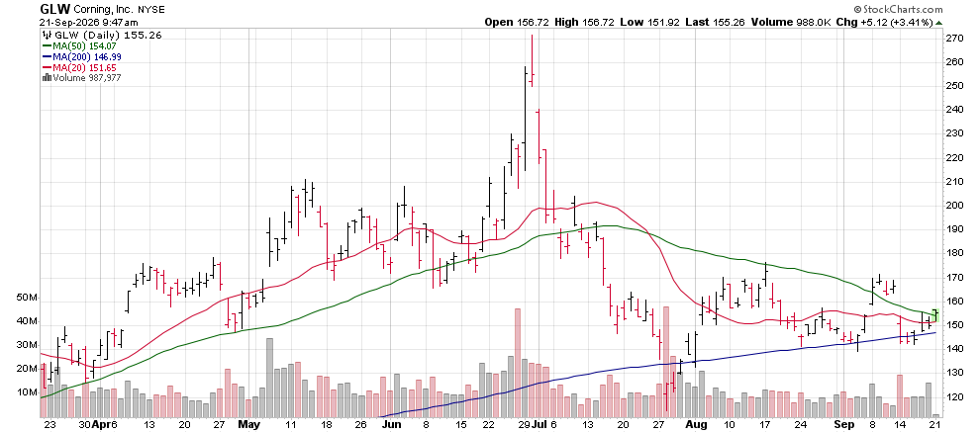
Your Action Plan
Everybody on this list is waiting, coiled around the same thing: a catalyst.
The UN could hand oil one. Greenland could hand the dollar one. A VIX close under 15 could hand the whole market one.
Springs don't uncoil slowly. And when the waiting ends, it’ll end fast.
[nonWAR]
P.S. While our experts are waiting, Iran isn't... It's quietly bought over 100 tons of gold this year, more than it spent on phones and pharmaceuticals combined, and started settling weapons deals in bullion instead of dollars.
That kind of hoarding has pushed gold stocks to some of the richest premiums Karim has seen in 46 years in this business.
On Thursday, September 24, he's showing how to buy the world's top gold assets at half price. Register here.

