Image: 
SL: Free Demo Tomorrow: Introducing Profit-Launch Sequence
SSL: The MIT method that broke Vegas…
HL: The MIT Method That Broke Vegas, Applied To Wall Street
SSL/Excerpt: A team of MIT students took the casinos for more than $3 million by counting what was left in the deck. I spent three years finding out whether the same idea works on stocks that have been down four days in a row.
Tags: Bryan Bottarelli, Trade of the Day, Monument Traders Alliance, Profit Launch Sequence, Flash Rallies, swing trading, MIT blackjack, card counting, Nasdaq 100, backtest, AAPL
Slug: mit-method-that-broke-vegas-applied-to-wall-street
Author: Bryan Bottarelli
Mobile Tag: Education
Push HL: The MIT Method That Broke Vegas
Push Body: They counted what was left in the deck and took the casinos for millions. I spent three years testing the same idea on stocks. Live demo Wednesday.

TD Quote: “Every Trade Of The Day Reader Needs To Attend Wednesday’s Live Trade Demo” – MTA Co-Founder Bryan Bottarelli
======================================
It started over three years ago…
When I asked myself a simple question.
Could the counting method developed by MIT math students and engineers to break the Las Vegas blackjack casinos be applied to Wall Street?
You see, most blackjack players place the same amount on every hand, rather than increasing or decreasing their bets based on the situation.
MIT's success involved a running count technique, and increasing bet sizes when the deck count was more favorable.
How they did it was simple…
They had one individual standing behind the table where the other players were playing.
This "counter" behind the table was counting face cards. Whenever the deck had a majority of 10s remaining, the odds favored the player.
In other words, any deck with a higher-than-normal amount of face cards left meant the dealer had a higher chance of busting.

When the deck skewed toward more face cards, the person standing behind the table would motion to their runner, who would sit down, bet the table max, and leave after the card shoe ran out.

A quick "in and out" whenever the deck favored the player and was stacked against the dealer.

In less than two years, this technique took some of the world's most sophisticated casinos for more than $3 million.

The entire story was featured in the NY Times bestseller "Bringing Down the House."

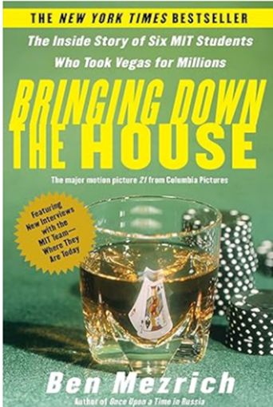

Could This Method Get Applied to Wall Street?
I huddled up with my research team, and we got to work beta-testing a method that used that same counting approach to see what happened when some of the most actively-traded stocks experience periods when they have multiple down-days in a row.
Since algorithmic trading has dominated the market over the past decade, we studied the Nasdaq 100 over the past 10 years.
What we found was remarkable…
The 10-year dataset, which included 7,377 triggers, delivered a 98% accuracy rate.
Specifically,
every time our trigger hit, showing that a stock experiencing a multiple-down-day move was finally changing direction…
98% of these stocks swung higher at some point within the next seven days.
Let me show you a recent example…
Shares of Apple (AAPL) were down four consecutive days in a row…
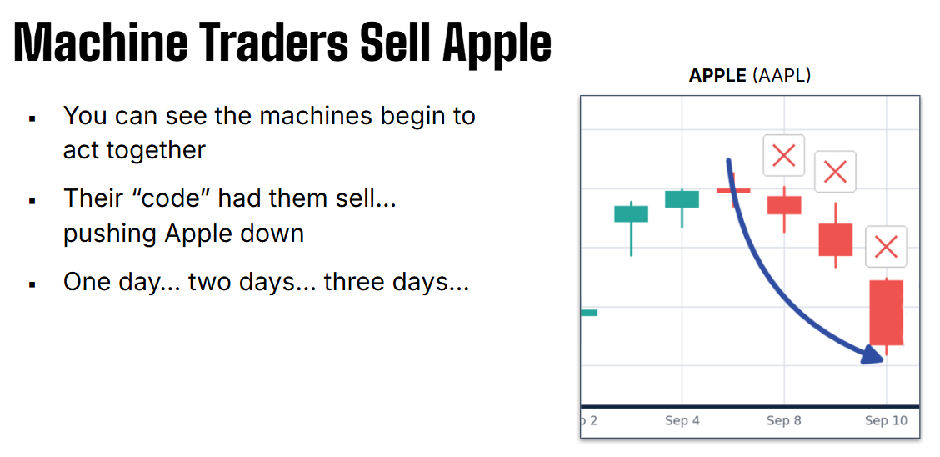
But then, Apple started to stabilize, and stopped the downside trend.
This green day triggered a green check mark.
In other words, this was our “Flash Rally” moment.
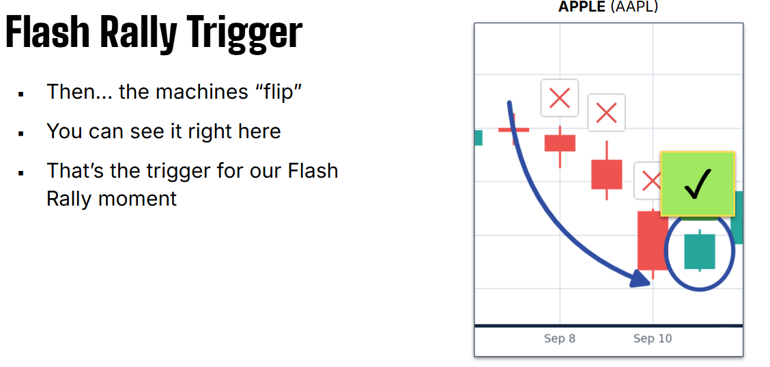
As you can see below, the move on Apple after receiving this green check resulted in a powerful upside rally.
This “Flash Rally” trade could’ve delivered a +531% gain over the next week.

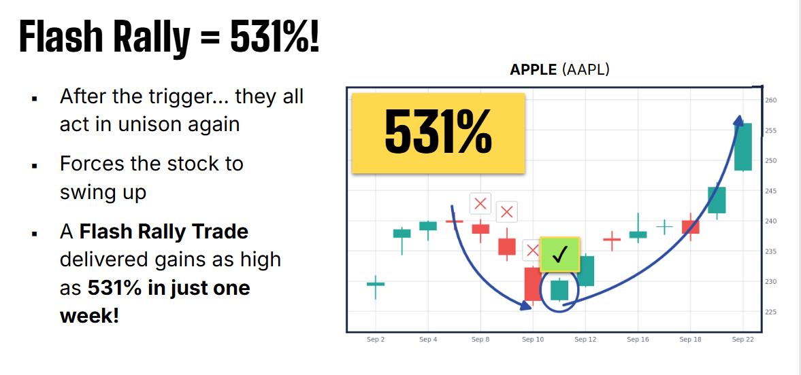

Your Action Plan
After three years of back-testing, this powerful new methodology is ready to be released to the public… but I’m only willing to share it with Monument Trader’s Alliance members (like you).
I’ll be debuting a new methodology tomorrow, Wednesday, September 16th. It’s called the “Profit Launch Sequence,” which uses a unique trigger that tracks consecutive down-days to predict the precise moment that a bounce/turnaround will happen.
But
unlike most of my shorter-term trading strategies, this one is specifically designed as a swing-trade method, which takes around 7-days to play out.
This is dramatically different from my shorter-term strategies, which is why it could be perfect for market conditions like this one.
That’s why I believe that every Trade of the Day reader needs to attend Wednesday’s live trade demo.
Be sure to sign up for this new and unique swing-trading event next week!
Sign up for FREE right here.

