Image: https://www.shutterstock.com/image-photo/dhaka-bangladesh-11-april-2025-modern-2611110551?trackingId=c80bf47f-f3a1-4113-a555-609fa9ef66e2&listId=searchResults

SL: What Nate, Bryan, and Karim Are Buying Before the Fed Speaks
SSL: All three ideas land before Wednesday…
Headline: Three Trades Ahead of Wednesday: an AI Dip, a Free Sequel, and a Defensive Pivot
Excerpt: Two AI executives talked over the weekend, and the semiconductor complex opened red. Nate's buying into it. Plus a 13-year-old video game with no development costs left, and the one thing Bryan is doing Wednesday that nobody saw coming.
Tags: Stephen Prior, Monument Traders Alliance, week ahead, Nate Bear, Bryan Bottarelli, Karim Rahemtulla, NVDA, TTWO, FOMC, rate hike, semiconductors, pharmaceuticals, Flash Rallies
Slug: three-ideas-into-the-fed-decision
Author: Stephen Prior
Mobile Tag: Speculation
Push HL: The Semis Just Got Spooked by a Conversation

Push Body: Nate's buying the dip anyway. Plus the reason Bryan is slowing down for the first time ever.
TD Quote: "Nothing about earnings or demand changed this morning. What changed was a safety argument between two AI labs." — Stephen Prior

Two AI executives talked over the weekend and the semis opened in the red.
Nvidia (NVDA) was down 2% premarket, Broadcom (AVGO) down 4%, and AMD (AMD), Intel (INTC), and Marvell (MRVL) down 5%, 6% and 7%.
Nate's buying it.
That's one of three things the team is watching this week, and all of them land in front of the Fed meeting on Wednesday afternoon.
Here we go:

Nate: Nvidia (NVDA), Chips Down, Conviction Up
What happened is that Anthropic's chief executive called for slowing down development on the most capable AI models, and OpenAI's Sam Altman said an IPO this year would be ill-advised.
Nate's going the other way on it. He wants the biggest semi of them all, and he likes the daily chart right here.
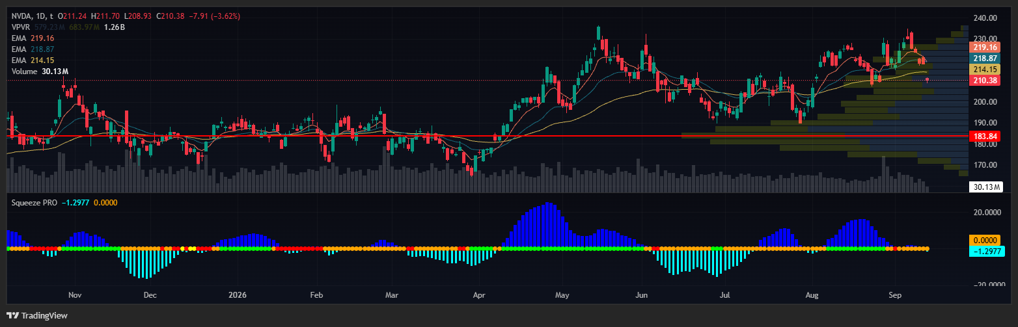
The idea is picking it up somewhere around $208 to $212 on this dip, then running it into new all-time highs above $236 over the next couple of months.
Worth knowing what you're buying into. Nothing about earnings or demand changed this morning. What changed was a safety argument between two AI labs, and whether that argument translates into anything real is the entire trade.

Bryan: Take-Two (TTWO), Grand Theft Profits
Bryan's been tracking this one for about a month and he's back on it again.
Grand Theft Auto V came out 13 years ago and became the biggest video game in history. The follow-up is expected in November, and all of the development costs have already been accounted for.
Which means the release should be close to pure profit on the way in.
Some are predicting it doubles Take-Two's (TTWO) earnings. Bryan's looking at calls on it.
And speaking of Bryan, he's doing something Wednesday that nobody who knows him would have predicted.

Karim: Playing Defense Before the Midterms
Karim's watching money move into defensive names ahead of the midterms, with pharmaceuticals at the top of his list.
Big cash flow producers hold up when everything else is getting repriced, and pharma and telecom have been about the only groups doing that lately.
One caveat he added, and it matters. Post-election is a different conversation entirely, because a lot of these same sectors come under pressure once the votes are counted. This is a pre-election read with a shelf life on it.

Your Action Plan
Everything above feeds into the Fed, with the market pricing in an 88% chance of a quarter-point hike.
If they hike, it's priced and the market should shrug at it. If they hold, a lot of people are going to be repositioning in the same afternoon.
Either way, Thursday and Friday are where the volatility sits this week, because Friday is triple witching and a large amount of open interest comes off the board.
[nonWNM]
Which brings me back to Bryan.
At 2pm EST this Wednesday, the same hour the Fed decides, he's going live with something he's never released publicly. He calls them Flash Rallies, and the setup behind them showed up 7,377 times over a ten-year backtest.
A few of those trades showed possible wins as high as 341%, 531%, and 695%.
Bryan’s famous for same-day trades, and now he's waiting a week on purpose. He'll explain exactly why on the call.
It's free, and there's a live Q&A at the end.
Reserve your seat here.

