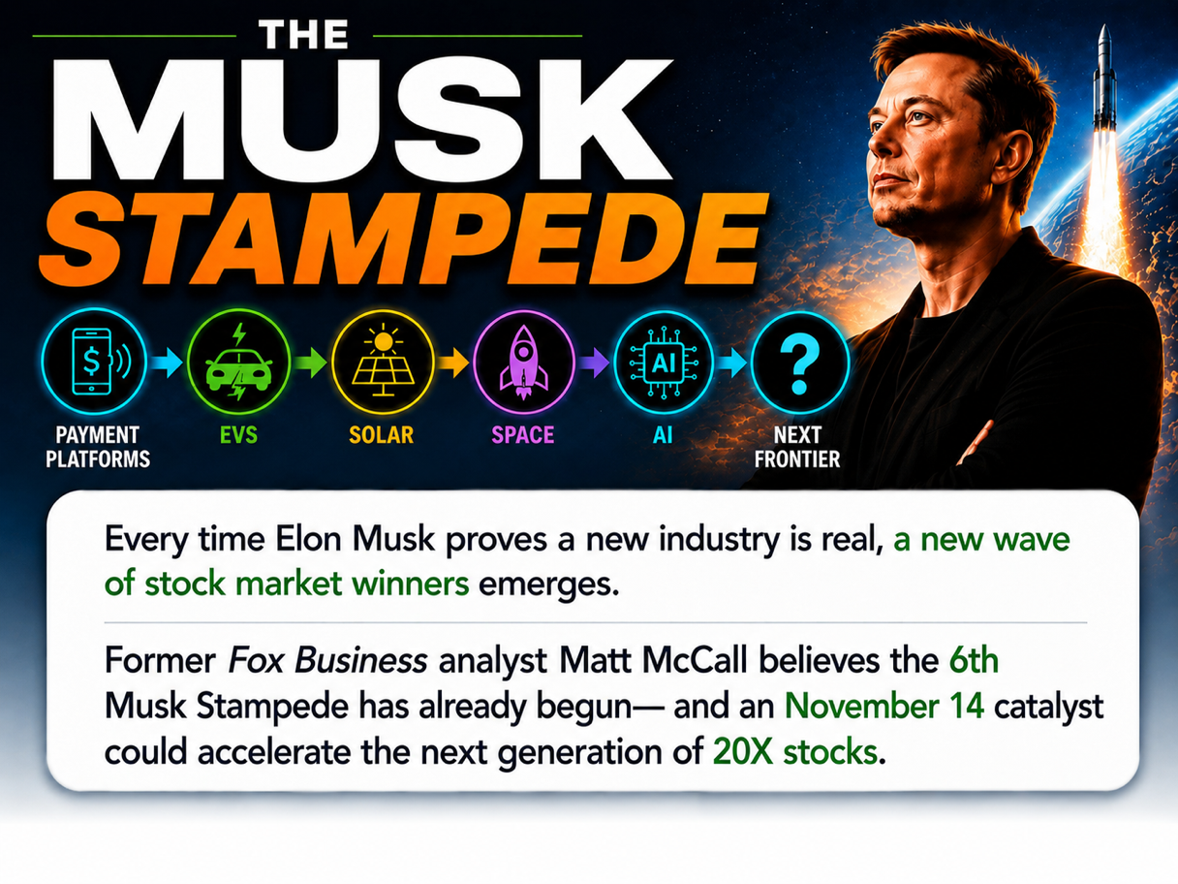

The Musk Stampede
Every Time Elon Musk proves a new industry is real, a new wave of stock winners emerges.
Former Fox Business analyst Matt McCall believes the 6th Musk Stampede has already begun – and a November 14th catalyst could accelerate the next generation of 20X stocks.

HOST:

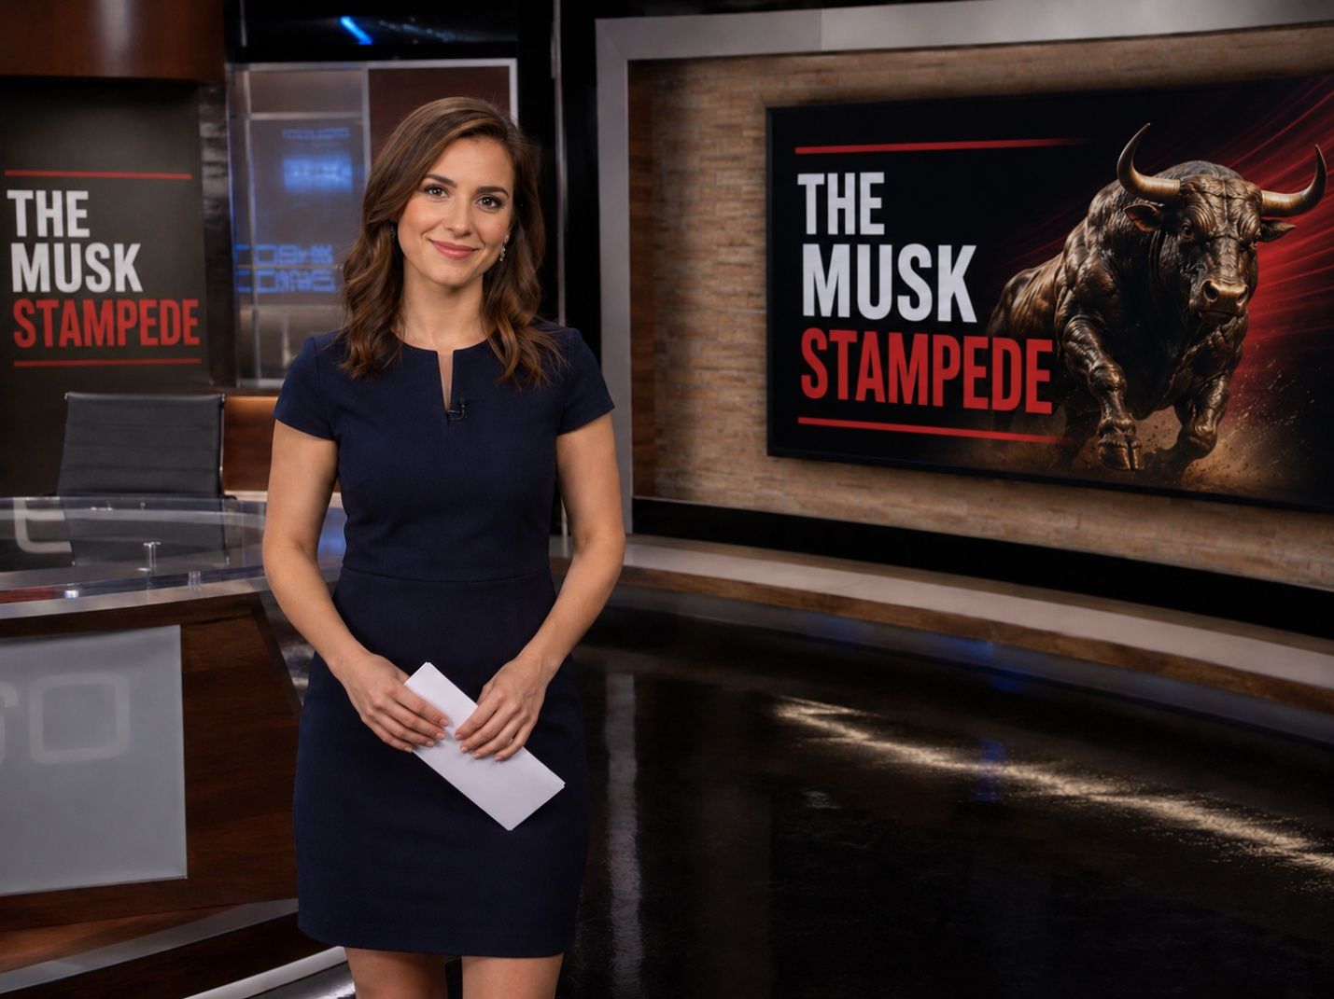

INTRO:

If you've followed the news lately…

You've seen plenty about Elon Musk.

SpaceX…
https://youtu.be/XP5k3ZzPf_0?si=mv_O7jDQzvXn1zwK&t=166

Tesla.
https://youtu.be/6sUwRiIncKU?si=DV1UTEFjlcMVdI6w

Artificial intelligence.
https://youtube.com/shorts/qOpM0Ar_0OY?si=GBDW_VuuM_jISr_H

Politics.
https://youtu.be/l7kQNwJ4H_w?si=1-Q8-K4lCBL6Krq4

Hardly a day goes by without Elon making headlines.

But look beyond the headlines...

And another story begins to emerge.

One that could be far more important to investors.

Because for more than 25 years…

The same pattern has repeated itself again and again.

Elon enters an industry many people dismiss.

Online payments.

Electric vehicles.

Private space.

Artificial intelligence.

He invests.

He builds.

And eventually...

He proves the skeptics wrong.

That's when something remarkable happens.

Money doesn't just flow into Elon's company.

It pours into the entire industry.

Investors scramble to back the next wave of companies hoping to follow his lead.

In fact...

Some of the biggest fortunes weren't made in PayPal...

Or Tesla...

Or even SpaceX.

They were made in the public companies that came afterward.

Veteran Wall Street analyst Matt McCall has been tracking that pattern for years.

If you've watched Fox Business…

You've probably seen him alongside Charles Payne…

Neil Cavuto…

And many of Wall Street's biggest names.

{b roll, string these together:

https://www.cnn.com/videos/bestoftv/2012/07/27/ym-mccall-riley-buy-facebook-fb-stock.cnn

https://www.youtube.com/watch?v=LfrSg62YZM4&t=20s

https://www.youtube.com/watch?v=HhyB1PH-uiU&t=19s

https://www.youtube.com/watch?v=4nH9L0ETgcE

b roll for html:

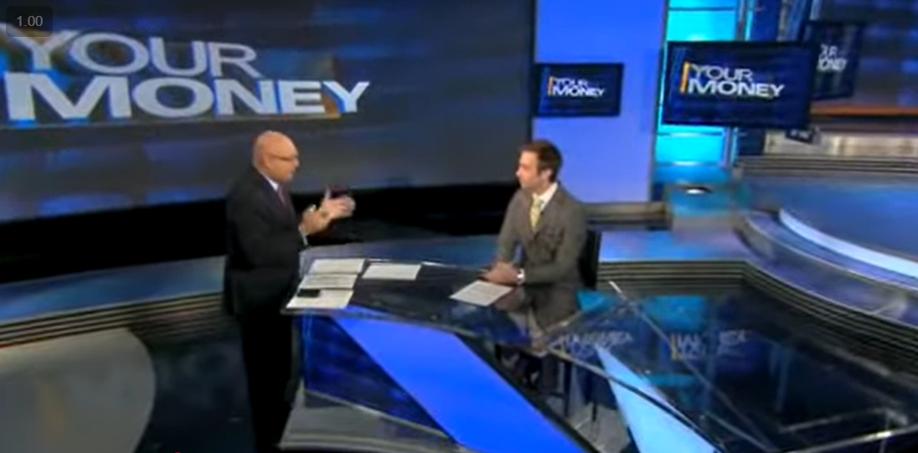

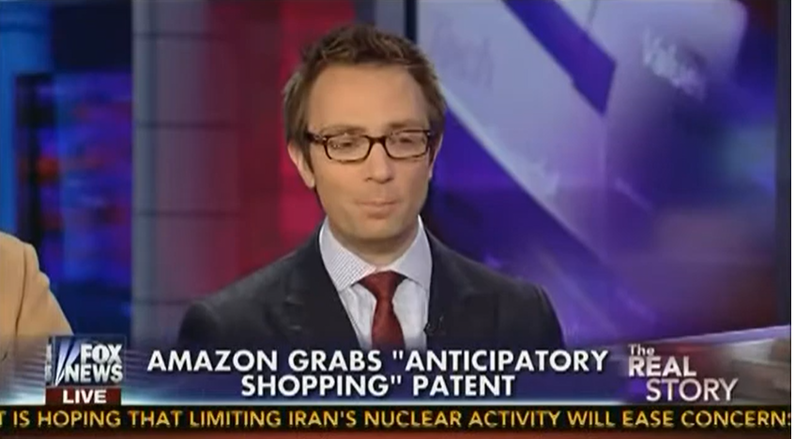

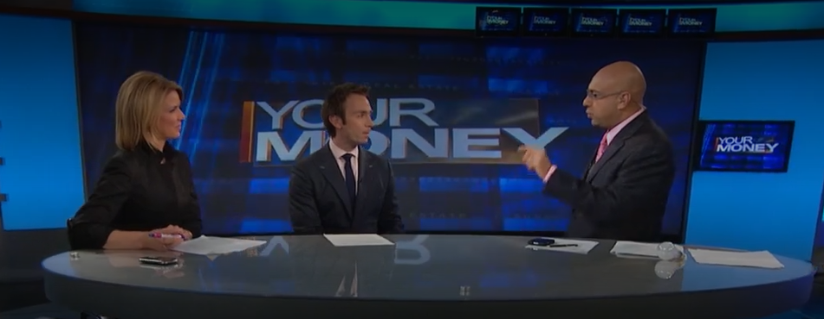
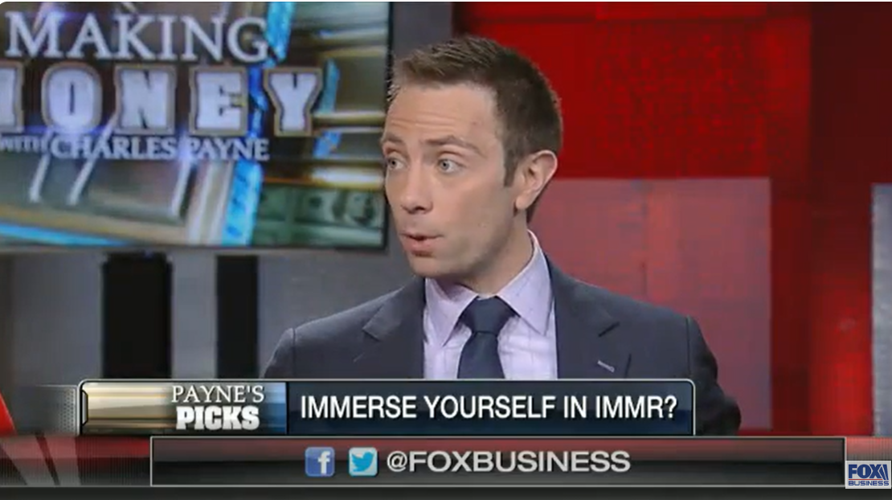

He's made more than 1,000 television appearances...

Identified Tesla back in 2014...

And uncovered 50 investments that eventually returned 1,000% or more over the past two decades.

And Matt believes Musk is about to do it again.

Only this time…

It has nothing to do with rockets.

Electric cars.

Robots.

Or satellites.

Musk is moving aggressively into an entirely different industry.

One that could ultimately dwarf everything he's done before.

Matt has a name for what happens when Musk enters a market…

And billions of dollars come stampeding in behind him.

He calls it…

The Musk Stampede.

And he believes another Stampede may already be beginning.

Because Musk isn't alone.

The biggest technology companies on Earth are pouring billions into the same emerging field:

And the largest technology companies in the world are already jumping in, like:

- Nvidia.

- Google.

- Apple.

- Amazon.

- Microsoft.

- Meta.

- Even Tesla.

Every member of the Magnificent Seven is now investing billions of dollars into the same emerging field Musk is targeting.

He's already circled a specific date:

November 14.

January 12.

That's when he believes this story could break wide open…

And the rest of Wall Street could finally begin to catch on.

Stanford professor Daphne Koller calls what's happening…

"An absolutely critical, pivotal shift."

And Nobel Prize winner Demis Hassabis believes it could become...

"Ten times bigger than the Industrial Revolution."

So today…

We asked Matt one simple question...

If another Musk Stampede is beginning...

Which little-known stocks will soar next?

His answer could change your financial future forever.

INTERVIEW

HOST:

Matt McCall, thank you for joining us.

MATT:

Great to be here.

HOST:

Matt, you've spent more than two decades identifying major technology trends before Wall Street caught on.

And—one thing people may not realize...

You've also been one of Elon Musk's earliest supporters.

Today you're saying Elon is setting off another investment wave.

Not just in one company...

But across an entire industry.

Explain that please.

MATT:

Every few years…

Elon Musk walks into an industry most have already dismissed.

People roll their eyes.

They say,

“…It'll never work.”

Then, he proves them wrong.

And that's when something fascinating happens.

Capital floods in.

Not just into Elon's company...

But into dozens of public companies racing to build around him.

That's the pattern I've watched for more than two decades…

Elon doesn't just create successful businesses.

He validates entire industries.

And once he does...

Wall Street stampedes in.

I've watched this happen five different times.

And I believe we’re looking at the sixth NOW.

Just like the others...

I believe it will create a new generation of extraordinary stock winners.

HOST:

Walk me through it. Start at the beginning…

MATT:

Back in 1999...

The idea of sending money over the internet sounded absurd.

Elon believed it anyway.

He founded the company that would eventually become PayPal.

A few years later…

eBay bought it.

And Elon walked away with $176 million…

Roughly 13 times his original investment.

That's the part of the story most people remember.
The part that fascinates me...

Is what happened next.

Once PayPal proved digital payments were real...

Wall Street didn't just invest in PayPal.

It poured money into the entire industry.

And many of the biggest winners weren't PayPal at all.

Block, for example climbed as much as 2,000% over 7 years.
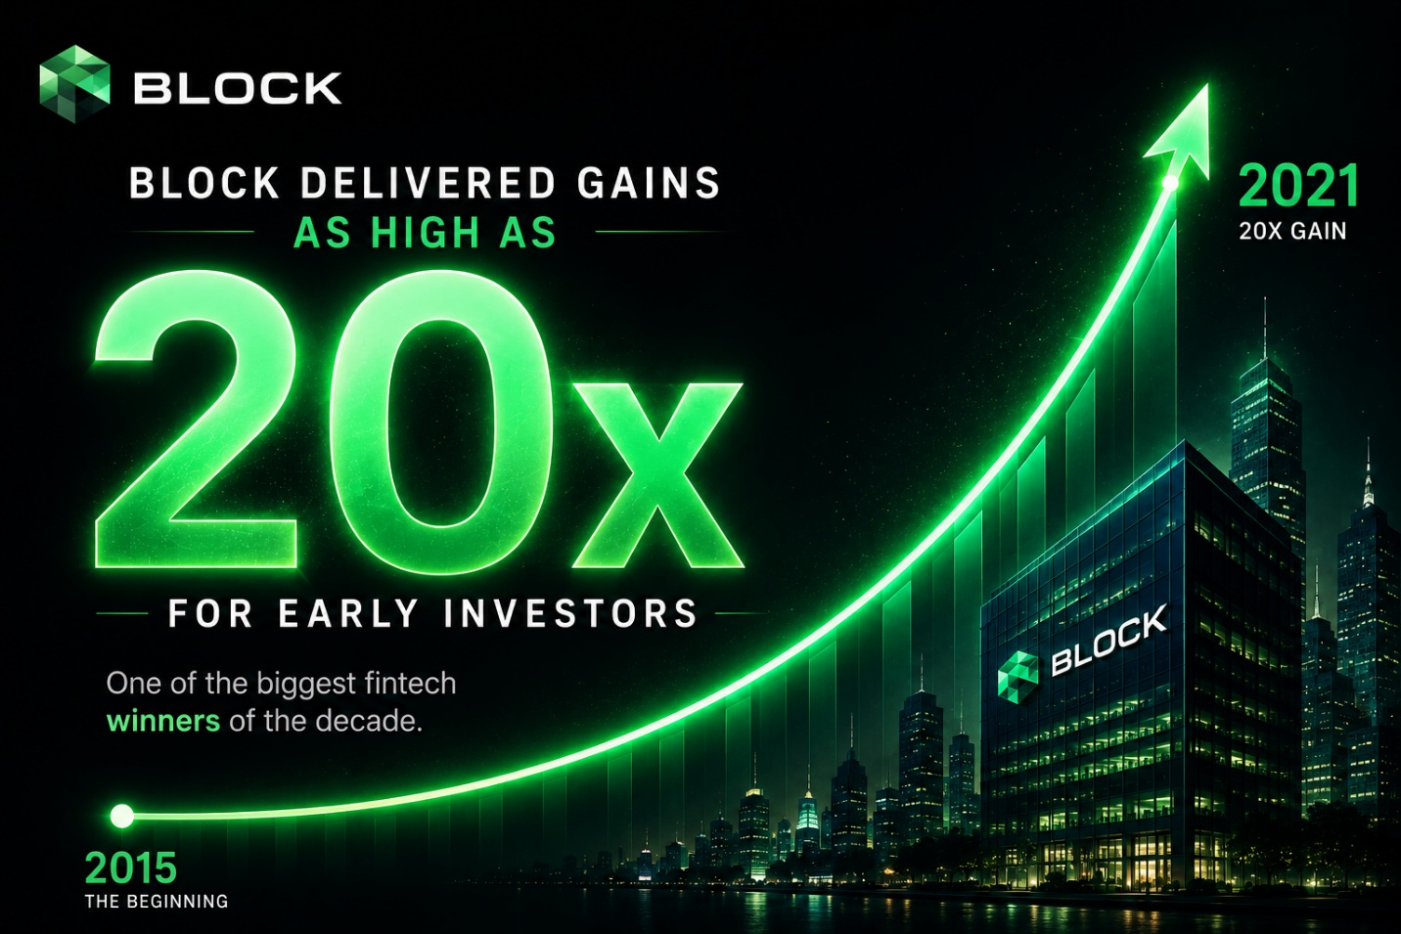

Shopify...

Built on the same shift toward digital commerce...

Has gained more than 90 times since it went public in 2015.

That's $454,000 for every $5,000 invested…

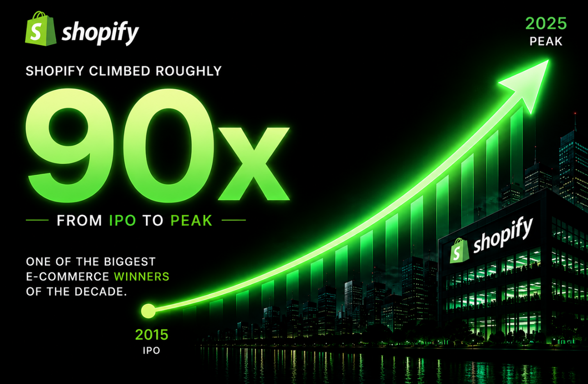
And MercadoLibre, which built Latin America’s PayPal, climbed over 100x from 2007 to 2021.

Turning every $5k into half a million….

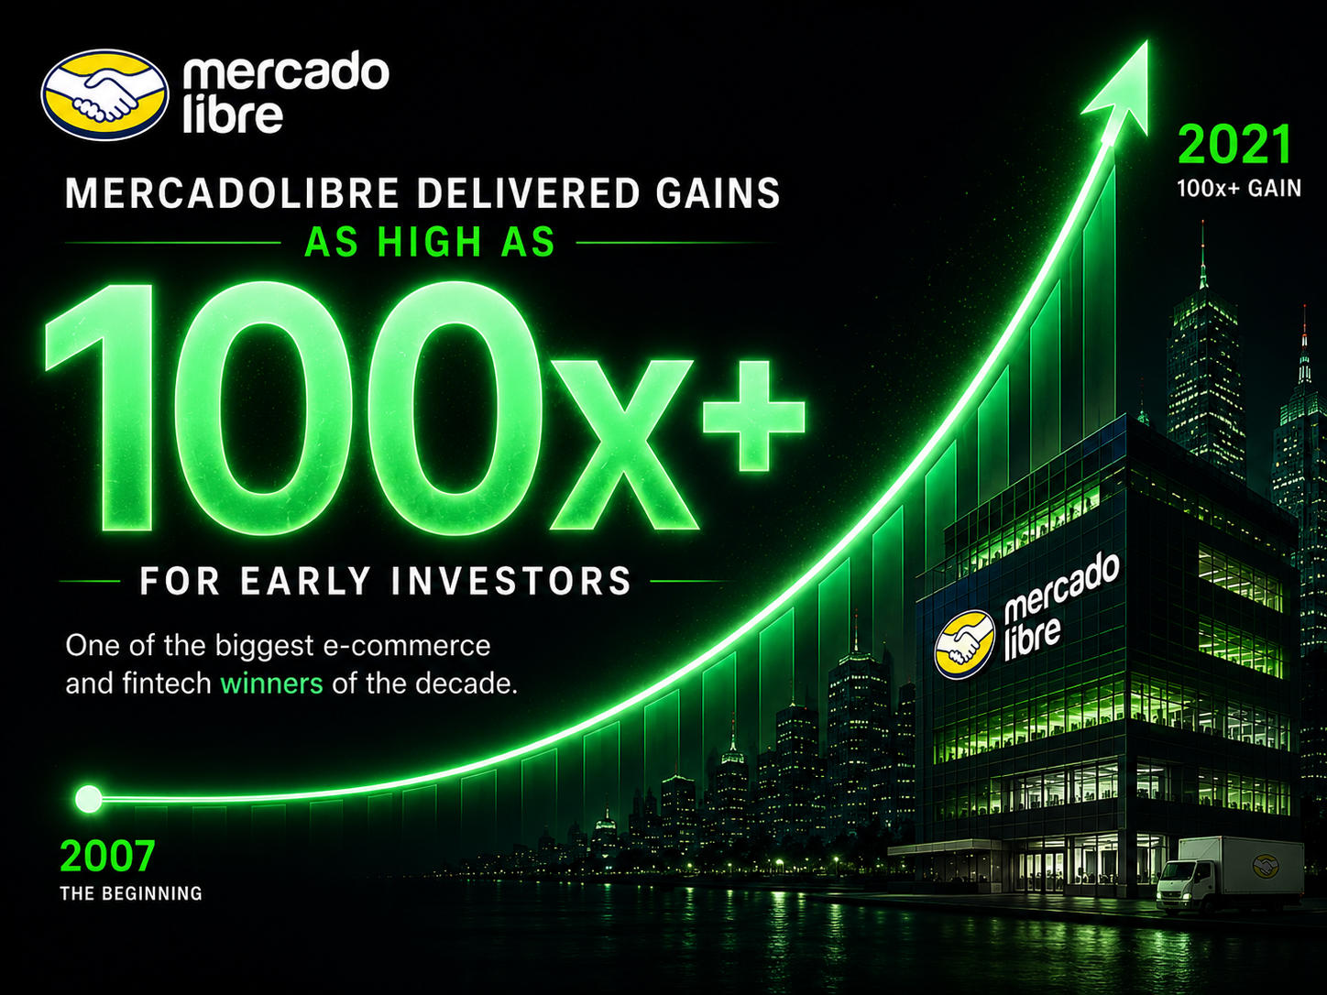
HOST:

So Elon proves the market...

And everybody else rushes in?

MATT:

Exactly.

The same thing happened with electric vehicles.

When Elon launched Tesla...

Most of the auto industry thought EVs would remain a niche product.

General Motors had already abandoned its first electric car.

Gasoline was cheap.

Wall Street wasn't interested.

Then Tesla changed the conversation.

I identified Tesla in 2014. Since then, investors have had the opportunity to make roughly 26 times their money.

That’s 130 grand for every 5k invested.

But Tesla wasn't the end of the story.

It was the beginning.

Once Tesla proved electric vehicles were here to stay...

Capital poured into the entire ecosystem.

Early investors had the opportunity to make as much as 22 times their money in NIO in a year...

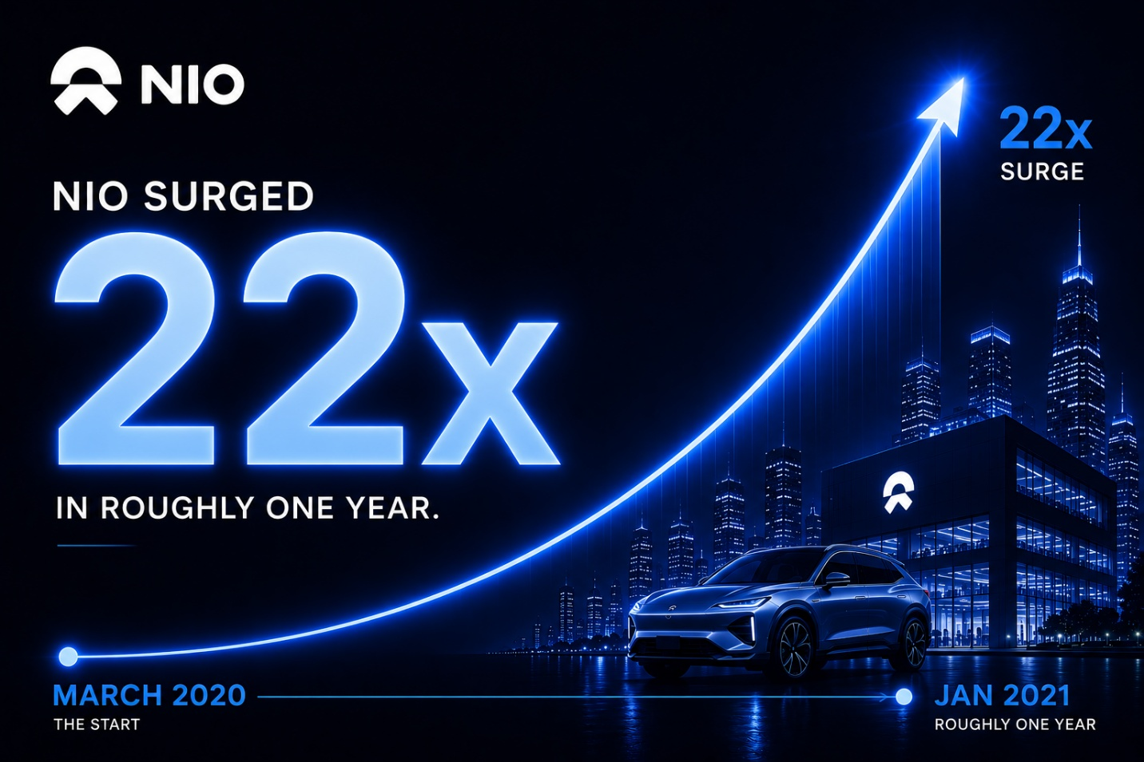

Around 31 times in Blink Charging over a similar time frame.

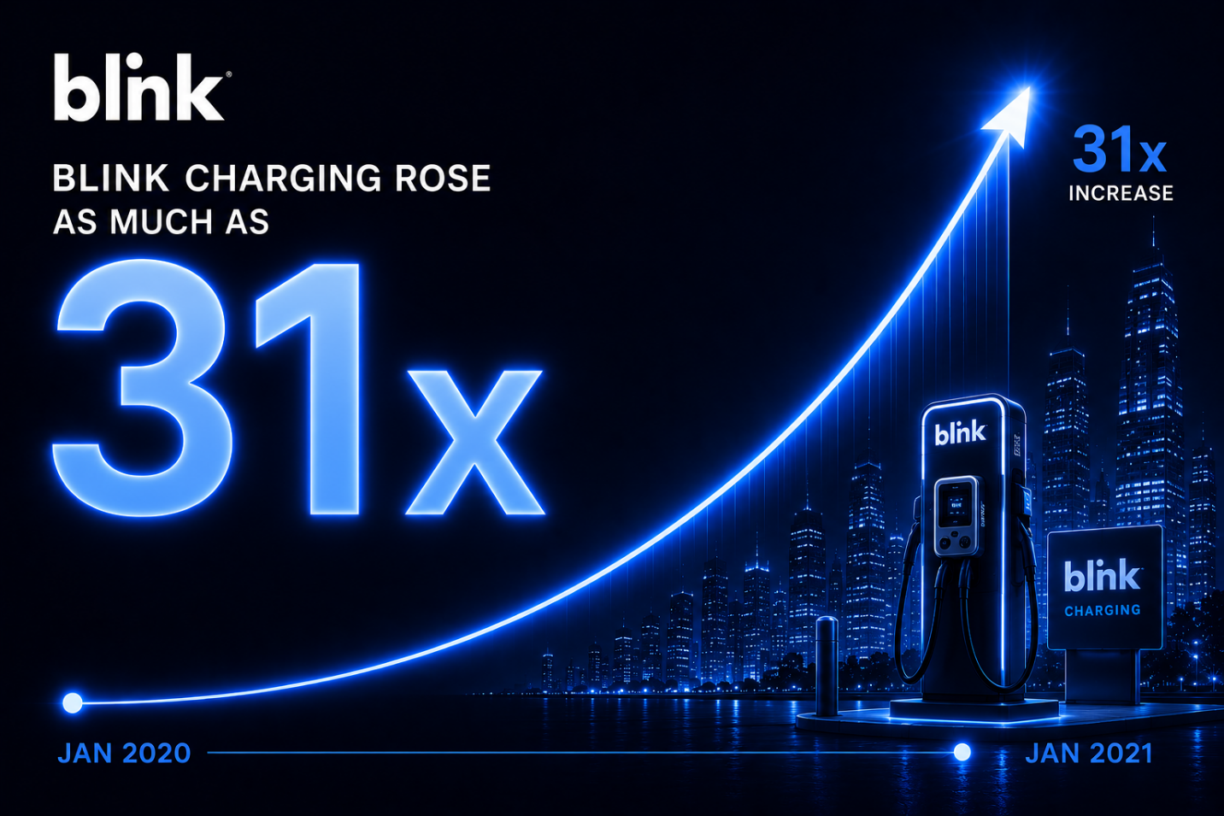

And roughly 40 times in BYD between 2008 and 2022.

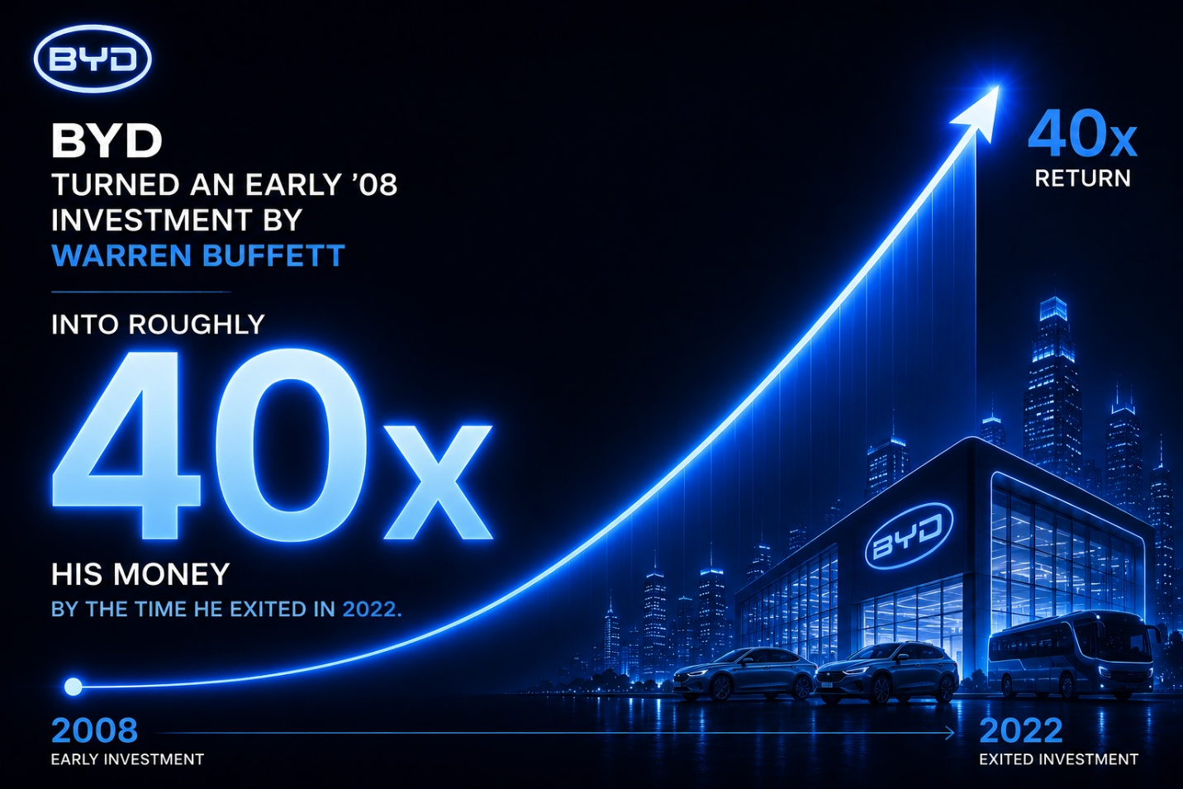

HOST:

So the real opportunity wasn't just Tesla.

MATT:

Exactly.

Most people focus only on the companies Elon builds.

I focus on the industries he validates.

Because once Wall Street becomes convinced...

It rarely stops with one stock.

The same thing happened in solar.

In 2006…

Elon backed SolarCity.

And another Musk Stampede began.

Early investors had the opportunity to make as much as 24 times their money in Sunrun...

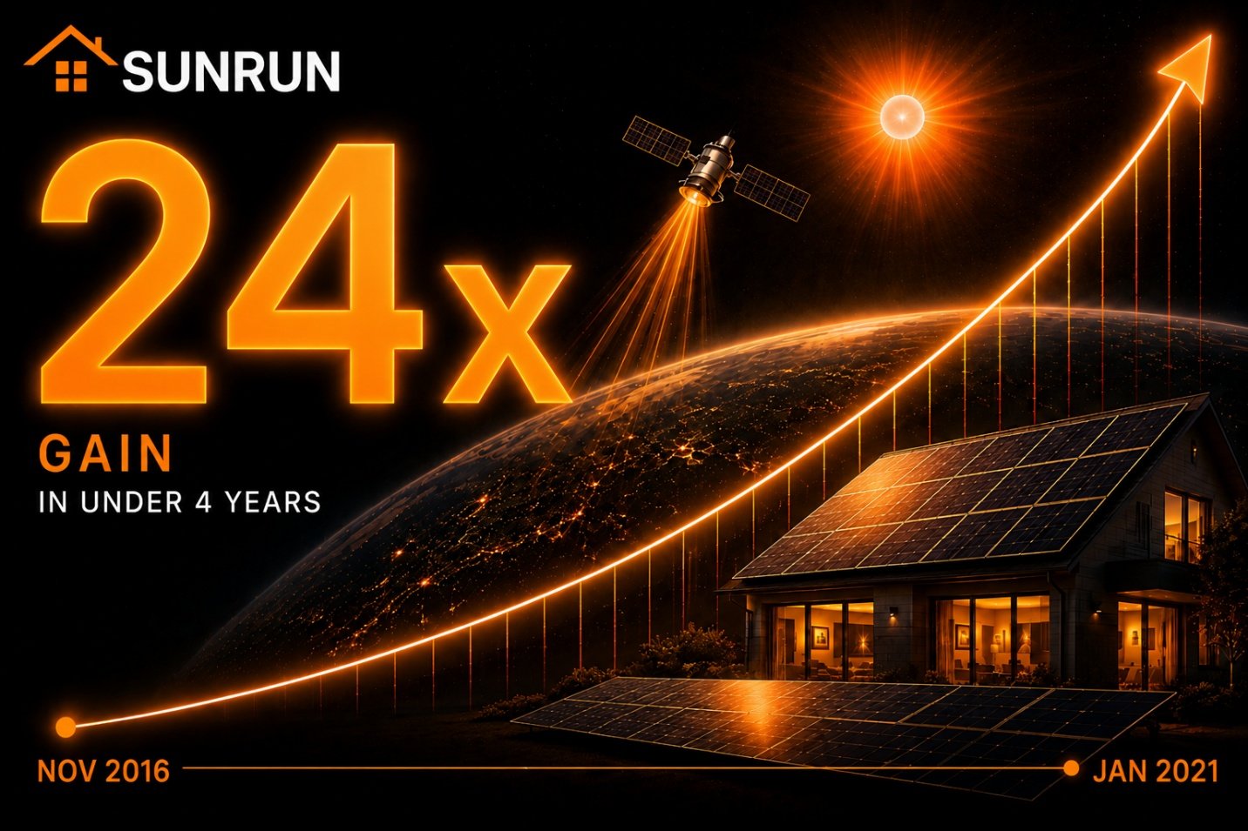

In under 4 years.

First Solar climbed as much as 28 times between 2012 and 2026.
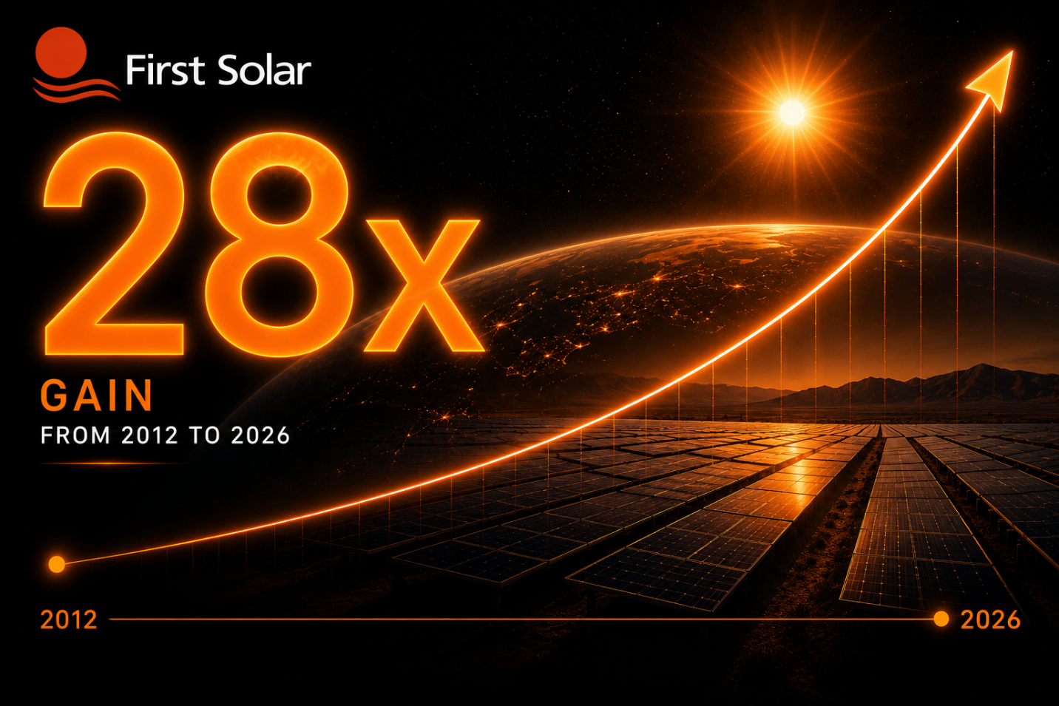

And Daqo New Energy (DQ) rose as much as 129 times between 2012 and 2021…



Which could have turned every $5,000 invested into $646,510.

Then it happened again.

With space…

SpaceX didn't just build a remarkable company.

It transformed commercial space into a real industry.

And once again...

A Musk Stampede followed.

Capital poured into the businesses building around it.

With most big winners happening during a compressed 2-year period.

Planet Labs delivered 17x gains.

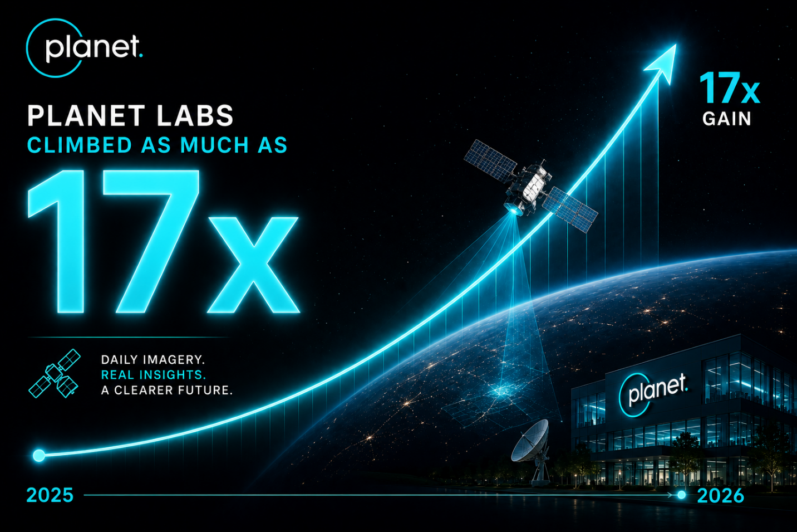

Rocket Lab climbed as much as 42x.
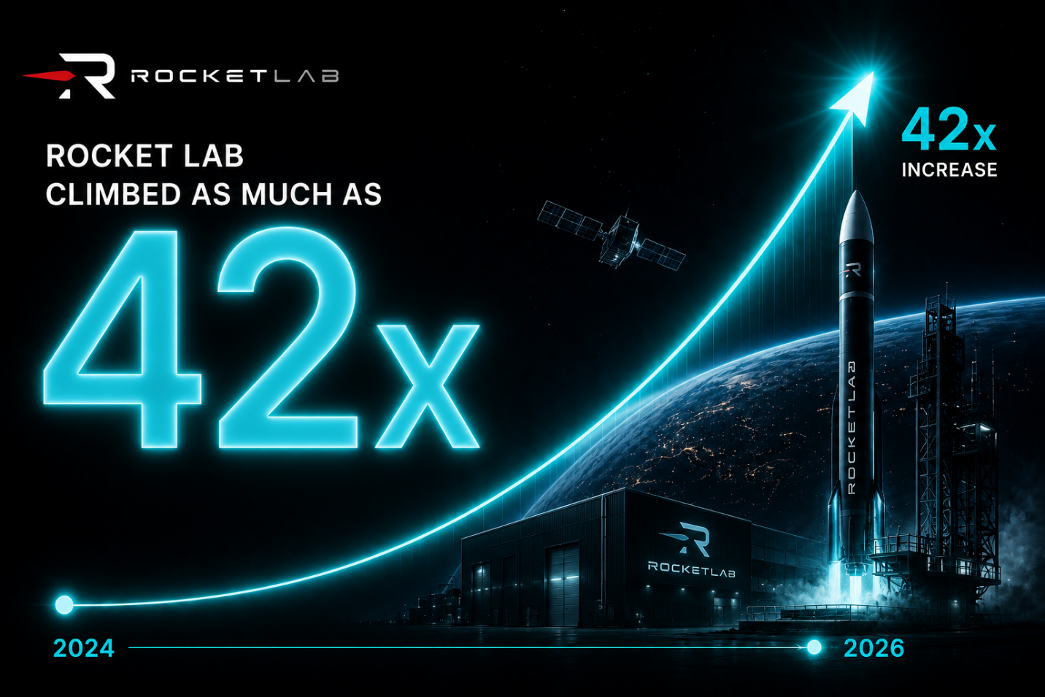

And AST SpaceMobile surged as much as 66x…

Which would have given $330,000 for every $5,000 put into it.
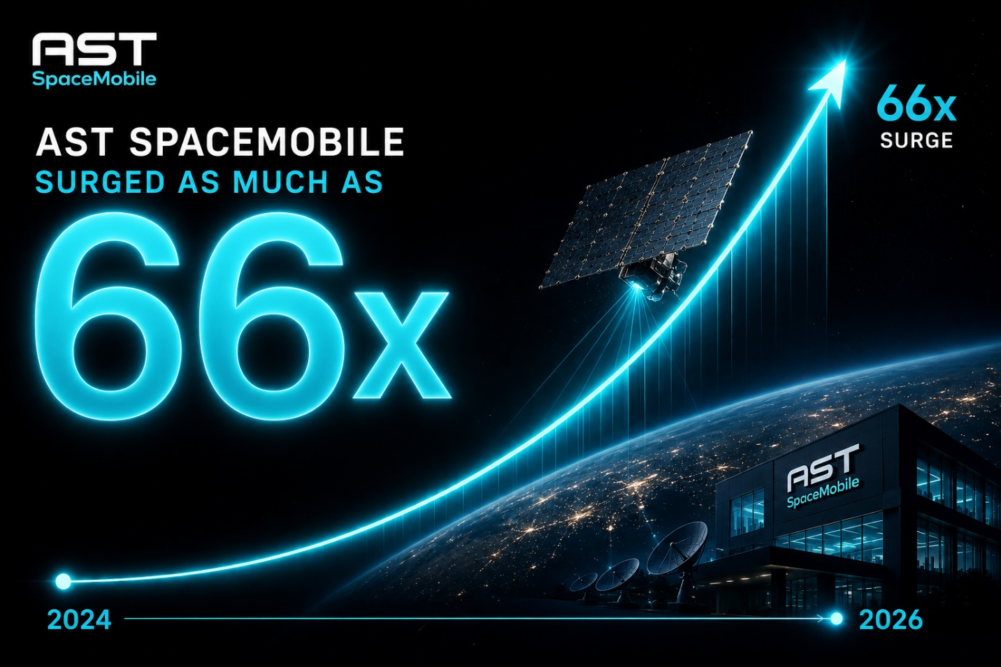

HOST:

Okay...

I think I see the pattern.

First, Elon proves a market is real.

Then Wall Street piles in.

And the companies building around him often create enormous wealth.

MATT:

Exactly.

Now, the examples showed you included some of the most exceptional gains these trends produced.

But here's what I want you to notice.

Musk doesn't just build successful companies.

He gives Wall Street confidence that an entire industry is real.

- PayPal pioneered online payments.

- Tesla pushed electric vehicles into the mainstream.

- SolarCity put solar on ordinary rooftops.

- SpaceX created a new era of private space exploration.

And almost every time…

The biggest gains weren't made inside Musk's own company.

They were made in the businesses that followed him.

The Musk Stampede.

Or as CNBC once called, “The Elon Musk Effect.”

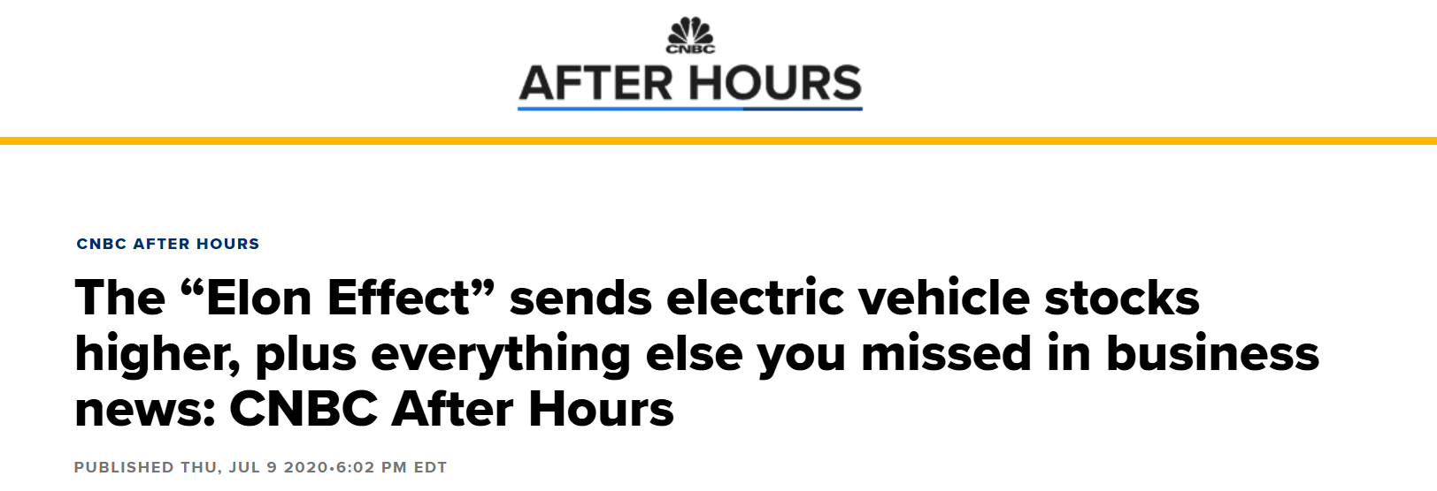

Whatever you’d like to call it…

It’s real. And it’s documented.

HOST:

What about AI—

Wasn’t Elon late to the party with Grok?

MATT:

Well that’s where things get interesting…
Long before AI dominated every headline on every financial network…

And before ChatGPT became a household name…

Elon Musk helped launch OpenAI, the owner of ChatGPT.

People forget this because Musk decided to create how own AI company afterward…

But he was the force behind the entire AI revolution that started with OpenAI.

This was more than decade ago…

HOST:

Unbelievable. The man really is not human.

MATT:

{reacts} He’s a machine.

With A.I., he created the mother of all stampedes….

Just look at some of the winners that followed in his wake.

For example…

Since 2015…

Palantir generated gains as high as 20X…

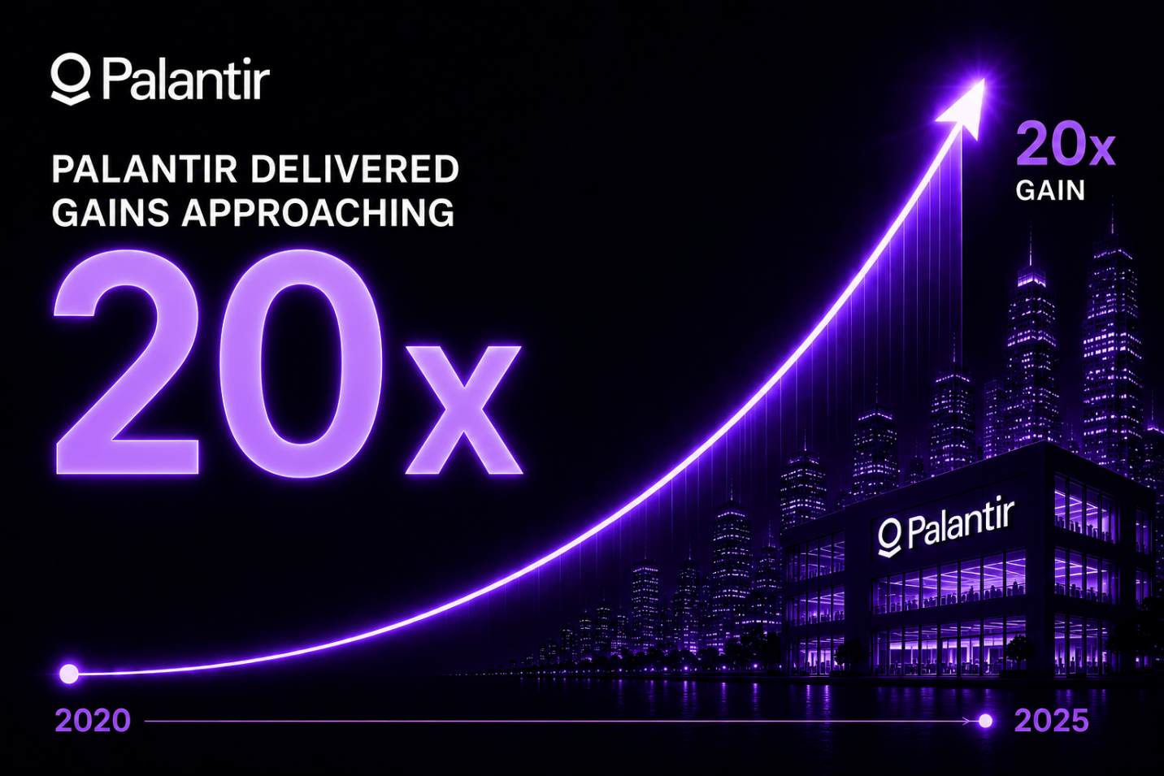

Super Micro Computer climbed as high as 50x…

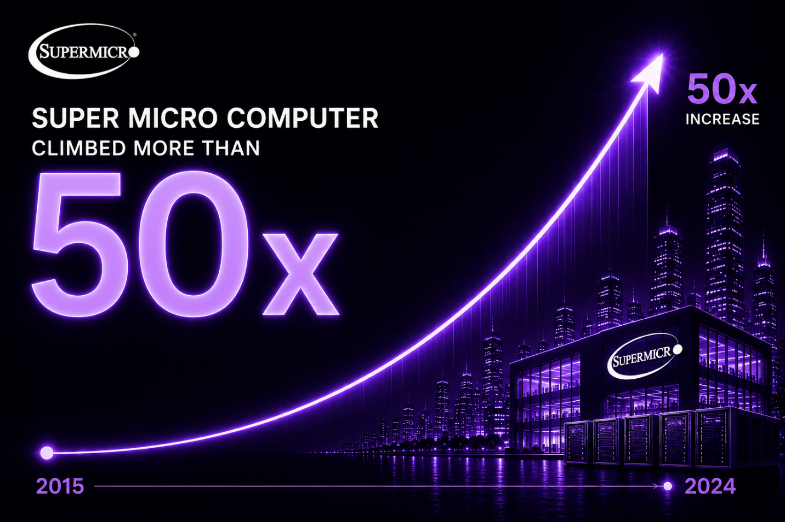

And Nvidia rose as much as 293x.

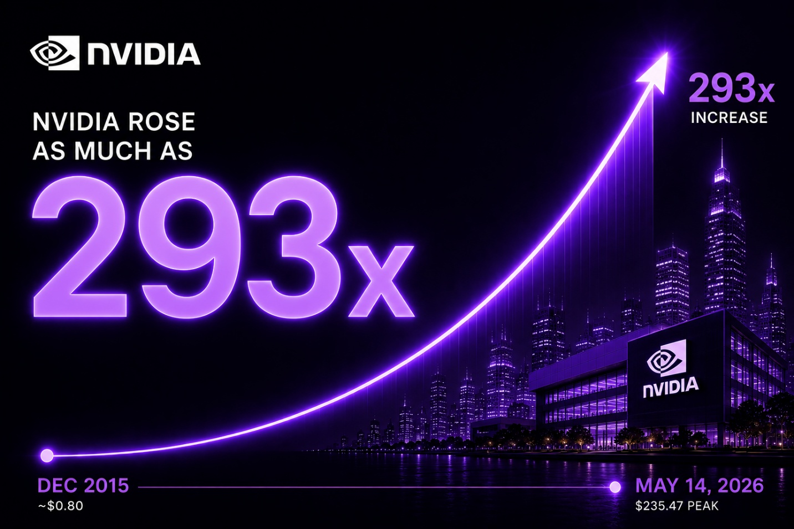

HOST:

293 times… unreal.

MATT:

That's $1.46 million for every $5,000 invested.

Every time Musk gets into an industry… he creates a stampede of profits.
It’s a pattern that repeats over and over..

And look at what that pattern has paid.

- Forty times your money in electric cars.
- Forty-six times in payments.
- Sixty-six times in space.
- 129 times in solar.
- Two hundred and ninety-three times in AI.

And I didn't just spot this after the fact.

I identified Tesla all the way back in 2014.

Back in early 2020 -- before most of that run -- I told my readers to buy Nvidia.. before it would become one of the biggest companies in the world..

[MATT TURN TO AUDIENCE CAMERA]
That, folks, is the Musk Stampede.

And I’ve followed what Elon does to help identify many of my best winners.

Over the past two decades…

I’ve identified over 50 investments that went on to gain more than 1,000% at their peak.

SCROLL LIST

- Advanced Micro Devices (AMD): 256.6x gain
- Bitcoin (BTC): 197.2x gain
- Cardano (ADA): 79.9x gain
- Binance Coin (BNB): 78.7x gain
- TASER / Axon (AXON): 62.6x gain
- VeChain (VET): 52.4x gain
- Quanta Services (PWR): 49.2x gain
- O'Reilly Automotive (ORLY): 44.6x gain
- Nvidia (NVDA): 39.2x gain
- Dillard's (DDS): 35.8x gain
- Microsoft (MSFT): 35.2x gain
- Enjin Coin (ENJ): 34.6x gain
- Tesla (TSLA): 32.3x gain
- Ubiquiti (UI): 31.6x gain
- NetEase (NTES): 28.6x gain
- Google (GOOG): 28.4x gain
- Boston Beer / Samuel Adams (SAM): 26.7x gain
- MYR Group (MYRG): 26.6x gain
- Netflix (NFLX): 26.1x gain
- Meta (META): 26.0x gain
- Deckers Outdoor (DECK): 25.4x gain
- Ross Stores (ROST): 24.4x gain
- TJX Companies (TJX): 20.3x gain
- Amazon (AMZN): 17.8x gain
- Ilika (IKA-L): 17.5x gain
- JPMorgan Chase (JPM): 16.7x gain
- Starbucks (SBUX): 15.2x gain
- Dollar Tree (DLTR): 15.1x gain
- Eaton (ETN): 14.6x gain
- Apple (AAPL): 14.5x gain

And I credit the Musk Stampede for some of them.

One man keeps walking into industries the world has written off…

And every time, a stampede of winners comes charging in behind him.

And the only reason I'm sitting here today is this:

I'm convinced the next one has already started.

HOST:

And you’re saying a new Musk-driven stampede is underway?

MATT:

I am.

And this time...

It's happening in a field most investors still barely understand.

Yet Elon says it contains "a lot of opportunity"...

And represents a much bigger breakthrough than most people realize.

I've seen this movie before.

First...

People dismiss the idea.

Then Elon proves it can work.

Then the smartest money in the world quietly begins to move.

That's exactly what's happening now.

Peter Thiel...

The investor who backed PayPal...

Facebook...

Palantir...

And SpaceX...

Has invested.

So has Sequoia Capital...

The firm behind Apple...

Google...

WhatsApp...

And dozens of the biggest technology companies ever built.

Now the Magnificent Seven are moving too.

- Google.

- Meta .

- Apple…

- Amazon…

- Microsoft…

- Tesla…

- Nvidia

Every one of them has exposure in one form or another.

When I see that many smart investors...

That many great companies...

And Elon Musk...

All converging on the same technology...

I pay attention.

HOST:

Okay...

Where is all this money going?

What's the next Musk Stampede?

MATT:

This time...

Elon is taking on what may be the most complex machine in the known universe.

The human brain.

And what he's building could eventually transform medicine...

Communication...

Even the relationship between people and computers.

But it starts with one company.

It starts with a company almost everyone has heard of...

But very few people actually understand.

Neuralink.

HOST:

I've heard the name.

Brain implants, right?

Sounds pretty crazy.

MATT:

(laughs) I know… almost just as crazy as wanting to colonize Mars.
But that’s what Elon does… he thinks big.
But HOST… take a moment…

I want you to think about moving your hand.

HOST:

Ok…

MATT:

Move your index finger…

You decide to move it...

And your brain sends an electrical signal.

That signal travels down your spine...

Into your muscles...

And your hand moves.

HOST:

Right I’m with you.

MATT:

Now, for someone who's paralyzed...

The brain still sends the signal.

The problem isn't the thought.

The pathway is broken.

HOST:

So the message never arrives.

MATT:

Exactly.

Neuralink captures that signal...

Then reroutes it to a NEW connection…

That could be a computer… a robotic arm… anything that can be controlled with an electric current.

HOST:

Has it actually worked?

MATT:

It has.

PLAY BROLL: https://www.youtube.com/watch?v=tN1lVwTHCMw
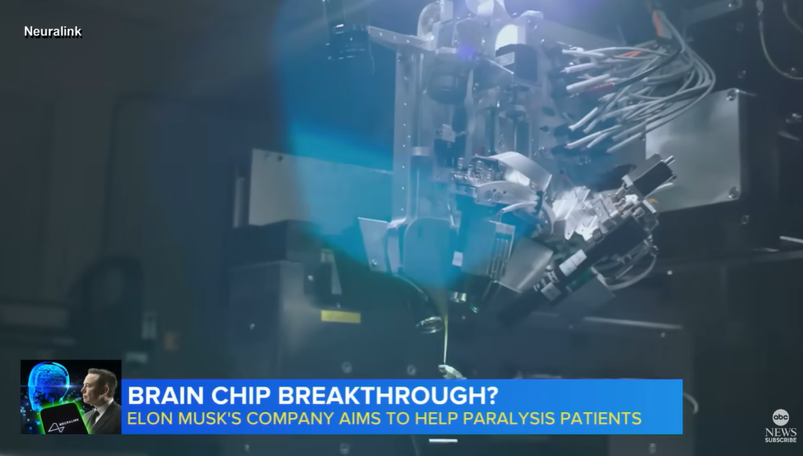

In January 2024…

Neuralink implanted its first device in a human being.

A young man named Nolan.

A diving accident left him paralyzed from the shoulders down.

For eight years...

He couldn't control his hands.

Then, within weeks of the implant, Nolan moved a cursor across a screen.

With his mind.

He played chess.

He stayed up until six in the morning playing video games with his friends.

He had not been able to do that since the accident.

Someone asked how he moved the cursor.

Nolan said he just thinks about where he wants it to go.

Then it goes there.

He said it felt like using “the Force.”

And this was not one slow letter at a time.

Nolan broke the world record for cursor control with a brain implant.

He still holds it.

HOST:

That is incredible.

Is Nolan the only one?

MATT:

Not at all.

This next story really stayed with me.

A man named Brad has ALS.

By the time Neuralink reached him, he could not move.

He could not speak.

The only way he communicated was with a device that tracked his eyes.

And it only worked in the dark.

In his words — "I was basically Batman. I was stuck in a dark room."

Brad has a wife.

Three children.

Imagine not being able to tell your kids you love them.

Then he received the Neuralink implant.

Later, Brad made a video about his life.

He edited the entire thing using only his thoughts.

For the voice, his team found old clips from before he got sick.

They trained an AI on those clips.

Then they rebuilt his voice.

So a man who had not spoken in years told his own story.

And his children heard their father's voice again.

HOST:

{reacts}

MATT:

I've spent more than twenty years studying breakthrough technologies.

Very little surprises me anymore.

That did.

And Brad isn't alone.

More patients are joining the program.

The list keeps growing.

Once Elon proved this could work...

His ambitions grew even bigger.

He said Neuralink should not stop with paralysis.

He wants to restore sight.

Imagine bypassing damaged eyes altogether...

And sending visual information directly to the brain from an HD camera.

It's a glimpse of where Musk believes this technology is going next.

HOST:

It's incredible.

And life-changing for people living with paralysis.

But I'm wondering...

Is this really on the scale of Tesla or SpaceX?

How does it change life for everyone else?

MATT:

Because this isn't really a story about brain implants.

That's just the first application.

The real breakthrough is what Neuralink had to invent to make the implant work.

HOST:

What do you mean?

MATT:

Think about Nolan moving a cursor with a thought.

His brain wasn't sending one clean signal.

Millions of neurons were firing at the same time.

Neuralink had to teach a machine to separate one meaningful signal from all that electrical noise...

Understand it...

And translate it into action.

That's not just a medical breakthrough.

It's an artificial intelligence breakthrough.

Because once a machine can learn to decode one of the most complex systems in nature...

The human brain...

A much bigger question emerges.

What else can it decode?

The answer...

Life itself.

The same artificial intelligence that learned to write...

Generate images...

And write computer code...

Is now learning to read the code of biology.

Computers run on ones and zeros.

Life runs on just four letters.

A. T. C. And G.

Those four letters determine how our bodies develop...

How proteins are built...

Why diseases emerge...

And how cells function.

For the first time in history...

Artificial intelligence can read that code at a speed no human ever could.

And increasingly...

Help scientists rewrite it.

A 2024 study from Boston Consulting Group examined more than one hundred biotech companies using AI to discover new medicines.

The results were remarkable.

AI-discovered molecules reached Phase 1 successfully at roughly twice the historical rate.

In other words...

What sounded like science fiction...

Is rapidly becoming science fact.

Elon summed it up this way.

"You can effectively think of the future of medicine as being digital."

Then he went even further.

He said that if we learn what to program into synthetic RNA...

We could...

"Basically cure almost anything."

Think about that.

For thousands of years...

Medicine has mostly treated symptoms.

Now...

For the first time...

We're beginning to understand...

And eventually rewrite...

The underlying code itself.

That's the real breakthrough.

Not a better drug.

Not a better microscope.

A completely new way of understanding...

And ultimately programming...

Human biology.

HOST:

“Cure almost anything.”

That's an extraordinary statement.

MATT:

It is.

But Elon isn't the only person saying we're entering a new era.

In 2024, Demis Hassabis shared the Nobel Prize in Chemistry.
https://youtu.be/YtPaZsasmNA?si=f5POT2u85KGKVsR0

His AI system solved one of biology's greatest challenges...

Predicting the three-dimensional structure of proteins.

A problem scientists had wrestled with for half a century.

And when he was asked what comes next...

He said he believes this technology will be...

"Ten times bigger than the Industrial Revolution."

HOST:

Ten times bigger than the Industrial Revolution.

MATT:

And he's far from the only one saying it.

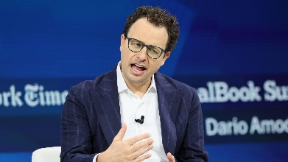
Dario Amodei...

The founder of Anthropic...

Believes AI could compress 50 to 100 years of progress in biology...

Into just five to ten years.

Eric Schmidt, Google's former CEO, says AI's biggest impact may not be on software at all...

But on biology and human health.

Jeff Bezos is investing here.

So is every member of the Magnificent Seven.

- Google.

- Meta.

- Apple.

- Amazon.

- Microsoft.

- Tesla.

- Nvidia.

Every one of them is making major bets on the future of biology.

By our count, Nvidia alone has invested in roughly a dozen companies in the field.

HOST:

Hold on.

All seven?

MATT:

Every one.

In all my time on Wall Street…

I have never seen the world's biggest technology companies...

The richest founders...

And the fiercest competitors...

All making the same bet at the same time.

That only happens when they believe something transformational is underway.

That's the stampede.

This time, it is not electric cars.

It is not rockets.

It's the moment artificial intelligence meets biology.

I believe it has the potential to reshape almost every corner of medicine…

Including aging itself.

But revolutions this big don't happen everywhere at once.

They begin where the science is already working...

And where the commercial opportunity is already enormous.

Right now...

That's programmable medicine.

Peptides.

Protein-based drugs.

The same science behind the breakthrough weight loss drugs like Ozempic...

And many of the next generation of medicines now moving through clinical trials.

Unlike some of the futuristic ideas we've been discussing...

This isn't years or decades away.

It's happening right now.

Which means investors have an opportunity to participate today.

That's why I started here.

HOST:

So what's changing?

MATT:

For almost a century...

Drug discovery followed essentially the same playbook.

Scientists searched through thousands...

Sometimes millions...

Of possible compounds.

One at a time.

It was slow.

Expensive.

And incredibly inefficient.

Developing a single successful drug could take ten years...

And cost roughly $2.6 billion.

Even then...

Nearly nine out of ten drugs entering Phase 1 clinical trials never reached patients.

HOST:

No wonder medicines cost so much.

MATT:

Exactly.

But AI is turning that entire process upside down.

Peter Diamandis is one of the world’s top thinkers on the future.

In Tony Robbins’ book Life Force, he said drug discovery could get:

- “100-fold cheaper…

- “100-fold faster…

- “And more intelligently targeted.”

AI can now help us make drugs at record speed.

Dr. Andrew Hopkins is an Oxford-trained expert in drug design.

He says that by 2030, every new drug will be made with help from AI.

HOST:

That's a completely different way of making medicine.

MATT:

It is.

And it's already happening.

One of the clearest examples comes from a company called Insilico Medicine.

Researchers used AI to uncover a hidden biological target behind a deadly lung disease.

Then they used AI again...

To design an entirely new drug against it.

Think about what that means.

The same technology identified the problem...

And helped create the potential solution.

Today, that drug has advanced to Phase 3 clinical trials.

For patients with this disease...

Every breath matters.

Walking across a room can feel like climbing a mountain.

Some survive only by receiving a lung transplant...

If one becomes available in time.

This AI-designed drug could give those patients something priceless.

More years.

And more time with the people they love.

That's game changing.

AI isn't just speeding up research.

It's beginning to invent medicines we might never have found otherwise.

HOST:

So drugs are just the start.

MATT:

Exactly.

Because once a machine can read biology...

It doesn't stop with medicine.

Take your eyes.

Google trained an AI on hundreds of thousands of ordinary retinal scans.

The same images you might get during a routine eye exam.

Then it showed the AI scans it had never seen before.

From one picture...

It could estimate a person's age within a few years.

Tell whether they were male or female.

Whether they smoked.

Estimate their blood pressure.

Even predict their risk of heart attack or stroke.

HOST:

From one photograph?

MATT:

From just one photograph.
But here's the extraordinary part.

Doctors don't fully understand how the AI knows.

No one programmed it to look for those clues.

It found patterns humans didn't even know existed.

The information was always there.

We simply couldn't read it.

Now a machine can.

HOST:

{reacts}

MATT:

Here's one you'll never forget.

Think about a slice of bread in a toaster.

It starts out soft.

Add a little heat...

And it turns brown.

You can't turn it back into bread.

That process has a scientific name… the maillard reaction. It’s the chemical reaction proteins and sugars.

But here's the important part.

A very similar reaction is happening inside your body every day.

HOST:

Wait...

Really?

MATT:

Really.

Tiny amounts of sugar in your bloodstream slowly stick to proteins throughout your body.

Your skin.

Your joints.

The walls of your arteries.

It starts when you're young...

And it keeps going for the rest of your life… compounding over the years.

This, in short, is what ages us.

For generations, scientists believed that damage only moved in one direction.

Like toast.

HOST:

So... we're all slowly being toasted?

MATT:

In a sense...

Yes. Very slowly. Over decades.

It's one reason our skin loses its elasticity…

Our arteries become stiff…

And our bodies get old.

But then a company called Revel asked a different question.

What if that damage could actually be reversed?

They partnered with another company named Calico...

The longevity company backed by Alphabet, Google's parent company.

Their mission was to find an enzyme that could remove that damage...

Without harming the healthy tissue underneath.

They built more than 500 million versions of an enzyme, keeping only the winners…

With AI predicting the shape of every one.

Eventually...

It found one.

Researchers tested it on artery tissue from a 75-year-old donor.

More than 70% of the accumulated damage disappeared.

Then they tested it on aged skin.

The remaining damage fell to levels you'd expect in someone around 31 years old.

HOST:

Whoa! Sounds like we’re tapping into a fountain of youth…

MATT:

Think about it…

For the first time...

Scientists showed it’s possible to reverse aging.

But the story that changed me wasn't about aging.

It was about a little boy named KJ.


He was born in the summer of 2024.

Within days, he was in intensive care at Children’s Hospital of Philadelphia.

KJ had been born with an incredibly rare genetic mutation.

Roughly one in a million.

His liver was missing an enzyme his body needed to clear ammonia from his blood.

And here's what made it so dangerous.

Every time KJ ate protein…

His body produced ammonia it couldn't properly remove.

Even breast milk could put him at risk.

The ammonia could build up in his blood…

Reach his brain…

And cause permanent damage.

In the most severe cases, babies don't survive infancy.

HOST:

And there was nothing doctors could give him?

MATT:

Nothing that could fix the underlying problem.

And that's what was so frustrating.

Doctors knew exactly what was wrong.

They could identify the precise error in KJ's DNA.

They just couldn't correct it.

And the traditional drug industry wasn't built to solve a problem this rare.

Developing a new medicine can take years and cost enormous amounts of money.

For KJ, the potential market was essentially…

One baby.

HOST:

So what did they do?

MATT:

Something extraordinary.

A team at Children's Hospital of Philadelphia and Penn Medicine didn't go searching for an existing drug.

They designed one for KJ.

They identified his exact genetic error…

Designed a gene-editing treatment aimed specifically at that mutation…

And delivered it directly to his liver.

HOST:

How long did that take?

MATT:

About six months.

Think about that.

They went from identifying the genetic error…

To designing the treatment…

To giving it to KJ…

In about six months.

He received his first treatment at seven months old.

And it worked.

Three hundred and seven days after he was admitted to the hospital…

KJ went home with his parents.

HOST:

Wow…that’s extraordinary.

MATT:

This past February, his parents carried him into meetings on Capitol Hill.

His father summed it up simply:

"We're very, very happy with the results."

But here's why I'm telling you this story.

KJ wasn't simply given a drug somebody happened to discover years earlier.

His treatment was designed.

Doctors read the error in his genetic code…

And built a treatment intended to correct it.

HOST:

But Matt…

That's one child.

MATT:

Exactly.

And that's what makes this so extraordinary.

For most of medical history, if you were born with a genetic error like KJ's…

Doctors could identify the problem.

They could manage the symptoms.

But they couldn't rewrite the underlying code.

Now they can.

Think about what happened here.

They read KJ's DNA…

Found the error…

And designed a treatment specifically to correct it.

Read the error.

Write the fix.

That's an entirely new way of thinking about medicine.

And KJ's story isn't happening in isolation.

Because when you step back...

You realize we've really been talking about the same breakthrough all along.

- An AI that helps invent a drug for a deadly lung disease.

- An eye scan that uncovers risks doctors never knew were visible.

- A possible way to reverse one of the fundamental processes of aging.

- A personalized genetic treatment built for a single child.

Four different corners of biology.

With one thing in common.

For the first time in human history...

Biology isn't just something we can observe.

It's becoming something we can read...

Understand...

And increasingly...

Write.

That's the revolution.

Everything else--

Every investment opportunity we're about to discuss...

Flows from that one breakthrough.

HOST:

So how big could this become?

MATT:

No one knows for certain.

But McKinsey tried to put a number on it.

And when McKinsey sizes a market...

Wall Street pays attention.

Its estimate?

Once biology becomes something you can engineer…

It's worth as much as four trillion dollars a year.

Four trillion. Every year. By the 2030s.

That's larger than the entire economy of many countries.

HOST:

So we're not talking about another biotech cycle.

MATT:

We never were.

This isn't one new industry.

It's a new layer underneath medicine itself.

Which brings us back to Elon.

Because Elon has never gone after a small market.

He goes after industries so large they're almost impossible to imagine.

- Payments.

- Cars.

- Solar power.

- Rockets.

- AI.

And each time...

He doesn't just compete. He rewrites the rules.

HOST:

And now he's doing it again.

MATT:

He is.

Neuralink is the proof.

But most people will look at Neuralink and see brain chips.

That is not the real story.

I see something much bigger.

Neuralink only works if artificial intelligence can understand biology.

That's the real breakthrough.

Whether it's reading a neuron...

A protein...

Or one broken gene in one child...

It's the same underlying idea.

Machines learning to read...

And eventually rewrite...

Life itself.

That's the bet Musk is making.

And I don't think he's making it alone.

Washington sees it too.

The FDA is opening the door to AI-designed medicines.

Because this isn't just about healthcare anymore.

It's about national competitiveness.

China has become dramatically faster at developing new medicines.

It's also become remarkably good at copying successful discoveries.

After Novo Nordisk released its obesity data...

Chinese labs immediately began pursuing the same target.

That got Washington's attention.

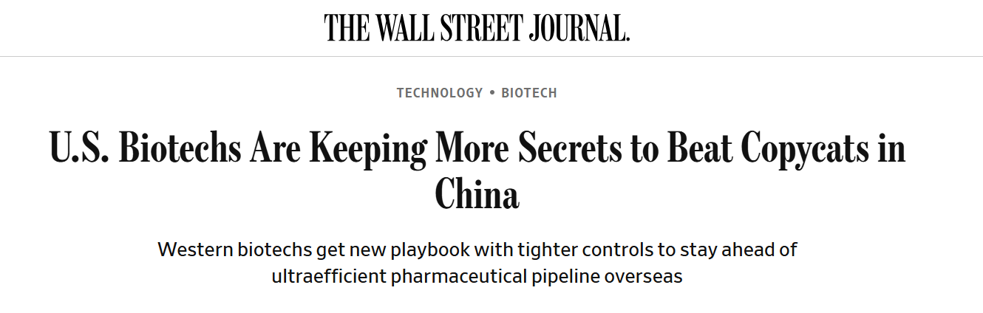

A bipartisan national security commission warned Congress that America risks falling behind. A setback, they warned, we may never recover from.

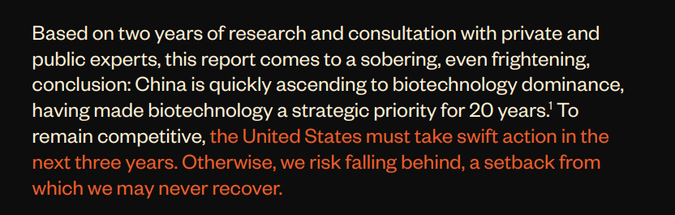

Its recommendation?

Fifteen billion dollars. Minimum. To stay ahead.

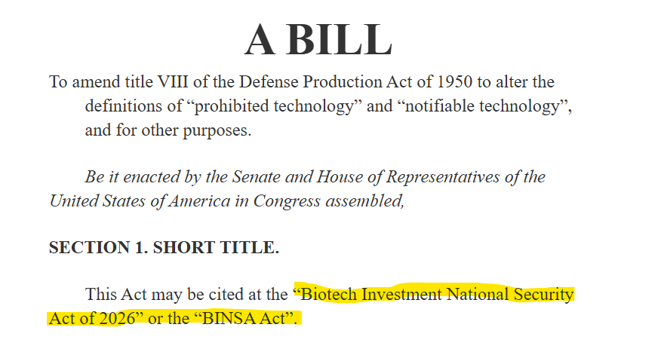

Because AI may be America's biggest advantage.

The faster we discover new medicines...

The harder they become to copy.

HOST:

So Washington isn't just encouraging this.

It's treating it as a strategic priority.

MATT:

Because the country that leads AI-powered medicine...

Won't just discover the next blockbuster drug.

It could set the pace for medicine itself.

The next breakthrough in cancer...

Alzheimer's...

Heart disease...

Rare genetic disorders.

That's not just a healthcare advantage.

It's an economic advantage.

A scientific advantage.

Even a national security advantage.

Washington understands that.

And history shows what can happen when America decides a technology is too important to lose.

We saw it with the space race.

We saw it with semiconductors.

And now we're seeing it again with AI and biology.

When Washington starts clearing the runway...

Capital usually follows.

And it’s already starting…

Nvidia has backed 11 AI-biotech firms.

It also built BioNeMo...

Its own AI platform for drug discovery.

Google created Isomorphic Labs.

It has already signed multi-billion-dollar partnerships with Eli Lilly and Novartis.

Anthropic launched Claude Science...

Then announced plans to help develop medicines itself.

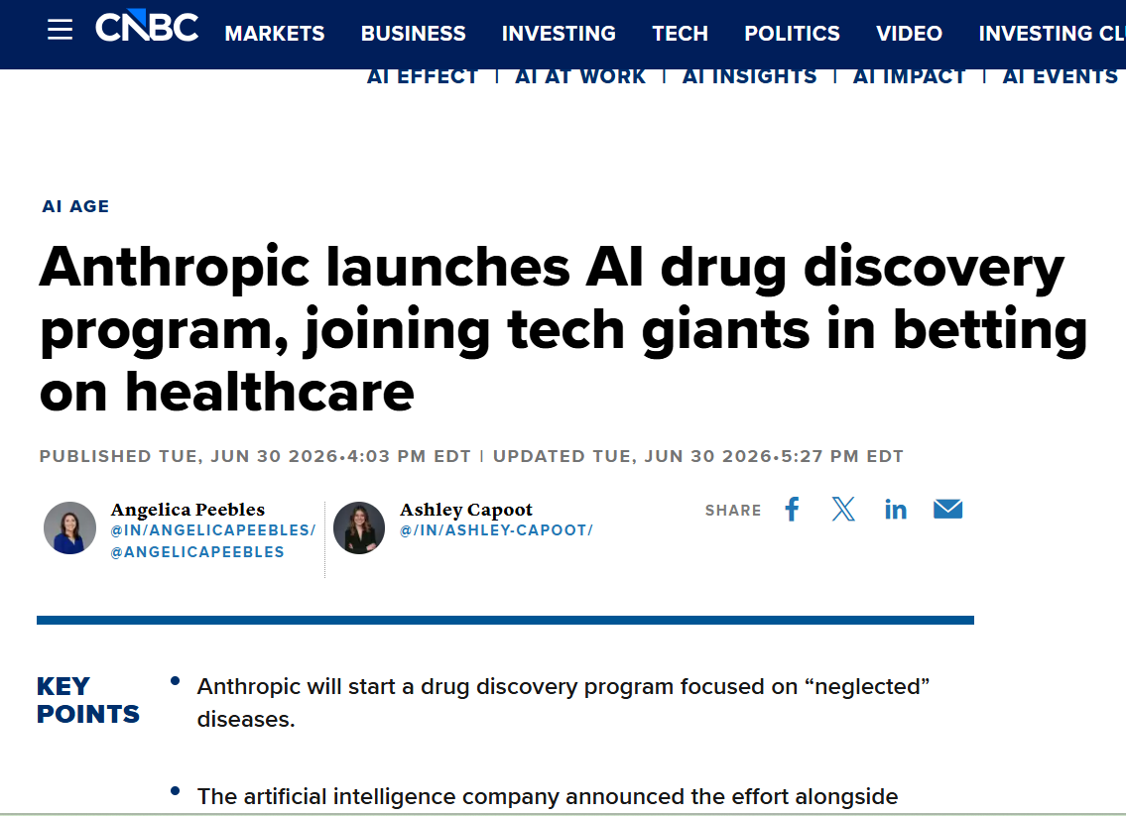

Meta is building biological AI models.

Sam Altman has said much of his personal wealth is concentrated in AI-driven biotech.

And startups like Xaira have raised more than a billion dollars before bringing a single product to market.

HOST:

Those aren't small bets.

MATT:

Not even close.

These companies compete over everything.

- Chips.

- Cloud computing.

- Artificial intelligence.

- Talent.

- Energy.

They're some of the fiercest rivals on Earth.

But they are all following Musk into this NEW industry… a brand new stampede.

HOST:

Okay.

So how do we get ahead of this Musk Stampede?

MATT:

Well, for now, Neuralink is private.

There is no stock you can buy.

But to be candid…

Neuralink is not what excites me most.

Every Musk Stampede we have looked at followed the same pattern.

The biggest gains were not always inside Elon’s own firm.

They often came from public firms that became vital to his plan.

Think about Nvidia.

Nvidia didn't build ChatGPT.

It built the chips ChatGPT runs on.

It happens across industries…

It’s the companies behind the innovations that often create the most wealth…

Take solar.

Enphase Energy didn't make solar panels.

It built the technology that helps those panels convert energy into usable electricity.


And Enphase rose as much as 520 times in under 6 years.

A $5,000 investment had the opportunity to become roughly $2.6 million.

Or electric vehicles.

Aehr Test Systems never built a car.

It didn't even build the chips inside them.

It built the machines used to test those chips.

And Aehr rose as much as 316 times.

A $5,000 investment had the opportunity to become roughly $1.5 million.

Then came the AI boom.

Lumentum developed technology that helps move enormous amounts of data between the chips powering AI.

Its stock climbed as much as 66 times in under 11 years.

Every $5,000 invested had the opportunity to grow into more than $300,000.

And then there's the electricity behind all of it.

Vertiv doesn't make a single chip.

It makes the power and cooling systems that keep AI data centers from shutting down.

And Vertiv rose as much as 80 times in about six years.

Every $5,000 had the opportunity to grow into roughly $400,000.

HOST:

[reaction]

MATT:

Enphase.

Aehr

Lumentum.

Vertiv…

Truly staggering peak gains, yet…

None of these companies made the headlines.

But each made something the headline company couldn't succeed without.

That's the pattern.

When a new industry breaks open...

It rarely creates just one winner.

It creates a market.

Elon proves that market.

Then the companies enabling that market often rise right alongside him.

HOST:

So where do you start?

What's the first company?

MATT:

The first stock I'm targeting in this new Musk Stampede is doing exactly what we've been talking about.

It doesn't discover new medicines.

It designs them.

HOST:

Designs them?

MATT:

For the last hundred years...

Drug companies have searched nature.

They found proteins that already existed...

Then copied them...

Improved them...

And turned them into medicines.

This company doesn't search.

It creates.

HOST:

What do you mean?

MATT:

Think about an AI image generator.

You type a prompt...

And it creates an image that never existed before.

This company does the same thing.

Except instead of pictures...

It creates proteins.

In the simplest of terms, you tell the AI what you want.

Attack this cancer.

Block this disease.

Calm this immune response.

Then it designs a brand-new protein built specifically for that job.

Not something borrowed from nature.

Something that has never existed before.

HOST:

That sounds almost impossible.

MATT:

That's what I thought.

So I looked for proof.

I found a paper in Nature.

They were trying to break the machine.

They tested a sample of 310 proteins that had never existed on Earth… then built every one in a lab to see how many were real.

Not theoretical. Physical. Sitting in a dish.

They folded the way the AI said they would.
HOST:

So it wasn't just theory.

MATT:

Exactly.

And that's why I think this changes everything.

For a hundred years...

Medicine has searched for drugs.

This system doesn't search.

It creates.

It doesn't build one medicine. It builds a machine that can keep inventing medicines.

HOST:

Has it actually created one?

MATT:

It has.

A few years ago, the company targeted severe asthma.

The AI designed a completely new protein.

Today...

That antibody is in two Phase 3 clinical trials...

Across 40 countries...

With about 1,600 patients.

HOST:

Has anything like that made it that far before?

MATT:

A few AI-designed drugs reached Phase 3.

But they're small molecules.

Chemistry we've been doing for a hundred years — just done faster.

This is a protein.

Designed by a machine.

And Bloomberg reports this company could become the first ever to win FDA approval for an AI-designed drug.

HOST:

The FDA has never approved one?

MATT:

Not one. Ever.

The leading asthma drug generated $17.8 billion last year.

This entire company is worth less than $2 billion.

That's what first caught my attention.

But here's what really matters.

I'm not recommending that you buy one asthma drug.

I'm recommended that you invest in the platform.

If this works...

It doesn't validate one medicine.

It validates an entirely new way to invent medicines.

HOST:

So what convinced you?

MATT:

First, the people behind it.

The same team behind Moderna is also behind this company.

Early Moderna investors had the opportunity to make roughly 20 times their money within three years of the company going public.

And after that success, the team started looking toward the next breakthrough:

Using artificial intelligence to design new medicines.

Today, they're still this company's largest shareholder.

HOST:

So they've done this before.

MATT:

Exactly.

But then I saw who else was involved.

Nvidia.

HOST:

Nvidia?

Why would an AI chip company invest in a biotech?

MATT:

Because Jensen Huang has been saying for years that AI won't transform one industry.

It will transform every industry.

Medicine is simply one of the biggest.

Nvidia clearly believes this company is helping lead that transformation.

HOST:

That's a remarkable endorsement.

MATT:

I thought so too.

But then I found one more name.

Baker Bros.

If you don't follow biotech…

You've probably never heard of them.

Inside biotech...

They're legendary.

Last quarter...

They opened a position of more than 1.4 million shares in this company.

So you have the leader in the AI industry… Nvidia… That's why this is my first Musk Stampede stock.

Because I don't think the real opportunity is one successful drug.

I think it's a new way of creating them.

HOST:

So that's one way AI is changing medicine.

MATT:

Exactly.

But every revolution creates an ecosystem.

Some companies invent the breakthrough.

Others make those breakthroughs possible.

That's where my second stock comes in.

This company solved a problem the drug industry had been trying to crack for nearly forty years.

Think about insulin.

Millions of people inject it every day.

Why not just swallow a pill?

HOST:

I always wondered that.

MATT:

Because insulin is a peptide.

And your stomach treats peptides like food.

It breaks them down before they ever reach your bloodstream.

Ever since insulin was discovered, people have tried to get around that.

Few have been successful…

But this company finally found a way.

HOST:

How?

MATT:

It figured out how to protect a peptide long enough to survive the stomach…

And reach the bloodstream.

Earlier this year...

In March, the FDA approved the first pill ever built on that technology for the treatment of plaque psoriasis.

The first of its kind.

And in two head-to-head trials, it beat the leading pill on the market.

HOST:

That's huge.

MATT:

Johnson & Johnson thought so too.

They licensed it years before any of that data existed.

By approval, they had hundreds of millions committed.

But what really caught my attention...

Is what comes next.

A treatment for a rare blood cancer called polycythemia vera.

Do you know one of the primary treatments doctors still use today?

HOST:

No.

MATT:

They remove blood from the patient.

Literally.

HOST:

Seriously?

MATT:

Seriously.

It's called therapeutic phlebotomy.

The practice dates back centuries.

In fact...

It's one of the reasons barber poles still have red stripes.

They originally represented bloodletting. And “barber surgeons” were the ones who did it.

And for this disease…

Doctors are still relying on a version of that treatment.

Until this company came along.

It developed a once-weekly injection that may finally replace it.

In the pivotal trial...

77% of patients no longer needed the blood draws.

In the placebo group...

Only 33% did.

That's the kind of improvement that gets the attention of the entire industry.

HOST:

When will we know if it's approved?

MATT:

The FDA is expected to decide this quarter.

And one company already moved.

Takeda…

One of the largest drugmakers on earth…

Has already paid $200 million tied to the U.S. rights.

Approval triggers another $275 million.

Think about that.

Johnson & Johnson took the first drug.

Takeda took the second.

Two global pharmaceutical companies…

Backing two different products off the same platform.

HOST:

So Wall Street sees two drugs. You see something bigger.

MATT:

Exactly.

The first company could change how medicines are invented.

This company could change how protein medicines are delivered.

Different problems.

Same revolution.

That's why they belong in the same basket.

HOST:

And the third stock?

MATT:

This one's the boldest.

You know Ozempic. You've heard of Mounjaro.

But the strongest weight-loss drugs on the market don't hit one hormone.

They hit two — at the same time.

That's the difference between losing some weight and losing a third of your body.

HOST:

And this company has that?

MATT:

This company has that same double mechanism.

In Phase 3. Right now.

Two trials. 5,500 patients between them.

Both fully enrolled. And proceeding according to their plan.

HOST:

What's the market saying?
MATT:

Here's what tells you everything.

February 2024. This company reported Phase 2 results on that drug.

The stock closed up 121%. In a single day.
HOST:

One day.
MATT:

One day — on Phase 2. A few hundred patients.

Now multiply that by 5,500 and Phase 3.
HOST:

When do the results come?
MATT:

They haven't announced a date.

Which means there's no bell to wait for, no calendar to circle. One morning those results exist — and this stock moves before most people have finished their coffee.

The only way to be in it is to already own it.

HOST:

Anything else we should know about it?

MATT:

This spring they put a second drug into human trials. Different hormone entirely — amylin. It's the mechanism Novo and Lilly are both chasing right now.

So it's not one bet on one drug.

HOST:

You called it the boldest.

MATT:

It's a company most investors can't name, running Phase 3 trials in the biggest market in pharma.

Every big winner I've ever owned, I found before the crowd did.

Right now, almost nobody is watching this one.

HOST:

Okay.

I understand why you like these 3 companies.

But why now?

Why is this the moment?

MATT:

The first company is reinventing how medicines are created.

The second is reinventing how protein medicines are delivered.

The third is trying to solve one of the biggest remaining problems in obesity treatment.

I recommend owning all three.

Now, I would be crazy to tell our viewers that they should expect the same exceptional gains I’ve shown them today.

But you don't need every one of them to become a huge winner.

You need one.
And even a small fraction of the best gains in history would do wonders for your bank account.

And the reason it's right now is that several powerful forces are arriving at the same time.

Artificial intelligence is changing how medicines are discovered.

The FDA is becoming more open to AI-designed drugs.

And peptide science is reaching an inflection point.

Think of peptides as tiny biological instructions.

Each one tells your body to do something specific.

Reduce inflammation.

Regulate appetite.

Fight disease.

Repair tissue.

The biggest drugs in the world today...

Ozempic.

Mounjaro.

Wegovy.

They're all built on peptide science.

Now imagine combining that with artificial intelligence.

Instead of hunting for molecules that already exist in nature...

AI can write new ones.

HOST:

So AI isn't replacing peptide medicine.

It's making it dramatically better.

MATT:

Exactly.

And that's why people from completely different worlds are all paying attention.

Elon Musk...

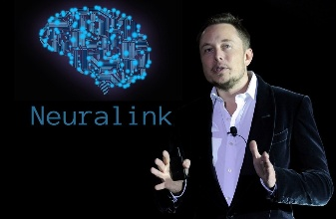

Andrew Huberman...

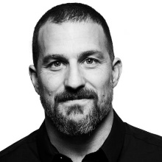

Peter Diamandis...

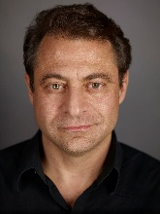

Vinod Khosla...

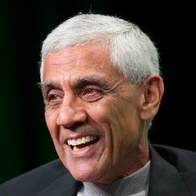

RFK Jr...
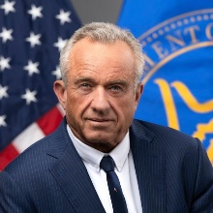

When leaders from technology...

Medicine...

Investing...

And public policy...

All start talking about the same breakthrough...

I pay attention.

Because that's usually when an idea stops being a scientific curiosity...

And starts becoming an investment trend.

That's when stocks begin to move.

The biggest money usually isn't made after a drug reaches patients.

It's made when Wall Street starts believing it will.

I've watched that happen over and over.

- When Terns Pharmaceuticals released its first promising obesity data...

The stock jumped 27% in a single day.

- When Altimmune reported encouraging obesity results...

Its shares surged more than 80% in one day.

- When Structure Therapeutics released positive oral obesity data...

The stock doubled—up about 102% in one session.

And I believe we’re about to see the another boom in this market…

Starting on November 14th…

Many of the world's leading obesity researchers will gather in Washington.

That’s when many of the world's leading obesity researchers will gather in Washington.

New clinical data is expected.

If the results are strong...

Wall Street won’t wait for FDA approval.

We’ve already seen what can happen when promising data hits:

Stocks jumping 80%… even 100% or more… in a single day.

And this is happening as everything else begins to converge.

Big Pharma is investing billions.

Big Tech is pouring money into AI biology.

And the story is breaking out of the scientific journals…

Into Bloomberg…
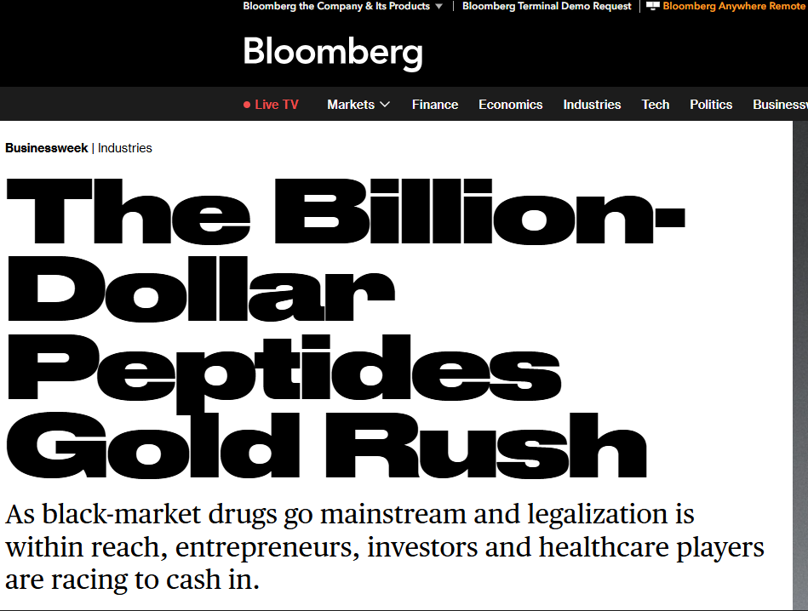

60 Minutes…

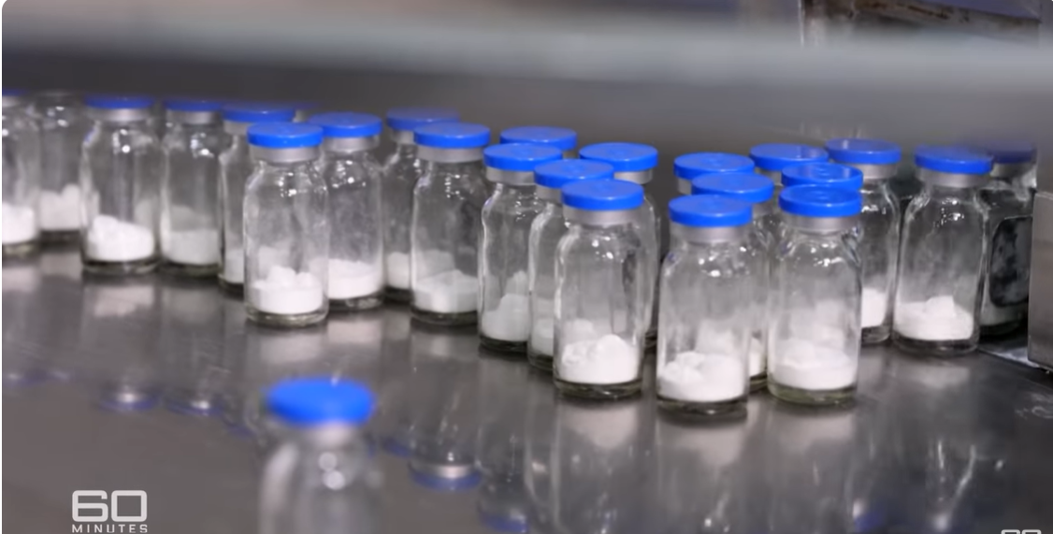
And podcasts reaching millions of people.

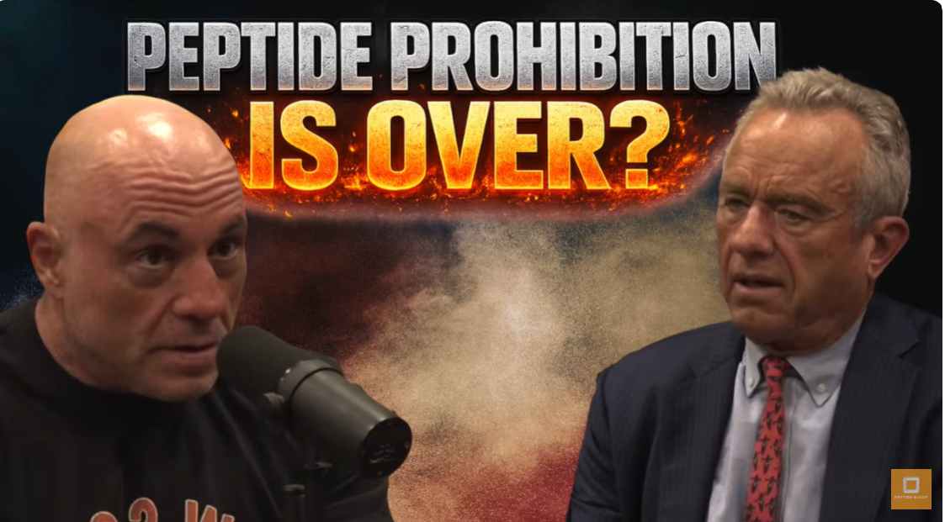

The science is advancing.

The capital is flowing.

And the smartest institutional players are already investing.

Which brings me back to my basket of stocks.

I believe these companies could be some of the biggest winners as AI transforms medicine.

HOST:

All right...

You've made the case.

How can people get the names of these 3 stocks?

MATT:

I put everything my research uncovered into one special report.

It's called...

The Musk Stampede Master List: The 3 Companies I Believe Could Ride Musk's Next 20X Wave.

Inside, you'll find:

- All three companies...

- The ticker symbols...

- The prices I'd be willing to pay...

- Why I believe these stocks could 20x or more over the next few years.

- And the specific catalysts I believe could move each one higher.

Including the company Bloomberg says could become the first in history to win FDA approval for a an AI-designed drug.

I'm not selling this report separately.

I'm including it free for anyone who joins The McCall Innovation Report today.

HOST:

Tell us about it.

MATT:

Everything we've talked about today comes back to one simple idea...

Finding transformational trends before Wall Street does.

That's what I do every month in The McCall Innovation Report.

And it's all built around one principle...

The Innovation Curve.

Every breakthrough follows the same path.

First...

The technology works.

Then...

The smartest money moves.

Only later...

Does Wall Street catch on.

Most investors buy after the headlines.

I try to buy after the technology is proven...

But before the opportunity is fully priced in.

That's where I've found many of the biggest peak gains across my various services.

Quanta Services...

Up more than 49 times over seventeen years.

Impinj...

Currently up more than 12 times in under eight years.

Ilika...

More than 17 times in just over two years.

Enjin...

Nearly 30 times in nineteen months.

None of those ideas looked obvious at the time.

They all looked obvious afterward.

That's the Innovation Curve.

Finding technology after it's been proven...

But before Wall Street fully understands what it's worth.

And that's exactly where I believe this sixth Musk Stampede sits today.

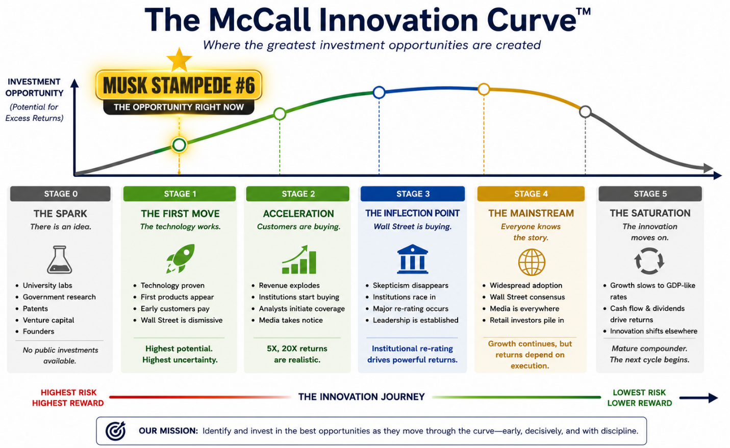

- The technology works.

- The smartest money is already moving.

- The crowd hasn't arrived yet.

That's the window I'm trying to capture.

So I start with one massive trend...

Then I ask one simple question:

Which handful of companies absolutely have to win if that trend plays out?

I don't try to guess one winner.

I select a basket of stocks.

Because after more than twenty-five years...

I've learned something important.

You don't need every winner.

History says one extraordinary stock can make the entire basket worthwhile.

HOST:

And that approach has worked before.

MATT:

It has.

Over my career...

My research has identified More than 50 stocks that went on to gain 1,000% or more.

Back in 2009...

When almost everyone was selling...

I recommended a basket of companies Wall Street had given up on.

One was AMD.

It went on to gain more than 25,000%.

Others gained 1,500%...

1,800%...

Even 2,300% since then.

Now, I want to be clear.

Results like that are exceptional.

Not every stock was a winner.

I've had losing recommendations too.

No honest investor gets every pick right.

And that's exactly why I don't believe in betting everything on one stock.

With a basket, you don't need every company to become a home run.

You may only need one.

The problem is…

Nobody can tell you in advance which one it'll be.

That's why I want you to begin with The Musk Stampede Master List.

But that's just the beginning.

HOST:

What else do members receive?

MATT:

First...

A special bonus report called:

The 8th Magnificent Stock.

Everyone knows the Magnificent Seven.

I'm asking a different question.

Who's next?

Over the years I recommended Apple...

Amazon...

Google...

Tesla...

Nvidia.

Before their biggest advances.

[GRAPHIC: THE MAGNIFICENT SEVEN + gains]

Today I believe one company is beginning to separate itself from the pack.

HOST:

An eighth member of the Magnificent Seven?

MATT:

Exactly….

Last quarter...

Revenue grew 93%.

HOST:

Ninety-three percent?

At that size?

MATT:

That's why it caught my attention.

The bigger this company gets...

The faster parts of its business are growing.

And despite becoming one of America's best-performing stocks...

I still don't think most investors understand what this business has become.

I explain why I believe it could become the next trillion-dollar AI giant...

In my bonus report...

The 8th Magnificent Stock.

It’s included free to new members of The McCall Innovation Report when you join today.

So far, everything I’ve shown our viewers has been about new opportunities in new trends…

But finding winners is only half the job.

Avoiding losers matters just as much.

And while Artificial Intelligence has a lot of money still flooding into it…

There are certain companies that have gotten too expensive…

And you need to make sure you don’t have them anywhere near your portfolio.

That's why I'm also including...

Past Peak: Three AI Stocks to Sell Now.

Three well-known AI companies...

That I believe have already peaked.

There's a good chance you'll recognize at least two of them.

HOST:

That's a lot.

- The Master List...

- The Mag 8...

- The Sell report...

- The alerts...

- The live calls...

And your monthly newsletter, The McCall Innovation Report—
MATT:

Let me stop you there. You've got it backwards.

The reports are what you get right now.

The McCall Innovation Report is what keeps you connected to me for the next 12 months.

You'll get a new issue every month...

Access to all five of my model portfolios — AI, robotics, electrification, space and deep-sea mining...

Every recommendation, including my buy-up-to prices...

A live call with me every Thursday...

And an alert the moment I buy or sell anything.

The reports show you where I stand today.

The McCall Innovation Report shows you what I do next.

HOST:

What would someone normally pay for all of that?

MATT:

Before I answer...

There's one more report I promised you.

Remember...

Neuralink is still private.

There isn't a ticker.

You can't buy it directly.

But there are legal ways to gain indirect exposure before any IPO.

I explain them in...

The Neuralink Exposure Report.

Including one opportunity almost nobody talks about.

I'm including that too.

HOST:

So what does everyone receive?

MATT:

Today you'll receive...

• The Musk Stampede Master List.

• The 8th Magnificent Stock.

• Past Peak: Three AI Stocks to Sell Now.

• The Neuralink Exposure Report.

• And a full year of The McCall Innovation Report.

Altogether...

That's a package worth [$X].

But today, you won't pay anything close to that.

You can get started for just $XXX.

That's less than X dollars a week for everything we've talked about today.

But if that’s even too high for you, I’ve arranged special way you can get in for even less… just click below to find out what it is.

On top of that…
I want to make your decision even easier.

Join today.

Read every issue.

Attend every live call.

Follow every alert.

Put me to the test for a full year.

If you decide it's not for you...

Just let us know.

We'll refund every penny.

HOST:

Matt, thank you.

Just to recap for our viewers… if you join today… you get…

- a full year of The McCall Innovation Report
- The Musk Stampede Master List.
- The 8th Magnificent Stock.
- Past Peak: Three AI Stocks to Sell Now.
- The Neuralink Exposure Report.

All with Matt’s 365 day guarantee!

Just for $XXX.
Any final thoughts, Matt?
MATT:

Yes… (TURNS TO CAMERA)

Listen, I suggest you don't wait on this.

The Musk Stampede is already happening.

It's happening now… not tomorrow.

And I've told you the date I have circled:

November 14.

Alt:
January 12.

That's not a deadline I made up to rush you.

It's on the calendar either way.

Right now, the companies I've shown you are still in the early stages of my Innovation Curve.

That's where I want to find them.

Before the story becomes obvious.

Before Wall Street piles in.

Before everybody suddenly wants to own the same stocks.

Because nothing stays early forever.

And once the crowd arrives…

You can't go back and buy at yesterday's prices.

You can't buy Stage One after the crowd shows up.

That's why, if you're interested in joining me…

I suggest you do it now.

The biggest opportunities rarely feel obvious at the beginning.

They feel early.

They feel uncomfortable.

Sometimes...

They even feel unbelievable.

You saw that today.

Enphase quietly solved the problem behind rooftop solar.

Its stock climbed more than 500 times.

Lumentum quietly supplied the lasers behind AI.

Its stock climbed more than 66 times.

Neither company was the headline.

That was the point.

The biggest fortunes often go to the companies working behind the scenes.

I believe we're at another moment like that today.

My job is to find those companies before Wall Street does.

The only question is...

Will you find them before the crowd...

Or after?

HOST:

Matt, thanks so much for being here.

And thanks for walking us through your research.

If you'd like to get a copy of Matt's Musk Stampede Master List, along with everything he just showed you, simply follow the instructions on your screen.

On behalf of everyone here…

Thanks for watching.

And we'll see you again soon.

August 2026

