*** NEW FOR LEGAL *** Aug. 6, 2026: Ryan Fitzwater backup…

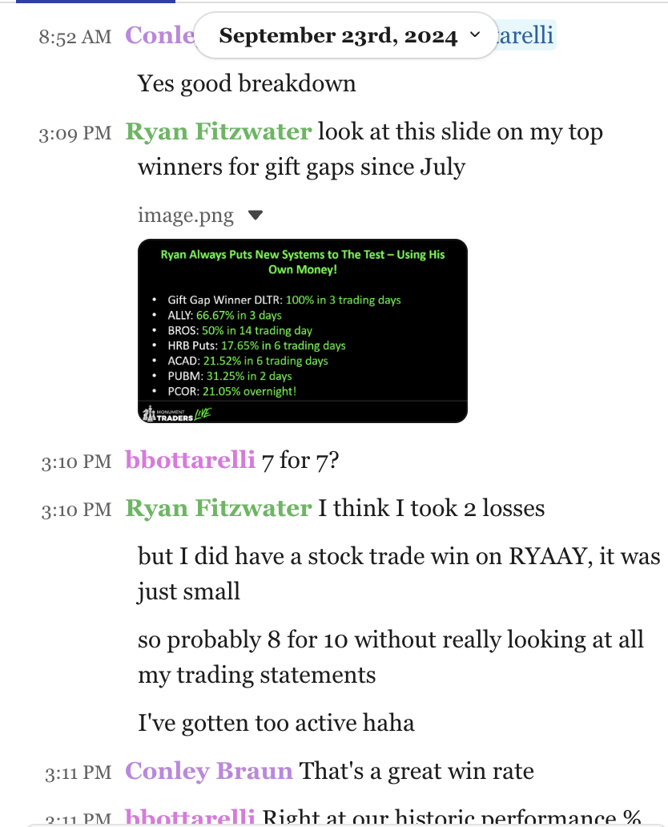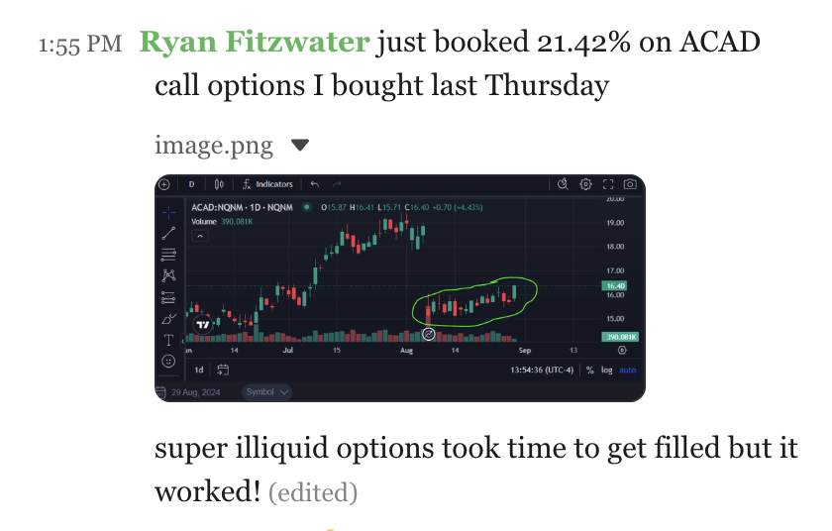F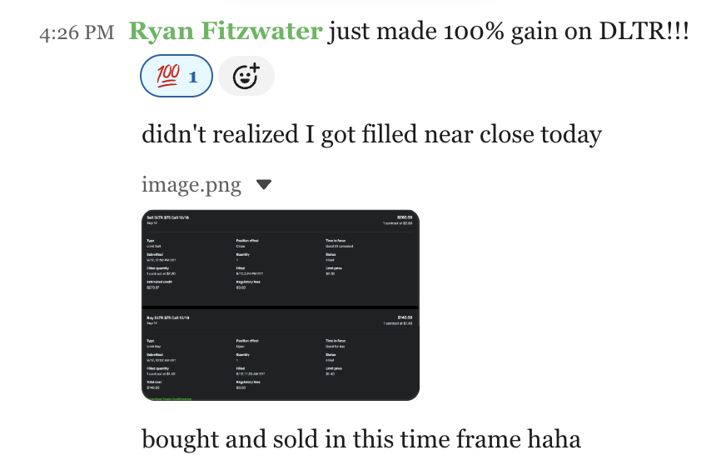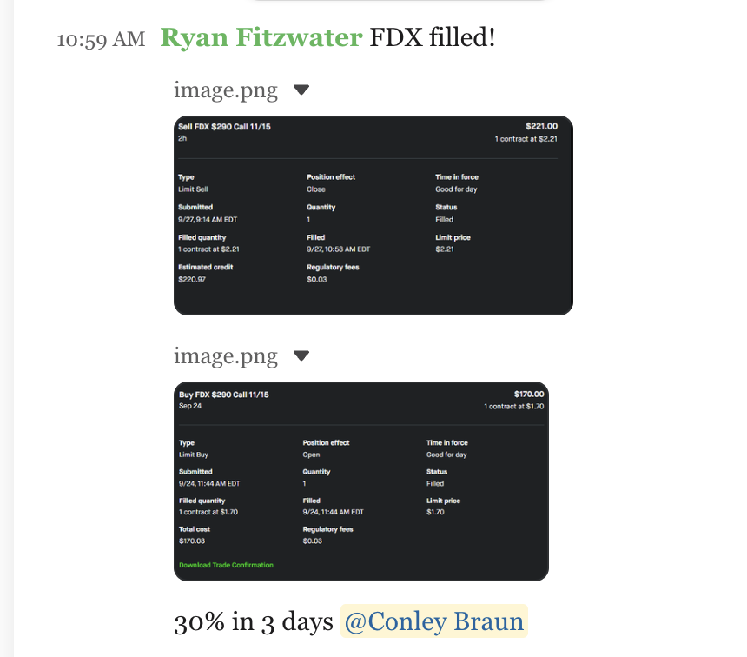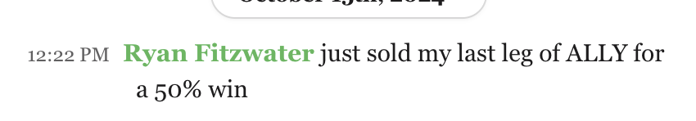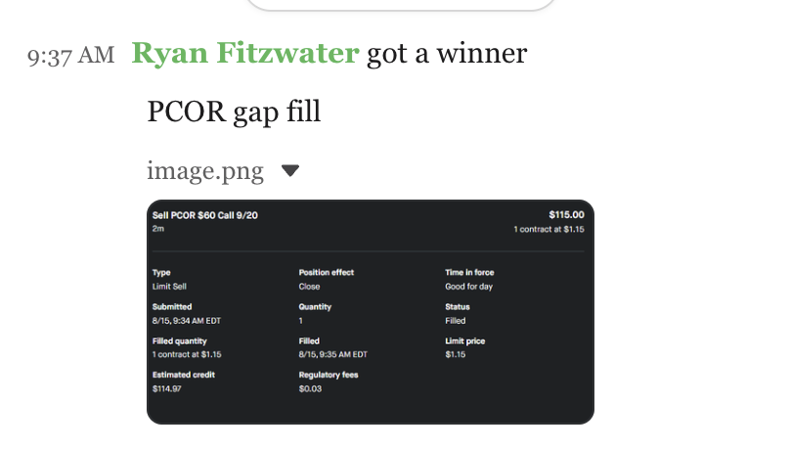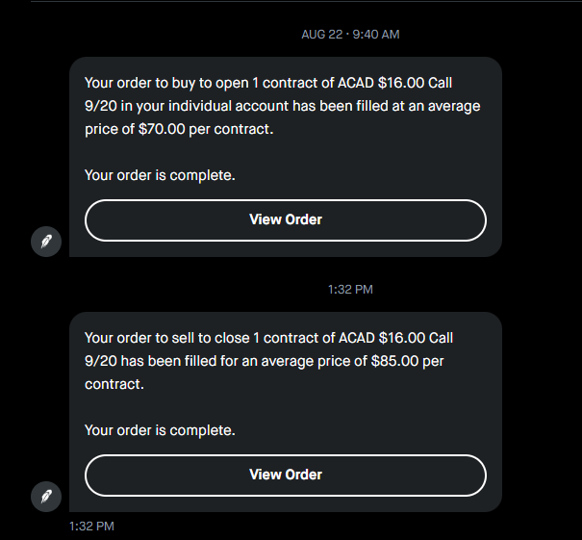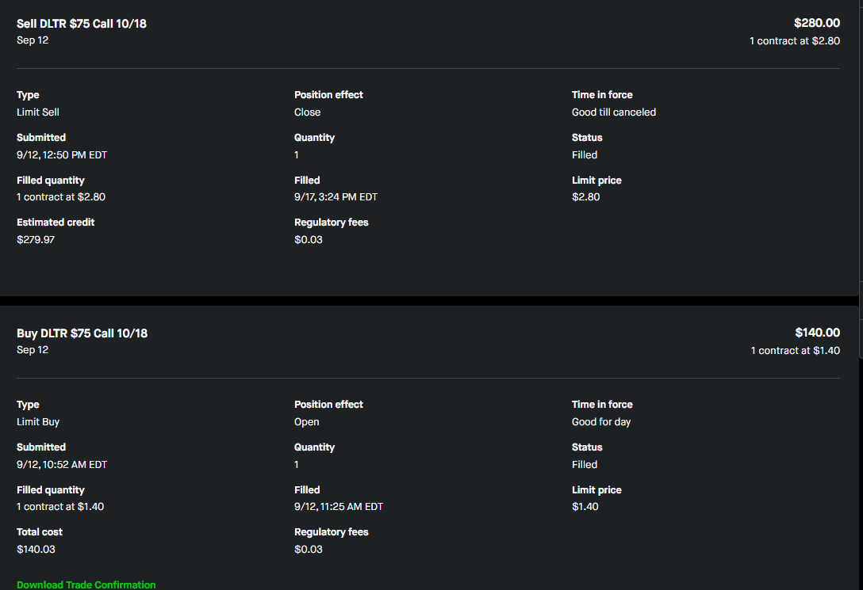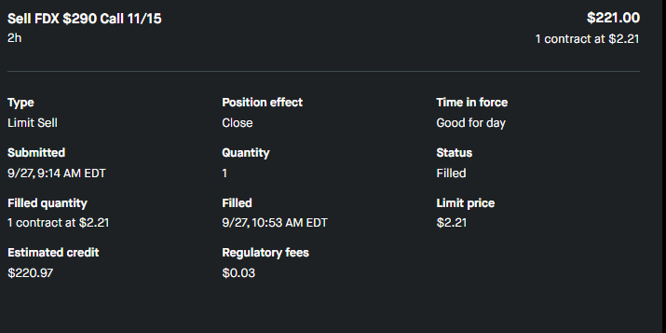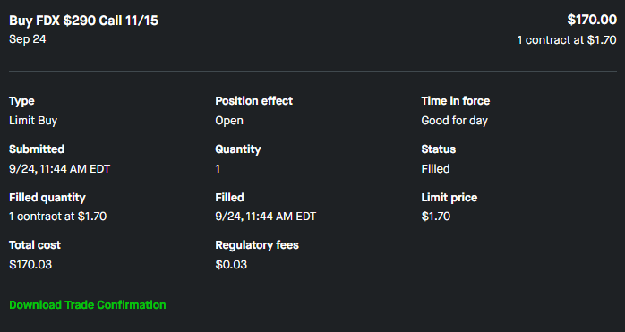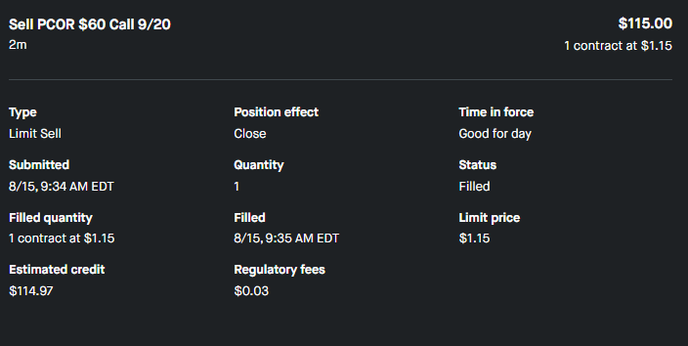

Former “Pit Trader” (and millionaire at age 34) reveals what to do before October 13 to target…
The Panic Payout
Whenever Wall Street had a panic attack, it revealed a stock trade setup that had a 97% win rate* in 23 days …

* Based on the win-rate of an exclusive 5-year backtest of 831 trade set-ups, which could have showed peak gains of 103% in 1 day… 235% in 11 days… and 452% in 8 days…

### IMAGE FOR LEGAL ONLY/DON’T DISPLAY>> BACKTEST >> SUMMARY

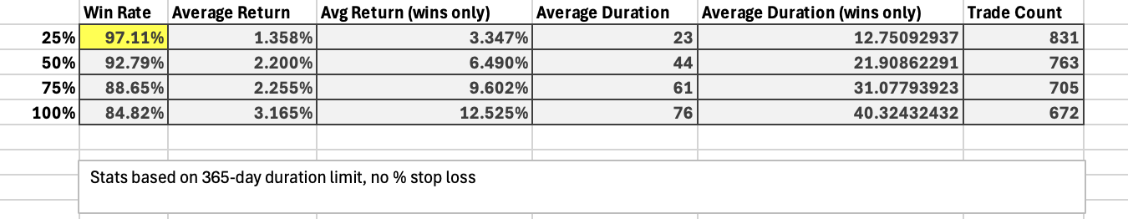

[VOICE OVER/B-ROLL]

At 3:55 pm Eastern, on an ordinary Monday afternoon earlier this year…

A stock many retail traders owned… or were thinking about owning…

Went into freefall.

Fulcrum Therapeutics.

Earlier this year, it tanked 50% in a single day…

[Show chart for FULC below on screen… even better to show an animation, or some sort of arrow dramatizing the drop.]

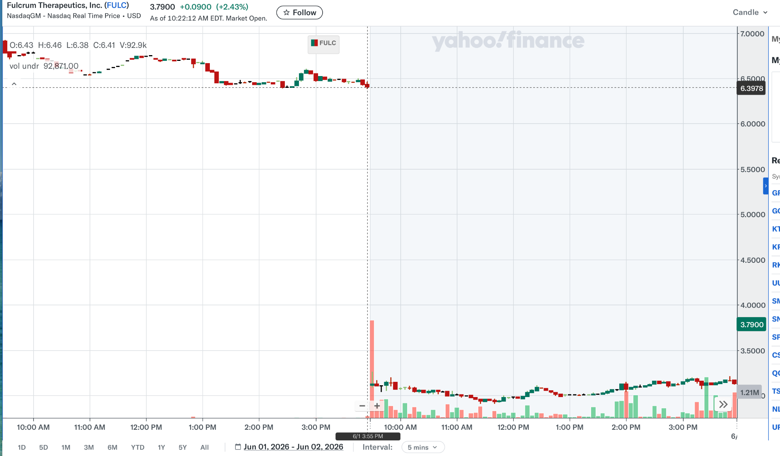

If you owned it, you felt it.

That cold, sinking moment in your gut.

The fear of losing half your money in hours.

No doubt you’ve felt something similar with every massive drop of every stock you’ve ever owned.

Hands hovering over the sell button.

Maybe you sold. Maybe you froze. Maybe you held and watched it bleed.

Either way, you watched it fall off a cliff.

And it hurts.

But here’s the thing…

Hidden inside these panic-driven drops is an unusual chart pattern…

That has been shown to target as much as 5 times your money back in a little more than a week.

And this unusual pattern could have been used to collect a payout up to 97% of the time using stock trades, based on a groundbreaking backtested study you’ll see in a moment…

This method was developed by a former “Pit Trader” who became a millionaire at age 34.

And right now is the time to take advantage of what this man has discovered...

Because short-term panic in the markets isn't unusual anymore...

It seems like Wall Street is having a panic attack every few weeks.

It shoots up, then comes crashing down.

[SHOW VARIOUS HEADLINES OF STOCK MARKET DROPS FROM EVENTS MENTIONED]

Wars…

Oil prices…

Inflation…

Rising unemployment…

Politics…

A bad earnings report…

Every few weeks, another headline. Another sell-off.

Another stock drops 20%.... 40%…

Or 50% in less than 24 hours.

Even IBM recently dropped 25% in a single day after an earnings miss.

Well…

According to a man you'll meet in a moment, that’s why the timing is now perfect to take advantage of a strange chart pattern…

A winning pattern that showed up as often as 2 times a week.

Because every time Wall Street panicked…

In every sell-off in a specific stock…

There was a potential golden opportunity for a payout as large as 452% in 8 days….

Without short selling or doing anything more complicated than placing one trade at a specific time.

The man who discovered this simple secret has spent 27 years in the markets…

Including a legendary run on the floor of the Chicago Board Options Exchange working as a “pit trader”…

He observed Wall Street traders panic in real time, every single day, while in the trading pits.

[SHOW VIDEO CLIP OF CHAOS IN THE PITS]

And most important, he’s the inventor of a method he calls “The Panic Payout.”

A way to get paid back for every time the market panicked and you got stuck holding the bag..

And the math says this set-up worked 97% of the time.

That number… 97% …

It comes from a 5-year backtest of every major panic event in the U.S. stock market during the period between 2019 and 2024.

It revealed 807 winners out of 831 trade set-ups… or a 97.11% win-rate….

Which was possible using basic stock trades.

But our research uncovered a special type of trade that could take advantage of these setups to target much larger returns

And the wins weren't small.

103% gain in a single day…

235% gain in 11 days…

452% gain in 8 days…

A small group of traders have been trying this out, with real money…

They’ve reported gains enough to turn $5,000 into…

$7,850 in 1 day…

$8,600 overnight…

And $10,000 in 24 hours…

Those are just a few of our best notes. You’ll see these reports today…

And as you will see, everything comes to a head starting October 13, when a new wave of panic could hit the markets.

[ALT LINE] And as you will see, everything comes to a head starting January 14, when a new wave of panic could hit the markets.

Now... let me introduce you to the man behind all of this.

He's a former CBOE pit trader…

A 27-year veteran of the markets…

The co-founder of Monument Traders Alliance...

And the inventor of the “The Panic Payout” strategy.

Bryan Bottarelli…

[2-PERSON INTERVIEW BEGINS]

HOST: Bryan, thanks for being here.

BRYAN: Glad to be back.

HOST: Before we get into the strategy…for anyone watching today who hasn't met you before, let me quickly introduce you.

Bryan, you’ve traded options in the pits of the Chicago Board of Exchange…

A self-made millionaire by age 34…

You and Karim Rahemtulla co-founded Monument Traders Alliance, which includes the legendary trading chat room The War Room.

And for the last 7 years, you’ve been sharing and teaching your trading methods to thousands of traders…

Your top students from across your services have seen incredible results…

Like David, who took $20,000 and turned it into $185,000 in one year….

And Mo, who turned a $25,000 portfolio into over $225,000 in just four months…

And today, you’re going to reveal a trading research system that blew me away when you first showed it to me.

A reliable way to target profits from stocks taking massive drops... that isn’t short selling or selling options.

So, spill the beans, Bryan… tell us how you’ve done it… and how we can do it, too.
BRYAN: Sure, and the very first thing I want to mention is how simple this strategy is to understand…

And the best way to back up that statement is to show you right now.

Ready?

HOST: Ready!

[SHOW PODD CHART] SLIDE # 11

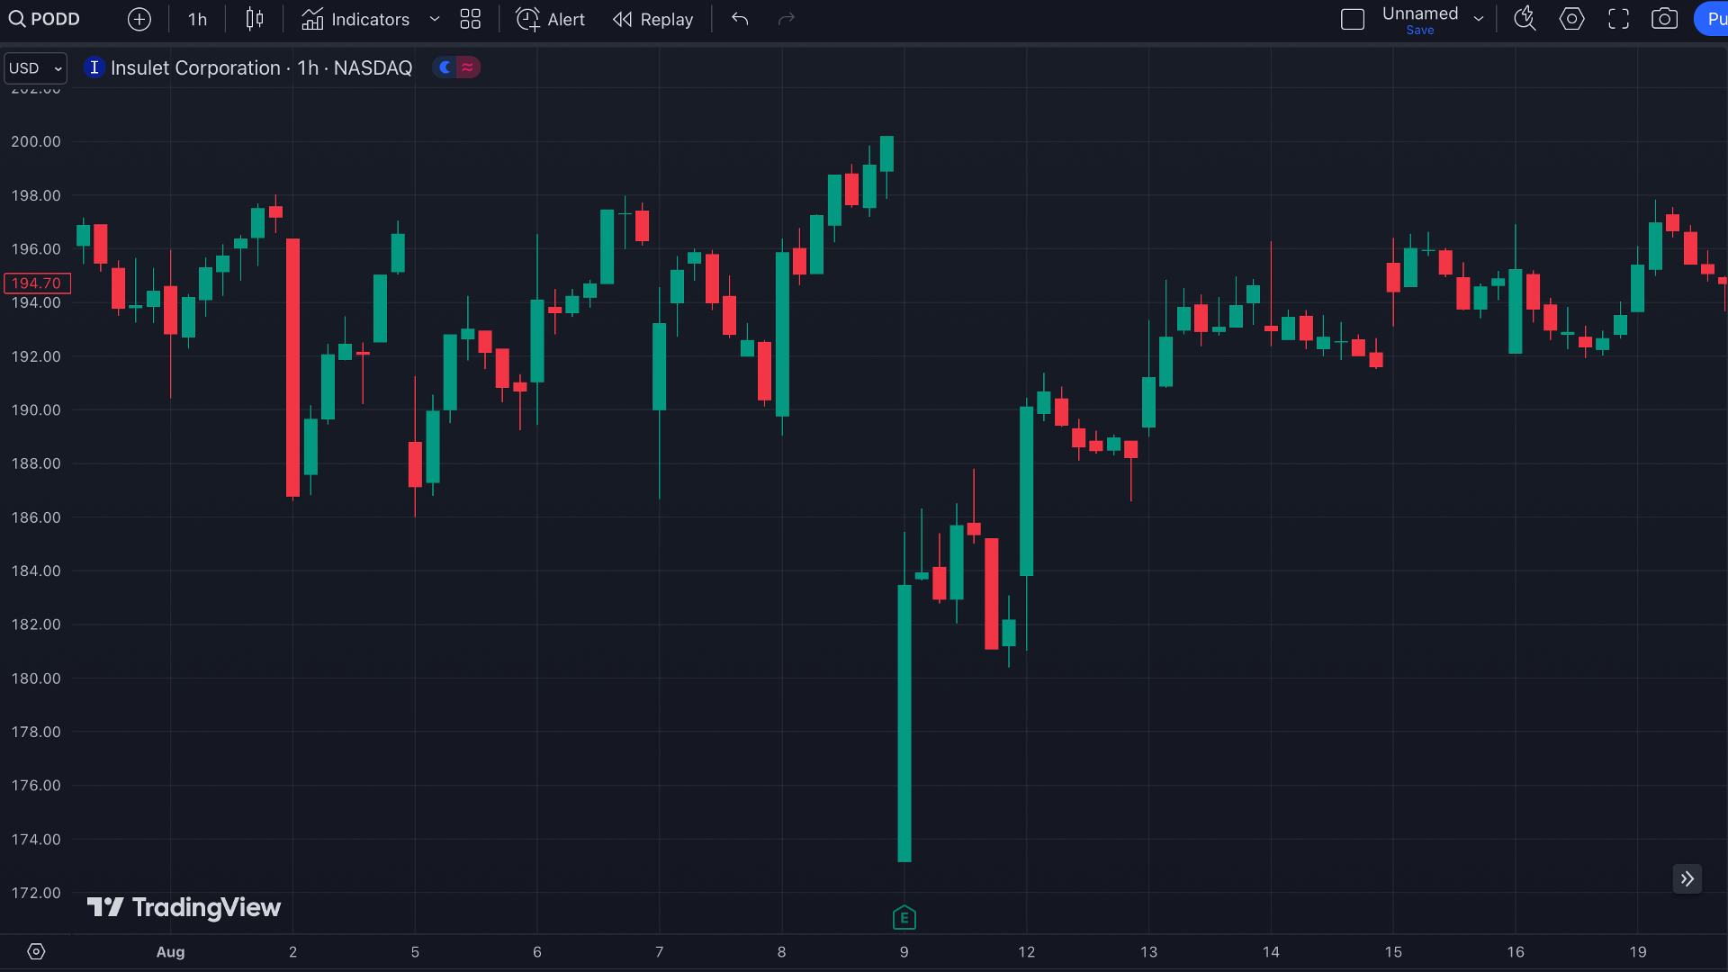

BRYAN: Spot anything unusual on this chart?

HOST: I see a big black hole on a chart, then a green line dropping.

BRYAN: Exactly!

But what you are really seeing in this unusual pattern is what panic looks like, frozen in time.

In this case, it’s for Insuler… ticker symbol PODD.

They make medical devices for diabetics.

On August 8, 2024, PODD reported pretty good earnings…

But the next day, this stock was getting beaten to a pulp.

[SHOW PODD CHART, ARROW SHOWING DROP]

See that big drop?
HOST: So the company reports good earnings, but the stock gets crushed by the market.

BRYAN: You see it happen all the time…

Usually it happens with bad news…

But sometimes it even happens with good news.

In this case, a great company reports rising earnings… but it doesn’t meet Wall Street’s expectations.

The market does what it does.

The market panics and hits the sell button.

And when the stock drops BIG and FAST… it creates a gap in the stock price.

Take a look at the chart again…

[SHOW PODD CHART, CIRCLE THE GAP]

Right here, just below the opening price, you can see this strange blank space on the chart.

Nothing trades there.

It's just a void.

See the void? That blank space?

This unusual pattern is the first signal in spotting a trade setup I call a “Panic Payout.”

As you can see, the line on the chart opens up a space, a gap.

[SHOW PODD CHART, CIRCLE THE GAP]

And every time one of these gaps opens up on a stock…

There’s a high chance the stock rebounds and fills that gap.

You can place ONE simple trade and walk away with a payday.

In this case? PODD could have shot up 114% in 19 days.

[SHOW PODD CHART, CIRCLE THE GAP - ARROW UP “114% in 19 days.”]

If someone watching had known what to look for, and how to set up this trade, they could’ve doubled their money in less than 3 weeks.

HOST: And the money someone could have gotten from the 114% gain is what you call the “Panic Payout” trade?

BRYAN: Yes, indeed.

Now the “gap” on the chart I showed you is really just showing the first step of finding these gaps on a chart.

In a moment, I’ll show you an even more precise way to do this…

It involves a couple more steps, based on a mathematical secret that I discovered.

But if you do these steps correctly using this secret, backtesting shows it could have paid off 97% of the time utilizing just basic stock trades.

HOST: Bryan, a 97% win rate seems incredible!

When you first mentioned this win-rate to me, that’s what got my attention.
But it seems like you are saying this strategy could have paid off almost every time.

If that were true, everyone in the world would be trading this way.

There is no way this seems possible.

What’s really going on here, Bryan?

BRYAN: I’m sure everyone watching is getting excited by that win-rate number.

I know I was when I first saw it.

I had to check the results three times to make sure the numbers added up.

But let’s be clear on something, HOST…

I’m NOT saying this strategy wins almost every time.
What I am saying is I ran a 5-year backtest…

I had a computer check every major panic event in the U.S. stock market during the period

And this computerized backtest showed a 97% win-rate… utilizing just basic stock trades.

And that win-rate is even more astounding when you consider a 2020 study covered by CNBC…

This study said 97% of all individuals who traded for more than 300 days lost money.

To quote this news story:

“Only 1.1% [of traders] earned more than the Brazilian minimum wage and only 0.5% earned more than the initial salary of a bank teller – all with great risk.”

Meanwhile, the backtest I ran for the “Panic Payout” showed an extraordinary win-rate going back 5 years.

The only problem was that just trading stocks left too much money on the table.

That’s when I discovered using a special type of trade would allow us to maximize returns.

And that’s when I decided to get on camera with you today.

HOST: You gave me a list of some of the winners from this backtest, and really it’s astounding.

The top winners on some of these special trades include:

452% in 8 days…
33% in 4 days…
89% in 5 days…
235% in 11 days…
80% in 18 days…
92% in 8 days…
70% in 3 days...
57% in 1 day…
59% in a day…
103% in 1 day…

[SHOW ALL GAINS ON SCREEN]

Keep in mind the speed of these gains…

A gain of more than 50% in a week is huge.

And a gain of 50% or more in a day? Even rarer.

And if you could have doubled your money with a 100% gain in 24 hours…

Well… that should make you smile as a trader.

And making more than 4 TIMES your money back in a little more than a single week?

A monster trade like that is the dream of most traders.

Now, the caveat you were telling me about is that using these special types of trades means we are taking on more risk than just trading the stock.

But when you can double, triple your money or more on a single trade, that type of asymmetry is very powerful.

And with a 97% backtested win-rate on the stock trades, I like my odds very much.

And that’s what’s blown me away about what Bryan discovered… the accuracy and reliability of his system in targeting these setups.

Bryan, I also understand that real-world traders, including some of whom follow you in your War Room service, are sending you reports of their successes.

BRYAN: That’s correct…

That’s the fun part. I get these reports all the time

HOST: And some of your followers have reported win-rates as high as 89%...

In other words, they all discovered a precise way to target a “Panic Payout” trades.

BRYAN: I love it.

And honestly, don’t we all deserve some payback from how irrational and stupid the market acts every day?

How many times have you bought an amazing stock… or spotted a perfect trade setup?

You did your homework.

And then Wall Street traders freak out and crush a stock for no rational reason whatsoever.

You know this roller coaster.

That pit in your stomach when you watch a stock you own fall off a cliff.

But maybe worse than the loss itself…

Is the FEELING that comes after.

You know the feeling I mean.

It's the feeling of being too late.

Of having missed the warning signs.

Of holding too long and selling at the bottom, just in time to watch the stock recover without you.

It's the feeling that you're always one step behind.

That the rules of this market were written by someone else, for someone else.

HOST: When you describe it this way, I get a feeling of being trapped.

BRYAN: It’s not a fun feeling, is it?

I look at it this way:

You're targeting a “payout” trade from every time a panic move screwed you over in the past, for every stock you sold too soon…

For every position you held when you should've folded.

The market panics.

And the timing is right…

The market seems like it’s” bipolar” right now.

It’s practically schizophrenic.

Yes, overall the market is performing very well.

But day to day, Wall Street is often freaking out.

A single news headline, such as something happening in the Middle East, a bad jobs report or something negative about AI, and we see panic.

Sometimes it’s the entire stock market making a big drop in a day.

Sometimes it’s entire sectors.

Sometimes it’s specific stocks.

This is just how the market is today.

I say, why not turn lemons into lemonade with a strategy to help turn these panics into a “payday”?

HOST: And to be absolutely crystal clear with everyone watching…

This isn't some complicated multileg spread that requires a Bloomberg terminal?

BRYAN: Nope.

You're just making a simple stock trade at the right moment.

You hold it for an average of 23 days.

Based on real-world results we’re seeing and the backtest, you can often get “paid out” even sooner.

That’s the beauty of the “Panic Payout.”

Using everything we’ll cover today, you can get started tomorrow and potentially win thousands of dollars, depending how much you choose to risk.

And even more exciting, I’ve also come up with a radical, extremely easy way to find these “payout” trade opportunities…

HOST: We’ll cover all that in a few minutes, Bryan…

But first, can you tell us what’s really going on with the “Panic Payout” strategy?

BRYAN: It’s really an easy concept…

Let me show you with another quick example…
This is Comerica, the bank, ticker CMA, back on July 19, 2024...

[CMA CHART EXAMPLE] SLIDE # 13

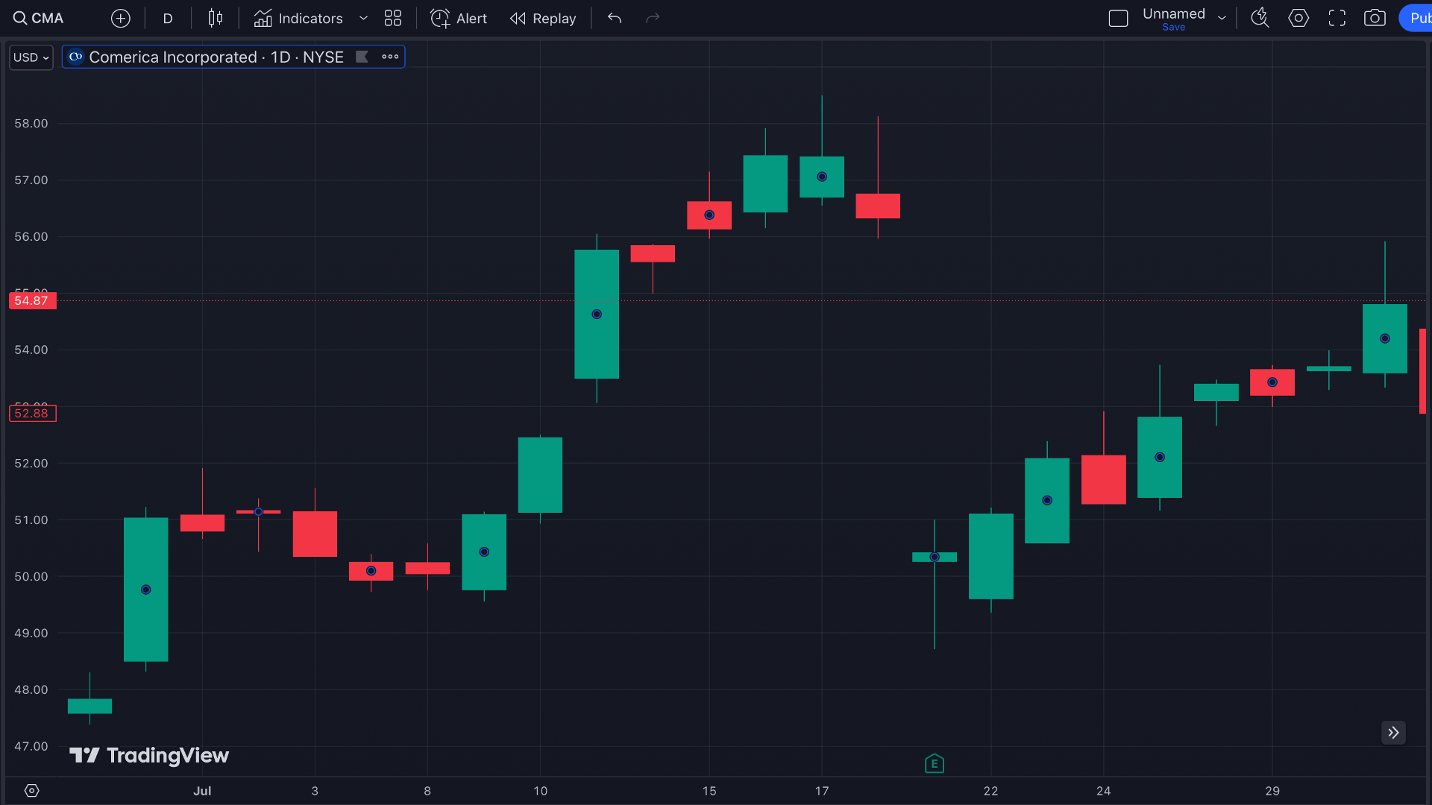

The markets were panicking with this stock.

The stock dropped overnight.

And once again, you see the gap in the chart…

[CMA CHART EXAMPLE - CIRCLE GAP]

This gap was the opportunity to grab a “Panic Payout” trade!

If someone watching us had made a special trade on this play, they could have been sitting on a 250% gain in only 35 days…

[CMA CHART EXAMPLE - ARROW POINTING “250% gain in 35 days”]

With a $5,000 stake, they could have been sitting on $12,500.

And the great thing is, you can target these trades whenever you spot one of these gaps…

And if you base your trade on a mathematical secret I will reveal in a few minutes…

HOST: As they say, Bryan, seeing is believing.

But why not give us one more example just to make sure everyone watching is getting this?

BRYAN: Absolutely…

Here’s another example, for a stock called Ecolab.

[ECL CHART EXAMPLE] SLIDE # 12

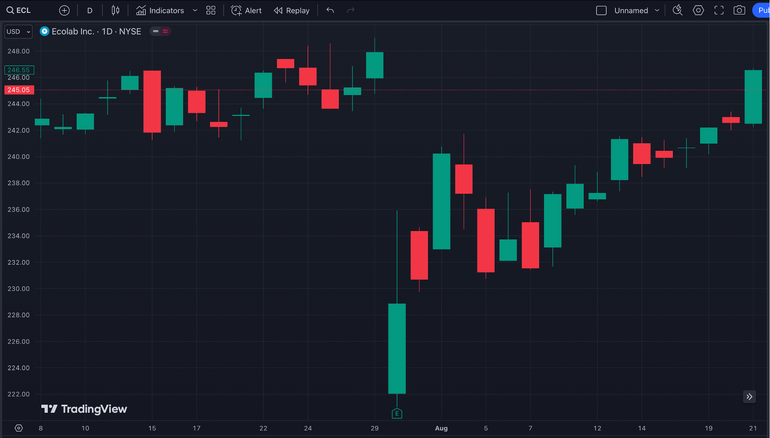

On July 30th, the stock got pummeled. It went down 10% in a day.

[ECL CHART EXAMPLE- ARROW DOWN “10% drop in a day!”]

Yet, as you probably know by now… this drop was a good thing.

Because the gap you see on this chart opened up a “Panic Payout.”

[ECL CHART EXAMPLE- CIRCLE AROUND BAP]

You see the pattern now on the chart, right?

When you see this gap open up the cart, you could’ve made a special trade I’ll reveal in a moment…

And… you could’ve banked a 454% gain in about a month.

[ECL CHART EXAMPLE - ARROW POINTING “454% gain in 31 days”]

HOST: How much is that for a $5,000 trade?

BRYAN: The math is around $23,000.

HOST: This trade could have made around $23,000 in a “Panic Payout.”

BRYAN: That would feel nice in your pocket, wouldn’t it?

And this isn't luck.

The gaps you see on these charts?

The break in the line, then the stock opening way lower?

These spaces or gaps only appear when Wall Street overreacts on stock.

And the next time you spot one of these situations…

When you see this panic show up on a chart with one of these “gaps”...

You’ll know there might be a “Panic Payout” opening up.

HOST: Alright Bryan, take a step back for me.

What’s going on behind the scenes here?

BRYAN: One word…

Algorithms.

HOST: The trading bots.

BRYAN: The trading bots. Yeah.

Now, in the old days, when I was on the floor at the CBOE trading options, this same “Panic Payout” strategy worked because of human beings.

People, as you know, are prone to panic.

And when they panic, they sell.

I saw this plenty when I was on the trading floor.

But today, the “Panic Payout” strategy works even better, because so many trades are made by computers

Roughly 65 to 70 percent of every share that trades on a US stock exchange today is traded by a machine.

And these algorithms? They're programmed to do one thing really, really well: react fast.

So let’s say a stock reports good earnings… but the number didn’t hit Wall Street estimates…

The algos are programmed to immediately sell.
They aren’t listening to the CEO on an earning conference call…

They aren’t digging into the business…
They simply see raw numbers.

And when those numbers don’t match, they sell.

And that triggers other algos to sell.

And that triggers more algos to sell, and so on.

The whole thing turns into a stampede in milliseconds.

HOST: Can you give me an example of this happening?

BRYAN: Here’s a famous one:

Do you remember the "Flash Crash” on May 6, 2010?

The Dow Jones dropped almost 1,000 points in about 36 minutes…

That was the biggest one-day point drop in history at the time.

Why? Algos triggering a selling cascade triggered by one big sell order.

The machines went crazy.

Almost a trillion dollars in market value vanished and reappeared in less than an hour.

Now that’s an extreme example… but it shows how fast computers react, often in a bad way…

And that’s our opportunity here for the Panic Payout.
These algos force a quick panic drop in the stock… then the stock recovers after the drop.

Then we place a special trade, which I’ll reveal in a few minutes.
It's that simple.

HOST: It’s simple… but powerful. Bryan, you’re helping people make money with it right now.

There’s a guy in a chat room you run who used this strategy in 2024…

His name is Ron C., and he made two trades back-to-back… 41% in one day, 37% within two days.

Those are just a couple of chat messages I’ve seen.
BRYAN: I love seeing these messages in my chat room, all from using this strategy.

But I do want to make something very clear on what everyone is seeing here…

It’s true a “37% winner in two days” isn’t the “1,000%” gains you might often see promised in these kinds of videos…

But what separates what I’m showing from the “other guy’s trading system” is precision…

Using the mathematical secret I will share with you today, my backtest targeted a “payout” up to 97% of the time using stock trades.

And remember, this isn’t about short selling and this isn’t about selling options.

HOST: Bryan, one more dumb question, and bear with me, because I want every viewer to understand what we are seeing on the chart…

That blank space on the chart you keep showing me.

This gap...

Why is it blank?

Why doesn't anything trade in that price range?

BRYAN: Great question. Here's why…

News usually hits after the market closes… earnings report, regulatory announcement, whatever.

Between the close at 4 p.m. and the open at 9:30 the next morning, no shares are trading.

There's no live market.

But the news is out. Investors are panicking in their living rooms.

They're queuing up sell orders for the open.

The algorithms pick this up, and they respond in an instant... and amplify the panic.

When the bell rings the next morning, all those sell orders hit at once.

The stock opens at a price far below where it closed the day before, because that's the only price level where the panicked sellers find buyers.
So on the chart, you see this visible blank space between yesterday's close and today's open.

You can see it on F5, ticker FFIV, an enterprise networking company….

[FFIV CHART EXAMPLE, CIRCLE GAP, ARROW “127% in 77 Days”] SLIDE # 29

The stock gapped down overnight…

It could have opened a up a special Panic Payout trade of 127% return in around two and a half months…

Same with Meta Platforms, ticker META, the company that owns Facebook and Instagram.

[META CHART EXAMPLE, CIRCLE GAP, ARROW “151% in 6 Weeks”.] SLIDE # 31

A “Panic Payout” opened up on April 25, 2024…

And there it is again. You could have seen a chance to get 151% in exactly 6 weeks…

Oracle, you’ve heard of them…

Big drop overnight on December 12, 2023.

[ORCL CHART EXAMPLE - CIRCLE GAP, ARROW UP “387% in 52 Days”] SLIDE # 33

Anyone watching could’ve used a “Panic Payout” setup for a 387% gain, or nearly 4 times your money back, in only 52 days…

And one more with DuPont, a 225-year-old industrial chemicals giant…

Where it could have been possible to get 437% in about two months.

[DD CHART EXAMPLE, CIRCLE GAP, ARROW UP “437% in 2 Months”] SLIDE # 35

HOST: Bryan, I have to ask you… what you're describing sounds similar to what regular folks call "buy the dip."

And “buy the dip” has burned a lot of people over the years…

Including a bunch of people watching us right now.

How is what you are showing us different?

BRYAN: What I have is as different as night and day.

"Buy the dip" is a guess.

You see a stock down a lot, you guess it might recover, you cross your fingers and buy.

Sometimes it works.

A lot of times it doesn't, because the stock just keeps falling.

That's called “catching a falling knife.”

And it's how people lose their shirts.

HOST: You are saying this is different?

BRYAN: Yes.

Because I’ve found the secret that separates a falling knife… from a great buying opportunity.

Telling us exactly when the best time is to get in for a potential payout.

HOST: Ok, I’m excited to hear it.

BRYAN: I call it “The 10 Line Trigger.”

Now, I’ve known about these “Panic Payout” trades for years, going all the way back to when I traded options on the floor of the CBOE.

But a few years ago, I decided to really optimize this set-up.

To run through the math and see if I could figure out a way to put the odds massively in my favor.

I commissioned my team to run a backtest and go through every major panic event in the US stock market over a five-year period.

Every single one. From August 2019 through August 2024.

The numbers blew me away.

We went through 831 episodes.

[SHOW SCROLLING VIDEO OF BACKTEST XLS]

And we learned two things…

First, just because you spot a gap on the chart, it doesn’t mean it’s a “Panic Payout” trade.

For example, you might find a gap on a chart that looks like this:

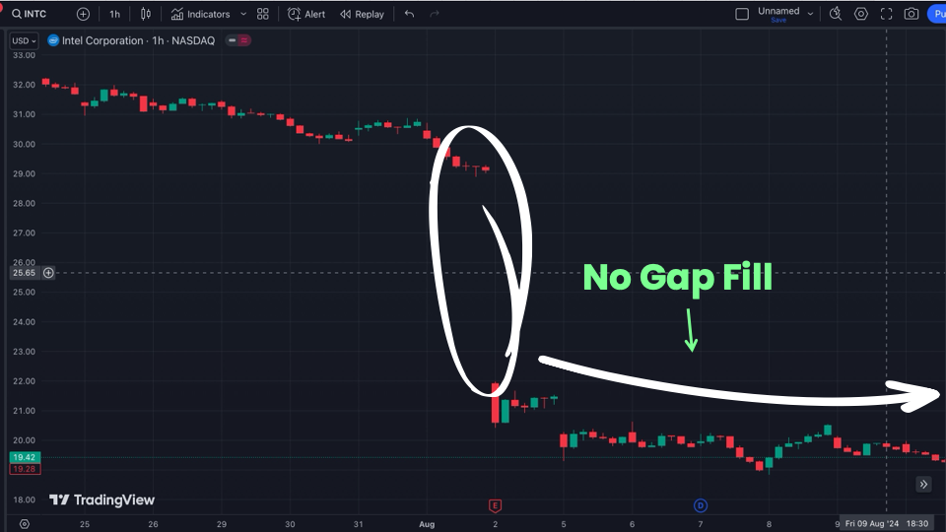

HOST: What are we seeing on screen?

BRYAN: Simply put, what you are seeing is that blank space…

Which means it is pretty certain there was a panic…

But this example is NOT a “Panic Payout” for one big reason…

The stock never bounced back.

There was no payout.

HOST: So the study helped you figure out when these gaps DON’T pay out.

BRYAN: Exactly…

Here’s another example, Walgreens, which had the ticker WBA…

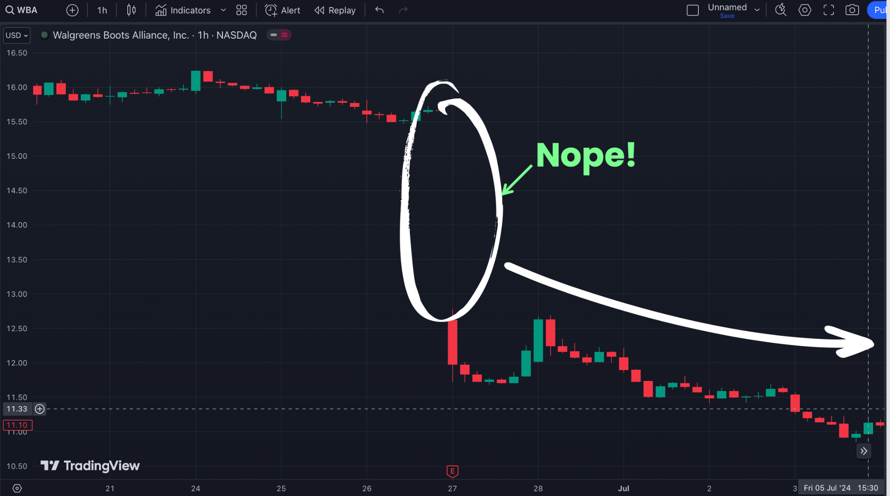
On the surface it looks good, right?
We see a gap in the chart.
If you remember, Walgreens was a disaster.
It was so bad, the stock was delisted from the Nasdaq.
But as you can see on the chart, the stock didn’t bounce back.
Buying the dip would’ve been a terrible move!
This was a stock which had a gap in its chart because Wall Street panicked…
And it should’ve been panicking, because this stock sucked.
So you can’t just look for a gap on a chart and expect a win in return.
HOST: That’s a good tip, Bryan....
What was the second thing you learned?
BRYAN: The second thing we learned is out of the 807 winning trades we analyzed in the backtest... ALL had something in common.
And just as important …the losers, like the ones I just showed you, were all missing this critical factor.
Wanna guess what it was?
HOST: Was it the 10-Line Trigger?
BRYAN: Yup, the 10-Line Trigger.
This is the mathematical secret I mentioned earlier.
The secret is figuring out where the stock would “fill” the gap in the chart… or simply keep dropping.
HOST (interrupts): Hold on, Bryan… I don’t want this to get lost in the mail…
What does “fill” mean?
BRYAN: I glad you asked, because the “fill” is really the heart of what I’m sharing today.
Here’s a metaphor:
Think of the gap you see on screen as an empty cup.

The panic-day low is the bottom of the cup.

The previous day's closing price is the top of the cup.

When the stock price starts to rise back up the inside of the cup, that’s what we call a “fill.”

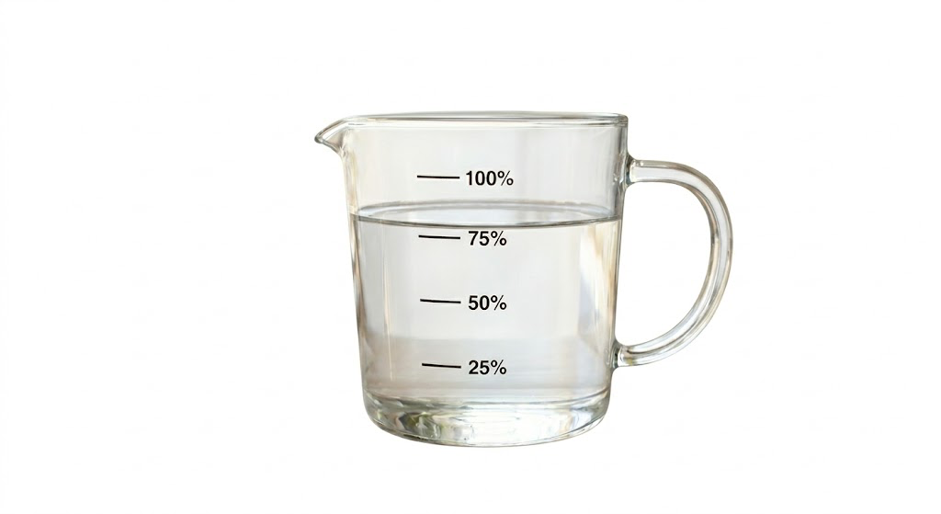

A full fill is when the water reaches all the way back to the top.

Meaning the stock fully recovers.

That's called a “100% gap fill.”

But here’s the big twist:

You only need to watch for the first 10% of the fill.

HOST: Ten percent?

BRYAN: Ten percent.

If the stock fills 10% of its gap-down move…

Meaning, if the stock moves 10% back up in the cup…

It hits that 10-Line Trigger.
[SHOW IMAGE OF CUP …WATER FILLED TO 10% … LABEL “The 10-Line Trigger”]
And we could have a “Panic Payout” on our hands...

If the stock doesn’t reach this trigger level, then no dice.

We don’t make a trade.

That’s why I call it the 10-Line Trigger.

HOST: In other words, if you spot the trigger… it’s looking good and you should make a move.

No trigger, don’t make the trade.

BRYAN: That’s it in a nutshell.

The 10-Line Trigger is how you find a stock that's about to rebound...

Versus getting stuck from a “falling knife.”

I have to say this again, but this was the true breakthrough.

And it’s key to how we get to the 97% win-rate we found in our backtest.
Let’s play it out using a real stock chart…

Here’s Ecolab, ECL… which we looked at earlier….

As you saw earlier, Ecolab had a gap on its chart July 30, 2024…

[ECL CHART EXAMPLE] SLIDE # 12
And, when looking back, I knew it could have had a fantastic chance of being a “Panic Payout” because we can measure out the gap size, which was about $25.
If the stock went up $2.59, it would mean it filled 10% of the gap.
And that’s exactly what it did…
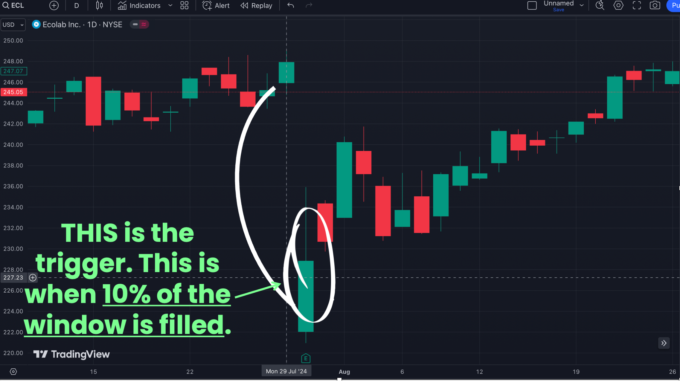
It went up exactly $2.59.
It could have set up a trade for as much as 454% in about a month.
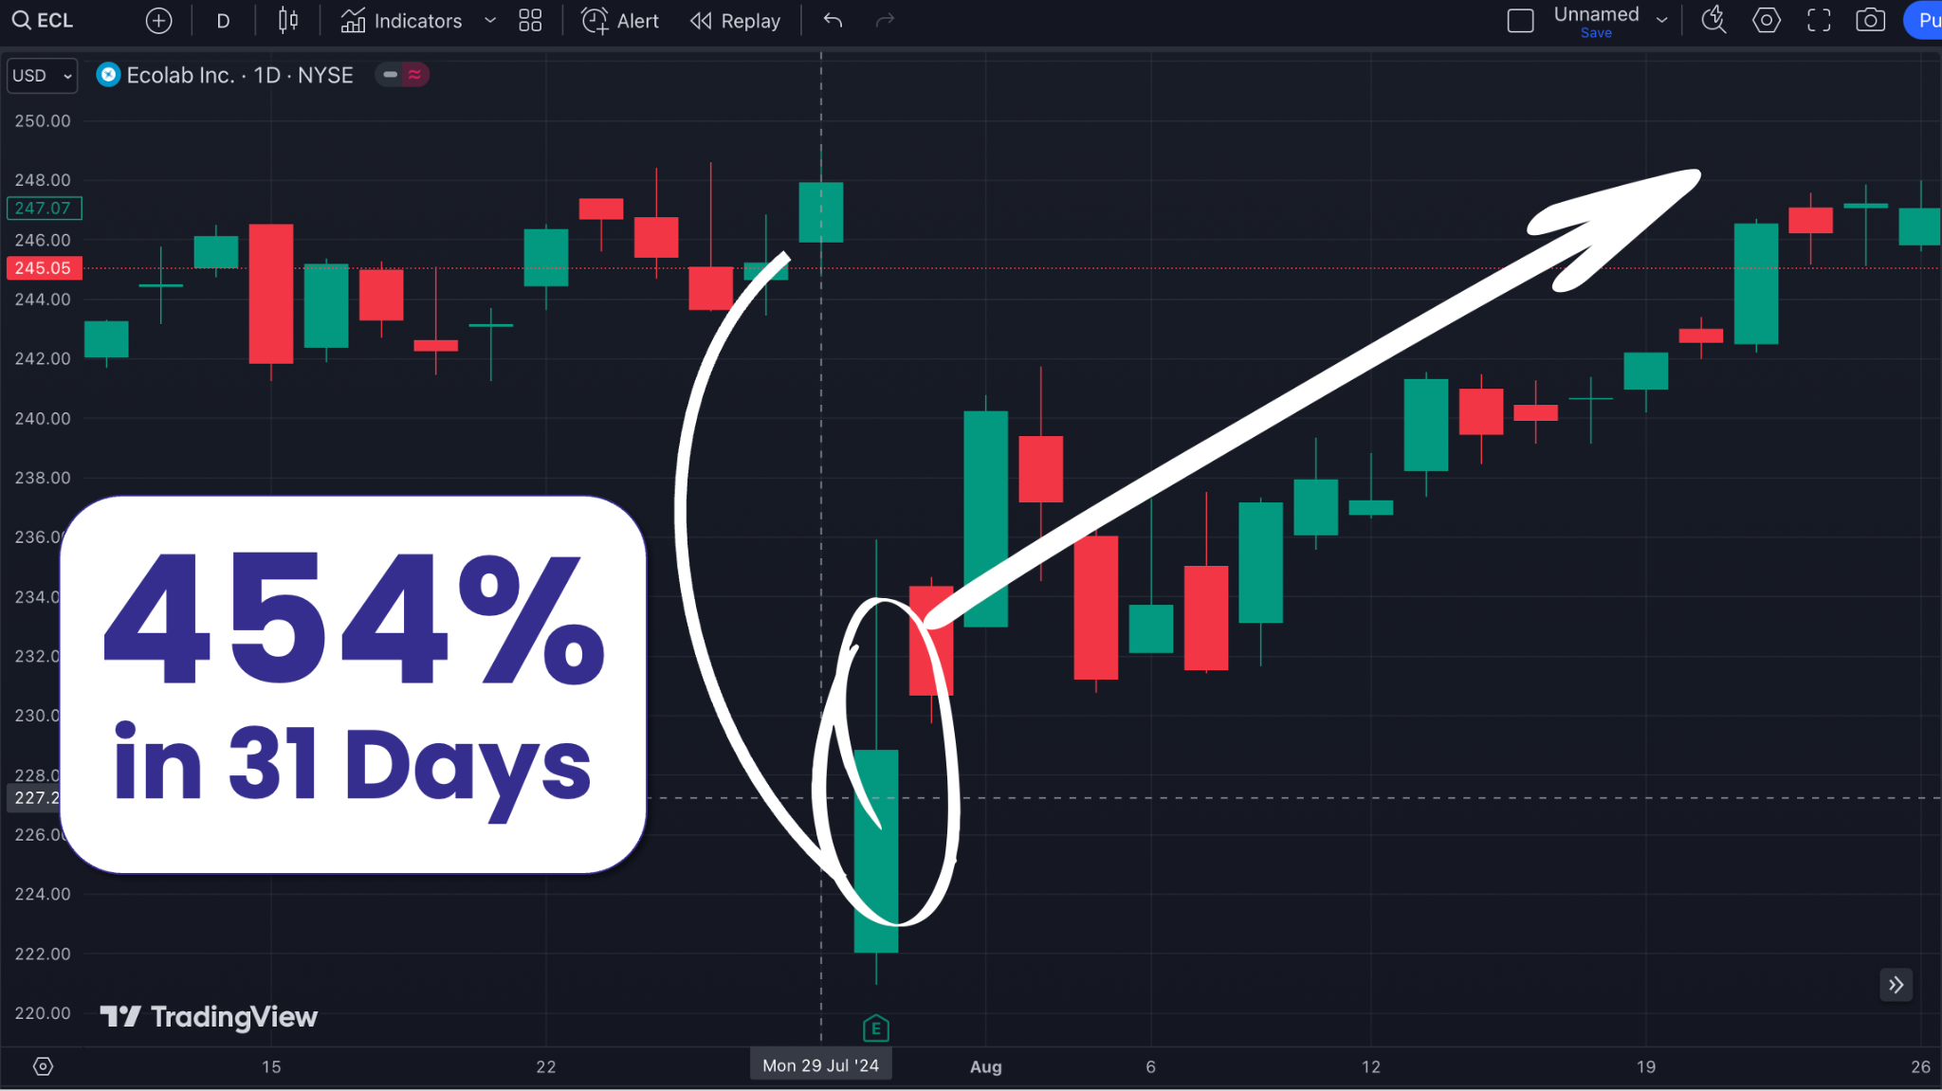
HOST: Ok, you got this mathematical secret, the 10-Line Trigger, figured out…

This is the BUY signal.

But when do you know when to sell?

BRYAN: Well, that's another amazing thing we discovered from this backtest…

You can sell anytime you want during the fill.

But if the fill hits the 25-Line on the cup, the chances of winning were maximized at 97% using stock trades according to the backtest.
[SHOW IMAGE OF CUP …WATER FILLED TO 25% … LABEL “97% Win-Rate” …ADD FOOTNOTE “** according to backtest”]
HOST: Once again, that 97% win-rate number is huge. Astronomical.

I don’t want anyone at home missing out on what you are saying here, Bryan.
Can you give us a little more about what this means?

BRYAN: Finding the 25-Line was another breakthrough.

The backtest found 831 setups.

And 807 were winners if you sold when the stock reached the 25-Line.

That's a 97.11% win rate when using stock trades.

### IMAGE FOR LEGAL ONLY/DON’T DISPLAY>> BACKTEST >> SUMMARY

Pretty sweet.

If you waited until the fill reaches the 50-Line, the win-rate went down a little, but the returns went up.

And so on, until the “cup” fills back up to the 100-Line.

Which still had an almost 85% win-rate, which is still incredible.
[SHOW IMAGE OF CUP …WATER FILLED TO 100% … LABEL “85% Win-Rate” …ADD FOOTNOTE “** according to backtest”]
Again, this is from the backtest. It’s not a track record.

But we’ve mentioned some of the testimonials from real traders using this, which I believe are the ultimate proof this works.

But there’s one more amazing thing about this backtest…

HOST: What’s that?

BRYAN: That 97% winrate would have been possible thanks to stock trades. But targeting those same setups with a special type of trade could have magnified those gains 10-fold.

HOST: What is that special type of trade?

BRYAN: Call options. After discovering that incredible winrate on the stocks, we went back and analyzed the optimal return these options could have made with these setups.

And using options is how you could have seen gains like …

103% gain in a single day…

235% gain in 11 days…

452% gain in 8 days…

In fact, every winning trade I’ve shown you is from buying a simple call option.

Not selling options. Not selling stocks short.

Not doing some complicated multi-leg spread.
Not anything that requires a Bloomberg terminal or a margin account or a six-figure portfolio.

You just buy a call option.

That's it.

You can place this trade in any standard brokerage account that allows options trading.

It simply turns a smaller move on the stock into a bigger gain.
That’s what makes these Panic Payout trades the “holy grail” of trading strategies, in my opinion…

You get the amazing leverage of options combined with a trading strategy which had a win-rate up to 97% on stock trades depending on what fill you take.

Now I am not promising you can win 97% of the time using options. That’s just not realistic.

And you don’t need to when your winners can return 100%, 200%, or more.

HOST: Now that we know your secret, Bryan, why don’t you walk us through one more example and bring it home.

BRYAN. Sure. Let’s look at this one…

Rockwell Automation… ticker ROK… a company specializing in industrial automation and information technology.

On the morning of January 31, 2024, before the market opened, ROK formed a big gap…

[ROK Chart - Show Gap - Circle Gap] SLIDE # 70
Next, we look for the 10-Line Trigger.

After trading began, the stock jumped up by $4.33, which hit the 10-Line Trigger.

[ROK Chart - Show Gap - Show Arrow at 10% Fill, Label “10-Line Trigger here”]

Right on target.

So let’s say someone watching bought a call option as soon as it hits this trigger?

The stock shot up to $ 279.77 in just 8 days.

[ROK Chart 36% - Show Gap - Show Arrow at 25% Fill, Label “25-Line Trigger here”]

This hits the 25-Line right on the nose.
[SHOW IMAGE OF CUP …WATER FILLED TO 25% … LABEL “97% Win-Rate when using stock trades” …ADD FOOTNOTE “** according to backtest”]
But what happens next is the really fun part…

HOST: I can’t wait to see it…

BRYAN: Because if you used a call option to make a trade…

You could have been sitting on a 452% gain.

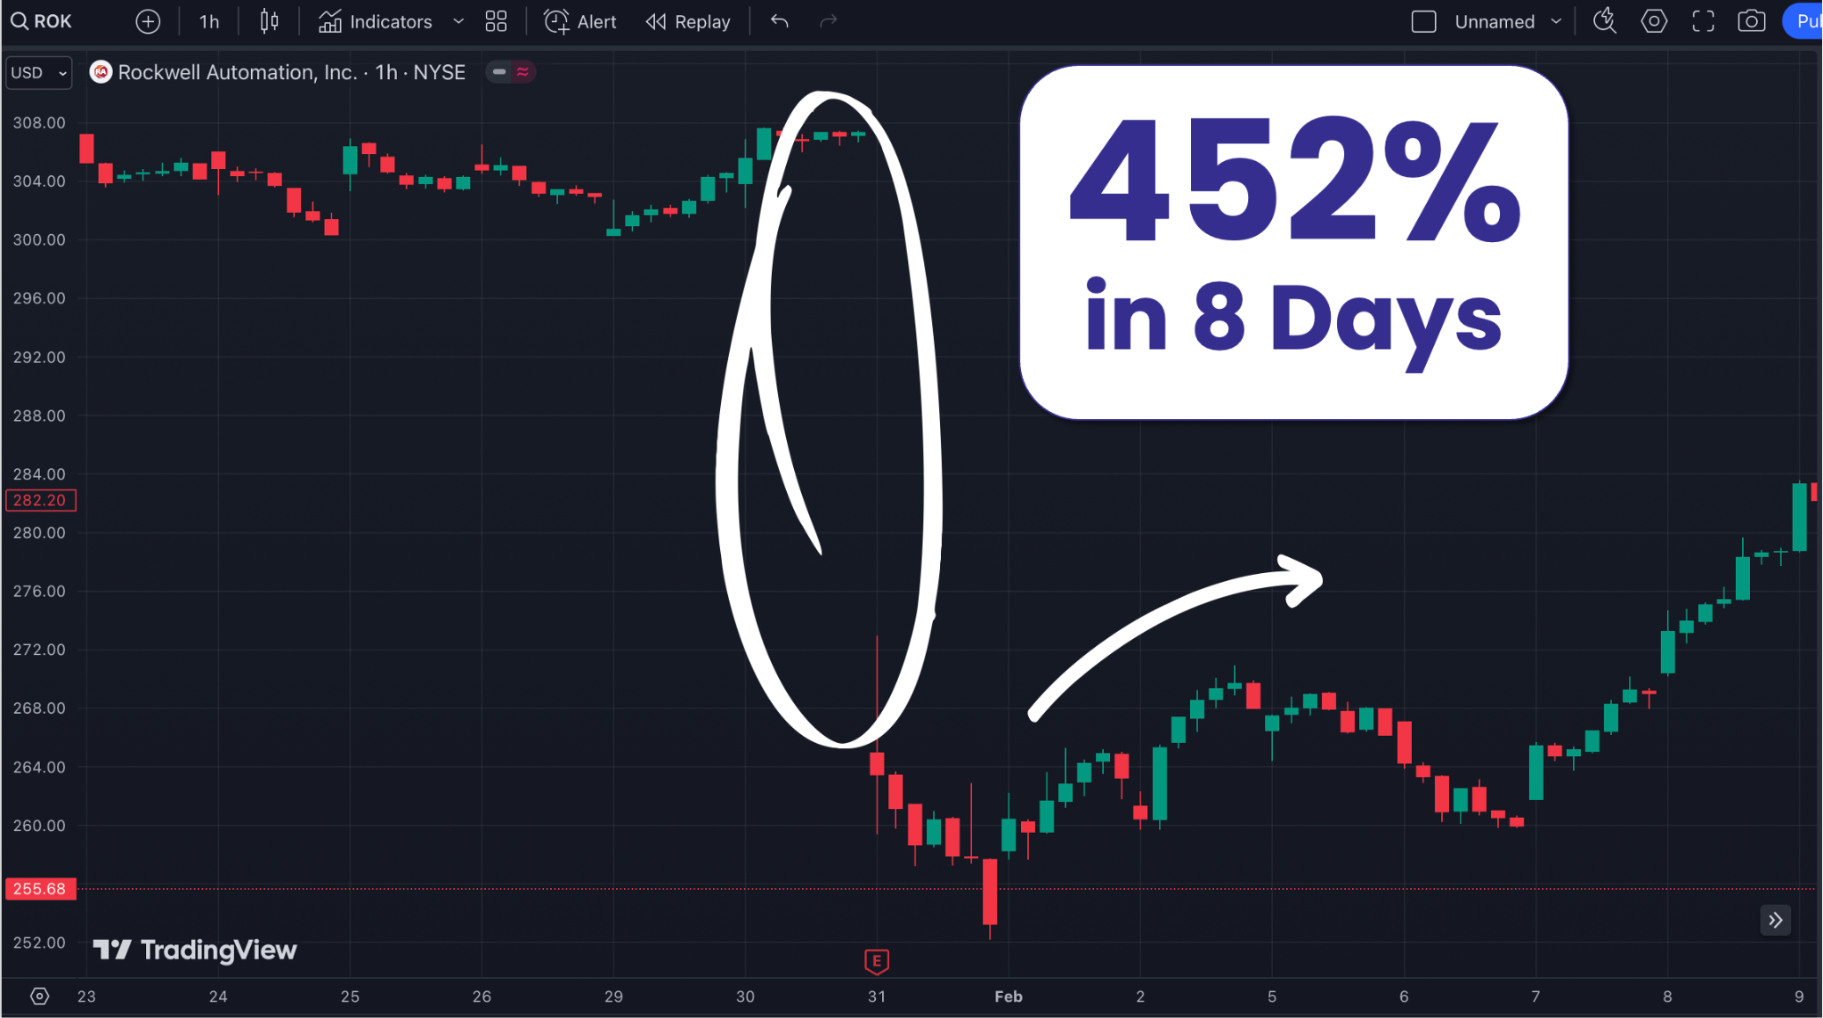

HOST: I’m not super fast with math, but that’s like five times your money back right?

BRYAN: Exactly.

That's what options do.

They take small price moves on the underlying stock and turn them into big percentage moves on your position.
We didn’t have to wait for the stock to fill the gap completely.
All we had to do was place the trade after the 10-Line Trigger…
And close out the trade once as the stock moves just a bit higher.

We can use the leverage of options to target big gains

Now, you’re welcome to wait for the full fill.
It’s up to you.

But for me, knowing the stock trades showed a 97% win-rate, I’d take the money and run every time I saw it hit that 25-Line.

It’s a no-brainer.

HOST: I’m floored, Bryan.

I’ve never seen a trading strategy in my life based on such reliable setups in backtesting…

BRYAN (interrupting): Sorry to interrupt. But I want to be super-clear on something…

Yes, the 97% win-rate on the stock trades is from the backtest.

But using options to target those setups means you are taking on more risk.

Nobody is winning 97% of the time buying options.

Look, everyone has seen the examples, and I’ve mentioned the real-world reports of gains.

We know this works.

And options allow us to supercharge the gains from these setups.

The backtest is validation, and it helped us optimize this trade to specific mathematical thresholds.

But I don’t want anyone watching to be under the impression this is all a theoretical set-up that comes from a backtest.

And it should go without saying that all investment carries risk. Never bet more than you can afford to lose. Past performance does not guarantee future results.

We are getting extremely positive real-world reports from those who write to me, and others who post their results in an online trading chat room I run.

HOST: I have a few of these reports now, let’s go through them.

Dean S. reports he made 57% in 1 day using this…

Aaron G. made 63% in 8 days…

John C. made 64% in a single day…

And talk about reliability! A guy named Illini O. said he made 15 of these trades for 13 wins and only 2 losses, or an 86% win rate..

BRYAN: Yup, this lines up both with the backtest and what I’ve seen in the real world.

HOST: Bryan, how quickly do these trades pay off?

BRYAN: For the 97% win-rate, we averaged a 23-day holding time, according to the backtest.

Meaning a hold time of 3 weeks is the preferred speed for these trades.
Again, you can hold longer for a full fill… but I like to get in and out with my trades!

HOST: Ok, Bryan…

You told us exactly what to look for.

Exactly when to enter.

Exactly how to exit.

How long to hold the trade.

The math is right there. You showed us the backtest. You showed us the cases.

So I have to ask the obvious question.

If somebody watching today wanted to do this themselves…

Without ever subscribing to anything, without ever paying you a dollar…

Could they do it themselves?

BRYAN: Honest answer? Technically, yes.

I've shown you the whole strategy today.

Nothing hidden.

No "wait until you subscribe to learn the real trick."

Everything you need to do this is right here in this interview.

But here’s the problem…

There are thousands of stocks in the market…

And every day, there are hundreds of stocks which gap down like the examples we looked at.

Now, everyone is welcome to go through each of these thousands of stocks…
Wait for the 10-LIne Trigger…

And decide when to sell.

HOST: Well, you'd need to be glued to a computer screen, watching dozens of charts at once, doing the 10-Line Trigger in your head as each one moved… and so on.

You'd burn out in a week.

HOST: And miss most of the trades anyway.

BRYAN: And miss most of the trades anyway.

And here’s another thing, which is a big positive for Panic Payouts… but creates a problem for finding these trades

If you do the math on the 807 winners we found in the backtest, which went back 5 years, that’s an average of 2 winning trades per week.
HOST: I don’t know, Bryan… 2 winning trades a week sounds pretty awesome.

BRYAN: It sure is…

But it takes looking at thousands of stocks to find the stocks with gaps, and a lot of calculations to find the 10-Line Triggers.

In other words, someone can do it themselves without any help, but it takes a lot of time and work.

That’s why I’ve created a FAR better way to track these.
I’ve created an AI-powered scanner called ProfitSight that tracks over 3,000 stocks minute by minute… looking ONLY for these gaps.

The instant any stock forms a gap on a chart, the scanner flags it.
Then… It automatically calculates the triggers.

So instant the 10-Line Trigger fires on any of those flagged gaps, the scanner alerts you.

It’ll tell you when it hits the 25-Line of the fill… where the backtest shows a 97% win rate…
It’ll tell you when the fill line hits 50-Line, 75-Line, the 100-Line…
It does the heavy lifting for you.

Automatically…

You're not glued to a screen. You’re not stuck trying to watch hundreds of charts on three computer screens.

You're going about your day. The scanner does the watching.

HOST: In other words, a scanner makes this easy.

BRYAN: At least 10 times easier.

Look, I like to make things easy, and fun.

Trading is really about making your life better.
That’s why the whole process is automated in my ProfitSight scanner.

Every day it alerts you when the signal fires.
It even gives you a list of potential call options to buy!

Everything I walked you through today, the scanner does all of it for you

Automatically.
When the alert comes, you can choose to place the trade.

BRYAN: I'm going to show you the whole thing in a few minutes. The full scanner system you get with ProfitSight.

But there’s one more benefit to this method that this scanner ALSO tracks…

Everything I've shown you today has been on gap-DOWNS. Stocks Wall Street panicked on. Stocks that crashed.

But here's the thing…

Sometimes a piece of good news hits a stock and Wall Street loses its mind in the opposite direction.

The stock gaps UP at the open. Up 10%, 15%, 20% overnight, all based on hype.

Same gap…

Same overreaction. Just in reverse.

Take a look…

Here's an example for Alphabet, or Google, with ticker GOOGL…

[Show gap chart for GOOGL] SLIDE # 75

See how it shoots up, and there’s a gap in the chart.

That overshoot? That gap UP? It also has to fill.

So you do the exact same thing as a gap down…

But you use an option that benefits from when a stock corrects this direction.

In this case, you could’ve made a trade here for 60% in only 3 days….

[Show gap chart for AMGN - circle gap up -- arrow pointing up from gap with label “69% gain in 3 days”]

Same with a stock called Amgen…

Where you could’ve made a trade for nearly 70% in 3 days…

[Show gap chart for AMGN - circle gap up -- arrow pointing up from gap with label “Almost 70% gain in 3 days”]

And here’s one more for a stock with ticker HWM…

With this one, someone watching could’ve grabbed a massive win of 233% in 6 days…

That’s more than triple their money back in less than a week.

[Show gap chart for HYM - circle gap up -- arrow pointing up from gap with label “233% gain in 6 days”]

HOST: So this works the same way, just for stocks shooting up, right?

BRYAN: Yes, you are seeing it now.

Stocks that gap up on euphoria correct back down toward fair value the same way panic-driven gaps correct UP toward fair value.

You look for a similar gap when the stock overshoots…

Same system…

The same 10-Line Trigger fires.

Same backtested win-rates.

In fact, everything else I showed you before applies here.

The only difference is the vehicle you use to make the trade…

Instead of buying a call option, you buy a simple put option.
HOST: So this is basically how to get a “Hype Payout.”
BRYAN: Yes, I like that...a “Hype Payout.”
Which is really just a “Panic Payout” in the other direction.
HOST: This doubles the opportunity universe, right?
BRYAN: Exactly.
We double our chances to find these trades.
Every time Wall Street loses its mind in either direction…
If a stock shoots up, or shoots down, opening up a gap on the chart...
ProfitSight can spot it in real-time.
In fact, this is the same tool I use to find these setups in my War Room chat service every single day.
[VISUAL: ProfitSight dashboard screenshot]
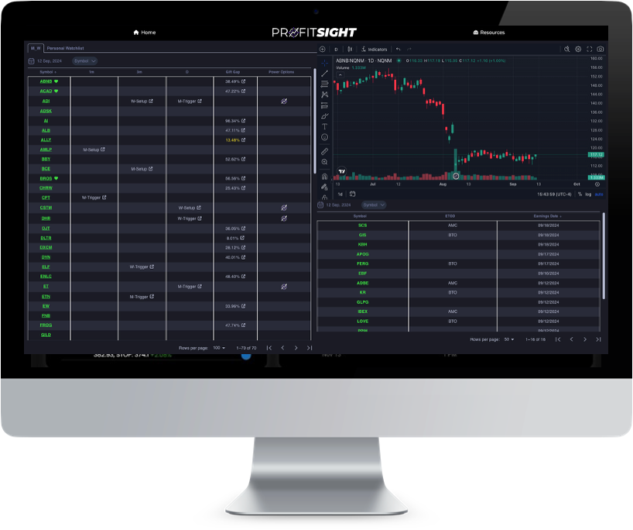
The way it works is simple.
You log in to the website.
The scanner is already running.
ProfitSight is already watching every optionable U.S. stock for gaps in real time.
When a gap forms, you see it on the dashboard.
When the 10-Line Trigger fires, the scanner sends an alert and then my team sends out a daily set up.
You can be alerted by text message, email, whatever you set up.
The alert tells you exactly which stock, exactly which call option to consider, exactly at what price is optimal based on historical data.
[VISUAL: Quick screen recording / demo of a live alert firing]
You can choose if you want to place the trade.
Again... it’s important to note that you should never blindly follow an alert.
ProfitSight is a tool designed to help you find setups, not a trading system with buy or sell alerts.
You should always do your own due diligence for any setups.
But ProfitSight makes things much easier.
The research alert tells you all the details... like the fill rate…
When it hits the level you want, you sell the option and potentially walk away with the gain.
Really, we’ve pulled out all the steps on ProfitSight.
This scanner software makes targeting “Panic Payout” trades so simple.
And again, when I look for these trades, I use ProfitSight.
You can have the very same tool I use everyday.
HOST: So the viewer doesn't have to be glued to a screen.
BRYAN: They don't have to be glued to anything.
They don't have to calculate 10% retracements in their head.
They don't have to watch 50 charts at the same time.
The scanner does all of it.
The viewer just analyzes the setup and decides whether to take the trade.
After that, all they need to do on their end is buy the options.
HOST: And it scans for “gap ups” or “Hype Payouts” too?
BRYAN: That’s right. Same scanner. Same alerts.
Whether it's a panic creating a gap down or hype creating a gap up, ProfitSight aims to catch both.
HOST: Bryan, you’ve already shown a ton of “real world” trade results and members singing praises for your system.
Let me quickly show everyone watching a few more examples of what some of your most successful members are saying…
T. Bird says 89% of his trades are winners.
Robert D. banked over a 100% win in just 24 hours.

Geno made a 72% gain overnight.
Thom I. has been averaging 51.75% per trade for two months running.
And Ryan Fitzwater, Monument Trader Alliance’s CEO, tested this himself with his own money in 2024 for a brief period after I first went public with this strategy.
Ryan reported gains of:
100% in 3 trading days.
66.67% in 3 days.
50% in 14 trading days.
BRYAN: For me, that’s the ultimate proof.
HOST: Bryan, one more thing before we wrap.
Earlier you mentioned October 13 as a big date coming up.
What happens on October 13?
[ALT LINE] Earlier you mentioned January 17 as a big date coming up. What happens on January 17?
BRYAN: Yes. October 13 is when JPMorgan Chase reports their Q3 earnings.
[ALT LINE] Yes. January 17 is when JPMorgan Chase reports their Q4 earnings.
It's the first of the megabanks to report in the quarter.
And historically, earnings reporting season is when we see the BIGGEST wave of panic-driven gaps of the entire year.
At a top-level, we know there are tons of uncertainties right now…
The problems in the middle east…
Oil and energy prices…
The impact of AI, the costs of data centers and the big question if AI is making companies money…
Plus we’ll have midterm elections coming up in November, and based on the last couple elections, we can bank on political craziness.
All that adds up to potentially a lot of PANIC in the markets, particularly if any earnings reports are really bad.
Every earnings report from a major bank, an industrial, a tech company, all of them have the potential to open up a ton of “Panic Payout” trades.
I expect ProfitSight to be alerting members all day, every day, for the entire reporting season.
If you're sitting there thinking "I'll wait a few weeks and see how this works for other people first…”
You'll miss the biggest single wave of Panic Payout opportunities of the year.
HOST: So now is the moment.
BRYAN [to audience]: Now is the moment.
And let me say one more thing before we end.
For everyone watching today, if you've been on the wrong side of Wall Street's panic moves for the last decade…
If you've sat there as a stock you owned dropped 30, 40, 50 percent overnight…
If you've felt that pit in your stomach watching the algos punish you for holding too long…
If you've sold at the bottom and watched the recovery happen without you…
I built ProfitSight specifically for you.
Not for the institutions.
Not for the algorithms.
Not for the Wall Street insiders.
For the trader who's been on the wrong side of this pattern for years and never had a tool to flip it.
The next time Wall Street panics on a stock… and it will, because it always does… you don't have to be on the losing side of that move.
You can be the one collecting a payout instead.
The next time the algorithms overshoot and crater a good stock on bad news that doesn't actually justify it… you don't have to be the one frozen in place watching it happen.
You can be the one walking away with money in your pocket
The trades that have haunted your trading account for the last decade, the ones you keep missing, keep getting wrong, keep losing on…
This is like getting a payback for all those times Wall Street left you holding the bag.
This is the day you can stop feeling like prey and start feeling like the trader you always knew you could be.
HOST: Beautifully said, Bryan
Now when somebody signs up for ProfitSight, what do they get?
BRYAN: At the top level…a level we call the Gold Tier… you get everything.
Here's what's included:
You get what I call “The Gift Gap Scanner.” This is the primary scanner which gives real-time alerts on every Panic Payout gap-down setup, plus every gap-up.
You also get full tracking of fills, including every 10-Line Trigger fire. Across every optionable U.S. stock.
[SCREENSHOT OF GIFT GAP SCANNER]
You get what I call The CashCodeX Perfect Timing Indicator. A second scanner I built years ago and refined in the War Room. It catches W and M chart patterns on intraday timeframes, and short-term setups on stocks you're already watching. This is a bonus tool, and it comes bundled with Gold as a 100% free added bonus.
[SCREENSHOT OF PERFECT TIMING SCANNER]
You get the Earnings Tracker. A scanner that monitors every upcoming earnings announcement across the U.S. market. Most of the Panic Payout setups you saw today were earnings-driven. The Earnings Tracker lets you anticipate where the next ones might fire.
[SCREENSHOT OF EARNINGS TRACKER]
Plus you get Power Options Unlimited, which is a Gold exclusive. This is the ultimate leverage layer. For every ProfitSight alert that fires, Power Options gives you three trade options to consider: conservative, moderate, and aggressive. If you think those options are optimal, you can just pick the leverage level based on your risk tolerance. This is how a 5% move on the underlying stock turns into a 100%, 200%, or 400% move on your position.
[SCREENSHOT OF POWER OPTIONS UNLIMITED]
And we also give you a Full Training Library. The Gift Gap Trading Guide, a written walkthrough of the entire system. The ProfitSight Quick Start video, a step-by-step tour of how to use the platform. Everything you need to be making your first Panic Payout trade within an hour of joining.
[SCREENSHOT OF TRAINING MATERIALS]
And this last one is really great, because we’ll send you Daily Email Alerts. Every day, you will automatically be emailed the gaps, including both gap-down Panic Payouts and gap-up opportunities that the scanner found overnight.
[SCREENSHOT OF DAILY EMAIL ALERT]
HOST: So that's the whole ProfitSight platform. Every scanner. Every training course. The extra leverage of Power Options if you want it. The daily email alerts…
BRYAN: That's the Gold level of ProfitSight. The whole thing. Nothing held back.
HOST: Bryan, this is a lot.
What's the retail price for all of this?
BRYAN: Retail, ProfitSight Gold runs at $5,000 a year.
And honestly, given that one trade hitting a 100% return on a $5,000 stake covers the cost of the platform for the entire year…
That's not unreasonable.
But for those in the audience joining today, I'm doing something different.
We're not selling Gold as an annual subscription.
For today only… and as part of this special video presentation… Gold is being offered as a one-time payment for unlimited access.
One payment.
Unlimitd access to the platform.
Unlimited access to every future Panic Payout alert.
For as long as we publish the ProfitSight platform.
And the price isn't $5,000…
It isn’t $3,500…
It's $2,497.
One payment. Plus $199 a year to cover platform maintenance and the data feeds.
That's it.
HOST: That's less than the annual subscription to a typical trading newsletter, and it's for as long as you publish ProfitSight.
BRYAN: That’s right. As long as ProfitSight is running, you're in.
And I should note that everyone who takes advantage of this special offer today also gets every future scanner software update.
We are always adding new features.
So that $199 maintenance fee not only covers the data feeds, which are really expensive…
But we are always improving this thing with new scanners and new features.
HOST: Now if Gold is more than you can swing right now, we have other options.
On the order form you're about to see, there are cheaper tiers with fewer features.
Bryan, what if somebody joins Gold today, uses the scanner for a few weeks, and decides it's not for them?
BRYAN: Then they get their money back. Simple as that.
We're offering a 60-day satisfaction guarantee.
For 60 days from the day you join, you can use the platform.
See the scanner in action. Watch the Panic Payout setups fire.
Everything.
If at any point in those first 60 days you decide ProfitSight isn't for you, you call our VIP concierge team and we refund your money.
There's a small processing fee of 10% of the membership cost. This covers the data and platform costs we've already incurred on your behalf. But the rest comes back to you.
HOST: 60 days is plenty of time to evaluate this.
BRYAN: It's plenty of time. According to the backtest, the scanner should fire 25 to 30 trade setups in that timeframe.
Honestly, that's more than enough to know whether the system works the way I say it does.
Oh, and one more thing…
There's a $997 special gift everyone watching can claim by hitting the button for the order form, which I believe will pop up in a few seconds.
I don’t have time to tell you about it here. If you click, you’ll see more about it.
And if the price I mentioned seems too rich, we’ve arranged some more inexpensive ways to get this scanner with most of the features included.
HOST: That’s a great thing to mention…
There are several “tiers” or levels you can get for ProfitSight, including the Gold tier, which includes all the features we discussed today.
So make sure to check out the order page when we display it in a second so you can get whichever tier you desire.
Bryan, I think we're ready.
[ADDRESS AUDIENCE]
For everyone watching, if you want in on ProfitSight Gold tier…
…with the Gift Gap Scanner, the CashCodeX Perfect Timing Indicator, the Earnings Tracker, Power Options Unlimited, the full training library…
…AND a special $997 bonus gift you can see on the order page…
…all for a one-time payment of $2,497 plus $199 annual maintenance…
…and backed by Bryan's 60-day satisfaction guarantee…
…here's what you do.
[VISUAL: Subscribe Now button / CTA link]
Look at your screen. You'll see a button or a link to ProfitSight.
Click it.
You'll be taken to a secure order form. Fill in your information. Confirm your tier. Submit.
Within 60 seconds, you'll have full access to the platform.
The scanner is already running. The next alert is coming.
One last time, here's what you're getting at the Gold level today:
ProfitSight Gold… with unlimited access.
The Gift Gap Scanner… real-time alerts on every setup, including Panic Payouts.
The CashCodeX Perfect Timing Indicator.
The Earnings Tracker.
Power Options Unlimited, a Gold level exclusive.
The Gift Gap Trading Guide.
The ProfitSight Quick Start video.
Email alerts every single day the market is open…
All future software upgrades, scanners and trainings…
And a special $997 gift, which you can see by clicking to the next page.
Everything backed by the 60-day satisfaction guarantee...
All for a one-time payment of $2,497 plus $199 a year for maintenance.
If you're in, click the link or button on your screen to see all the details.
You can be inside ProfitSight in less than 60 seconds.
Whatever you do… don't wait.
The next Panic Payout is coming soon, maybe as soon as this week.
You can be in front of it…
Or you can watch it happen without you.
The choice is yours.
And as Bryan shared with us, the most lucrative trades could be coming up as soon as next earning season, which kicks off October 13. This date is coming up fast…
[ALT LINE] And as Bryan shared with us, the most lucrative trades could be coming up as soon as next earning season, which kicks off January 17. This date is coming up fast…
Bryan, before we go, we know some viewers will have questions.
Let's tackle the most common ones quickly.
Do they need to install or download any special software on their computer to use the scanner?
BRYAN: Nope.
All you need is a web browser, and you can access the scanner.
HOST: OK, here’s a biggie… I've never traded options before. Can I do this?
BRYAN: Yes. Every research alert tells you exactly which call option to buy, including the strike price and expiration. If you can place a stock order with your broker, you can place a call option order.
Honestly, once you buy 1-2 options, you’ll see how easy it is.
Plus, we’ll give you training materials and a full library of how-to guides, all of which come with whatever tier you choose for ProfitSight.
HOST: How much money do I need to start?
BRYAN: As little as $100 per trade. Some of the option contracts in our backtest were priced under $1.50. With $100, you can take your first trade. You can scale up as you build confidence.
HOST [to audience]: If you’re still watching, make sure to hit the button now to see the complete offer for ProfitSight, including the special pricing, 60-day satisfaction guarantee, and added features.
You won’t be obligated to do anything by hitting the button. If you hit the button, you’ll be directed to another page with all the details on this special offer.
[To Bryan] We have a few more questions…
HOST: Does someone need to know technical analysis to use this scanner?
BRYAN: Absolutely not…
That’s the beauty of a scanner.
It spots the setups for you.
All you need to do is determine if you want to buy an option when alerted and sell it when the timing is right.
The scanner software tells when to do both.
HOST: Bryan, what if I miss a few alerts?
BRYAN: That's the entire point of the scanner. It catches what you would miss. Every alert is logged. You can review past setups inside the platform. Most setups stay actionable for hours after the 10-Line Trigger fires, so you're not racing the clock.
HOST: Will the strategy stop working if too many people use it?
BRYAN: No. The Panic Payout strategy is rooted in human panic amplified by the algorithms, which is basically a “renewable resource” on Wall Street.
As long as Wall Street has emotional traders and algorithms are reacting and amplifying the emotional response of these traders, gaps will form.
In my mind, this means pretty much forever as long as human beings are involved in the markets.
HOST: How is this different from the newsletter services I already subscribe to?
BRYAN: Newsletters send you a written recommendation to read later.
Newsletter research services are great. I run several myself.
The difference is ProfitSight alerts you the instant the signal fires.
You get the trade in real-time, no reading required, no worries about missing an email.
You're not buying my research here.
In fact, you’re buying the exact same scanner I use to do my research.
HOST: Again, everyone watching can get a very special deal on the ProfitSight scanner just by hitting the button you see now.
Bryan, what if my brokerage doesn't support options trading?
BRYAN: Every major U.S. broker offers options trading. Fidelity, Schwab, E*Trade, Robinhood, Interactive Brokers… all of them.
You may need to fill out a quick options-enabled application, but it's universal.
HOST: What about someone close to retirement? Is this strategy too aggressive for someone in their 60s or 70s?
BRYAN: That's a decision you and your financial advisor should make.
But here's the thing… because we're only buying call options, your maximum loss on any single trade is the premium you paid. Not more.
So you can scale this to ANY account size. Risk $100 per trade if that's what's comfortable. The position size is entirely under your control.
You can paper trade using the scanner if you want, for as long as you like, without risking a dime in the markets.
Of course, with paper trading, you also won’t make any money either. But it’s a great way to try our ProfitSight with zero risk to your capital, if that’s what you want to do.
What you should NOT do is gamble retirement money you can't afford to lose. Use the same money management discipline you'd use for any speculative position.
And honestly? The 23-day average payoff is actually attractive for traders closer to retirement. You're not tying up capital for years waiting on a slow-growth strategy.
HOST: Is there any academic research backing up this whole "panicked stocks recover" idea? Or is this just your theory?
BRYAN: Forty years of it.
There's a famous Journal of Finance paper from 1985 called "Does the Stock Market Overreact?" by Werner De Bondt and Richard Thaler.
Their conclusion: Stocks that crash on bad news systematically overreact and recover.
Thaler later won the Nobel Prize in Economics for this kind of work.
Daniel Kahneman won a Nobel Prize before him for studying WHY humans overreact in markets.
Robert Shiller won it for documenting the same overshoot-and-correction patterns in asset prices.
Three different Nobel laureates, all studying the same thing.
And get this, there was an academic paper published in 2019 showing this kind of strategy can deliver returns 553% more than the market.

The researchers backtested it on S&P 500 stocks from 1998 to 2015.

The paper was published in the Journal of Risk and Financial Management. Anyone can look it up.
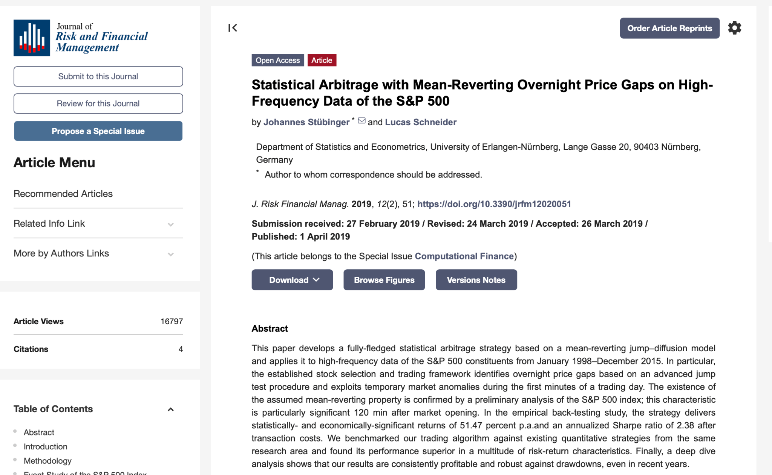
I didn't invent this phenomenon.
I just figured out the precise mathematical moment to step in, use options and target Panic Payout trades.
HOST: That wraps up all the questions, Bryan. I want to thank you for joining us today.
Any final words?
BRYAN: Look. I've shown you everything today.
The system. The backtest. The real-money results. The testimonials.
Nothing held back.
If this isn't for you, walk away. No hard feelings.
But if you're sitting there thinking about every panic move that ever burned you… every time you held too long, sold at the bottom, watched the recovery happen without you…
You already know whether this is for you.
I built my ProfitSight scanner so you don't have to be on the losing side of that move ever again.
The rest is up to you.
And on October 13, this opportunity could go into overdrive, so the timing is really good to get in now.
[ALT LINE] And on January 17, this opportunity could go into overdrive, so the timing is really good to get in now.
HOST: Well said. Thank you again, Bryan.
And for everyone watching us, we’ll keep the button you see on your screen live for as long as we can.
But if you click away, we can’t guarantee this offer will still be up.
So take as much time as you need to consider, and hit the button now to see all the details on this special offer.
This is [HOST NAME] signing off.
Thank you.
August 2026

Per below, from Bryan: “October 13 is when JPMorgan Chase reports their Q3 earnings. It's the first of the megabanks to report in the quarter. And historically, earnings reporting season is when we see the BIGGEST wave of panic-driven gaps of the entire year.” https://www.jpmorganchase.com/ir/events OK
BACKTEST >> GG Options Examples >> HAS Long
BACKTEST >> GG Options Examples >> JBL Long
BACKTEST >> GG Options Examples >> DD Long
https://www.reuters.com/legal/litigation/fulcrum-plummets-50-after-scrapping-lead-sickle-cell-drug-fda-concerns-2026-06-02/ OK
Refers to the gaps, gap ups or gap downs, on the chart: https://centerpointsecurities.com/what-is-a-gap-fill-in-stocks/ OK
BACKTEST >> GG Options Examples >> DD Long
BACKTEST >> SUMMARY >> 97%
https://www.marketwatch.com/story/ibms-stock-dives-toward-worst-day-in-nearly-40-years-after-the-surprise-release-of-an-earnings-miss-8519741e
BACKTEST… 807 winners over 5 years with the backtest: 807/5/52= 3.1
This refers to the gaps up or gaps down, which is the “Gift Gap” or in this promo, a “Panic Payout” trade.
BACKTEST >> GG Options Examples >> DD Long
It’s not shorting or selling options. The trade is based on BUYING options, calls or puts. OK
“Panic Payout” = trading gap ups or gap downs
BACKTEST >> SUMMARY >> 97%
BACKTEST >> GG Options Examples >> HAS Long
BACKTEST >> GG Options Examples >> JBL Long
BACKTEST >> GG Options Examples >> DD Long
DEAN S. (Gift Slide 91) 57% in 1 day x $5,000 = $7,850 >> SLIDE # 91
GENO (Gift Slide 98) 72% overnight x $5,000 = $8,600 >> SLIDE # 98
ROBERT D. (Gift Slide 96) 100% in 24 hours x $5,000 = $10,000 >> SLIDE # 96
I didn’t put in all the images of the charts because it made the file size ginormous. But I tried to put in links to the original slides for these examples in the footnotes, if you want to look those up.
https://www.sec.gov/Archives/edgar/data/0001145197/000114519724000037/podd2024-06x30ex991.htm
BACKTEST >> GG Options Examples >> PODD Long
The "mathematical secret” is the 10% fill (“10-Line” in the promo) and 25% fill (“25-Line”) which get to the 97% win-rate of the BACKTEST
https://www.cnbc.com/2020/11/20/attention-robinhood-power-users-most-day-traders-lose-money.html
BACKTEST >> GG Options Examples >> 452% in 8 days… >> ECL Long 33% in 4 days… >> ETSY Long 89% in 5 days… >> DPZ Long 235% in 11 days… >> JBL Long 80% in 8 days… >> KEYS Long 92% in 8 days… >> DVA Long 70% in 3 days. >> AMGN Short 57% in 1 day…>> MRNA Long 59% in a day… >> DLTR Long 103% in 1 day… >> ROK Long
T-BIRD (Gift Slide 95) >> SLIDE # 95
It’s buying call options (and buying put options), revealed later in the promo
BACKTEST >> Summary >> 25% fill, duration of 23 days
BACKTEST >> GG Options Examples >> CMA Long
5,000 x 250% = $12,500
Previous day close (Jul 29): $247.92 Gap day open (Jul 30): $222.05 Drop in dollars: $25.87 Drop in percentage: -10.4%
BACKTEST >> GG Options Examples >> ECL Long
$5,000 x 454% = $22,700
https://papertradingjournal.com/2026/03/12/algorithmic-trading-statistics/ OK
sec.gov/files/marketevents-report.pdf OK
SLIDE # 97
https://centerpointsecurities.com/what-is-a-gap-fill-in-stocks/
BACKTEST >> GG Options Examples >> FFIV Long
BACKTEST >> GG Options Examples >> META Long
BACKTEST >> GG Options Examples >> ORCL Long
BACKTEST >> GG Options Examples >> DD Long
SLIDE # 65 “10-Line Trigger” = 10% gap fill
https://www.investopedia.com/terms/g/gap.asp
SLIDE # 55 & 56
Previous day close: $247.92 Gap day open: $222.05 Gap size: $247.92 − $222.05 = $25.87 10% of the gap: $25.87 × 10% = $2.587 10% Trigger level: $222.05 + $2.587 = $224.637
BACKTEST >> GG Options Examples >> HAS Long
BACKTEST >> GG Options Examples >> JBL Long
BACKTEST >> GG Options Examples >> DD Long
10% Trigger Price: $268.23 (precise: $268.232) Gap size: $307.22 − $263.90 = $43.32 10% of gap: $43.32 × 10% = $4.332 10% Trigger: $263.90 + $4.332 = $268.232 Confirmed: GG Option Examples row 17, "10% Retracement Level" column + 25% sheet "Entry Avg Price" column. Both match exactly.
BACKTEST >> GG Options Examples >> ROK Long
25% Sweet Spot Price: $274.73 25% of gap: $43.32 × 25% = $10.83 25% Sweet Spot: $263.90 + $10.83 = $274.73 25% sheet actual exit at $279.06 on Day 8 — stock overshot the 25% target slightly when the trade closed.
BACKTEST >> GG Options Examples >> ROK Long
If we need more disclosures for the backtest, this is a good spot to put them.
Suggest putting RISK DISCLOSURE language here
SLIDE # 91
SLIDE # 92
SLIDE # 93
SLIDE # 94
SLIDE # 56
23 / 7 = 3.2
BACKTEST… 807 winners over 5 years with the backtest: 807/5/52= 3.1
BACKTEST >> GG Options Examples >> GOOGL Short
BACKTEST >> GG Options Examples >> AMGN Short
BACKTEST >> GG Options Examples >> HYM Short
SLIDE # 95
SLIDE # 96
SLIDE # 98
SLIDE # 99
SLIDE # 100
https://www.jpmorganchase.com/ir/events
This is 12 months of TPU/Monument Trends Advisory, which will be revealed on the order page
https://www.jpmorganchase.com/ir/events
https://fac.comtech.depaul.edu/wdebondt/Publications/DoesStockM.pdf OK
https://www.nobelprize.org/prizes/economic-sciences/2017/thaler/facts/ OK
https://fac.comtech.depaul.edu/wdebondt/Publications/DoesStockM.pdf https://www.nobelprize.org/prizes/economic-sciences/2002/kahneman/facts/ OK
https://www.nobelprize.org/prizes/economic-sciences/2013/shiller/facts/ OK
https://www.mdpi.com/1911-8074/12/2/51 OK
