Pro Trader Breaks the Internet with Unfair Market Hack…
Up to 240% OVERNIGHT
Discover How a 15-Minute Move at 4:00PM Could Hand You Huge Overnight Gains

Headline 2:
Pro Trader Reveals His…
Night Portfolio
Discover How a 15-Minute Move at 4:00PM Could Boost Your Brokerage Account With Huge Overnight Gains.

CJ:
My name is Chris Johnson.
For eight years of my life I worked as a financial auditor…
My job was to debunk and destroy the “can’t miss” trading strategies that looked like gold mines from a distance but were more like cesspits close up.
I tore down dozens of them…
But every so often, I would come across one that didn’t break.
I could pull it every which way.
But like an anvil, it was unbreakable. Solid all the way through.
What you're about to see is one of those strategies.
In fact, it's the only one I've ever put my own name behind.
After you hear what I’m about to tell you, you’ll know why.
This strategy has an 80%-win rate so far this year.
In the past four months it’s gotten even higher than that.
Since March 31…
Only one of these trades has been a loss. 18 trades. 17 wins. An 94%-win rate. And the average gain on these trades is 25%.

- July 1…. 53.4% OVERNIGHT… …
- June 18… 15.8% OVERNIGHT….
- May 13… 27.9% OVERNIGHT…
- April 8… 240% OVERNIGHT.
Remember these aren’t monthly gains or weekly gains. They’re overnight gains.
If we go back and look at the entire year…
It’s still impressive…
An 80%-win rate with an average gain of 16%.
- 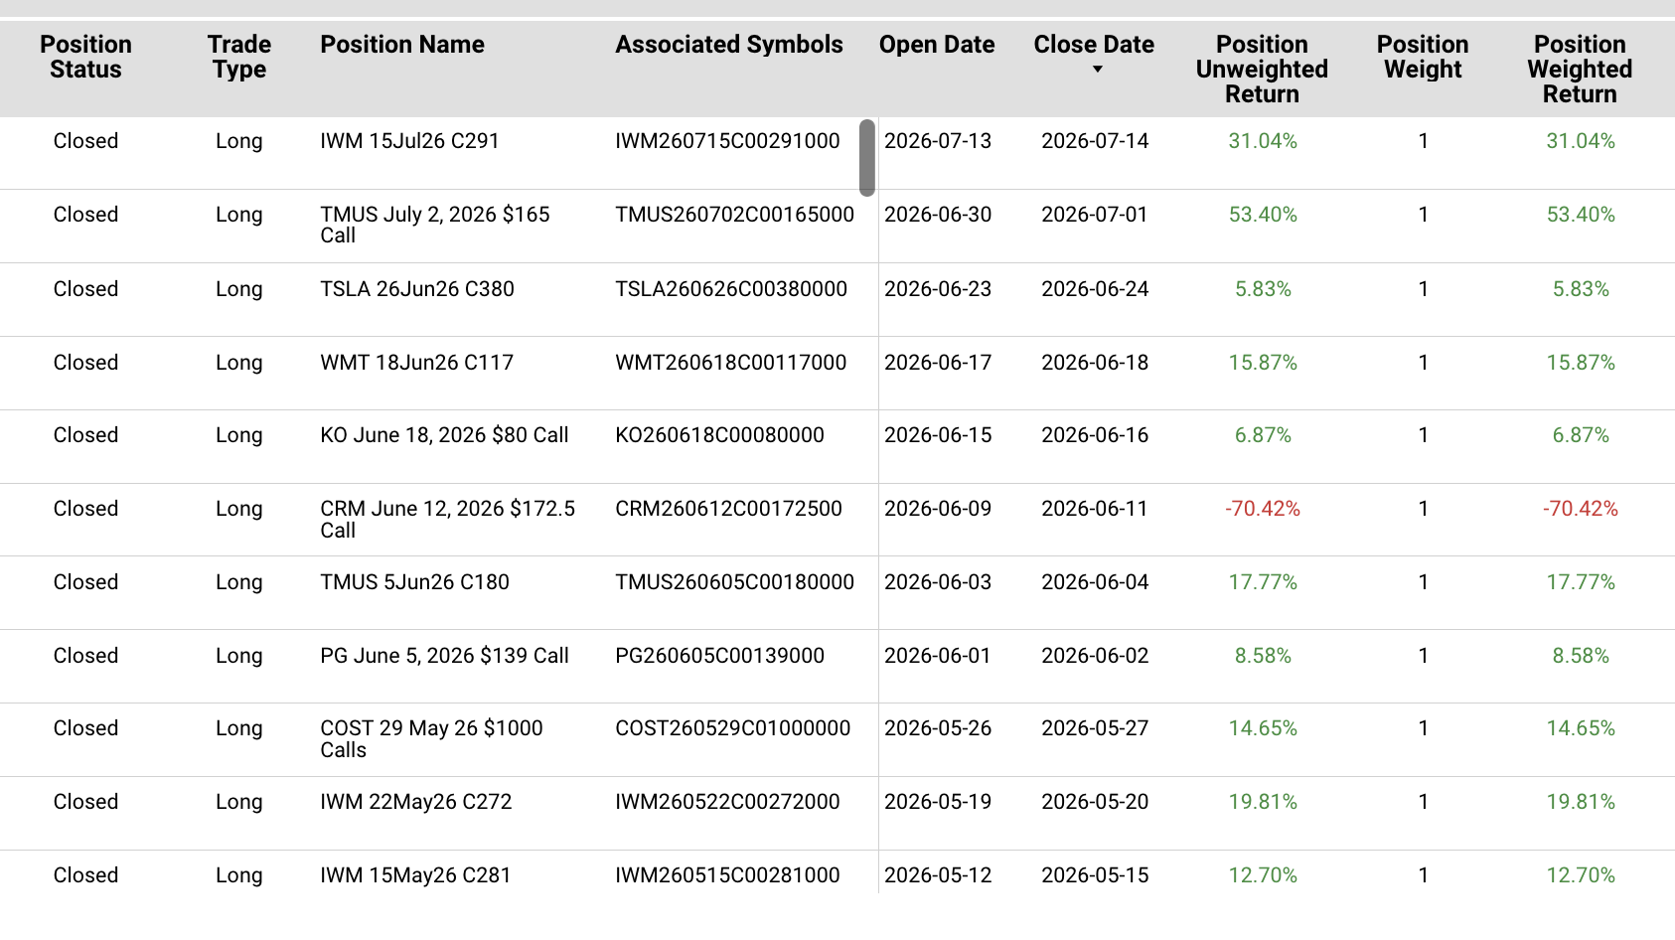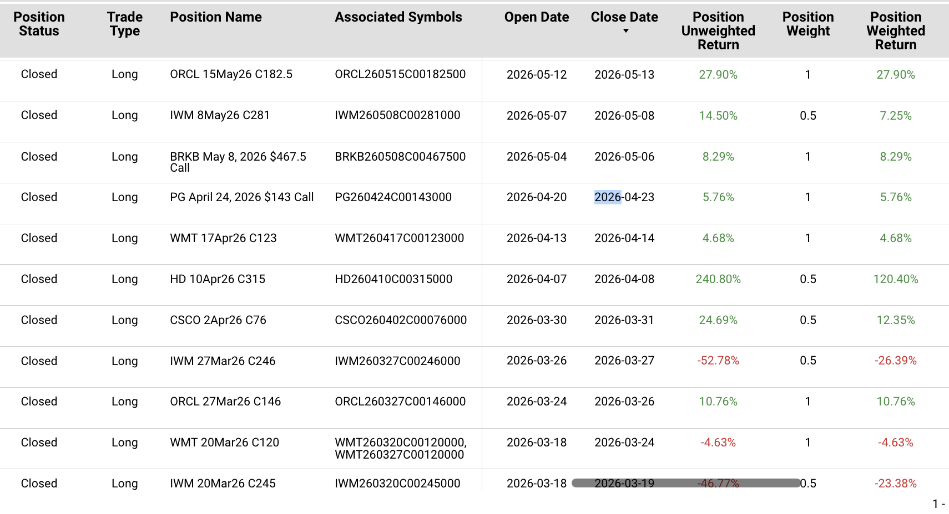
But what makes this strategy stand apart from everything else is that
it involves one corner of the market that most people completely ignore: THE NIGHT.
For years, Wall Street, the mainstream media, heck, even the government have misled the public into believing that you can only make money in the markets from 9:30am to 4pm.
They’ve managed to drill the same lie into everyone’s head…
That once the closing bell rings at 4pm, the action stops.
But that couldn't be more wrong. Because even though stock prices freeze and America’s financial system appears to go dark:
- The news doesn’t stop.
- The rumors don’t stop
- The viral catalysts that move shares, they don’t stop either.
In short, everything that drives up a stock…
It keeps going after 4pm, throughout the night, giving everyday people an opportunity to sometimes double or even triple their money while most everyone else is sleeping. 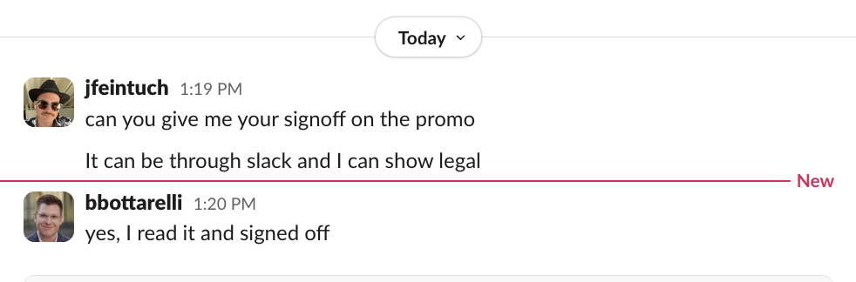
And this isn't a theory. It's one of the most documented patterns in the market.
As Liz Ann Sonders, Chief Investment Strategist at Charles Schwab, says:
“Over the history of the SPY (going back to 1993), nearly all gains have been outside regular hours.”
And she’s 100% right.
A New York Times study taken from 1993 to 2018 shows that nearly all of the S&Ps returns happened between 4pm and 9:30am.
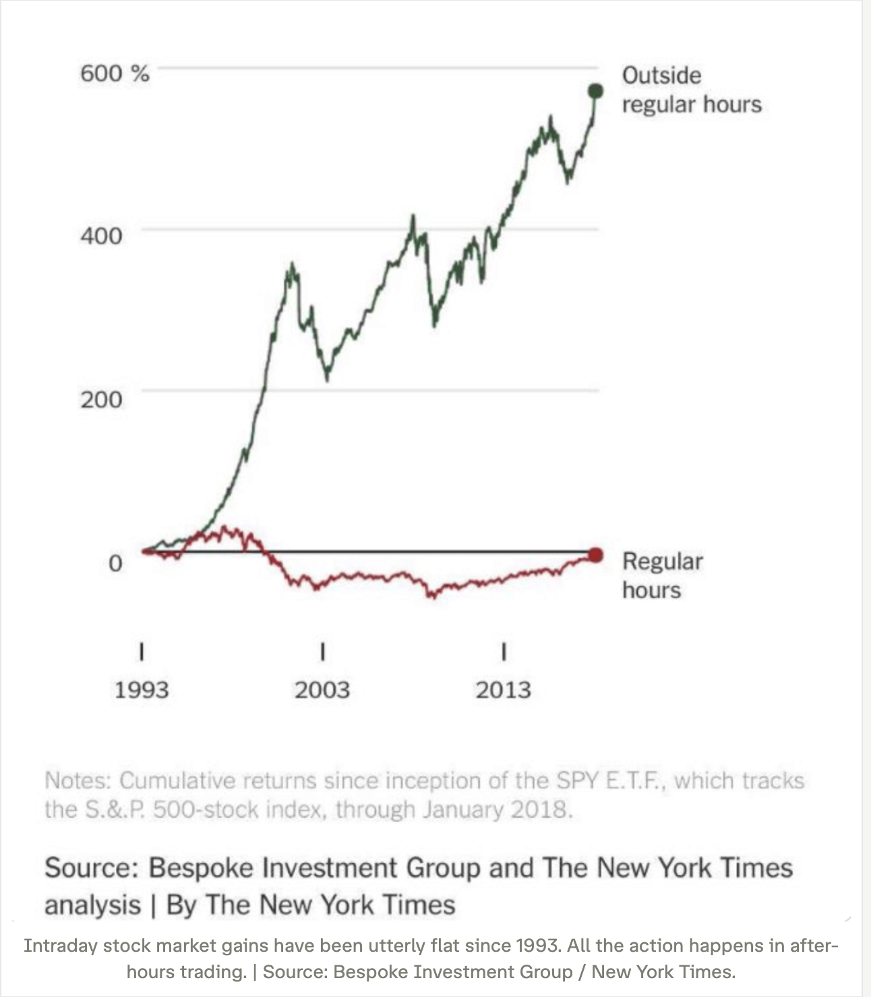
This is why I’ve spent 10 years of my life building financial models around these dark hours. I even ran a research service devoted to it, called "the Night Trader.”
And to this day, I use that edge to put my money to work while the rest of the market sleeps.
Over the last year I made almost $200,000 in profit on just seven of my trades, from a starting stake of $56,212

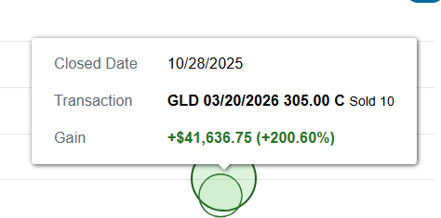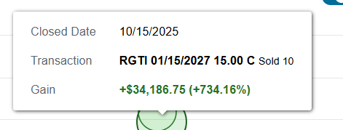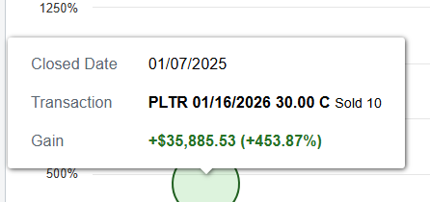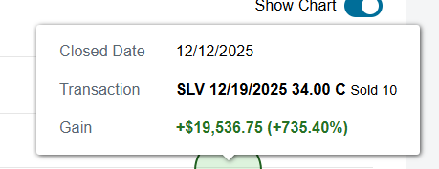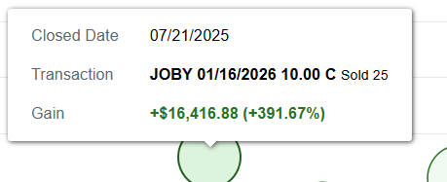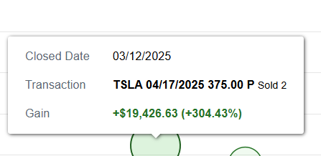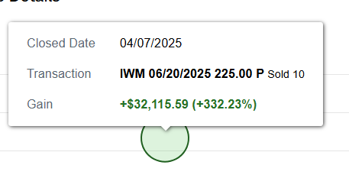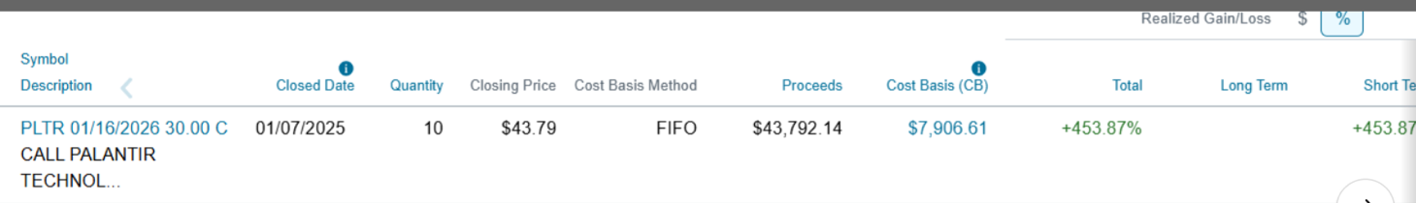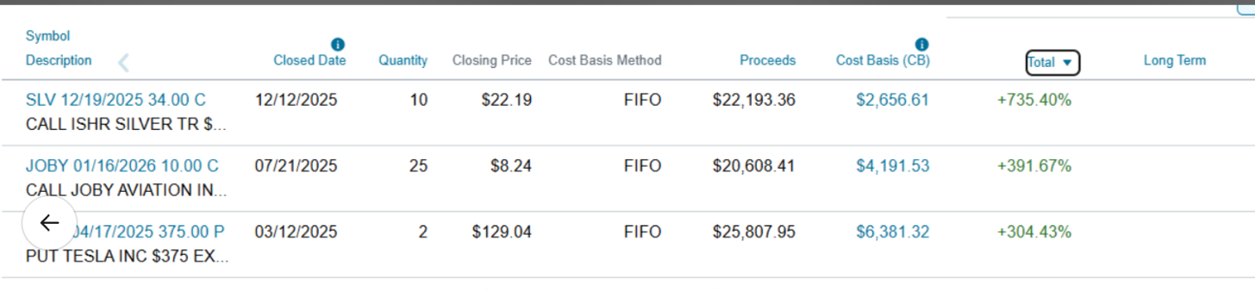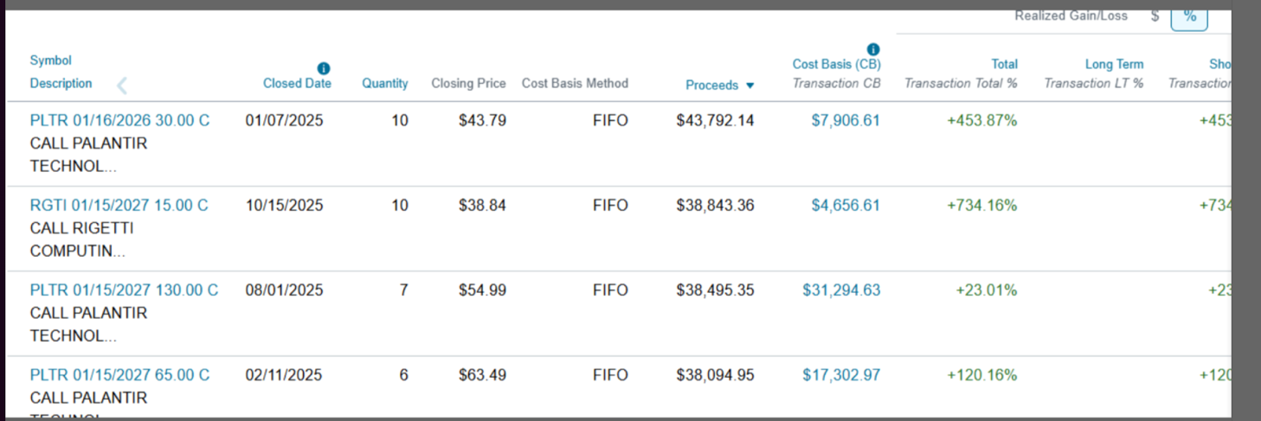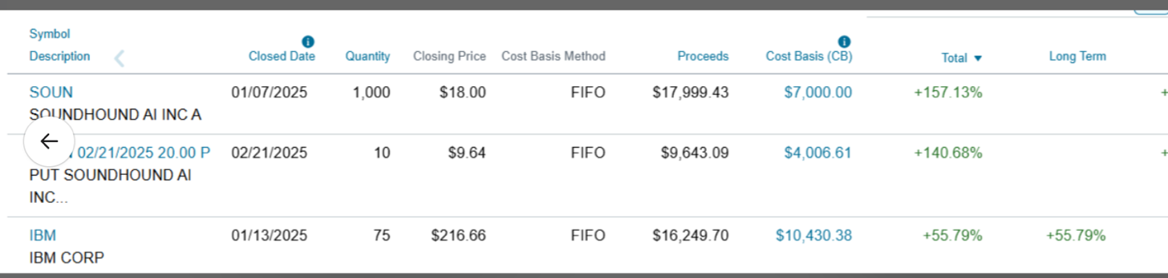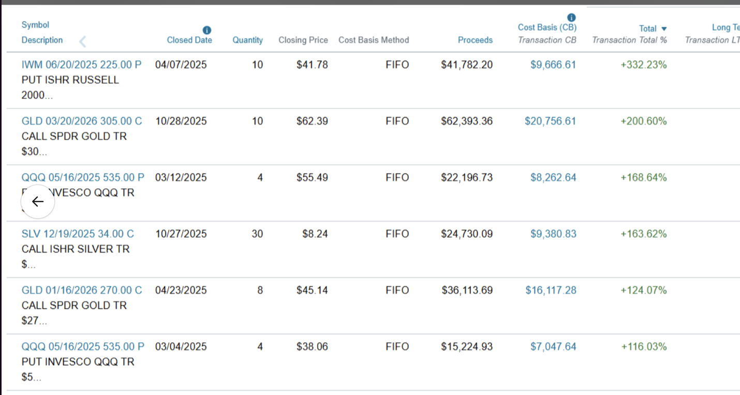
These were some of my biggest wins. Some trades I held for weeks, some longer, swinging for the big moves. That's how I've always traded.
So when I tell you that I’ve found something faster…
Something that plays out overnight instead of over months, I don’t say that lightly.
But that's exactly what I found.
A proven “night trading” system that has delivered massive overnight wins of up to $6,860, $7,710 and $10,220, starting with just $3,000.
And like I said before:
This system has an 80%-win rate so far this year, with an average return of 16% per trade. Over the last four months it’s done even better than that.
94% win rate; 25% average per trade
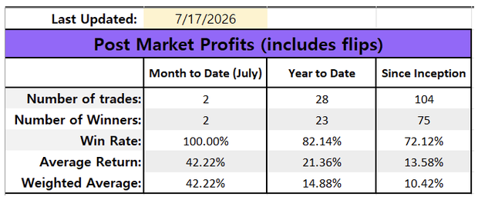
But the numbers are only half the story. The other half is who's behind those numbers.
His name is Bryan Bottarelli and he’s a former CBOE trader.
Since 2023, from his home in the Montana mountains, Bryan has issued 106 overnight trade recommendations, the vast majority following the exact same pattern::
- At 4pm, after the market closes, he has a 15-minute window to identify the trade on a single ticker and sent it out.
Once the alert goes out, his night’s over. He’s a free man… and he goes to bed.
- By the next morning, after the 9:30 open, the trade is closed. . No screens in between.
The trade begins when the market closes and ends when it opens back up again.
Every so often, a setup takes an extra day to play out, but the strategy is the same: get in at the close, let the overnight move do the work, get out at the open.
Bryan calls it a “moonlight trade.” And there's a reason for that, one that's almost too perfect. I'll show you why in a second.
For now, here's the detail you couldn't invent if you tried: the name of the little mountain community Bryan lives in is called Moonlight Basin.
The man is literally moonlighting... from a place called Moonlight.
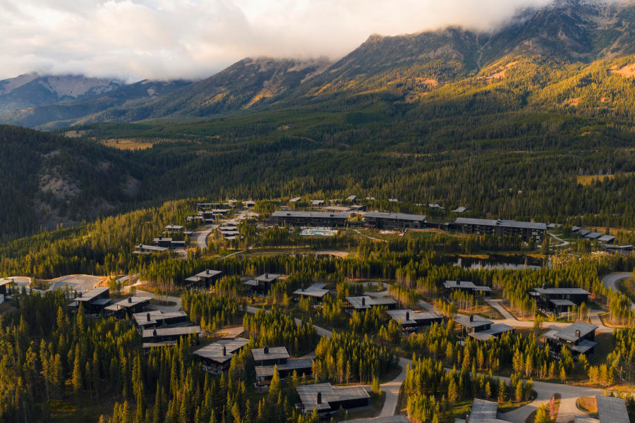
When Bryan first told me how much success he was having with these trades…
I did what any responsible auditor would 802 and asked him for the ledger. I had to know if this was real, or another “miracle strategy” that didn’t live up to the hype.
He sent me every trade without hesitation.
That’s when I began my official “audit.”
(scroll the list; show all columns)
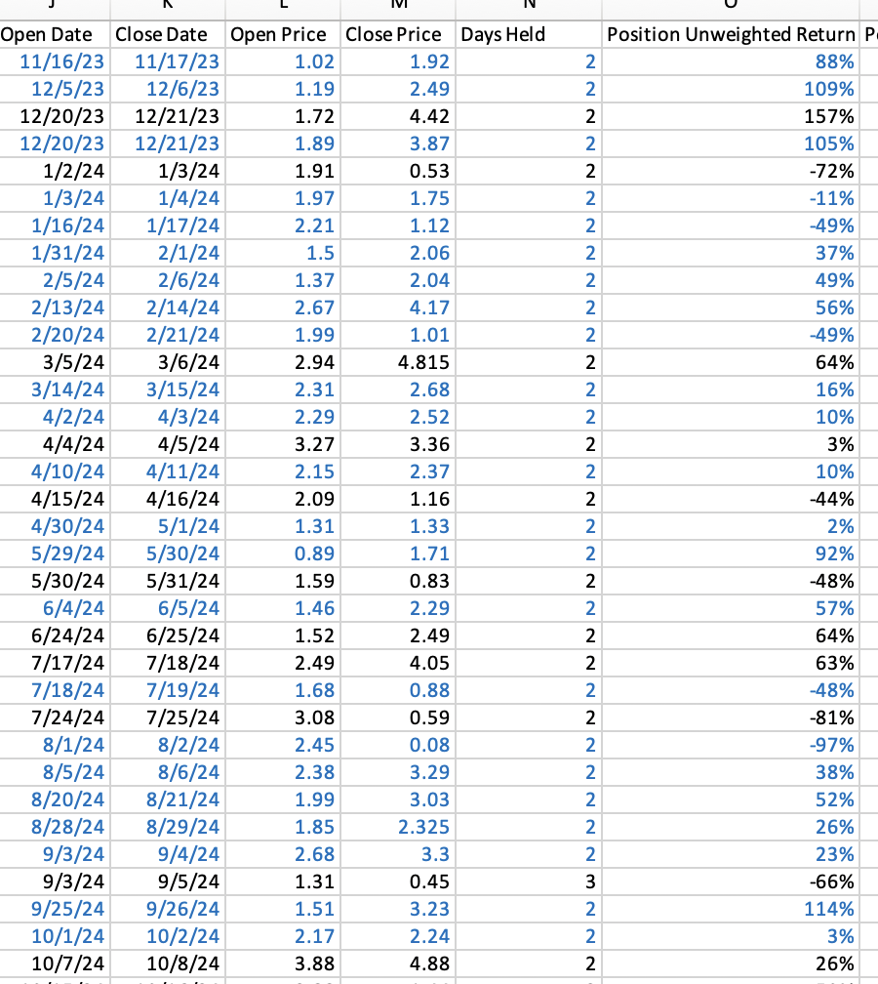
I analyzed every line of the spreadsheet, looking for potholes. I couldn't find one.
This is the entire ledger, 106 trades.

It is…. and I don't say this lightly… the single most impressive overnight strategy I have ever put under the microscope.

That’s why I went straight to the source.
I asked Bryan to walk me through how he does it.
I’ve spent 30 years taking apart strategies on paper. This time I wanted it explained, start to finish, by the only person who’s run it night after night.
Today, Bryan is going to take us through his moonlight strategy without holding anything back.
He’s going to reveal the one ticker that is behind the lion's share of his strategy’s success.

And why a recent move by the CBOE, on July 13, has made this strategy 20X times more powerful than it already is.
With that, I’d like to welcome in trading legend Bryan Bottarelli.
Bryan:
Chris, it’s great to be here…
You’re part of the reason why I got into this corner of the market in the first place.
In 2017, you put out one of the very first overnight strategies anyone had ever seen.
I studied it.
I memorized it.
I executed it.
More importantly, I learned from it.
I don’t know about you.
But what I love most about focusing on the night is that you're not worrying about the same day-to-day market noise as everyone else.
You put your trade on, you go to bed, and you sleep well.
As you just stated, this overnight strategy has an 80% win rate so far this year.
But over the last few months, it’s done even better.
17 of my last 18 trades have been wins, averaging 25% gains.
Imagine going to bed, knowing that when you wake up in the morning, you’ll have this high a chance of seeing a profit in your trading account.
That’s what I call a good night’s sleep.

CJ:

That’s the kind of sleep most traders only dream about.
But that’s the beauty of night trading isn’t it.
Daytraders live and die by the clock.
You don’t.
You’re not glued to a screen, watching candlesticks and chewing antacids at 2am.
You do your trade, spend the night doing whatever it is you enjoy doing, and go to bed.
Your money then goes to work while everyone else is asleep.
But the time you wake up, you’ve bypassed 10 hours of trading activity.
And given the results you’ve had since March 31…
A $1,000 position in each trade would have averaged about $250 a trade.
$2,000 in the trade, about $500.
$3,00 in, about $750.
$5,000 in, about $1,250.

I can’t think of anyone in our industry with a stronger ledger than this.

So Bryan, without wasting another moment…
Walk me through what a typical night actually looks like.
How does it work?
Bryan:
At 4pm, when the market goes dark, I have 15-minutes to place my trade.
Whatever device I’m closest to is the one I’m entering that trade on.
Once the trade is in, I turn off all screens. Play pickleball. Read. Go to Dinner. Hang out with my kids. Then, I go to bed.
(use b-roll and pics)
The minute the market opens at 9:30am I exit my position.
That’s why every morning I feel like a kid on Christmas Day … creeping down the stairs to see how big the present under the tree is. Or whether I got anything at all.
Some nights I end up making over $2,000. Some nights more.
CJ:
That’s the part people are going to have a hard time understanding.
You’re in this trade from 4pm, when the market goes to dark…
To 9:30am the next day, when it opens back.
That’s an 18-hour period where stock prices are frozen on our trading apps.
But as you and I know, that doesn’t mean they’re frozen in the rest of the world.
- Companies report earnings after the closing bell.
- Critical news breaks at midnight.
- And around 4 billion people live across Asia and Europe trade where the markets are wide open and moving while we sleep.
So all night long, the real value of stocks and ETFs is shifting.
You just can't see it yet.
But then the next morning, the market reopens, and boom, all that activity that happened while you were sleeping…
It impacts pricing almost immediately.
Bryan:
That’s what makes getting up in the morning so fun and exciting.
Even on days when I wake up aching from playing hours of pickleball the night before…
I still can’t wait to check my phone and see how the night’s setups played out.
Will I be looking at a
n 53% overnight gain like I saw on July 1
Or a 16% overnight gain like I saw on June 24.
This is the big secret nobody talks about.
And they don’t talk about it because they don’t know about it.
CJ:
Well, let’s be real…
Most people are on autopilot.
They buy and sell during the day alongside everybody else, because that's what they've always been told to do.

What they don't realize is that the market's biggest gains don't happen when the sun's up and the whole world is watching.

They happen at night, when the screens go dark and almost nobody's paying attention

Ever heard of
Bruce Knuteson? Former physics professor at MIT.
Bryan:
Never heard of him.
CJ:
He spent years working as a quant trade for D.E. Shaw one of the top hedge funds on Wall Street. He’s one of the only researchers I know of who has picked up on this pattern.
In his words:
The world’s stock markets display a stunning pattern of overnight and intraday returns but many of the people you reasonably rely on to bring such an issue to your attention – financial regulators, journalists, and academic economists – they choose to not tell you.
He’s 1,000% right.
People assume that after 4pm, nothing happens because they’ve never been told otherwise.
But in reality, that’s when everything happens.
It’s not just people like us saying that.
There is a ton of data to support it.
According to a study by Mr. Knuteson…
If two investors put $100 into the Nasdaq back in 1990.
Investor A got to keep the daytime gains, open to close.
Investor B got to keep the overnight gains, close to the next open.
By 2021…
Investor A, the daytime investor, would have been down -30%.
His $100 would have shrunk to about $70.
Investor B, who owned only the overnight hours.. he would have captured essentially all of the market's gains over those three decades. About 4,500%.
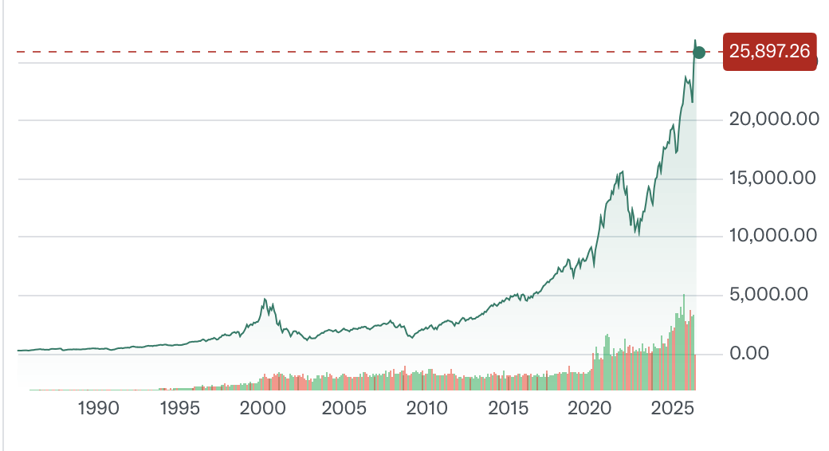
And it's not just the index.
That same research looked at the nine largest companies in America. For eight of them, nearly all the gains came overnight. Take Tesla. Over one recent stretch, Tesla returned more than 21,000% overnight, while its daytime return was negative.
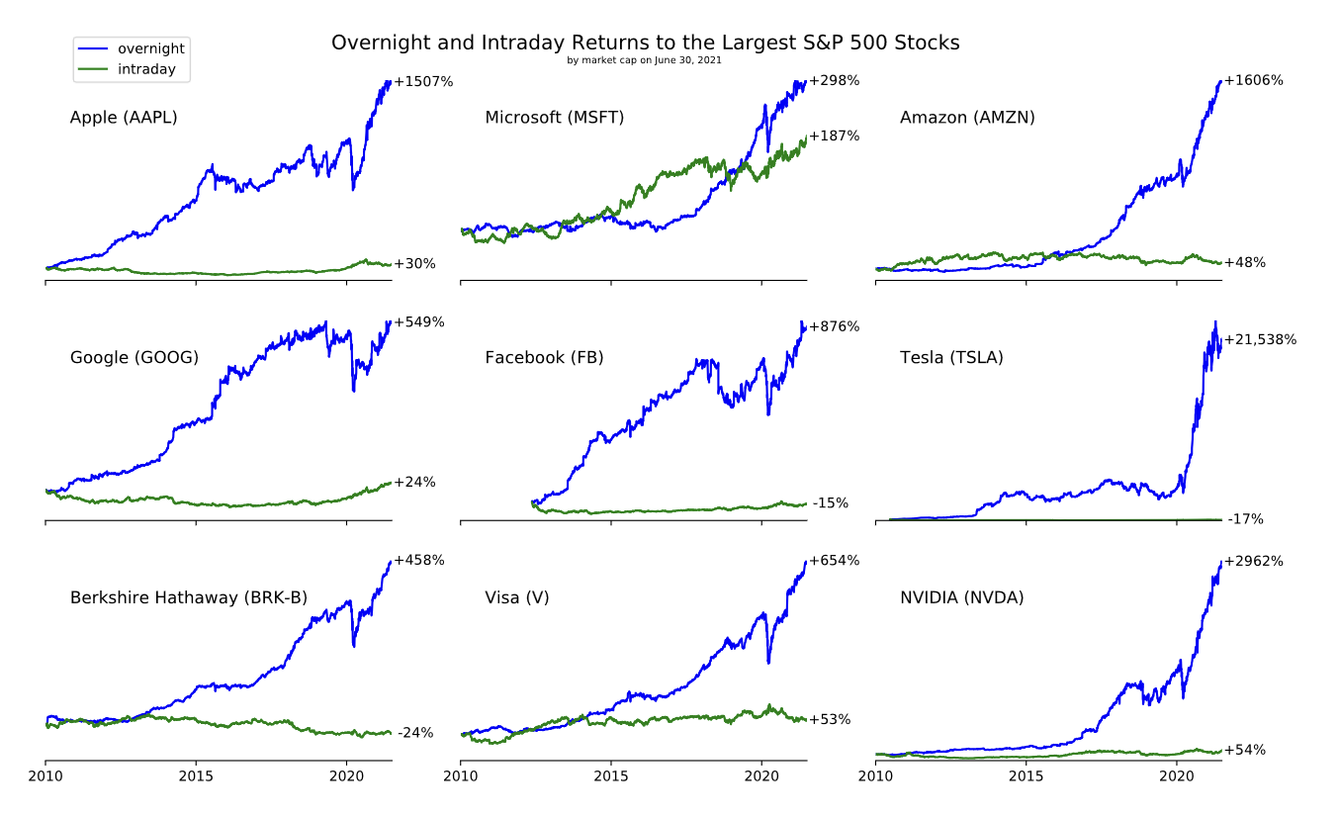
Bryan:
Chris,

you’re preaching to the choir.
That gap between last night's close and this morning's open, that's the move.
That's where money changes hands. The daytime, when everyone's glued to their screens? That's mostly just noise, people reacting to a move that’s already happened in the dark.
One of the world’s most respected research repositories, SSRN, actually calls this overnight effect: “The Grandmother of all market anomalies.”
In it, three researchers looked at the returns of AMC Entertainment.
A day-trader who bought AMC stock at 9:30am and sold it at 4pm every day from early 2019 to late May 2022 would have lost 99.6% of their investment.
But an investor who held the stock overnight would have made about 30,000% over the same period. Same story with Gamestop, Tesla, and Beyond Meat…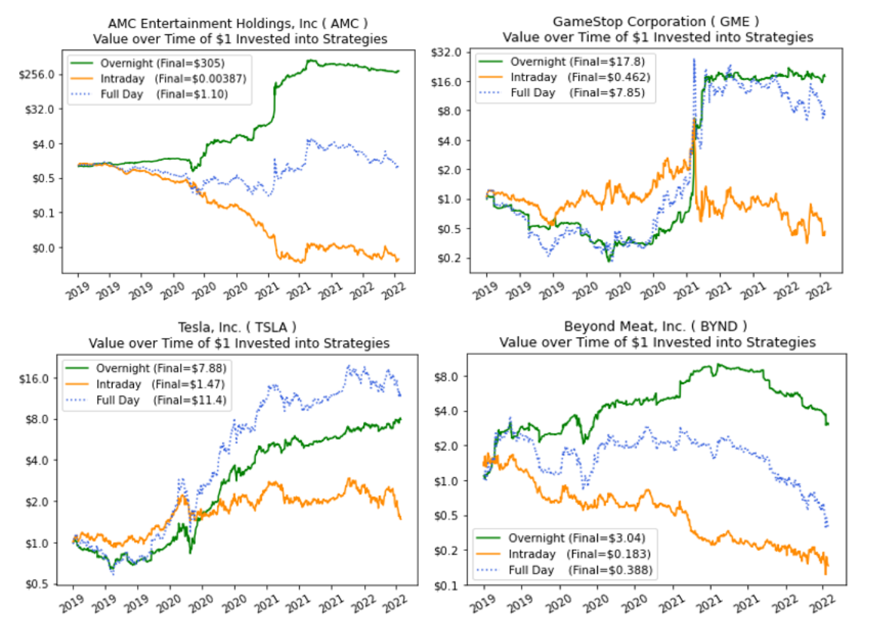
Even non-stock investments like the Grayscale Bitcoin Trust and the Ark Innovation ETF run by Cathie Wood, saw almost all of their gains occur at night.
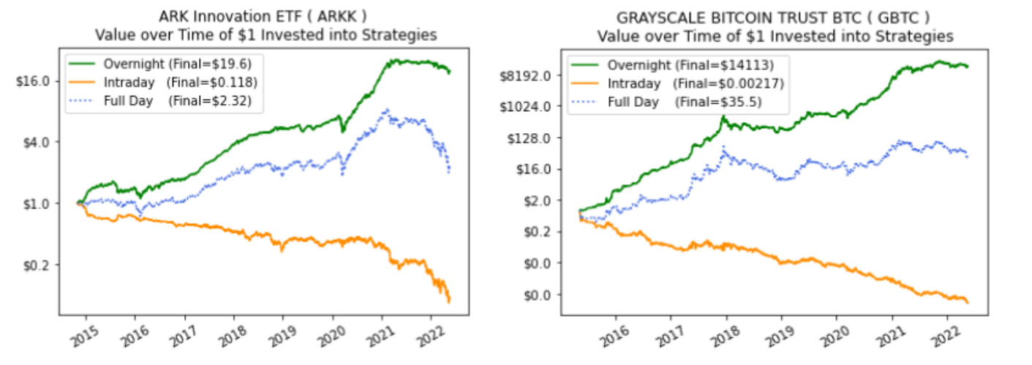
And the word’s starting to get out.
Bryan:
That's exactly it, Chris. We're no longer the only ones who've taken notice. Yes, I've won 94% of my trades since March 31.
But I also have 5,326 people following me as of this very moment. 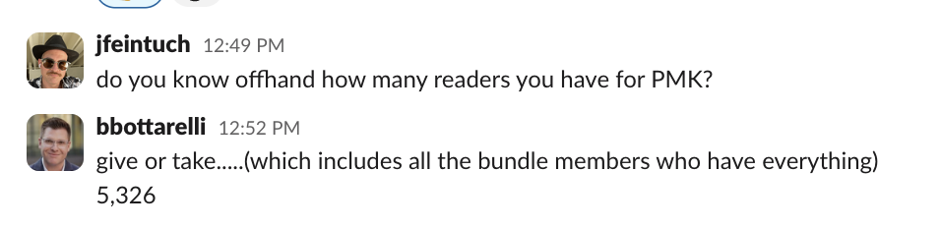
All of them understand that the real money is made overnight, not during the trading day.
And many of them are executing these moonlight trades right alongside me.

Jerry is one of them. He made $20,000 in one night, on one trade, with a $13k starting stake. 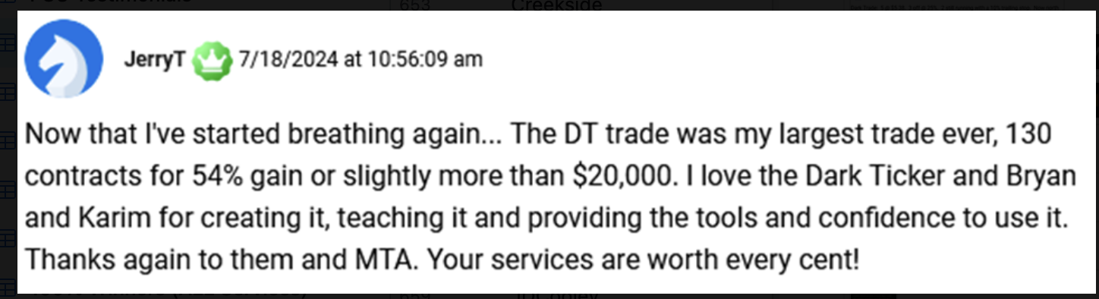
Zack H. tells me he made 680% on one trade, in one night. I don’t know what he put into trade. But even if it was just $3,000, we’re talking about a $20,000 profit overnight.
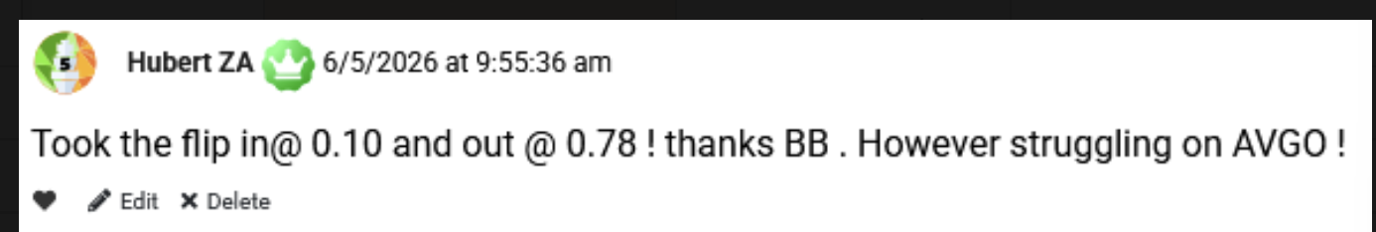
And listen to this…
A guy named John A. ran two moonlight trades in a single month and cleared nearly half a million dollars across 4 accounts, starting with $317,000across all 4. He also tells me he has made money in all of his trades over nine months. John, if you're watching, I'm happy for you, but ease up on the position size before you give me a heart attack.
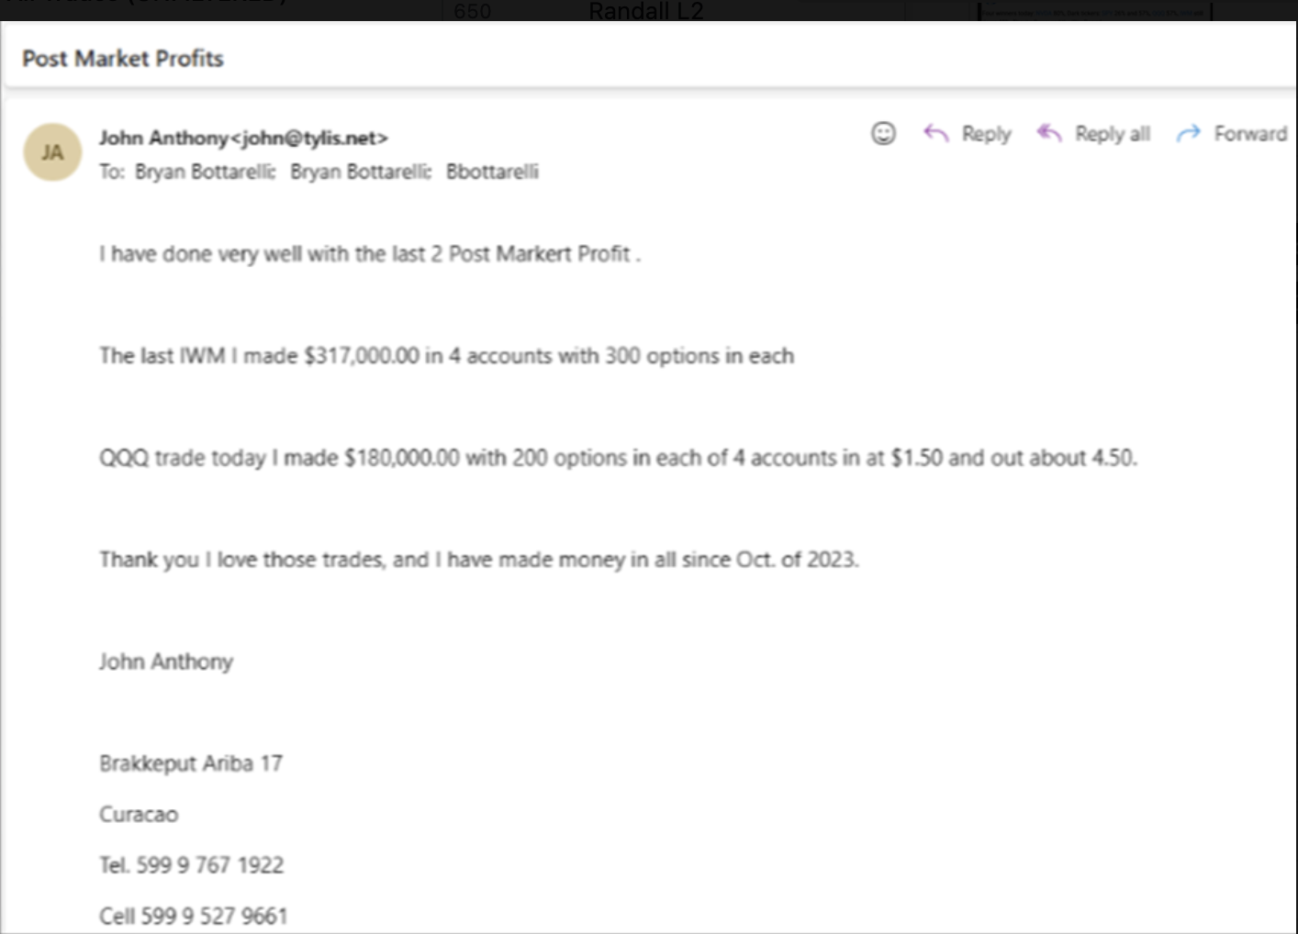
CJ:
Wow, that’s nearly half a million dollars of extra money in his portfolio… all by making this simple 15-minute trade… with a one-day turnaround.
Well, it’s not even a one-day turnaround. It’s an 18-hour stretch, and you’re asleep for most of it.
That’s the real story here.
It’s not about how much money you put into these trades.
It’s how little work you have to do to.
The
time commitment is almost nothing.
At 4:00pm, you enter the trade. The next morning, you're out of it. A quick flip.
So if you don’t mind, explain to our audience what you’re doing to
capture all the overnight action that gets baked into a stock so that when the market opens at 9:30 the next day…
You're not just out of the trade… you’re out with an average gain of 16%.
Or if we’re going by the last 18 trades you’ve made since March 31..
An average gain of 25%.
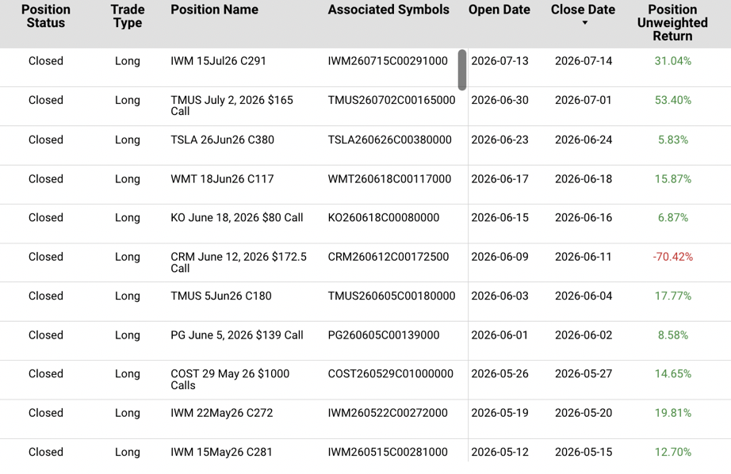
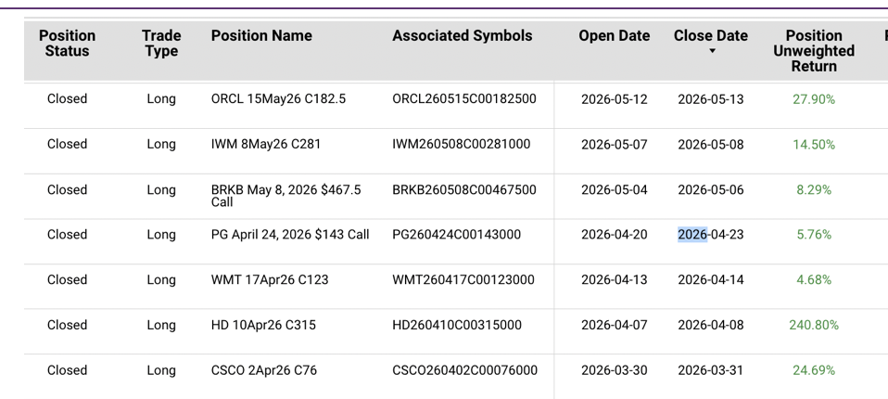
Bryan:
As you and I know, whenever a stock or ETF has a really bad day, and its price gets hammered…

What tends to happen next… it recovers, right?

Well, most people don’t realize just how fast this recovery happens so they completely miss out on this incredible opportunity to exponentially grow their wealth overnight.

We know it’s a proven fact that stocks make their biggest moves at night.

What’s also true is that these moves tend to be price rebounds.

After a sharp-one day drop, the market has a strong tendency to bounce back the very next day.

That’s not a figure of speech.

OptionAlpha analyzed 324 stocks from March 2002 to March 2022. In that study, they found that if a stock fell anywhere from 0.1 to 0.5%. In a single day…

There was a 92% chance the loss was recovered the following day.

On bigger drops between 0.5% to 1%, there was a 78% chance of recovery the next day.

But our team went back even further than that.
We analyzed 10 years of data going back to 2015. What we found wasn’t just a pattern, it was a hardwired response. Something the market does almost automatically:
- Anytime the S&P was down more than -1% in a day...
It went higher the next day, 88% of the time.

- When it experienced a -2% drop...
It closed higher the next day, 89% of the time.

- When it had a 5% drop, which only occurred 21 times:
It closed higher the next day, 100% of the time.

Of course, this hardwired response that I’m describing… where stocks almost instinctively bounce back from a sell-off
It doesn’t guarantee a winning trade. Nothing does. Past results do not promise future ones. Trading is a risky endeavor and you only risk what you can afford to lose.

But it does show that the market is like a rubber band. After you stretch it out, it returns to its original shape. The more you stretch it, the faster it snaps back.

CJ:

That behavior.
That elasticity.

It is an absolute godsend for night traders like us.
Because we know that an intense sell-off will typically lead to an intense rebound and that rebound tends to happen overnight.
But to actually capture that move, and make real money from it, we can’t just buy a beaten-down stock and sell it the next day.

The moves just aren’t big enough.

Sometimes it takes a few days or a few weeks for a stock to fully recover.

That’s why we use options.

Options give us extreme leverage on a company’s share price, which means a small move in the stock can turn into a much bigger move for us. And in a fraction of the time.

I don't trade the same instrument you do where you’re in and out overnight.

I use long-dated options that I hold for weeks, sometimes months. But the underlying idea is the same: use leverage so a move in the stock becomes a multiple of that move for us.

Last year, a company called Joby Aviation doubled in price. But through options I made 391% in a fraction of the time.

Same with Rigetti Computing.

The stock almost doubled, but I made 734%, 7X what the shareholders made.

Bryan:

Chris, as traders, that’s all we’re trying to do…

Amplify the move.

As we both know, the regular market is closed after 4PM...

That’s why I focus exclusively on one type of trade, one deliberately designed to capture the overnight move, the gap between the close and the next open, before anyone else can trade it.

So that when the opening bell rings and the stock rebounds, I can cash out almost immediately.
Let me give you an example.

On April 7th, Home Depot fell by -2.4% The stock closed at $316.40.

This didn’t happen because of earnings or anything to do with the company itself…

Home Depot is making more money than it ever has.

Last year it made $164.7 billion.
This year, it’s set to make $171 billion.

But because of mortgage rates, fewer home sales, and a bearish outlook on the home improvement sector…

Home Depot (-2.4%) took a beating that day, along with Lowe’s (-1.5%) and Tractor Supply (-2%)
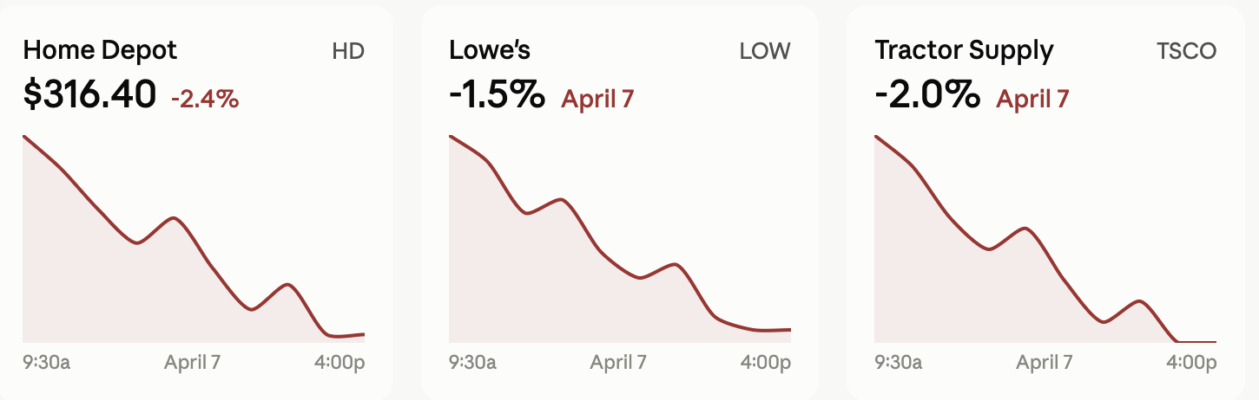
But I knew, based on decades of studies and my own statistical research, that the pros would spot this price gap and close it immediately.

That Home Depot would very likely rebound the next day.

So at 4pm, I placed a moonlight trade on the stock.

The next day, at 9:30am, the stock bounced $18.

This happened because during the night, all the big money algos picked up on the sell-off.

Institutions around the world instantly knew that Home Depot falling by -2.4% in a single day was an overreaction.

That’s why by the time the market opened, the stock was $333.26 – a 5% move overnight.

But through my moonlight trade, I made 241% overnight.

That’s almost 50X better than the shareholders did.

And if you can believe it, some of my readers did even better than that:
Jake made 280% on this same Home Depot trade.
LMman said he made 300% on Home Depot, and 236% on Delta, saying it was his "best morning ever."
MichaelJay reported making 340% on Home Depot.
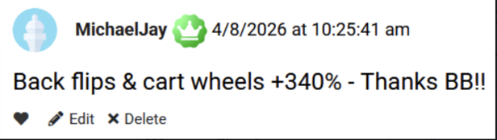
And then there was Mickey W.
He made 896% on Home Depot. Plus 120% on Applied Digital. All before lunch.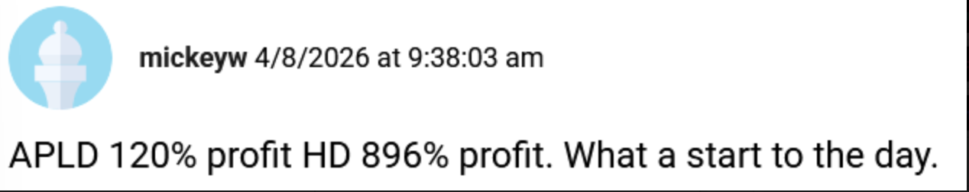
CJ:
As you know Bryan, I’m a skeptical person.
That’s why I wanted to see all of your trades - all of them.
Yes, you’ve taken losses like any trader.
But your wins have outnumbered your losses by 4 to 1 over the last few years.
109% in one night…
114% in one night…

157% in one night…
Once again, 80% of your trades this year have been winners.
In the last few months that number has become even higher.

I know I keep saying that but it’s something worth repeating.
I’ve audited dozens of trading systems but none have ever come close to this.
But going back to the option itself…
You keep calling it a specialized option, but you've never told anyone exactly what it is. What makes it so different?"
Bryan:
The option I use is built for speed.
But what’s interesting is that for decades it
only expired 12 times a year.
They were primarily the domain of professionals.
Now?
Anyone with a brokerage account can use them.
You can even do this in your IRA.
Not once a month, but every single day.
And this is happening right alongside a boom in night trading the likes of which we’ve never seen. In a single quarter last year, more than two billion shares changed hands outside regular market hours.
The night market is exploding, and this specialized option is driving that growth.
That's how I've won 80% of my trades this year. And 94% of my last 18 trades.
I’m using the only option powerful enough to catch an overnight move.
CJ:
That’s what overnight trading is all about.
It’s not about how big any single gain is. It’s how fast and consistent those gains are.
Even a modest night stacks up fast when you’re doing it over and over.
Bryan:
Y

es I have nights where my returns are smaller, or even negative.
But that’s OK because I’m focused on winning more than I am on taking big risks.
Look at what happened in June of this year… 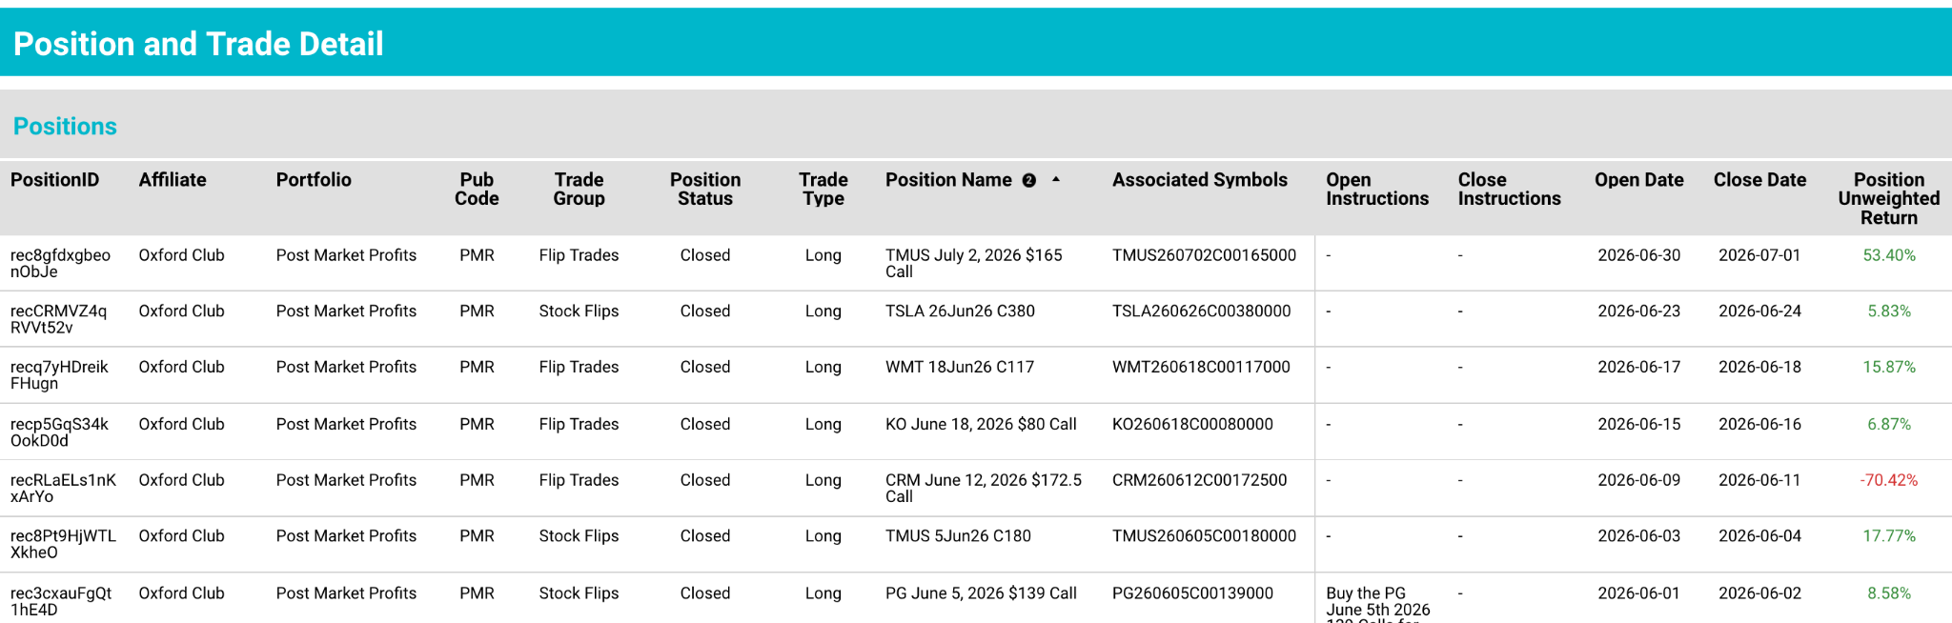
On June 1, Procter & Gamble dropped -0.9%. At 4pm, I did my overnight trade. Next morning, the stock is up 0.45%. A few minutes after the opening I exit my position for a small 9% win.
That’s nothing to run laps for…
But it’s still a 9% return overnight. It's still a win.
Two days later, on June 3. T-Mobile drops -3%. I do the overnight trade at 4pm. Bed. Sleep. Wake up the next morning and close it out for an 18% win.
That’s more my style.
Six days later on June 9. CRM plummets -4%. I execute my overnight trade. But the next day, the stock did not rebound as expected. I lost the trade.
It doesn’t happen too often. But it happens because no strategy – whether it’s a monthly, weekly or overnight strategy – is bulletproof.
Moving on…
June 15. Coca-Cola sinks 2.07%. The overnight trade is executed. Next day, the stock fell another 0.8% but I still made almost 7% on my trade.
We’re now on June 17. That day, Wal-Mart fell -2.4%. I did the overnight trade. Went to bed. Woke up and exited my position at 9:30am for a quick 17%.
On June 23, Tesla dropped -3.8%. I did the trade at 4pm. Then, at 9:30am the next day I closed my position for a 6% win.
On June 30. T-Mobile fell -3.6%. It ended the day at $167 a share.
But that night, the pros spotted the sell-off.
Their algos picked up on it.
By morning, shares were $175. The stock went up 3.2% and my overnight trade produced 53%.

CJ:
You know Bryan…
Those numbers may not impress someone who’s been promised the moon by every guru and thinks they’re next trade is coming with a private island and a helicopter to get them there.
But for gains that were earned overnight, you really can’t complain.
When you gave me access to your portal to verify all this, I spent just as much time reading your fan mail as I did looking for potholes in the system itself.
I couldn’t believe how many messages there were.
855 of them.
And when I read through them, it wasn’t what I expected I can tell you that:

In February, a guy named Ben F. posted on your portal that he made 300% overnight on one trade.
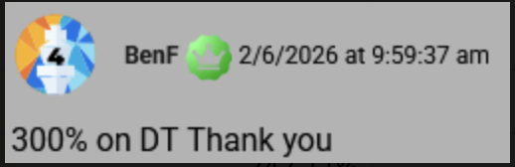
In March, Dave G.said he made 377% overnight on one trade.
In June, Nina said she made 230% overnight. 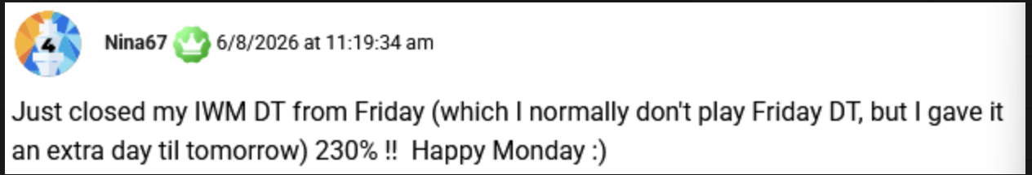
I know these are standout results.
Your average trade is clocking in at 16% so far this year.
But still…
For overnight gains, that’s a number I would put up against any trader I know.
Bryan:
And Chris, it’s about to get EVEN BIGGER.
Because I believe one major event that just hit the market will take our profits to the next level.
Not just our profits but the sheer number of opportunities available for us.
On July 13, the SEC approved after-hours trading on 20 of the BEST stocks in the market including Nvidia, Palantir, AMD, Microsoft, Oracle, Amazon, Tesla, and Apple.
Which means regular people can now trade these stocks in the exact same 4pm window I’ve been using since 2023.
The same 15-minute window that's given me 16% average overnight returns so far this year.
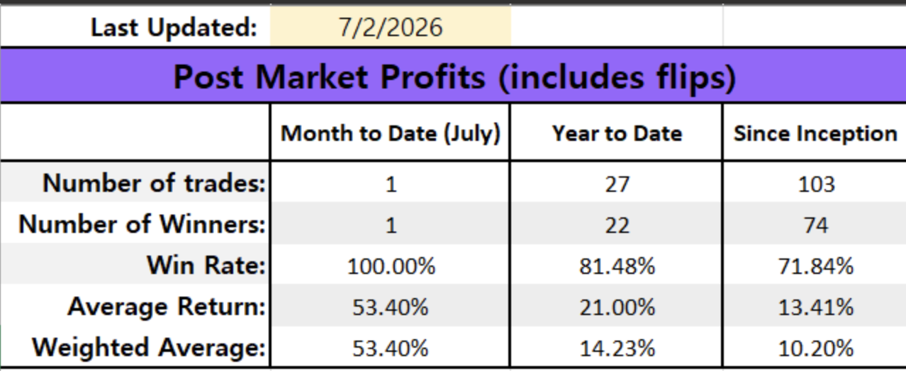
People have absolutely no idea what this is about to unleash.
These aren't a random assortment of companies.
They're globally recognized brands, the most actively traded companies in the world. Investors in Asia and Europe want to trade these U.S. giants during their own business hours.
So the exchanges started with the 20 names the whole world already wants to trade.
For us, that's better than perfect. Every one of these bad boys is a high-quality, heavily-traded stock, exactly the kind of name that snaps back after an overreaction.
Sure you could buy all of these stocks and have them sitting in your portfolio. At an average price of $290, you’re probably looking at a $200,000 portfolio.
AAPL — $305.56
AMD — $517.58
AMZN — $244.92
AVGO — $370.03
BABA — $98.96
BAC — $50
GOOG — $359.18
GOOGL — $358
HOOD — $120
INTC — $140.94
META — $588.66
MSFT — $388.52
MU — $1,058.48
NFLX — $74.19
NOK — $14.43
NVDA — $196.50
ORCL — $143.39
PFE — $24.29
PLTR — $190
TSLA — $397.43
TSM — $300
Once you’ve acquired shares you then have to follow the market every day…
Constantly worrying about whether the market's going to tank, a recession is going to hit, or whether some headline will wipe out all the gains you’ve accumulated over the last year.
CJ:
And let’s not forget just how stressful it is when you have a portfolio that you probably put a few hundred thousand dollars into…
That’s crawling along at a snail’s pace.
If that’s not the embodiment of stress, what is?

When you're invested in the market…
Everything that happens in the world affects your wealth.
When you’re an overnight trader.
You’re never invested in anything up front.
You're profiting off the wave that everyone else's money creates.
You're like a surfer as opposed to a passenger on someone else’s cruise ship.
You paddle out, catch the wave that the tide is already making, and head back to the beach before it ever turns on you. That's what traders like us do.
We're not holding the water. We're riding it, one night at a time.
Bryan:
And Chris, now that we can execute these overnight trades on 20 of the biggest stocks…
The market is basically saying “Hey, you don’t need to put tens of thousands, or hundreds of thousands of dollars into the market anymore.”
You can ride the market’s biggest waves, without ever stepping into the water.
You don’t need a big account either.
On average these contracts cost around $225.
.
And you’re not required to trade more than one contract at a time if you don’t want to.
CJ:
And you Bryan…
Because you’ve had a two and a half year headstart with these trades.
You’ve figured out the part nobody else has.
Which is that of all the tickers you can now trade during this 15-minute window, from 4pm to 4:15..
One ticker has done almost all the heavy lifting.
I noticed it the first day you sent me your ledger…
Almost every single one of your best trades has involved the same ticker…
The Russell 2000, traded through IWM, the ETF that tracks it.
Bryan:
It’s no secret…
The Russell 2000 is the only major index that’s made up of small U.S. companies.
And by small I mean tiny.
The typical Russell stock only has a $1 billion market cap.
The typical S&P stock has a $130 billion market cap. It’s like comparing a minnow to a whale.
CJ:
But that’s the edge isn’t it.
We’ve already touched on the fact that after a sell-off, stocks tend to rebound the next day.
But what we haven’t touched on is the fact this effect is strongest in small companies.
The smaller the stock, the harder it snaps back into place.
Once again, research backs this up.
In 1990, a researcher named Narasimhan Jegadeesh published a study in the Journal of Finance.
He looked at more than 50 years of market data and found that the most beaten-down stocks went on to outperform the market's high flyers by about 30% a year.
Month after month, the losers bounced.
Another study, also in the Journal of Finance, took it further and looked at where those reversals were strongest.
Not surprisingly, the stocks with the smallest market caps showed the largest rebounds.
In other words, the little guys snap back the hardest.
Bryan:
That’s because the big institutions that are moving billions of dollars around each day…
They can’t work small stocks. There’s just not enough liquidity.
They’d push the price against themselves before they ever filled the order.
But as they saying goes:
When the whales can’t fit in the pond, the rest of us eat better.
That’s why of the 106 moonlight trades I’ve recommended to my followers…
More than half of them were on the Russell 2000.
CJ:
And from all the comments I’ve read.
It seems like your readers are following your lead, night after night. Here’s a few comments from shall we say you’re most enthusiastic readers:

On January 14, a guy named Baron made a moonlight trade on the Russell 2000. Next morning, at 9:45am he posted this message on your portal saying he made a $6,300 profit. That’s with a starting stake of roughly $5,370.
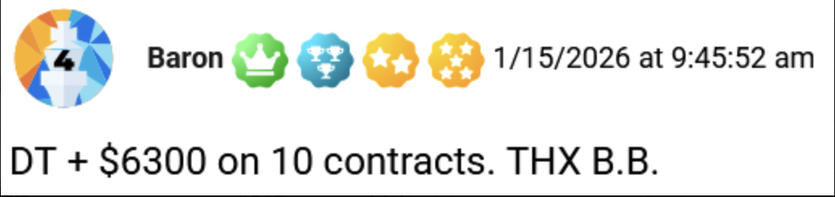
On February 5, DRH29 made a moonlight trade, also on the Russell 2000. Next morning at 9:41am, he exited the trade with a $8,300 profit on a starting stake of $4,980.
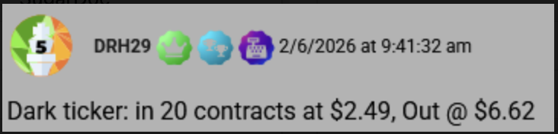
On June 18, JB69 executed a moonlight trades on the Russell. Next morning he cashed out with 188% gain. He posted this message at 10:08am.
Bryan:

I think we’re going to see a lot more stories like these coming down the pike.
Because right now, the conditions these trades thrive on are everywhere.
Political division… economic uncertainty… technological upheaval…war… conflict…
We’ve got all of it, all at once.
That kind of uncertainty is what moves markets.
And now… with 20 MORE tickers to trade… with the highest quality stocks in the market… OUR PROFITS COULD BE OUT OF THIS WORLD!!!!
This is no longer a fringe idea…
The industry itself is calling 2026 the year that the overnight market arrives.
And the numbers back it up.
Extended-hours trading has more than doubled in the last five years. 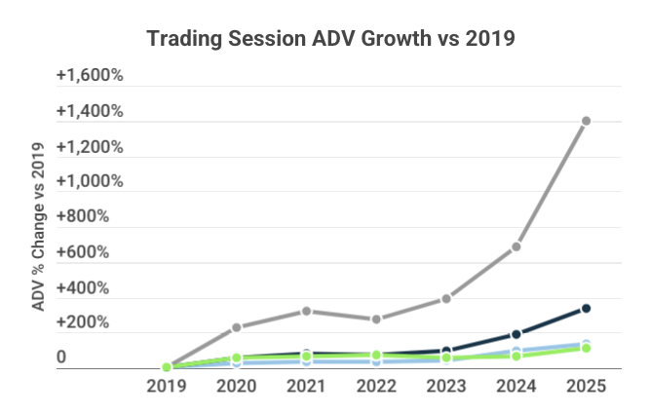
According to Ernst & Young, one of the biggest accounting firms in the country…
Within two years, up to 10% of all stock market volume will happen overnight.
Chris:
When I first started my run as the night trader…
Giving people trades to execute after 4pm was a fringe idea.
But that’s no longer the case.
Night trading… after hours trading… moonlight trading…
Anything that involves putting on positions after the market closes has gone from a niche curiosity to one of the fastest growing corners of the market.
The CBOE reported that after-hours volume hit record levels in early 2026, up 32% in a single year. The demand is exploding. That said, let's break down how this actually works, starting with the tool that makes it possible.
Bryan:
Sure, so the tool behind this 18% overnight move is the zero-day option, or 0DTE for short.
These are trades designed to pay off on the same day.
And they’ve quickly become the most popular tool in finance.
- In 2016, about 5% of all options volume on the S&P were zero-day trades.
- Today, it’s 60%.
In recent weeks it’s been even higher than that.
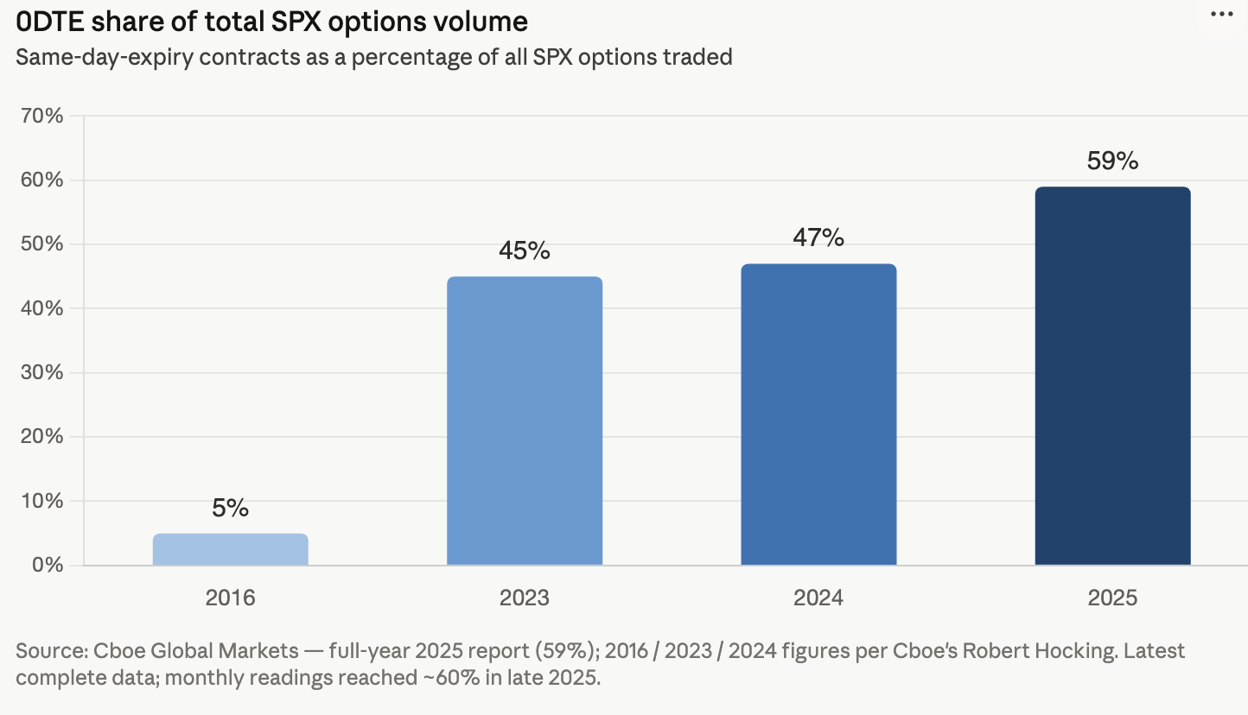
And the way a 0DTE trade works is very simple.
You get in, and by the time the market closes, you’re out.
Chris:
That’s true. But you Bryan, you’re doing something slightly different..
You’re buying the zero day option at 4pm, when the U.S. markets go dark, right?

Bryan:
Sort of. Let me be clear…
I’m getting into these trades right before the market closes…
So it’s not technically possible to use true zero day options.
That’s why I usually will buy the option expiration for the next day…
Or the next closest expiration.
And I will treat them as if they were 0DTE.

But as you know, I didn’t start doing these trades in 2026…
I’ve been doing them for the last three years…
Most have been executed on the Russell 2000.
Not just because it’s an index of 2,000 small stocks.
But because until recently…
You could only execute zero day trades on the major indices. The S&P, Nasdaq 100, Russell 2000, and the SPDR Gold ETF.
Either way, the pattern is the same.
- The market overreacts and sends a stock down…
- I buy the option at 4pm, betting the stock will rebound the next day 90% of the time it’s a zero-day option. Sometimes it’s a two to three-day option depending on the setup.
- Then, I let the overnight bounce play out
- The next morning, I sell when the stock corrects itself.
And because we’re in and out so quickly…
We can do this as often as we want.
- On November 16, 2023, the Russell fell -1.5%. At 4pm, I ran a zero day on the IWM. The next morning, the index recovered and I booked an 88% return.
- On December 5, 2023, the Russell dipped -0.77%. I did the same trade at 4pm. The next morning, the index recovered and I made 109%.
- On December 20, 2023, the Russell dropped -1.9%. This time I executed two trades. One on the IWM. The other, on the QQQ. Next morning I was out with 105% and 157%.
- On January 16, 2024, the Russell went down -1.2%. I did the zero day trade. Only this time, I wound up with a -49% loss because the rebound never happened.
- On January 31, 2024, the Russell went down -2.4%. I did the zero day trade. The Russell went up 1.3% the next day and I made 37%.
Chris, as you and I know…
No strategy is perfect…
I’ve had losses.
But not many. Not compared to every other strategy out there. Either way these options are subject to significant volatility. That’s the nature of an overnight trade like this.
They move lightning fast. And as with all options strategies, they aren’t for everyone.
CJ:
Here's the part that trips people up.
With almost every other strategy, all you want to see is good news.
An earnings beat. A buyout. An analyst upgrade. A Fed rate cut.
But with these moonlight trades..
All you’re waiting to see is a sell-off.
Like when Micron technology fell 13% on June 5.
Or when Roblox fell 18% in a single day back in May.
Usually these sell-offs are deserved.
Like when a company misses its earnings, does a massive layoff, or loses a contract bid.
But sometimes these dips happen for no good reason whatsoever.
And when they do..
The market will quickly correct itself. More often than not, the very next day.
And there is a mountain of research out there, going back decades, proving that this effect tends to be strongest in small-cap stocks.
One study out of the Journal of Finance found that the beaten-down stocks who bounced back the hardest were the small, thinly-traded ones…
The exact companies that fill the Russell 2000.
Bryan:
That’s why most of my moonlight trade recommendations are on this one ticker.
Instead of trading individual stocks.
We get to trade 2,000 of the best small caps at once.
On February 5, 2026, the Russell 2000 dropped -1.8%. The next day, the index bounced back 3.6% and my trade returned 129%.
$3,000 into the trade would have spit out $6,900 the next day.
That’s a $3,900 profit for one night’s worth of “work.”
Well, I can’t really call it work can I? It’s not like you’re filtering fryer oil in 5am like I used to do when I worked at McDonald’s.
You wait for the drop. Make the trade. Go to bed.

An active reader of mine that goes by DRH29 made 165% on this trade, turning almost $5,000 into $13,000.
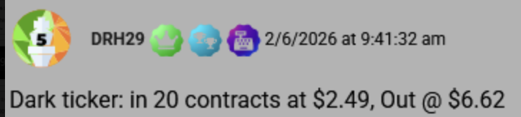
JBuchanan made 220%.
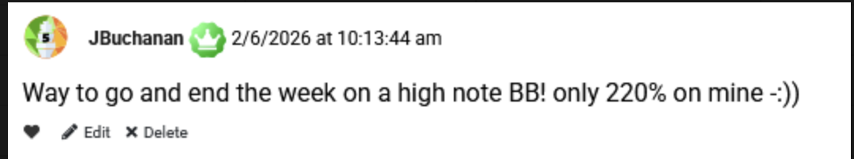
And Ben F. made 300%.
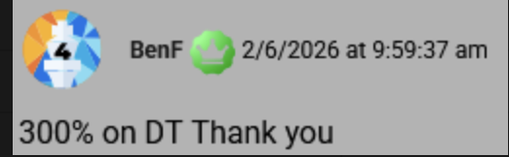
That was just one night.
Two weeks later on February 23, the Russell fell -1.6%. The next morning it bounced back 1.2%. Within minutes I recommended closing the trade for a quick 23%.
On March 3, the Russell dropped 1.79%. Next day, it recovered 1%.The 0DTE trade returned 44%.
The pattern is always the same. And sometimes I don’t even need the index to fully recover from its previous day's losses.
On March 12, the Russell dipped 2.1%. The next day it fell another -0.3%.
But the trade still turned 33% the next day.
CJ:
It’s unbelievable that you managed to make money even when the index only partially recovered.
That just shows you how great these 0DTE options really are.

Instead of throwing your chips on a single company…
You’re relying on the market's habit of correcting its own overreactions, one of the most proven patterns in history.
One most people don't even know exists, and you're using the market's most leveraged instrument to profit from it over and over.
It’s a real edge, not some made-up gimmick.
This is why I believe that what we do makes a difference…

By focusing on the market hours nobody else is paying attention to..
We’re able to peel back layers of the market that most people never discover on their own.
And as we peel back those layers, we uncover greater truths about how the financial system really works…
In this case, two truths:
Truth 1: Nearly all of the market's best gains happen overnight
Truth 2: Buying a zero day at 4pm and selling it at 9:30am is the best way to capture those moves.
Maybe that's why you and I hit it off so fast.
We both found the same edge, hiding in the same dark corner of the market.
Bryan:
And the best part? The market keeps giving us reasons to use it. Because it overreacts constantly. Whether it's a scary headline, a Fed scare, or a surprise downgrade..."

This setup comes almost every week.
Here’s a string of trades I had from last year. Exactly as they happened.

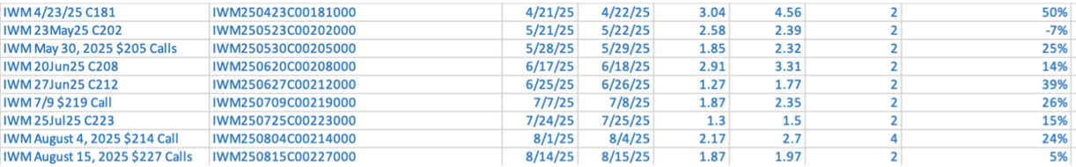

- May 28, 2025. The Russell tumbles 1.1%. Next day, it closes 0.2% higher.
My zero day trade returns 25%.

- June 17, 2025. The Russell falls 1%. Next day it bounces 0.5%.
My 0DTE trade returns 14%.

- June 25, 2025. The Russell falls 1.2% Next day it closes 1.7% higher.
My 0DTE trade returns 39%.

- July 7. The Russell drops 1.2% Next day, its up 0.7% and my trade returns 26%.

- July 24. Russell drops 1.4%. Next day, it’s up 0.9% and my 0DTE trade is up 15%.

- August 1. Russell drops 2%.Next day it falls another 1.7%.
Even still, my 0DTE trade returned 24%.

- August 14. Russell drops 1.2%. Next day it closes 3.1% higher.
My 0DTE trade squeaks in a 5% return.

That’s nine consecutive trades in a row.

- Every trade was on the IWM, our dark ticker.
- Every trade was executed using a zero day option.
- Every trade was made at 4pm.
- Every trade was triggered by a drop of 1% or more on the Russell 2000.

Altogether, it was 8 wins. The average trade produced 21% returns, right in line with what I’m averaging this year.

And let’s not forget…

These are not monthly or weekly returns. They’re overnight returns.
CJ:
You know what gets me about all this? It's not just that it works. It's who it can work for.
There’s this assumption that you need to be rich to trade options.

Especially zero day options. But you don't.

One of your readers posted this comment a few years ago. It really made me laugh.
He bought two contracts on IWM. He paid 19 cents a contract.
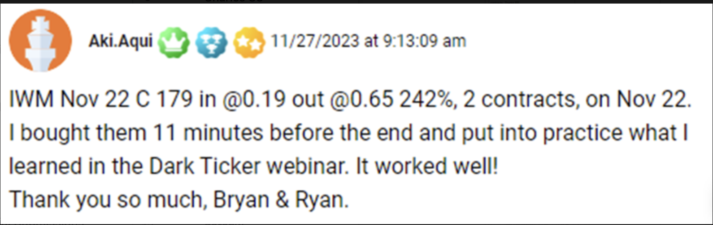
His cost basis was $38. The next day he sold those contracts at 65 cents and made $92.
That’s a 242% gain.
Had this guy put in $3,000… he’d have made over $7,000 in profit.
But you know what? $38 is what he was comfortable putting in and he was happy enough with those results to want to share them with you.
And in the end, that's the only rule that's never let me down: only risk what you're comfortable risking. For Aki, it was $38.
Bryan:
And you know what…
For a guy like Aki who probably never traded an option in his life…
This was probably a magical moment…
The first time in his life that he realized you can make money overnight without investing.
Then you have other people following me who are comfortable putting $75,000 into a trade…
Like Ron50 who bought 100 0DTE contracts on the QQQ back in November 2025. He filled them at $7.54.
Next morning, when the QQQ rebounded, he sold those contracts for $15.15. A $12,233 profit overnight!
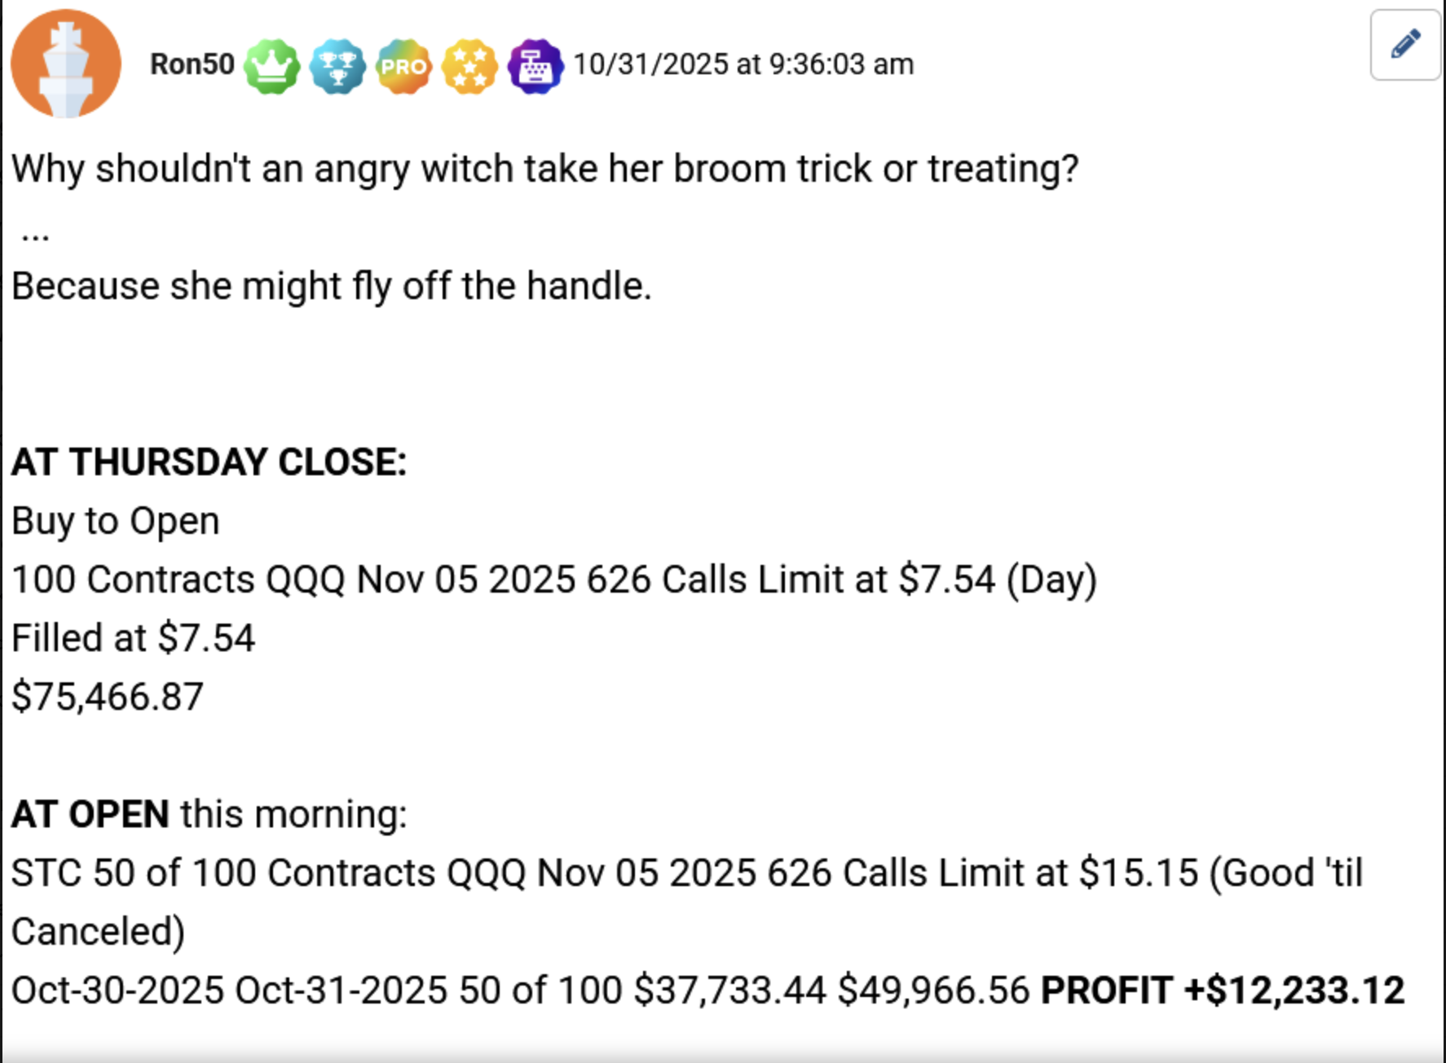
So while Aki is happy putting $38 into a trade…
Ron is comfortable putting more down. But no, generally speaking, these trades are not expensive.

And now, thanks to the CBOE, we can execute them on 20 of the most heavily traded stocks.

For someone like me whose entire career hinges on winning.

This matters way more than you think.

For as long as I can remember…

I could only run zero day trades on the major indices. I had no other choice. I had to wait for the entire market to have a bad day before I got a setup.

But now I don’t have to wait for the market to crack.

All I need to see is one great stock having a really bad day, and there it is. That’s our setup.
CJ:
When you sent me your ledger, a few things instantly jumped out at me.

Since March you’ve done 16 zero day trades on individual stocks, which you call stock flips.

Of these 16 stock flips, 14 were winners with an average return of 23% per trade.

Another thing I noticed is that with these stock flips, it’s the same setup:

- You wait for the market to overreact on one of these 20 stocks.
- You buy the zero day option at 4pm.
- Then exit your position at 9:30am the next day.
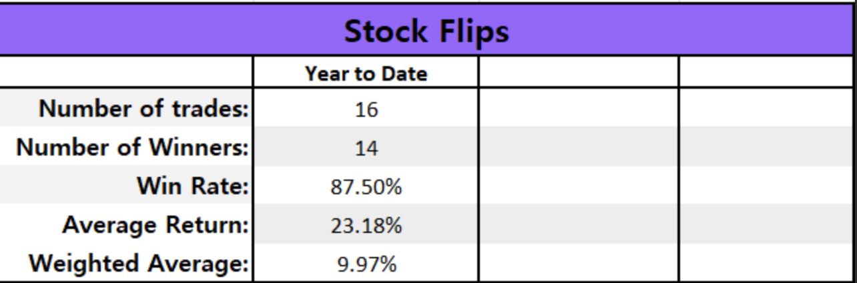

It's the exact same playbook as the Russell trade, just on individual names.

Here’s how a few of them played out:

- March 30. Cisco fell -3%. Next day, it bounced up 0.7%. Your zero day nets 25%.

- April 7. Home Depot drops -2.4%. Next day, it’s up 5.4%. Your zero day makes 241%.
- May 12. Oracle drops -3.6%. Next day it’s up 0.77%. You make 28%.
- May 26. Costco falls -2.9%. Next day it falls -0.8%. But even still, you made 15%.
And here's something else I caught while I was in your portal…
Oftentimes your readers produce bigger gains than what you record on your own ledger.
For the same trades.
Why is that?
Bryan:
So, as you can see, this is an overnight trading strategy.
We get in after 4pm after the market closes.
We get out at 9:30am, when it re-opens.
But that doesn’t people can’t roll the dice and stay in the trade for longer.
It’s their choice.
They can follow the system I’ve built. Or if they want, they can deviate from it.

If they do deviate from it, then yes, they can end up recording bigger gains.
Just like Steve C did on his Oracle trade. Instead of closing the trade the next morning. He rolled his call out a few days and captured a 300% gain.
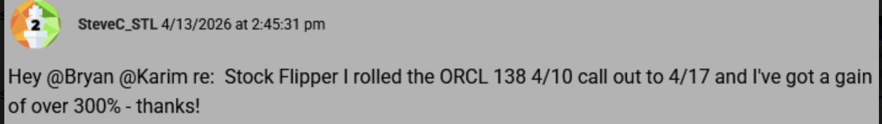
Do I care that my readers are recording bigger gains than what’s in the official track record?
Of course not! I love it.
People who feel good about a position are free to ride it longer, and some do.
When it pays off like it did for Steve, that's the kind of thing that fuels my engine.
And Chris now that we’re able to execute these moonlight trades on 20 different stocks.
Wall Street has just handed us a whole new set of names to run this play on which means the number of setups is only going to multiply.
CJ:
Even still…
Doing this type of trading does require a fair amount of work. We take it for granted because it’s what we do all day. But it’s not a cakewalk.
- First you have to watch the market like a hawk. You have to watch the Russell 2000, the QQQ, SPY, and GLD indices… along with 20 individual stocks.
- Then, you have to catch the drop at exactly the right moment. Miss the window and the setup's gone.
- Next you have to determine if that sell-off is warranted or not. Is the company actually broke or was this a knee-jerk overreaction?
- If it is an overreaction, you now have to pick the trade. Which strike? Which expiration?
There are hundreds of contracts on a single name, and the difference between picking the right one and the wrong one is the difference between making 50% on a given night or having a total loss.
All of these questions have to be answered within minutes of the market closing.
So that at 4pm, you can enter the trade with confidence.
Bryan:
Some people love the challenge.
But most people, I find, would much rather have someone else do it for them.
And that Chris is why my service, Post-Market Profits exists.
So people can skip straight to the trade I'd make, without having to do any of the hard work themselves. This service allows them to get all of my experience and research, and then all they have to do is decide whether they want to make a trade based on the information I’ve given them.
Of course, if someone wants to take the information we’ve given them today and run with it.
They’re free to do it.
They don’t have to sit and watch us for another second.
But for those watching, who want to execute these moonlight trades, but don’t want to stress about having to decide which options have the best potential, and on which stocks to make them on…
That’s where I come in.
Every trading day I’m at my desk watching the major indices (especially the Russell 2000). Thanks to the CBOE I’m also watching the 20 individual stocks that we can now trade at 4pm.
Altogether it’s around
30 tickers.
When one of these tickers drops hard enough to trigger, I pick the one setup I like best, choose the exact option, and send it straight to my readers with entry and exit instructions.
This way they don’t have to guess when to get in and when to get out.
All of my members get a recommendation that says, simply: Here’s the trade and here’s the option to buy.
CJ:
And Bryan, unlike a lot of these pain-by-number traders who just dish out random trades because that’s what their publisher wants…
You only send out trades recommendations when the market hands them to you.
You don’t follow a quota.
On some weeks, the market gives you two or three trades. On other weeks, none.
That's the difference. You're not manufacturing trades to fill an arbitrary calendar.
You're waiting for the market to give you the best setups.
That’s why your average trade has returned 16% so far this year.
So tell me, has it always worked this way for you, or is something different right now?
Bryan:
I refuse to allow a publisher to dictate when I need to issue trades.
But I will say that right now…
Because of all the volatility and price action we’re seeing in this new 24-hour market, I’m seeing more setups than I ever have before.
In April it was three.
May - six.
June - seven.
And our readers love them:
A few months ago, DocMoose said he made over 200% on META. He opened his position on Friday, closed it on Monday… the very next trading day.
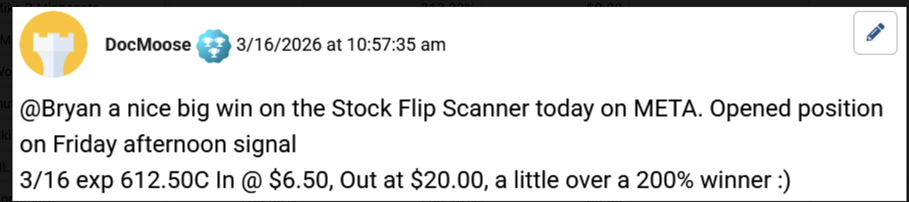
A few weeks after that, Steve L. told me he made 178% on T-Mobile in just over a week. “In at 1.90, out at 5.30. Thanks for the flip,” he writes.
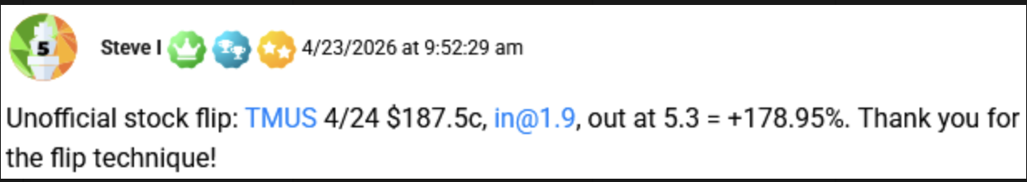
In June, Margonmoves told me she made 198% on Coca-Cola. She got in on June 4 and got out on June 5.
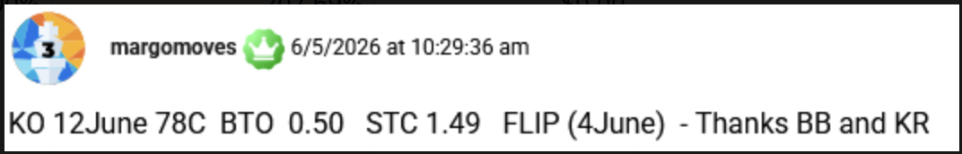
A few weeks after that, Hubert Z. told me he made 300% overnight on Wal-Mart.
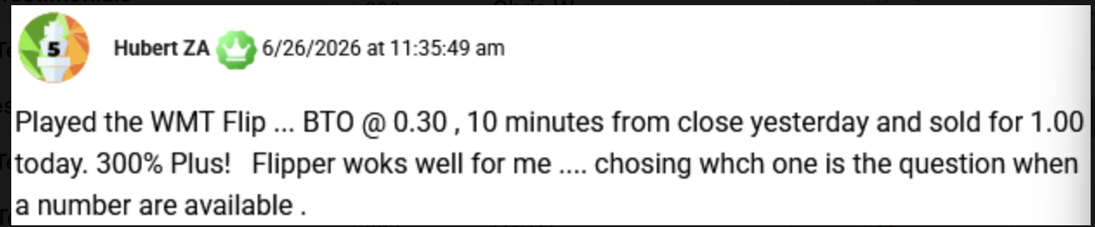
Chris, as you know, these are all messages members of my special moonlight trading research service, Post-Market Profits.
And yes, they’re among my most enthusiastic readers.
CJ:
I know and that’s what I can’t get over.
I've audited a lot of trading strategies in my day.
But the kinds of responses you’re getting in your portal are in a different league.
Hundreds of regular people, writing to you morning after morning…
Teachers. Nurses. Doctors. Retirees.
All excited to share their results with you.
Like this guy from North Wales in the UK who just made a 160% profit overnight, saying it was a “good start” to his journey.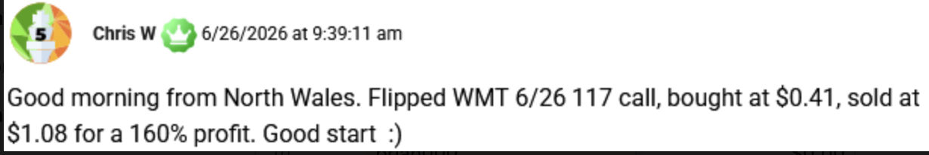
This is what made me want to understand the mechanics of the trade.
Because if this many ordinary people are pulling it off, it has to be simple.
Bryan:
It is. Any time one of these 30 tickers gets triggered, meaning the market overreacts and sends it down sharply, I immediately send out an alert.
The alert is sent by email, via text and posted in the Command Center which is our online portal.
From there you can just follow the instructions.
In these alerts I detail the stock we’re trading… the option we’re buying… and the setup.
All you have to do is buy the option and sell it the next morning.
That’s it.
CJ:
That's the part most people miss.
The hard part of trading was never clicking buy. Anyone can do that.
The hard part is knowing which contract to buy, the right strike, the right expiration, and when to get out. That's the part you've already done for them by the time the alert lands.
So when you say 'just follow the instructions,' that's not a small thing. It’s the entire play.
Bryan:
That’s right.
And even though the alerts alone would be enough to justify joining.
They’re not everything:
Do not read subhead
Post-Market Profits: Monthly Briefing.
Every month I sit down and record a full briefing, just for members.
This is me pulling back the curtain on what's actually working right now and where I think the next setups are forming.
Post-Market Profits: Dark Ticker Strategy Guide.
Next, the Dark Ticker Strategy Guide.
This is the complete playbook for the Russell trade, start to finish. Everything we walked through today, the trigger, the timing, the entry, the exit, written down in one place so you can run it in your sleep.
Post-Market Profits: Overnight Stock Flip Blueprint.
Then you get the Overnight Stock Flip Blueprint. This is the newer side of the strategy, the individual stocks. It lays out all 20 stocks we can now trade after the bell at 4pm exactly what to look for in each one, and how to play them when they take an ugly drop.
Lastly…
Post-Market Profits: LIVE Moderators.
And here's the piece I'm proudest of. You get live access to our moderators. Real people, not bots, not some overseas call center where you can’t understand a word they’re saying. These are hand selected individuals that are based right here in the U.S.
They're easy to talk to, and they're in the room all day, 8am to 5pm.
They can't give you personal financial advice, but they can definitely walk you the process and show you how to make a trade.
CJ:
That’s a huge plus. More than people know.

Not everyone needs their hand held, but having someone on the phone who can answer any questions you have about the recommendations makes all the difference.
And that's exactly what you offer...
From 8am to 5pm, you give people a support system, not just a hotline.
Between the alerts… the monthly briefings… the reports… the moderators…
I think it goes without question that this is more than just a run of the mill trading research service…
One of those “Hey, here’s your trade. Good luck, you're on your own. I’ll be praying for you”
Bryan:
Trading is not dark art.
Anyone can place a trade. It’s two taps and a confirmation button.
But not everyone can find a trade that is worth placing.
That's the part I've spent two and a half years getting right.
When most people find a strategy like this and run with it…
They’ll figure it out eventually, but not without getting some serious scratches and bruises along the way.
What I'm offering is the chance to skip that part. To start on the trade I'd take instead of the dozen you'd have to get wrong first to learn the difference.
That's what I believe sets Post-Market Profits apart.
It’s not just a trading research service. It’s a shortcut past the learning curve.
CJ:
On that note, there is one more thing I want to talk about and it’s probably my favorite aspect of your service. That is, The Overnight Stock Flip Screener.
This screener was built last year and it allows you to watch, in real time, which of these tickers is about to be triggered.
The moment a name crosses that line, the screener flags it at 3:30pm, and it gets a check mark.
Here, I’m going to put it up on the screen so people can see what this looks like.
Left to right we have the ticker being tracked, its current price, the percent change that day, how far along the stock is to hitting the 3:30pm trigger, and what the 'Power Option’ is on that stock.
It’s one of the most useful tools I’ve seen in a trader’s arsenal.
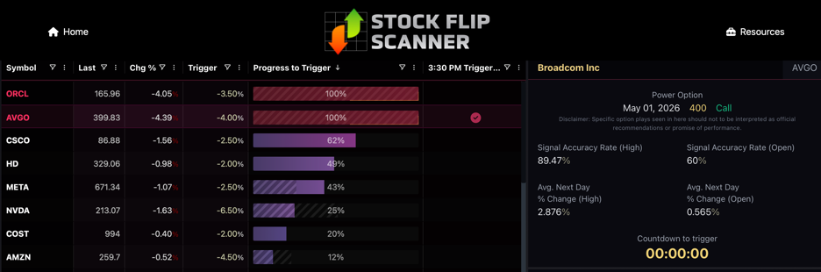
Bryan:
The stock flip screener tracks all 30 tickers at once…
The ETFs plus the stocks.
All someone has to do is pull up the screener…
And they can see, instantly, which stocks and/or ETFs have hit that 3:30pm trigger.
Or they can just wait for me to tell them which setup I like best. They don’t even have to look at the screener and they’ll still get plays from it.
CJ:
Okay, let me ask you this. Let’s say the market ends up having a bad day…
The Russell is down -2%.
But you also see an individual stock, like Broadcom, hit that 3:30pm trigger
What do you do then?
Bryan:
Well I don’t recommend every stock that triggers.
But if I like the setup, then we’ve got two opportunities for profits. Two overnight trades.
I can send out a Stock Flip trade at 3:30.pm
And then a trade on the Russell or any other index at 4:00pm.
It happens all the time, and it’s on days like these that my readers have the chance to double-dip and catch two wins in one night..
On March 31, Alma made 38% on a Stock Flip and 68% on an index trade. Same day.
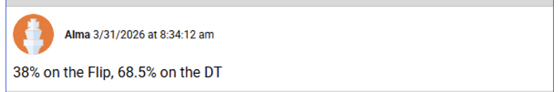
Alexa rang the register on a stock flip on Walmart… AND a trade on the Russell 2000 and QQQ. All in one morning.
AnOldDuffer made 101% on the Russell “while he slept” and 62% on Oracle the very same day.
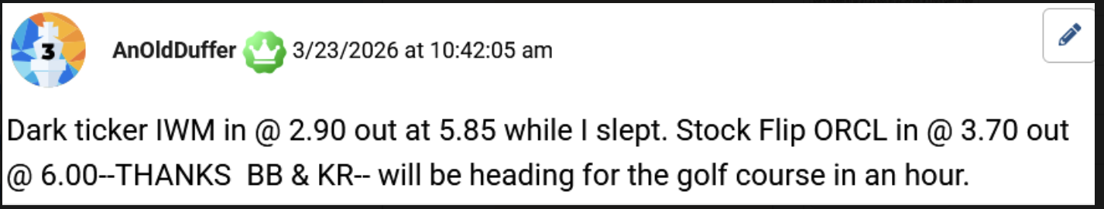
CJ:
You can’t fake results like this.
And I know the scanner works because you didn’t just build it and hope for the best.
You gave your readers access and they took to it fast.
With help from your scanner, as well as the knowledge gained from your monthly insights, Dan took two stock flip signals and made 101% on META and a small profit on AVGO.
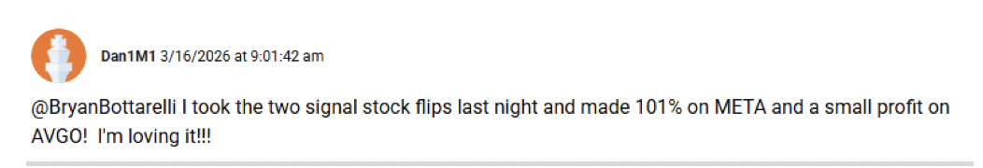
On June 26, Hubert said he made 300% on his Wal-Mart flip.
This is what I love…
You’ve created a community of people who’ve become obsessed with this type of trading once they start realizing how easy it is…
They get hooked into the world of nighttrading just as we have…
In April, Mr. Baseball reported FIVE winning trades in one day: 371% on Home Depot, 93% on Tesla, 90% on Applied Digital, another 90% on Delta and 33% on Hasbro. 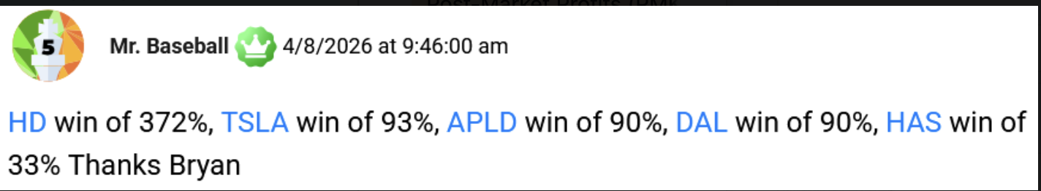
From there it was like one home run after another for Mr. Baseball, no pun intended.
He kept posting winners all spring. Costco, Coca-Cola, P&G, you name it. The guy got completely hooked.
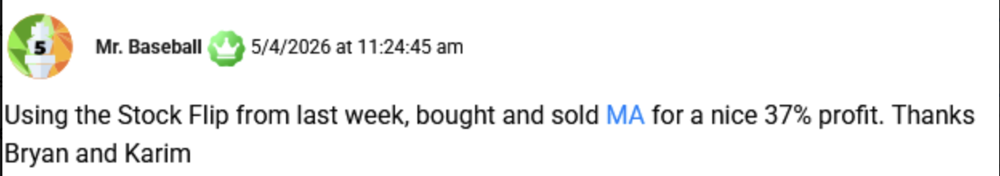
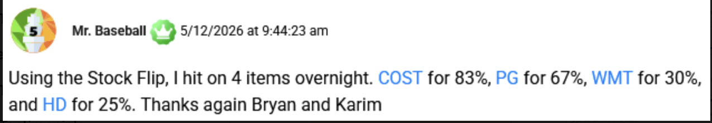
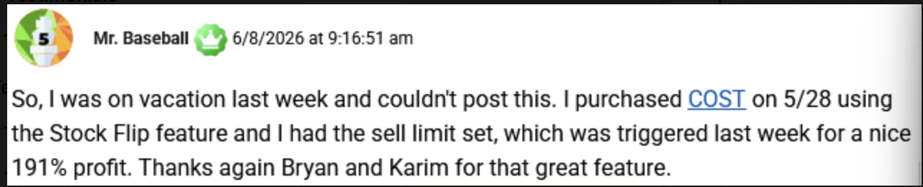
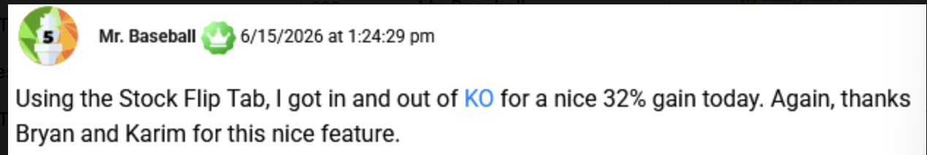
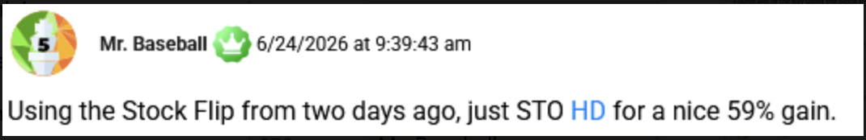
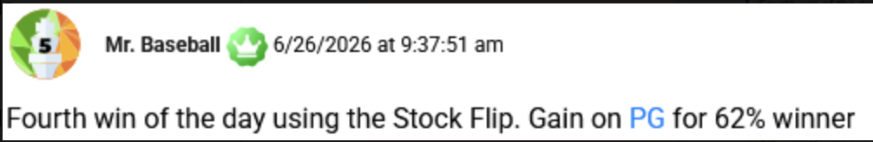
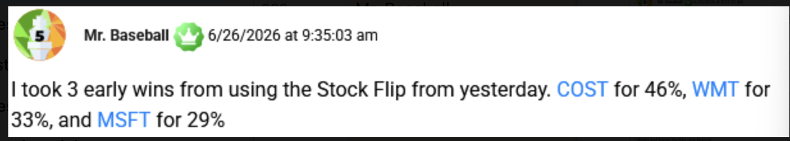
And he’s not the only one…
On March 23, Jon M. said he was 3 for 3 on his overnight stock flip trades… and already met his dollar goal for the week.
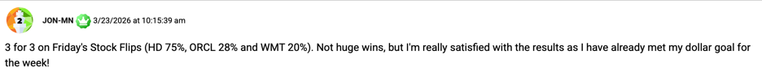

A few weeks later, on April 8 2026, Jon told you he won another 3 for 3 stock flip trades.
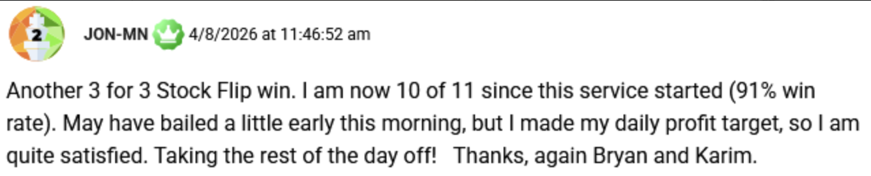
A day later, he bragged about his 93% win rate and how he’s won 13 of his 14 stock flips.
These people are beyond excited to share their results with you.
And it’s not like they’re pro traders.
They’re everyday people, using a tool that is typically something only guys like you and me use. But with help from this tool, as well as your research and insights, they are getting pro-level results.
That’s the part I didn’t expect.
Bryan:
Chris, just having access to the stock flip screener is enough to put people on a level playing field with the pros.
I see it everyday.
Back in May, Geno posted that he had made 27 trades with the help of the screener. “I have 20 wins and 7 losses within a two month period. I consider this service fantastic,” he writes.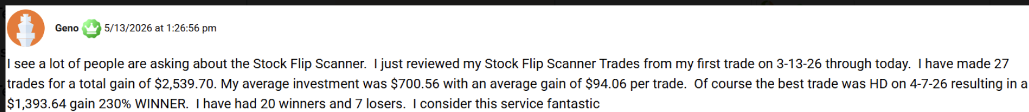
George T. has done 15 stock flips with assistance from the screener … He won 14 of them with an average gain of 39%. The one loser was only 9%. “I am loving this strategy,” he says.
One of my newest members, VT Dude, just sent me this message a few weeks ago. He told me he’s entered 13 trades since joining, and has won 11 of them. “Byran is THE MAN!” he writes.
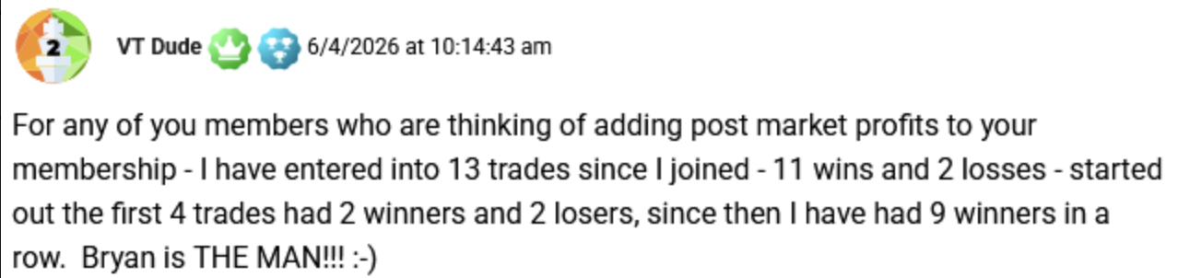
But I think my all time favorite story is from this guy…
He goes by 55TBirdDude
He once wrote to me saying how he’s a disabled vet that works full-time, has a $3,000 trading account, and needed to withdraw money out of his trading account to fix his wife’s broken down car. The guy clearly doesn’t come from wealth.
But by executing 3 overnight trades he was able to “more than cover the 20% withdraw”
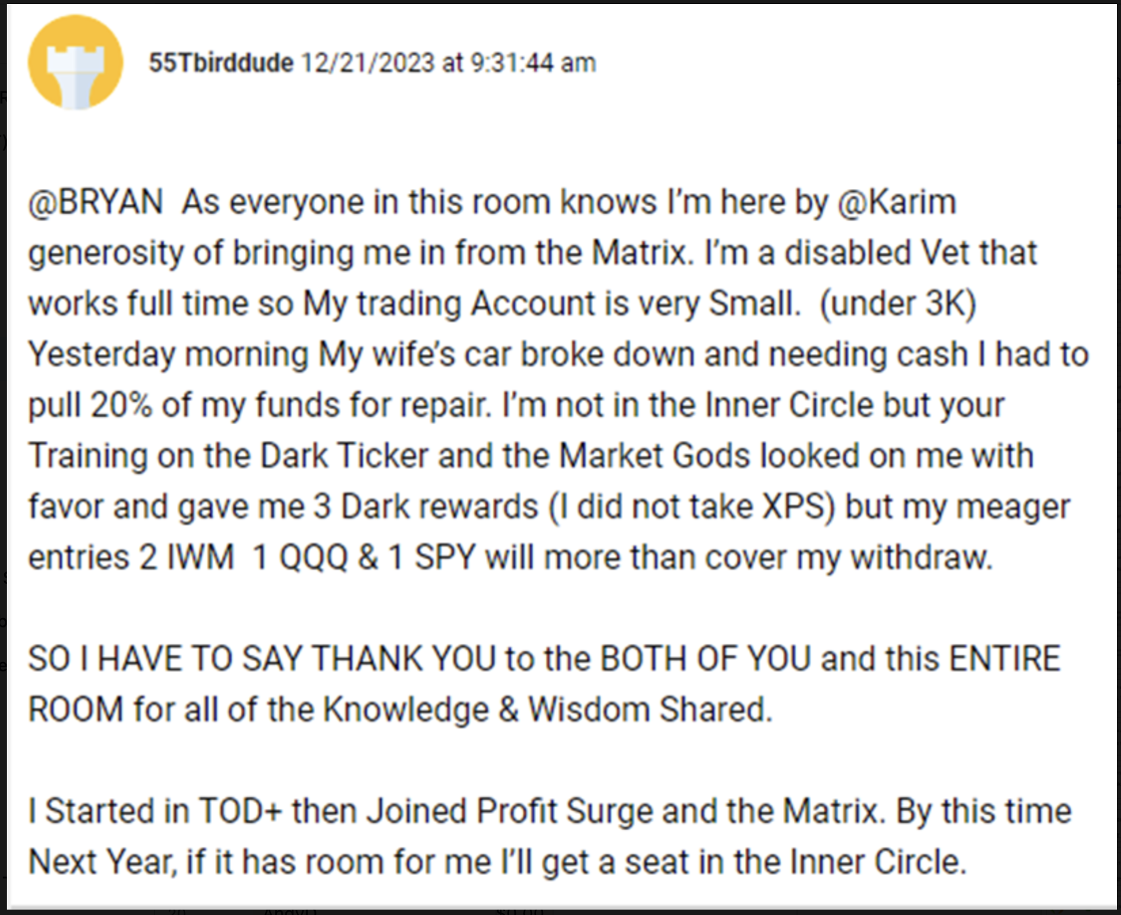
He’s still a member today, banging out zero-day trades and sharing his results, like how he made 120% overnight on this 0DTE trade on the Russell 200.
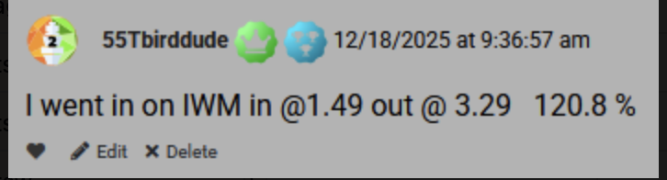
That's what the screener… combined with my trade alerts… and the entire Post-Market Profits research… can do.
It can give you a new hobby that doesn’t just excite you, but can make you richer as well.
That’s why my readers are so engaged.
They don't just follow my recommendations. They use the screener to see additional trade setups. This way, if they want, they can be like Mr. Baseball and do as many as they want as often as they want.
CJ:
That’s also what sets Post Market Profits apart from most of what’s out there.
It’s your trade alerts but it’s also access to the screener you use to help find those setups.
So let me ask you the question everyone watching is thinking.
How does someone actually get all this, the research, the alerts and the stock flip scanner?
Bryan:
Well, there’s two ways in:
- The first way is through our Unlimited Program.
- When I say “unlimited” it means membership includes the alerts, the briefings, the guides, the moderators, and exclusive access to the stock flip scanner for as many years as I’m doing this.
The scanner is exclusive to members with Unlimited access.
On our website, it’s $7,000 for unlimited access.
And when you look at what's inside, that price is fitting.
You're paying for a trading research service that also comes with access to a software that is not available to the public, and never will be.
The average Joe pays a private wealth advisor far more than that, but for far less.
But now that the CBOE has added 20 new names to trade after 4pm. I want to open this up to a much wider audience.
So for everyone watching this, you're not paying $7,000 retail.
Unlimited Membership today is being offered for $3,997.
For this price you get everything I just mentioned without ever paying a renewal fee.
Not in ten years. Not in 20 years. Not even in 30 years if we’re still here.
The only ongoing cost you have to pay is a small year maintenance fee.
This fee covers the data feeds and keeps the scanner running.
And if $3,997 is more than what you want to pay today…
- The second way in is through a one-year membership.
On our website, the one-year membership to Post Market Profits retails for $5,000 a year.
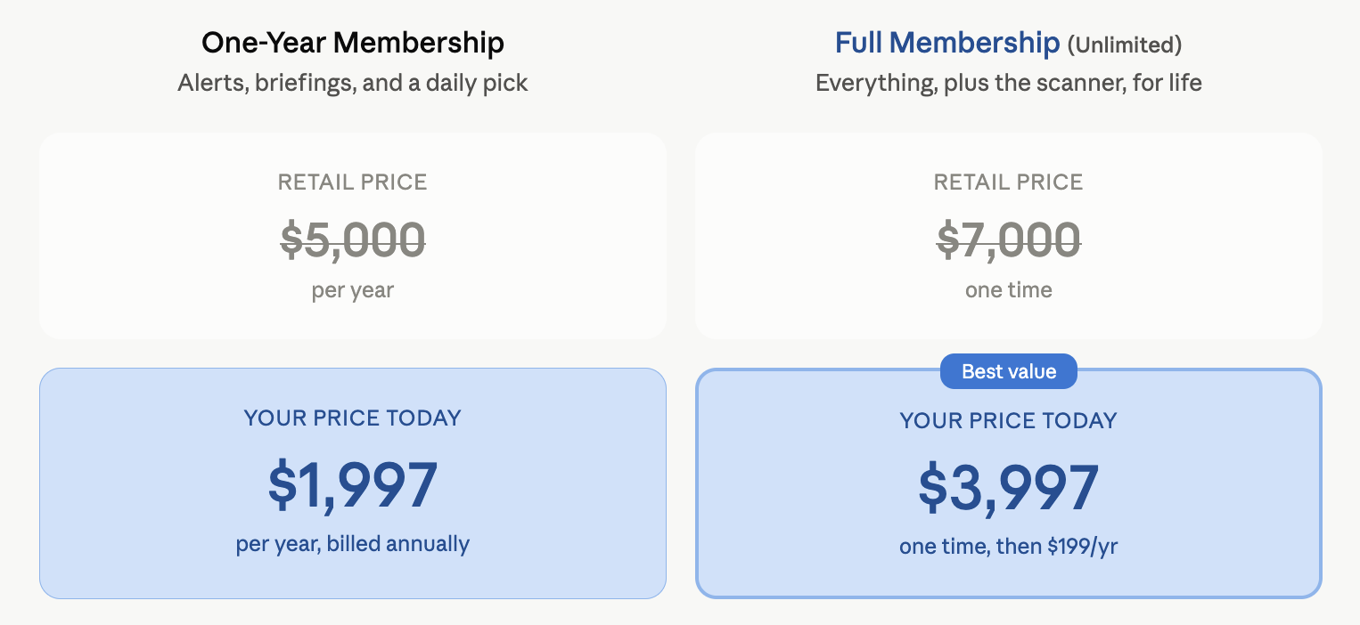
But like I’ve been saying.
Now that we’re able to run these moonlight trades on 20 additional securities, without needing a $25,000 margin in your account…
More people can do this than ever. And they should…
I don't know a better setup out there, and I don't think there's ever been a better time for it.
So to bring more people in, I've dropped the one-year price to $1,997.
For that, you get the same trades, alerts, and monthly briefings as our full members. The only difference is you have to pay that $1,997 every year to renew your membership..
CJ:
In other words if someone signs up today for a one-year plan and stays five years..
They’re going to end up paying $10,000 over that five year period. And they’re going to miss out on the stock flip screener.
An unlimited member will pay $3,997 today, plus a $199 yearly maintenance fee. And they’ll get access to the screener.
So over that five year period they’ll have saved $5,000.
Unlimited Membership is clearly the better option.
Bryan:
It is. It’s the far better deal, because even though there’s a higher entry price, paying annually will really add up after a few years. .
But a single good night could cover that Unlimited fee.
I know this for a fact because people tell me: .
- VMAX made enough money on two trades (167% gain and 98% gain) to cover the cost of an unlimited membership.
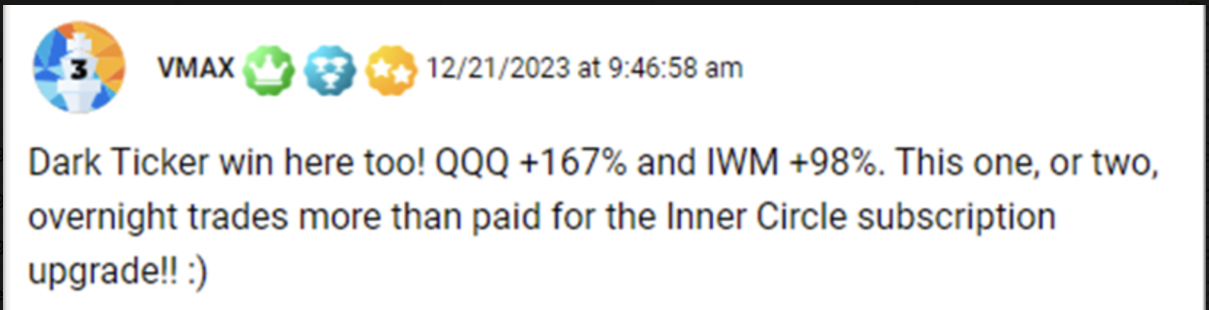
- PJ told me he made over $3,500 while sleeping one night. Almost 63% profit, almost enough to cover an Unlimited Membership to Post Market Profits.
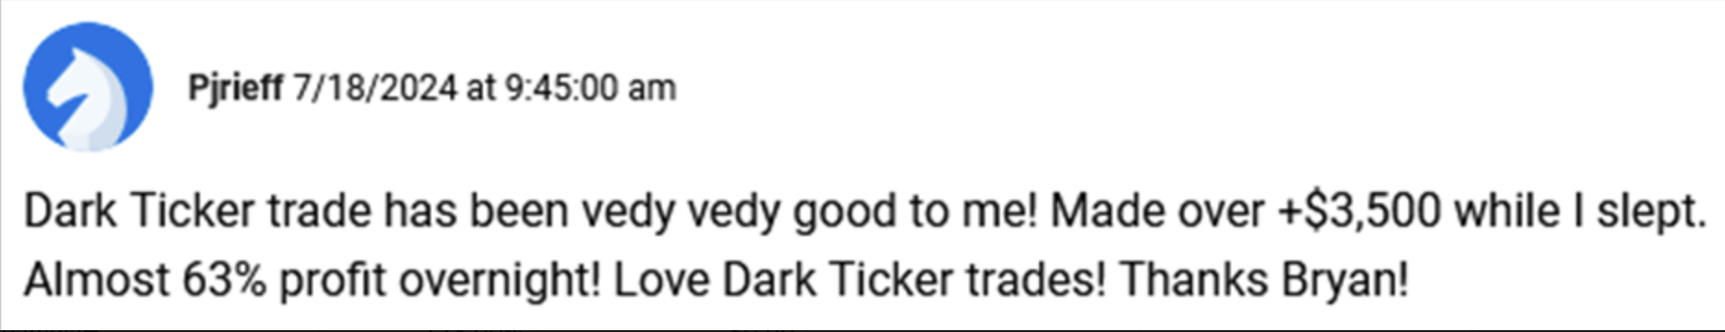
And so nobody has to take this on faith alone.
I’m taking the risk off the table by offering a 60-day money back guarantee.
This way, you can try Post-Market Profits for a full 60 days…
… whether you choose a Unlimited Membership or one-year membership. Doesn’t matter.
- Go watch my monthly briefings…
- Be prepared for my trade alerts
- Print out the ‘dark ticker’ strategy guide.
- Download the overnight stock flip blueprint.
- Talk to our live moderators – as much as you want.
- Use the stock flip scanner to get additional overnight trade ideas.
Test-drive everything.
If it doesn’t feel right to you… for any reason…
You can give our team a call within 60 days and we’ll refund every penny you paid… minus a small 10% processing fee to cover our data costs.
CJ
So there really is very little risk here.
You can try the service for 60 days.
If you love it… you keep going… give yourself as many shots on goal as possible.
If not… you get your money back minus the 10% fee.
Bryan:
That's the deal.
But you know what…
I don't think anyone is going to want a refund.
Once you experience what it's like to put your money to work while everyone else is sleeping…
There's no going back.
The feeling is beyond addictive.
I don’t have to tell you…
You’ve been night trading for 10 years now.
When I asked if you had any big trades this year…
You sent me seven of them with total profits of nearly $200,000, from a starting stake of $56,212.
You may think that’s not a big deal. But for the average person, it’s a year's salary, or a down payment on a house.
CJ:
Well look I’ve been doing this a long time.
And yes, I’m addicted.
I’ve found a strategy that doesn’t just make me money, but just like your moonlight trades, is also simple and highly effective.
You and I know it takes years, sometimes decades, to come up with a strategy like that.
And when we do, the last thing we do is share it with the world.
But you…
You just laid everything bare. The entire method, revealed in one conversation:
Bryan:
The way I see it Chris.
We don’t try to sell our research to hedge funds.
We’re not Wall Street.
Our target audience is everyday people.
If I forced those people to pay us just to learn about a strategy, I'd be no different than the private money clubs we both like to rail on.
This isn't a closed investment club. It's not a hedge fund.
My job, as a trade analysis, is to put tools in people's hands that I believe can help them do better. This is my best strategy. And yes, I just gave the entire method away.
CJ:
Some people will hear that and think you're crazy for doing it.
I think it's the most honest thing I've seen in this business in years.
That said, I want to say a few final words to everyone watching this.
(Chris turns camera)
If you’ve stuck around this long, you now know exactly how Bryan Botarelli has been able to churn out a 16% average overnight gain so far this year… with a 80% win rate.
You can now take what you’ve learned and execute these trades on your own.
But if you’d rather have the man – who has run more than 100 of these moonlight trades – do the watching and picking for you.
All you need to do is click the button below and sign up for Post-Market Profits.
You can choose an Unlimited Membership for $3,997 which includes the stock flip screener.
Or a one-year membership for $1,997.
Whatever you’re most comfortable with.
Bryan, I rarely advocate for other trades.
It’s not like I’m incentivized in any way to talk about Post Market Profits.
But I do think that the pattern you’re executing on – the “reflex” that occurs anytime there’s an overreaction on the market…
It is something I genuinely believe everyone should be exploiting alongside you.
Bryan:
I have a lot of respect for you Chris. You know that.
For someone who has made a career out of being a “night trader” …
Well, not a “night trader” - THE NIGHT TRADER..
Having you do this with me… it means a lot.
Having your endorsement… It means even more.
All I can tell folks at this point is that if they want a membership to Post-Market Profits, it’s theirs for the taking.
All they have to do is click that button below and choose what membership works best for them.
If they want to start with a one-year membership, that’s fine.
My guess is, they’ll probably pay that off with just the first overnight trade they do.
I know George did.
He told me as much… He made a 77% gain and a $2,685 profit on one trade on the Russell 2000, in just one day. Starting stake was $3,480. .

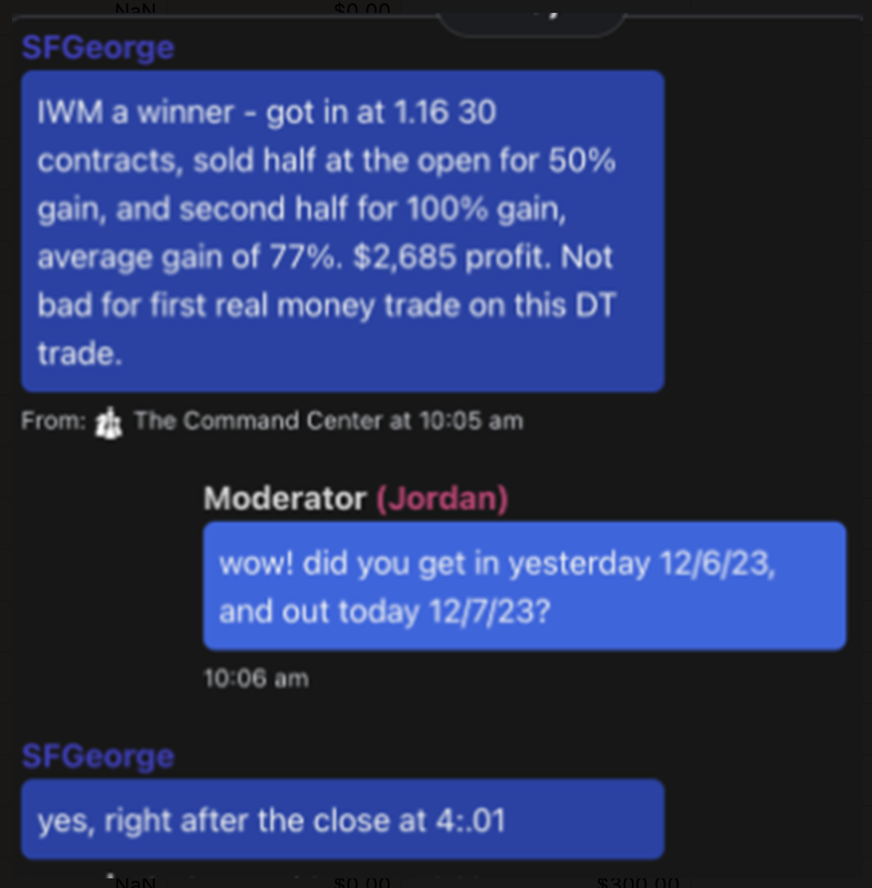

Same with Rich.
On one trade he made $5,530, a 104% gain.
That’s enough to cover not just a one-year membership, but an Unlimited Membership
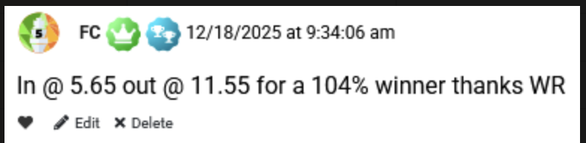
So here's the way I look at it. The first good night could pay for your whole first year, and everything after that is yours to keep.
The button is right below this video. Click it to lock in today's pricing and pick your plan. If you'd rather talk to a person first, our team is standing by at (say phone #).
Every trading day, I'll be right here…
From my little watchtower in Moonlight Basin, Montana.
Waiting for the next ugly day that hands us a setup. The second one of these tickers hits my trigger, you'll hear from me.
CJ:
Alright Bryan… before we wrap up…
I know there are going to be a lot of questions. So let's run through the most common ones.
July, 2026

Pro Trader Breaks the Internet with Unfair Market Hack…
Moonlight Trades:
His Daring 15-Minute Moves Can Make You Up to 241% in a Single Night

ALT HEADLINE TO TEST:

https://www.schwab.com/learn/author/liz-ann-sonders
https://twitter.com/LizAnnSonders/status/1265606013358608393
https://www.ccn.com/the-stock-markets-biggest-gains-always-happen-at-the-same-time-each-day/#:~:text=It%20turns%20out%20that%20all,U.S.%20market%20happen%20simultaneously%3A%20overnight.&text=For%20almost%2020%20years%2C%20the,trading%20on%20the%20futures%20market.
https://www.bruceknuteson.com/
https://arxiv.org/abs/2107.12516 https://bruceknuteson.github.io/spy-day-and-night
https://arxiv.org/abs/2107.12516 hit “view PDF”
https://papers.ssrn.com/sol3/papers.cfm?abstract_id=4139328&__cf_chl_f_tk=ufZKJOTJKpdvRASDnG5YKaCwQHNKXa6KbYwt4vL5620-1783002045-1.0.1.1-99lGTqbPAEjQDpTyYgEPH.3Pm881Z7eXJGqSgNF3VJ4
https://papers.ssrn.com/sol3/papers.cfm?abstract_id=4139328&__cf_chl_f_tk=ufZKJOTJKpdvRASDnG5YKaCwQHNKXa6KbYwt4vL5620-1783002045-1.0.1.1-99lGTqbPAEjQDpTyYgEPH.3Pm881Z7eXJGqSgNF3VJ4
https://airtable.com/appxO7QZIQ0CNfe6d/shrcqApOxXbmdu1GL/tblwt5mKUnYhWToGH/viwYI10VTudpH5Puf/recfq4uwW2dlEQnkD/fldhEta7VXKlkbpQJ/attGjXwatB9sPYv6G - JerryT
https://airtable.com/appxO7QZIQ0CNfe6d/shrcqApOxXbmdu1GL/tblwt5mKUnYhWToGH/viwYI10VTudpH5Puf - Hubert ZA
https://optionalpha.com/podcast/stock-analysis-price-recovery
https://www.wsj.com/livecoverage/stock-market-today-dow-jones-05-29-2024
https://ir.jobyaviation.com/news-events/press-releases/detail/124/joby-reports-record-certification-progress-and-delivery-of
https://finance.yahoo.com/markets/stocks/articles/rigetti-q1-earnings-revenues-beat-153900199.html
https://www.getyarn.io/yarn-clip/68f13fcb-d2c5-434f-8237-b87dfd10cab0
https://finance.yahoo.com/news/home-depot-sends-171-billion-003900418.html
https://www.tikr.com/blog/home-depot-fell-16-in-the-last-30-days-heres-how-much-upside-the-stock-could-have-in-2026
https://www.britannica.com/money/0dte-options-trading https://www.cboe.com/insights/posts/the-evolution-of-same-day-options-trading/ Cboe's own history says "before 2005, most listed options had one expiration date per month (on the third Friday),
https://support.sofi.com/hc/en-us/articles/10703655803021-Are-options-available-in-IRA-accounts
https://airtable.com/appxO7QZIQ0CNfe6d/shrcqApOxXbmdu1GL/tblwt5mKUnYhWToGH/viwYI10VTudpH5Puf -
https://ir.cboe.com/news/news-details/2026/Cboe-Receives-SEC-Approval-to-Offer-Extended-Trading-Hours-for-Select-Multi-Listed-Single-Stock-Options/default.aspx - on July 13 is when after hours trading on these 20 securities. By then, the promo will not have yet gone out.
https://www.cboe.com/notices/content/?id=59462
https://public.com/stocks/pfe/after-hours?wpsrc=Organic+Search&wpsn=www.google.com
https://international.schwab.com/stock-market-opening-closing-timings
https://www.vtmarkets.com/discover/russell-2000-index-trading-guide-2026-small-cap-investment-strategies/
https://www.spglobal.com/spdji/en/indices/equity/sp-500-value/
https://finance.martinsewell.com/stylized-facts/dependence/Jegadeesh1990.pdf https://www.jstor.org/stable/2328797 Abstract: This paper presents new empirical evidence of predictability of individual stock returns. The negative first-order serial correlation in monthly stock returns is highly significant. Furthermore, significant positive serial correlation is found at longer lags, and the twelve-month serial correlation is particularly strong. Using the observed systematic behavior of stock returns, one-step-ahead return forecasts are made and ten portfolios are formed from the forecasts.The difference between the abnormal returns on the extreme decile portfolios over the period 1934-1987 is 2.49% per month.
Avramov, Chordia, and Goyal, also in the Journal of Finance,. https://papers.ssrn.com/sol3/papers.cfm?abstract_id=555968
https://www.nyse.com/research/insights/the-early-bird-gets-the-worm-a-new-normal-in-off-hours-us-equities-trading
https://www.ey.com/en_us/insights/bankin%EE%80%80g-capital-ma%EE%80%80rkets/how-extended-trading-may-impact-us%EE%80%80-equity-markets “10% of total equity volume is projected to be traded during overnight sessions by 2028."
https://www.thetradenews.com/the-trade-predictions-series-2026-the-extended-hours-trading-debate/
https://ir.cboe.com/news/news-details/2026/Cboe-Global-Markets-Reports-Results-for-First-Quarter-2026-and-Continued-Execution-of-Strategic-Realignment/default.aspx
https://www.cboe.com/insights/posts/volatility-insights-evaluating-the-market-impact-of-spx-0-dte-options/
https://www.ifre.com/topic-codes/2321645/zero-day-contracts-become-dominant-force-in-sp-500-options-market
: https://www.schwab.com/learn/story/zeroing-on-0dte-options-learn-basics https://www.cboe.com/insights/posts/debunking-options-myths/
https://www.investing.com/indices/smallcap-2000-historical-data
https://fortune.com/2026/06/05/auto-draft-5/
https://www.cnbc.com/2026/06/04/stock-market-today-live-updates.html
https://www.cnbc.com/2026/05/01/roblox-rblx-stock-child-safety-earnings.html
https://www.wsj.com/livecoverage/stock-market-today-dow-jones-05-29-2024
Akbas, Boehmer, Jiang, and Koch https://ideas.repec.org/a/eee/jfinec/v145y2022i3p850-875.html
https://finance.yahoo.com/news/major-us-stock-indexes-fared-201825460.html
https://finance.yahoo.com/news/major-us-stock-indexes-fared-201818562.html
https://apnews.com/article/wall-street-stocks-dow-nasdaq-0676039281940d1f9dce6107e62ffeed
https://finance.yahoo.com/news/major-us-stock-indexes-fared-202342954.html
https://finance.yahoo.com/news/major-us-stock-indexes-fared-203035299.html
https://ir.cboe.com/news/news-details/2026/Cboe-Receives-SEC-Approval-to-Offer-Extended-Trading-Hours-for-Select-Multi-Listed-Single-Stock-Options/default.aspx
https://www.tradingkey.com/news/market-movers/261734875-market-movers-csco-20260330
https://www.marketbeat.com/instant-alerts/oracle-nyseorcl-stock-price-down-36-heres-what-happened-2026-05-12/

