“Up-Listing” Could 36x This $0.12 Stock
NEW “Millionaire Maker” Stock Pick, Revealed!
Secrets of Fortune
NEW “Millionaire Maker” Stock Pick, Revealed!
Grow $30K Into $1 Million (36x Multiplier)
==================================
Dynamic Headline Changes Date and Stock Price to that day’s levels
This $XXX CURRNET STOCK PRICE Stock Set to Blast on CURRENT DATE
NEW “Millionaire Maker” Stock Pick, Revealed!
=====================================

I have a new stock recommendation, that I can confidently say…..
Could make you a millionaire….
All starting with a very, very small investment.
That’s why I’ve just released my newest “millionaire maker” stock pick.
This new pick has all the makings for the next explosive winner.
First, it’s cheap. Very cheap.
Right now, you can buy this stock for less than a pack of gum (hold up gum pack)
In fact, this stock is so cheap, you can own 1,000 shares for the same cost as 1 single share of Newmont Mining.
You can own 2,000 shares for the same cost as 1 single share of Nvidia.
You can own 3,000 shares for the same cost as 1 single share of Tesla.
And you can own 7,000 shares for the same cost as 1 single share of Caterpillar.
Second, it has a series of major upside trigger catalysts that’ll happen very soon – perhaps in the next few weeks – that could send the shares blasting aggressively higher.
Third, they’re about to control a market that’s projected to grow by a factor of 480x today’s levels - all with very little global competition.
And fourth, they’re still a Wall Street secret. Not a single analyst has a price rating on this stock – making it basically invisible to every current investor.
As you’re about to see…
And as I’m about to prove to you…
This stock – right now – is the buy of a lifetime.
That’s why I’m calling it a “millionaire maker” stock pick.
If I’m right…
And this stock moves the way I predict…
The share price could double every year…
For the next 5 years.
That’s enough to create a new group of millionaires who are smart enough to follow my advice today.
Now, let me be clear….
Getting in right now represents a ground-floor opportunity.
Situations like this are so rare, they only come around once or twice in a lifetime.
Either you make one simple move before anyone else….and create generational wealth for your rest of your life…
Or, you miss your chance – and regret it forever.
In the next few moments, I’ll show you why I’m convinced that this is one such opportunity that you need to act on right now.
I’ll reveal everything.
And since your time is valuable, I’ll keep it short.
My name is Karim Rahemtulla, and the last time I found an opportunity like this was in March of 2022.
I recommended shares of Rolls-Royce Holdings, which was trading for $1.14 per share.
Based on my research – and my understanding of how companies are valued – I knew that this company was valued at pennies on the dollar.
It was inevitable that this company would soon blast higher – which is why I shared it with a small group of my paid readers.
Just look at what happened next…
Graphis: Please re-create
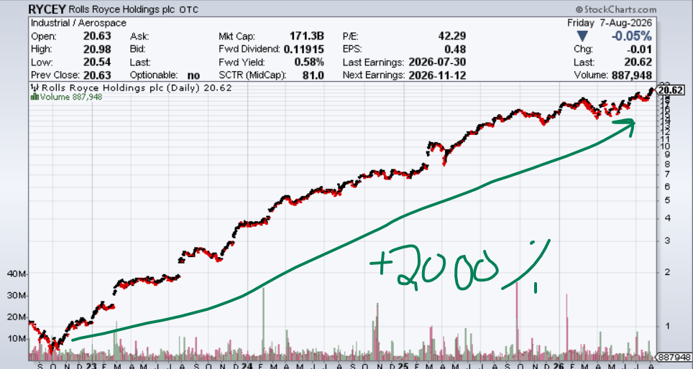
Rolls shares went from $1.00 up to a recent high just below $20.00.
In fact, $20 was my exact target in that presentation.
That’s a 20X move!
It was a buy of a lifetime – one that every investor dreams about.
And thanks to this pick…
Many of my followers are now millionaires.
Some have written me….or came up to me at conferences…..thanking me for making this recommendation.
Like this member TomB, who just told me…
“My account now stands with this stock over 1 million dollars. It has been life-changing”
Graphics: Please display full screen and call out “now stands with this stock over one million dollars” as Karim reads it off
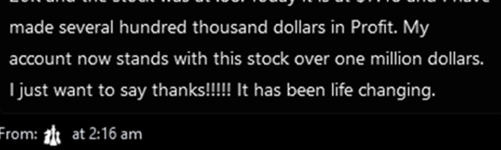
This below is for legal only (full testimonial)
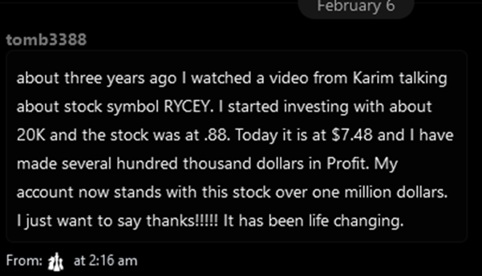
Another member of mine, ChuckD….
He told me that my Rolls pick generated enough profits for him to buy a brand new house.
He said…
“Karim, my wife and I use the money (from RYCEY) to pay cash for our retirement home in Texas. I am very thankful to you”
Graphics: Please display full screen and call out “my wife and I use the money (from RYCEY) to pay cash for our retirement home in Texas” as Karim reads it

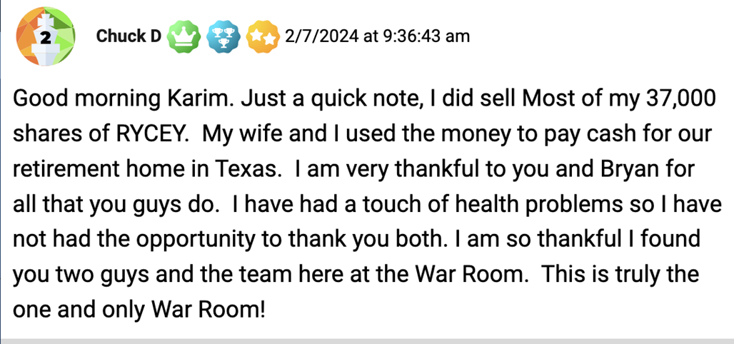
I even reached out to ChuckD to verify his story….
And he sent me this picture as proof!
So here you go...
Here’s the actual picture of ChuckD’s new Texas retirement home….paid for in cash….all thanks to my Millionaire Maker recommendation on Rolls Royce.


Check this one out….
Here’s a Google review that was just posted by my member named SugarDoc.
He said my picks helped him buy this beautiful new orange Corvette!
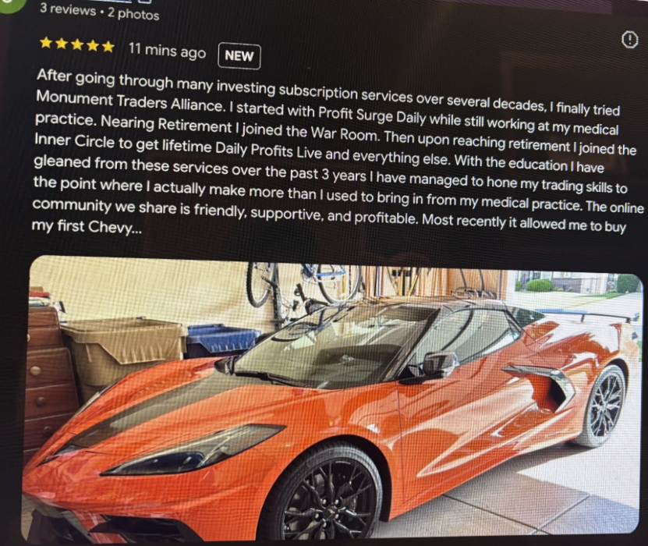
So, that’s three examples…from three of my followers….
One now has a million-dollar portfolio…
Another who bought a new house…
And another who bought their dream sports car…
But that’s just scratching the surface.
I have many, many other top members who have reported six and seven figure gains….
All thanks to my picks.
These are real people – just like you – who watched my Rolls video back in 2022 – bought my recommendation – and changed their lives forever.
It was truly a “Millionaire Maker” stock pick.
Now let me admit…
People throw around terms like “millionaire maker” all the time.
Most of the time, it’s nothing but noise…
Hot air….
B.S. hype just to grab your attention.
But that’s not the case here…
Because I’ve actually done it.
I’ve delivered for my members…
And, I have the receipts to prove it.
So yes…
Many of my followers have indeed become millionaires over the years with the help of my picks.
So, when I put my reputation on the line…
And make a claim to you that my recommendation could make you a millionaire…
That’s something I take very seriously…
Because I deliver on the promises I make.
It’s also something that I don’t take lightly.
You see, ever since making so many of my members millionaires…
What inevitably comes next is the newer people….
Who ask me…
“I Missed Rolls Royce…Can You Find Another One?”
Or more specifically….
Video: Go full screen with this question
“What Is Your NEXT Millionaire Maker Stock Pick?”
Well, I have a confession…
For the past few years…
I’ve spent countless hours scouring over company reports – looking for undervalued companies…
I’ve logged tens of thousands of travel miles on United Airlines meeting face to face with CEO’s…attending investor conferences……or seeing a company’s operation firsthand.
In order for me to make a new pick – I must be convinced that it represents an uncommon opportunity to grow your wealth at a rapid rate.
And throughout this process, I kept coming back to the same conclusion…
A pick like Rolls only comes around once in a lifetime.
You simply cannot find these types of life-changing Millionaire-maker recommendations more than once.
They simply do not exist.
But today, I have a big announcement…
One that starts with me telling you….I was wrong.
Completely wrong.
You see, I just discovered one tiny company that’s unique – so explosive – and SO undervalued – I had to share it with you today.
It trades for LESS than $1.00 per share. Way less, in fact.
And, if you get into it – starting today…
I believe it represents a new opportunity for ANOTHER 20x return.
Yes, this could be a 20-bagger….
Perhaps even a 36-bagger if everything goes as I expect.
I’m convinced that this new pick could change your life – and your future wealth – in ways that you’ve never imagined possible.
Just like when I found Rolls 5 years ago…
If this pick works out the way I think….
This could be second way to make yourself a millionaire….
Or fund your kids’ college…
Or buy your dream house….or even splurge on a new sports car.
Never in my wildest dreams would I think that I’d ever go on record again…
And say that I may have found ANOTHER Millionaire-Maker pick like Rolls.
I DID NOT believe it would happen again in my lifetime.
But today, I’m radically changing my opinion.
I’m now willing to put my reputation on the line – by releasing my newest “Millionaire Maker” stock pick right now.
And I’m so confident in this recommendation….
Because I know a winning stock when I see one.
And right now, the similarities between my Rolls pick – and this new pick – are unmistakable.
Except for the stock price…
You see, when I found Rolls, it was trading for less than $2.
This stock trades for less than 50 cents.
Way less.
That means the upside is even bigger!
And, as you’re about to see, this stock is facing a coming catalyst so explosive, it could rapidly move up in value – FAST.
The gains could start in a matter of days.
Yes, things are happening that fast.
The time to buy this stock is now.
I’ve already ran the numbers.
I’ve already assessed the opportunity.
And, I’ve already spoken to the CEO.
All the due-diligence checks out.
That’s why I’m willing to go on record – and stake my reputation – on this new pick today.
So….
Let’s start with the story behind this company.
Like most businesses, it starts with a problem – in need of a solution.
But in this case, it’s a big, big problem…
It’s something I’m calling, the Rare Earth Arms Race.
Now…
As I’m sure you know, rare earth metals are the unsung heroes powering the technologies that define our modern lives.
As a result, the entire world is on the hunt for them….
Video: Flash this image as Karim speaks the lines below
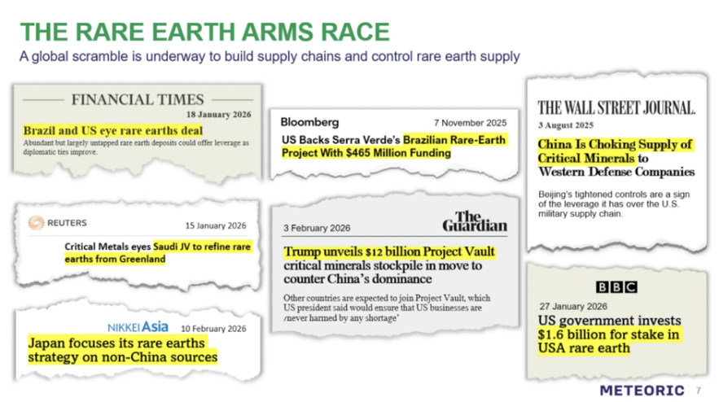
In their most basic form, rare earths make up the metals used to make high-performance magnets, which are essential components that allow modern technology to become smaller, faster, and stronger.
They’re used in motors.
They’re used in turbines.
They’re used in defense systems.
They’re used in fiber-optic cables, LED screens, batteries, and catalytic converters.
They’re also used in virtually every modern-day portable electronic device that you use on a day-to-day basis.
Plus, they also play a key role in the AI supply chain…
Such as semiconductors, data centers, robots, and drones.
So, think about the sheer size of this booming market….
Looking ONLY at robotics…
This one single market is expected to grow 480x between now and 205o….
480X growth – just from the robotics segment!
Add in everything else – and you can see why securing the rights to Rare Earth elements is truly a Global Arms Race.
It’s absolutely massive.
So, the bottom line is clear as day….
In order to support such booming growth…..the United States desperately needs access to rare earth elements.
Video: Full screen this image as Karim reads the bullet points below – highlighting each segment as he reads it off
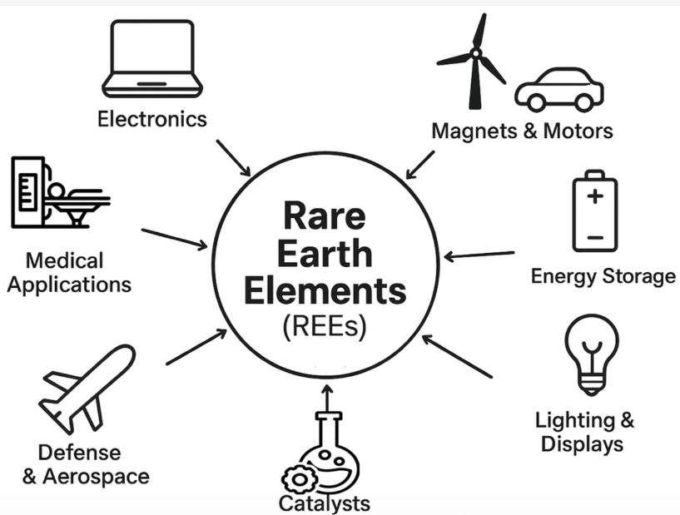
- In order to develop every modern-day portable electronic device – we need rare earths.
- In order to develop modern defense systems - we need rare earths.
- In order to develop LED screens, batteries, and catalytic converters – you guessed it – we need rare earths.
Without exaggeration, rare earth metals are absolutely critical for today’s global infrastructure.
And as you can guess, that leads us to the big problem….
You see, right now, when it comes to ownership of rare earth elements - China has us dead to rights.
China accounts for approximately 70% of global rare earth production.
And they also control over 85% of processing capacity.
When you consider the coming demand for rare earth elements, China is in a dominant position.
And that’s not good.
Because it means that China has what we need – and China hates us.
This means China can play hard ball – and we have no choice but to accept it and play along.
Just recently, China threatened to place a +100% tariff on all rare earth elements.
That’s why President Trump and China’s Xi have been in the news so much.
Tensions are high, and they’re each trying to leverage their position.
But Trump doesn’t want America to depend on China.
He hates having leverage against him at the negotiating table.
We need our own supply.
But how???
How can we control an asset that we desperately need – but don’t currently have?
Well, the short-term answer has been to dump piles of cash onto every company that has any non-Chinese rare earth exposure.
Look around, and you’ll see that the U.S. is elephant hunting for Rare Earth companies.
That’s why I told you that the Rare Earth Arms Race has started.
For instance…
The U.S. government just invested $400 million in MP Materials, the operator of the country’s only rare earth mine and processing facility.
That stock blasted from $12.00 in 2024 to $70.00 by mid-2025
That’s nearly a 5x gain in 12 months.
Graphics: Show chart with line saying “MP 5x’d after the US Government Invested”
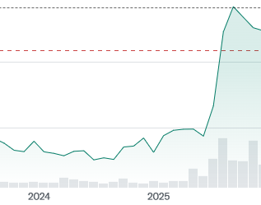
Other acquisitions and investments are coming fast and furious…
.
The government also invested in Trilogy Metals (TMQ)… which has a rare earth deposit in Alaska.
The stock went from $0.47 in 2024 up to nearly $5.00 in a year. That’s nearly a 10x gain!
Graphics: Show chart with line saying “Trilogy 10x’d after the US Government Invested”
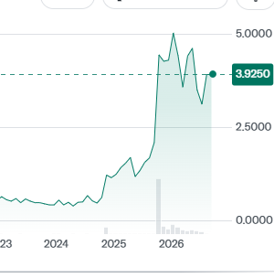
Also…
USA Rare Earth just agreed to acquire the Serra Verde Group for approximately $2.8 billion…..which was 9x their current valuation.
Imagine paying 9x the current price – just to get your hands on a company.
And despite paying this high multiple…
USAR stock still moved from $9.44 up to $32.00!
Yes, Wall Street celebrated a company paying a 9x premium – just to get rare earth exposure!
This shows you just how valuable these rare earth companies are right now.
Graphics: Show chart with line saying “USAR 3x’d After Acquiring a Rare Earth Company for a 9x premium”

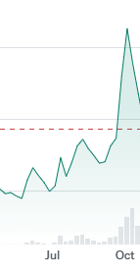
So think about it…
The US Government – and mining companies – both think this is such a serious issue, they’re prioritizing rare earths – and putting huge amounts of money behind it.
Right now, there’s an absolute global feeding frenzy occurring on any company that has exposure to rare earth elements…..or any company that could have future exposure to rare earth elements.
The cash is flowing…
The valuations are exploding…
And that’s exactly where this new Millionaire Maker stock comes in.
As we speak, one small, unknown company is on the cusp of solving the rare earth crisis for the United States.
Yes, I’ll repeat that.
They have the solution…
And they’re completely off the radar of Wall Street.
In fact, not a single Wall Street analyst is covering this company.
I found out about this opportunity through my close, personal connection with a billionaire natural resource investor.
I’ve known him for over 30 years.
And I trust him.
That’s how this game works.
This is how you get into ground-floor investment opportunities before Wall Street even has a clue.
You leverage your connections to get uncommon information before anyone else.
And that’s why I’ve made this urgent video…
I believe that what I’m about to share with you could be the biggest blockbuster story in the rare earth market has ever seen.
Just consider the facts…
First, this company currently owns the largest rare earth reserves outside of China.
They own 100% of an ultra-rare geological deposit of a material called Ionic Adsorption Clay.
Most people have never heard of this.
But it’s one of the most valuable substances on Earth.
Creating this clay is impossible for anyone to replicate.
In short, it’s created only in special regions filled with highly mineralized granite rocks and lots of rain.
When the rain breaks down the granite rocks – the deposits become dense clusters of rare earth elements.
And these rare earth elements are the most important material for modern technology.
They are used to create special high-performance magnets that do not lose their charge under extreme heat.
These special magnets are the essential components used in military, aerospace, and robotic applications.
As Science News puts it, these rare earths make…
“Possible Our Own Technology-Powered Society. [And] Demand For These Crucial Components In Nearly All Modern Electronics Is Skyrocketing.”
In short, they are the holy grail….
….which is exactly what Ionic Adsorption Clay offers.
So….
While traditional mining companies spend billions of dollars trying to crush, roast, and chemically blast rare earths out of stubborn granite boulders…
Ionic Adsorption Clay is a freak occurrence that offers a unique shortcut gifted by nature…
Surface Mining Without Blasting
The soft, weathered clay just beneath a thin topsoil layer allows excavators to simply scoop up the material.
No expensive explosives
No massive crushing circuits
No deep underground hazards
You simply wash the clay at room temperature using a mild chemical solution – and the rare earth elements simply "slide off" into a liquid concentrate.
So think about this….
Most companies require an upfront capital expenditure exceeding $1 billion – and a prolonged development timeline between 7 to 12 years – just to access rare earth elements.
But because of their access to some of the easiest and most dense rare earth deposits, this company will do it at a fraction of the cost…in a faction of the time.
And right now, as you read this…
They’ve secured a gargantuan 1.6-billion-tonne resource footprint…
Making it the largest ionic clay rare earth resource reported anywhere on earth outside of mainland China.
As you read this…
They’re about to extract this massive ionic clay asset that’ll help power the modern world— all cheaper, faster, and cleaner than anyone else.
That’s why I believe this stock represents the single most compelling risk-reward profile in the entire market today.
They have over 100 years’ worth of future production – all of which is entirely unknown to the investment community.
Why is it so under the radar?
Simple: They HAVE NOT gone into production yet.
But….they ARE on the cusp of production.
That’s super important….
You see, when it comes to Wall Street, analysts don’t assign a value to mining and exploration companies until they know one key market-based resource metric, which is…
Proven in-ground metal content.
Until Wall Street has a clear understanding of what a mining and exploration company has in the ground, they have no way of properly valuing it.
In other words…
Since early-stage explorers have no revenue or positive cash flow, the standard Wall Stret valuation tools like P/E ratios do not work.
That’s currently where this company stands right now.
Undervalued….
Mis-understood…
And completely unknown to the investment world….
But I’m here to tell you…
That’s all about to change.
You see, after spending hours talking to the CEO and other independent expert geologists, I’ve come to understand that the proven reserves of this company’s find are off the charts.
This is a piece of information that’s unknown to Wall Street - and the general public - as of now.
But when it DOES become known to Wall Street, all the firms will suddenly have to upgrade their ratings on this stock.
That’s when a stock experiences a “re-rating.”
This is the exact moment that new information gets factored into the share price, which causes investors to pay a higher price multiple.
In other words….
That’s when the stock goes up….and goes up FAST.
These re-rating events could dramatically multiply this stock’s valuation.
And, these events could happen imminently…
Which is why it’s so critical to act fast.
The first re-rating event is a final environmental study.
For every mining company, this is a formal check that looks at water safety, land harm, and air pollution.
But it also should be the first public filing that shows the true extent of this find.
It’s required before starting any mining project – and this company should receive this approval imminently.
The second re-rating event is a Construction Permit.
This is the official government authorization required before building physical infrastructure like processing plants, access roads, or waste facilities.
This is also required before starting any mining project.
And once again - this company could receive approval within the next few weeks.
As both of these events happen, this stock will start to become more of a known asset.
And that’s when I think the shares will start to rapidly increase.
Case in point….
Last September, this company received a preliminary construction permit – and just from that - the stock doubled in less than a month.
Graphics: Annotate this chart below, saying “Millionaire Maker stock receives preliminary construction permit – and the stock doubled”
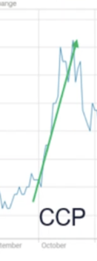
Then in December, this company received a preliminary environmental study – and the stock doubled again.
Graphics: Annotate this chart below, saying “Millionaire Maker stock receives preliminary environmental study – and the stock doubled again”

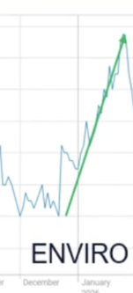
Each time this company experienced an approval event, the stock quickly doubled.
But even with these gains….
You have not missed the boat. Not by a longshot.
You see, these were the preliminary approvals.
Once they start getting permanent approvals – the gains could be far more explosive.
So, I urge you to listen to me very carefully…
And consider adding this stock to your portfolio today.
Because right now, this company is still being valued as an explorer.
But, as soon as they receive environmental approval – or a construction permit – or perhaps even both – that’s when the share price re-rating begins.
Mark my words…
The instant these happen…
That’s when this stock will trade aggressively higher.
And I’m telling you right now…
With full confidence….
Both of these re-rating events can happen imminently.
But that’s just the beginning…
There are even more re-rating events on the horizon.
A LOT MORE.
I am anticipating 6 separate re-rating events in the next 1-2 years alone.
That’s why you need to own this stock RIGHT NOW.
So, here’s my timeline….
Re-Rating Event #1 is what I call a “Technical Validation.”
It could happen within days.
When they receive environmental and construction permitting, these 2 events will dramatically alter the company’s technical valuation – causing it to rapidly spike in price.
My estimated price reaction is a +200%-300% gain.
The second Re-Rating Event is what I call “Commercial Validation”
That’s when some of the early-stage Wall Street analysts start getting wind of the sheer size of this rare earth deposit and the potential monetary value… assign buy-ratings and begin their coverage.
This generates more volume and buying liquidity moving into the stock.
My estimated price reaction from this is another +100% gain.
The third Re-Rating Event is what I call “Financing Validation.”
This company is currently in active talks with the highest levels of US government – and also the European Union - to provide financing or guarantees for their operation.
The moment any of these agreements are finalized, this could spike the stock even more.
My estimated price reaction from this re-rating event is ANOTHER +100%-200% gain.
Rating Event #4 is what I call “Off-Take Validation”
This is when a major conglomerate offers this tiny company agreeable financing terms for small parts of their operation – all in exchange for future mining revenues.
Just recently, a billion-dollar conglomerate signed a non-binding agreement to take a chunk of this company’s production.
That announcement triggered a+40% move in the share price – and there’s a lot more to come.
Deals like this can unexpectantly occur at any moment…
And the moment they do…
My estimated price reaction for any future deals is another +50% gain PER ANNOUNCEMNENT.
So, that’s four re-rating events that could all happen within the next few weeks…
But these next two are where the real explosive gains come into play…
You see, Re-Rating Event #5 is what I call a “Possible Exchange Up-Listing”
An “up-listing” is when a small stock moves onto a major stock market exchange.
As you’re about to see…
I have reason to believe that this company could soon be “up-listed” onto the Nasdaq.
And if that happens, my estimated price reaction is another gain between +100 to 300%.
And finally, we have re-Rating Event #6, which I call “Expansion of Rare Earth Mine Resource Deposit.”
This one will shock you….
You see, based on my research of this company’s property…
Everything I’ve told you so far is only based on ONLY 20% of their total mining property.
In other words…
This company has only performed geological studies on 20% of their total property size.
What that means is…
If the early readings from just 20% of their property hold up for their entire property size, then this stock could be massively under-valued at current levels.
My estimated price reaction on confirmation that their total property shows the same levels of production from the 20% they’ve currently studied is another +500% gain.
So…Listen.
That’s 6 HUGE re-rating factors – all of which are in play - right now.
And…
All 6 of them have not yet been priced into the current stock price.
To summarize….
- The Technical Validation could trigger a +200%-300% gain
- The Commercial Validation could trigger another +100% gain
- The Financing Validation could trigger another 100%-200% gain
- The Off-Take Validation could trigger a +50% gain PER ANNOUNCEMENT
- The Possible Exchange Up-Listing could trigger another 100%-300% gain
- And the Expansion of Rare Earth Mine Resource Deposit could trigger another 500% gain
Add them up…
And that’s +1,450% just from these near-term re-rating events.
But get this…
Even if this stock spiked 14x’d tomorrow, I’d still consider it dirt cheap.
Here’s why…
When I compare this stock to one of their top competitors – the upside potential is simply off the charts.
You see, this company’s main competitor has a smaller resource profile.
In plain English, that means that their deposit is geologically inferior to what this company is sitting on.
However, since this competitor is currently in production, that means that Wall Street is able on assign it a valuation multiple.
And even with an inferior resource profile, it’s currently valued at 36x this company.
So, when you consider all the re-rating triggers…
You can see why I think this stock could realistically increase as much as 36x its current price.
As some of these events start to occur, the rapid price appreciation could be massive.
$10K could grow into $360,000…
$30K could become $1 million.
And now, I hope you understand why I’m calling this stock my newest Millionaire Maker pick.
It’s trading for just pennies today.
Yet it could quickly rise anywhere from 10-20 fold, perhaps even more, in the weeks and months ahead.
So here’s the bottom line….
If you get in today…
You’ll be in at the absolute ground floor.
The stock is SO CHEAP because these events HAVE NOT happened yet.
And right now is your chance to get into this stock BEFORE these re-rating events are public.
That means, you could be getting into the biggest blockbuster story the rare earth market has ever seen – before anyone else even knows about it.
And, you don’t have to wait.
You can get access to this new pick right now.
This stock is revealed in my new report: The Next Millionaire Maker Stock.
Graphics: Show report full screen
Inside this report….
I give you the stock and ticker symbol.
I tell you where to buy it.
I tell you how to buy it on a US exchange.
And I tell you exact details of where I think it’s headed.
I reveal – in even more detail - why this could bring you an elephant-sized returns….
It’s all contained in my new report.
In fact, just to limit your risk…
I’ll also show you how your total downside on this play could be limited to just pennies.
Yes, that’s not a type-o.
Pennies!
It’s a risk management strategy that I call…
The Eternal Runway
Once you own this stock, you’ll be positioned to profit off a mine that has a projected lifespan of over 100 years.
That means the runway for this stock isn’t your lifetime…but MULTIPLE lifetimes.
You just need to buy this stock one time….
And that’s it.
Then, once you’re in…
I’ll show you how to use my risk management strategy called the Eternal Runway…
….where you take all of your risk off the table at one certain point.
And from there, every profit you make from that point on…
Is yours to enjoy forever.
It’s generational.
Almost eternal.
All risk free.
Zero downside.
A full explanation of this Eternal Runway strategy is detailed for you inside my new report: The Next Millionaire Maker Stock
Graphics: Show report full screen
The second you get this report, you’ll know the ticker symbol of this company…
Where to buy it…
What price to buy it at…
And the exact strategy for you to risk pennies – and possibly make 20X to 36X returns.
This pick has all the makings for the next explosive winner.
If you get in now, it could be the buy of a lifetime.
It’s extremely exciting…
Because picks like this do not come around very often.
Just so you can fully grasp the enormity of this new pick…
Let me quickly recap this opportunity…
First, you have a global rare earth arms race now happening – and my new millionaire maker stock pick could be positioned to solve it.
Second, they have a multi-decade mining operation – that could be months away from breaking ground…
Which represents the largest global rare earth reserves outside of China.
Third, they have over 100 years’ worth of future production – all of which is entirely unknown to the investment community.
In fact, the CEO told me directly…
“We Will be the Lowest Cost Producer Outside of China on the Planet”
And fourth, the stock is grossly undervalued.
Right now, this stock is trading for less than $1.00 per share. Way less.
If I’m right…
And this stock moves the way I predict…
This stock could trade 20x to 36x higher than today’s values – enough to create a new group of millionaires who are smart enough to follow my advice today.
And best of all….
The timeline for all of this starts in the next few months….if not days.
If you’ve ever dreamed of getting into a stock at the ground floor – and watching it explode higher for years afterwards – then there is no better opportunity on the planet right now than my new Millionaire Maker pick.
Simply get my new report…
And you’ll know the name of the stock, what price to buy it at, when to sell, and my Eternal Runway strategy on how to risk only pennies to enjoy a free ride for 20x to 36x returns.
That alone could dramatically multiply your future wealth.
But there’s an even more urgent reason to buy right now…
Which most investors do not understand.
It’s called The Lassonde Curve
Now, stay with me…
Because this is super-important in how to understand where this stock currently stands in their growth cycle.
The Lassonde Curve was created by mining expert Pierre Lassonde.
It shows how a junior mining company's share price changes as it moves from a raw land concept into an actively producing mine.
The key phases of the Lassonde Curve start with the Exploration Phase.
Graphics: Annotate this chart – by revealing the lines and phases of the curve below– as Karim explains them. Only reveal where the Millionaire Maker stock currently sits when he gets to that part of this explanation
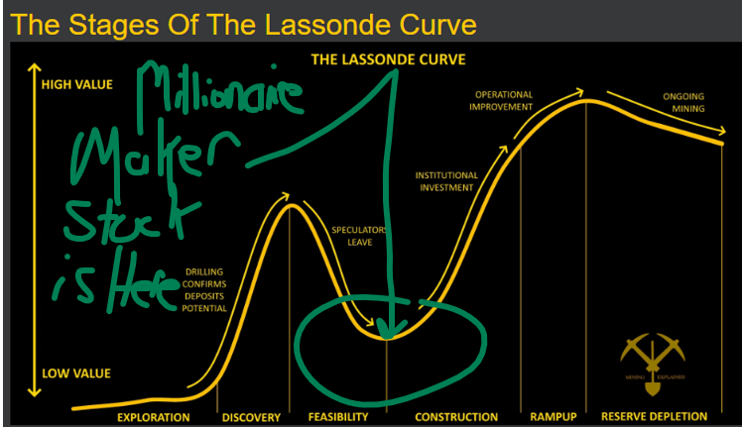
That’s the start of the project.
Risk is very high, and value is low – simply because geologists only have a theory on what’s sitting below the surface of their property.
Then you have the Discovery Phase, which happens when a small exploration company gets early drill results that reveal valuable minerals.
This is when speculation peaks, causing the company's stock value to spike rapidly to its highest early point.
Remember when I told you how this stock doubled – and then doubled again – after receiving preliminary environmental and construction permitting?
That was the stock pop from this discovery phase.
But what comes next is crucial…
You see, the Feasibility state is when share prices drop heavily.
This is because the excitement from the discovery period fades – and reality sets in.
The company must now spend time and money doing engineering studies without quick market rewards.
This is where the hard work begins.
It’s also when the early speculators lose interest.
So, they move into the next hot stock….
And the share price dips back down.
But here’s the thing…
This phase is actually the very best time to step in and buy.
During the Development/Ramp-Up phase, this is where the future potential of the company starts to unfold.
If the deposit appears strong…which my research confirms….
And the mine appears promising…which my research also confirms….
That’s when the project gets de-risked through official plans, permits, and funding.
What was once a speculative opportunity is now becoming the real thing.
That is precisely what we have with this stock.
So…..as this news start to break…
That’s when big investors return.
The valuation begins to get take shape….
And the stock value starts climbing back up – at an even higher rate than before.
Then, the true payoff comes when the mine opens and generates real revenue.
And this leads to the most important part….
Get ready, because here’s why I just walked you through this curve…
Right now, at this very moment, we’re in the exact “sweet spot” on the Lassonde Curve.
This company is transitioning past the heavy study phase and into the aggressive development and financing runway.
They’re on the cusp of announcing the key milestones that build tangible value.
As you just learned….
Their global mineral resource could soon get re-valued at a massive scale…
Their regulatory de-risking is currently taking place…
They’re attracting strategic backing…
And all of this is about to happen – at any moment….
Which makes the investment opportunity clear as day.
Add it all up…
And here’s where my Millionaire-Maker pick currently sits on the Lassonde Curve.
Graphics: Reveal what I annotated in green on the image above
This is the EXACT MOMENT to buy this stock.
Not tomorrow.
Not next week…or next month.
NOW!
And just so you’re clear…
There’s an even bigger catalyst coming.
You see, I have it on good authority that this company could get financed by the U.S. Government.
In my recent conversation with the CEO, he did not mince his words.
He flat out told me…
“We’re Talking to the US Government at the highest levels”
He also said that he wants his rare earth elements to go to the US – not to China.
He said…
“We Want Our Material To Go To The US. It’s A Deal I’ve Always Wanted To Do”
Even when I pressed him…
And asked whether or not a financing deal will happen soon, he flat out said…
“We Will Get A Deal Done. We Will Be Funded”
And here’s the part that stopped me dead in my tracks…
I asked him…
If you get a deal with the U.S. Government, what happens to your stock?
Without hesitation, he replied….
“The Stock Explodes Tomorrow - We’re Going To The Moon”
There’s no better scenario than an unknown stock…
Trading less than $1.00 per share….
Landing a major financial deal with the U.S. Government.
Just imagine owning this stock if that news breaks.
The gains just that day could be enormous.
And remember….
These explosive gains could come after you’ve already watched the stock double or triple from the environmental study re-rating…
And after you’ve watched the stock double or triple again from the construction permit re-rating!
Are you starting to see why I’m convinced that this could be a 20-36 bagger?
After the news breaks about a finance deal with the U.S. Government, that’s the time when every Wall Street analyst will FINALLY takes notice….
They’ll all rush in to cover the stock – assigning it a “buy” rating with price targets well above current levels.
This is when the public money starts to flow in…
And when a few financial news outlets start to cover the stock….
Or when a few speculative hedge funds start accumulating shares…
All of this does nothing but push your Millionaire-Maker stock higher and higher…
After a few months of this…
Then comes the life-changing pay-off….
The one that could make you rich beyond anything you’ve ever imagined possible.
As I mentioned earlier, it’s something called “Up-Listing”
This describes the moment a stock gets elevated from a smaller market exchange – to a major stock exchange.
In the case of this Millionaire-Maker stock….
I have a high degree of confidence based on my conversations with the CEO that a Nasdaq listing could be on the horizon
If this happens, it could represent the moment that could make you rich for generations to come.
Consider what happened with Monster Beverage (MNST).
They were originally an energy drink company trading on a lower-tier exchange under the name Hansen Natural.
Then, they up-listed into the Nasdaq – changed their name to Monster Beverage – and experienced one of the greatest performing stock valuations in market history.
After pursuing a Nasdaq up-listing, Monster Beverage has gained 817,000% over the last 30 years.
That means every $1,000 invested in MNST before moving over to the Nasdaq…
Is worth $81 million today.
Of course, this is one of the greatest up-listing examples in history.
But…
It just shows you how powerful a successful up-listing can be for any small, rapidly-growing companies.
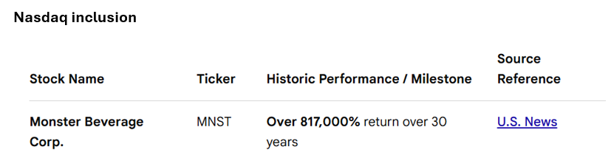
And just for full transparency…
Monster isn’t the only 30-year Nasdaq up-listing example.
Other popular winners include…
- NVDA, which gained 487,000% after up-listing
- AMZN, which gained 310,000% after up-listing
- AXON, which gained 101,000% after up-listing

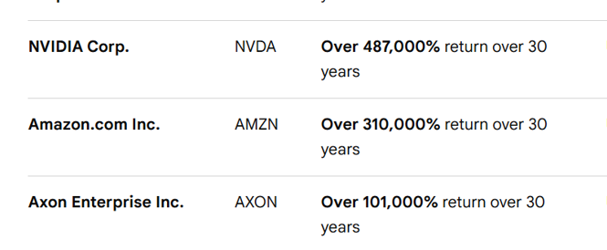
So, when a small – but growing – company successfully moves from one exchange onto the Nasdaq, that’s when the life-changing returns could begin.
And look, here’s the best part…
You don’t even need to wait 30 years to see tremendous returns.
Just recently, Celsius Holdings (CELH) got up-listed…
It moved up +200% in the 6 months leading up to its official Nasdaq debut – and then immediately gained another +130% from there.
Marathon Digital (MARA) also just got up-listed…
It moved up +150% in the 3 months leading up to its official Nasdaq debut – and then immediately gained another +30% from there.
Riot Platforms (RIOT) also just got up-listed…
It moved up +100% purely on the uplisting intent notices – followed by another +30% gain from there.
So, based on these up-listing returns….
And factoring in the situation with my new Millionaire-Maker stock pick….
Let’s talk best-case scenario….
First, you buy the stock at current levels today – and you’re in for way less than $1.00 per share.
A few days later, the stock triples when they get their environmental study….
Then, the stock triples again then they get their construction approval….
You’re already up +600% in the blink of an eye.
Then, news breaks about a finance deal with the U.S. Government.
This is a major re-rating moment.
Wall-Street analysts all start piling in…
Assigning “Buy Ratings” and aggressive price targets….
All of which pushes your stock even higher.
You could easily be up 10x or 15x.
But, you’re still just warming up.
The next big moment would be the Nasdaq up-listing.
The stock could 3X again.
And in total, you’d be up nearly 20x…
Perhaps even more.
That’s how big this could be.
However, I’ve been in this business a long time. I know not everything will go perfectly.
So now, let’s discuss what could go wrong…
For instance, say there’s no financing agreement with the U.S. Government.
That would be disappointing, of course.
But a company with this kind of resource deposit isn’t just attractive to the U.S. government.
This stock’s deposit is so big, it could become a major takeover target – and that comes with a massive price valuation multiple as well.
Case in point…
USA Rare Earth just agreed to acquire the Serra Verde Group for approximately $2.8 billion…..which was 9x their current valuation.
So, even if the best-case scenario doesn’t play out exactly like I outlined above…
You still have one of the best opportunities to make one of the strongest investments of your life – starting right now.
Even if the miss a re-rating event or two, you still have a very, very long runway for explosive gains.
Without a single ounce of hype or false praise…
Never before have I come across an investment opportunity with this many explosive trigger catalysts – all on the verge of occurring.
Owning this stock today…
While it’s still undervalued and unknown…
Could be the most powerful investment you’ve ever made in your life.
In fact, when I think about the enormity of this opportunity…
It feels like owning American oil in the late 1800’s.
That’s when John D. Rockefeller founded the Standard Oil Company – and eventually controlled 90% of U.S. oil refining – all before anyone truly realized the global importance of oil.
At the time of his death in 1937, Rockefeller had an estimated net worth of $1.4 billion, making him America's first billionaire.
To this day, 150 years later, the Rockefeller family is still rich…
Enjoying their mansions and servants…
And to me….right now….when I look at this opportunity….
This could be your Rockefeller moment.
You’d be owning a company that could solve the Rare Earth Elements problem in the U.S. for the next 100 years.
This is the closest thing to what John D. Rockefeller did when he founded Standard Oil.
That’s why I’m so confident when I say…
This one trade checks EVEY SINGLE BOX I look for in a potential life-altering investment.
And remember, when I make a promise, I do my level best to deliver
This is the same process I’ve used to discover my Roll Royce recommendation – and those who followed me are still reporting monster gains.
For instance, here’s a note from a member named Francis, who bought 10,000 shares for $0.80…
And just sold for $18.60.
That’s a 2,200% gain!
Another member, Chris T, bought 22,000 shares at $1.08.
At current prices just below $20.00, that means he’s showing a profit of $370,000.00.
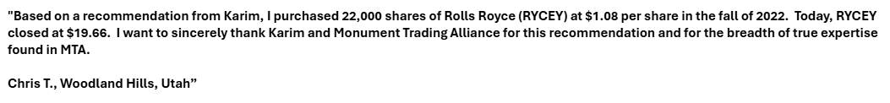
If you missed my Rolls pick….
Then you now have a rare chance to do it again.
So, take a moment and ask yourself…
“How many 20x to 36x opportunities are you holding in your portfolio right now?”
If the answer is “not many”…
Then we can fix that right here – and right now.
It starts with getting the pick revealed in my new report: The Next Millionaire Maker Stock.
Graphics: Show report full screen
Inside this report….
I give you the stock and the ticker symbol.
With a few clicks of your mouse – and a very small initial investment - you can own thousands of shares of a company that owns one of the largest rare earth deposits in the world – which is NOT committed to China.
I’ll tell you where to buy it.
And that’s important.
You see, at this point, I can tell you a little secret…
Most investors don’t even know how to buy this company – because it does not trade on the Dow, Nasdaq, or S&P 500.
This throws a lot of investors off.
However….
This is a special way for you to get in…
One that DOES allow you to buy it on a US exchange.
Today, I’ll give you the exact instructions on how to do this.
So, while everyone else is blind to this opportunity, I’ll show you exactly how to own it with a few clicks of your mouse – using the brokerage account you already have right now.
I’ll also tell you exact details of where I think it’s headed.
I reveal – in exact detail - why this could be a 20x to 36x return.
It’s all contained in my new report.
And to limit your risk…
I’ll also show you how my Eternal Runway strategy could reduce your total downside risk on this trade to just pennies.
Everything is revealed for you inside my new report….
The Next Millionaire Maker Stock
Graphics: Show report full screen
Best of all, you can get this report right now …100% for free.
All I ask in return is that you join my research service called Monument Trend Advisory.
You see, this new pick is so important, I’m only sharing it with my paid readers.
This ensures that only my top clients will get access to my very best picks.
If you’d like me to send you a copy today, then you’re invited to join this elite community of investors.
As you’ll see…
Monument Trend Advisory gives you a real market advantage.
I’ll share with you how to profit from this situation now... before the mainstream media picks up on it.
Get in now... and you have the chance to be part of that ride.
Wait and see what happens in the days and weeks ahead... and you’ll miss the ground-floor opportunity forever.
As a new member to Monument Trend Advisory, you’ll get three unique things every week that no other services offer…
First, I’ll send you Trade of the Day emails, breaking down what we’re watching in the markets.
Second, I’ll send you a monthly field report every month – which provide you with my very best recommendations.
And third, I’ll go LIVE for 30 minutes every Tuesday afternoon to give you full updates on this new Millionaire Maker pick.
Alongside my co-founder Bryan Bottarelli, we’ll give you live, weekly updates on this pick – plus any others – that need our immediate attention.
Best of all…
You can chat with us during every session – LIVE and unscripted!
That way, we can always be in full contact – and offer full support and transparency – with every single pick that we make.
As you’ll see….
This livestream component is a great way to stay in contact with me…
While getting timely updates on every pick along the way.
For instance…
If I get a new report from this company’s mine production, I’ll share it with you live each Tuesday.
If I get new information from the CEO, I’ll share it with you live on Tuesday.
This is what really sets us apart.
I give you access to information….
And LIVE weekly updates…
That you won’t get anywhere else.
A great example of this is Seabridge Gold (SA)
This stock has gone from $10.00 up to $40.00 in just over a year.
I recommended the stock to Monument Trend Advisory members…
I even invited the Seabridge CEO, Rudi Fronk, to join our Tuesday livestream to discuss the company!
This is the level of access you get with Monument Trend Advisory that you won’t get anywhere else.
Graphics: Illustrate this chart to show SA stock moving from $10 up to $40 and say “Seabridge Up 300%”

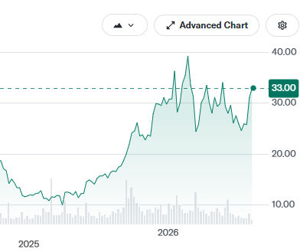
Graphics: Add a Screen Shot me a TPU Livestream episode with Karim, and Rudi
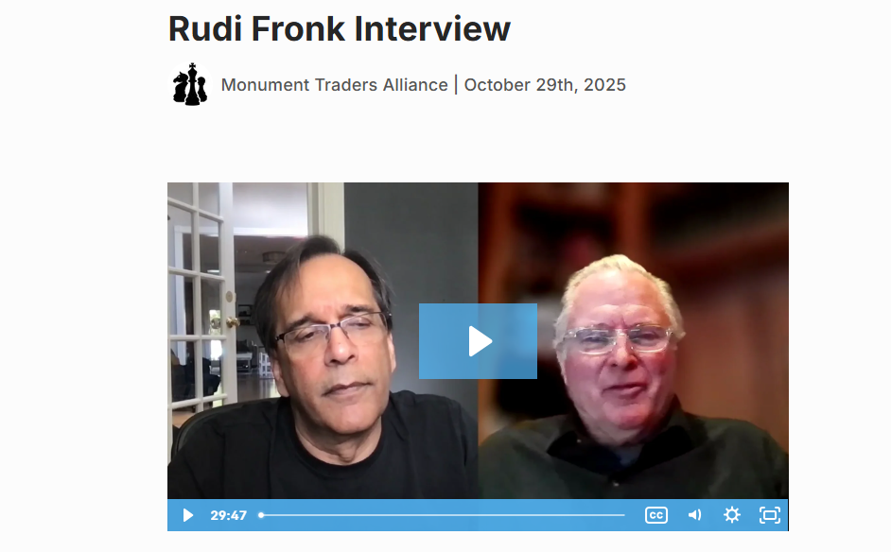
https://monumenttradersalliance.com/monument-trend-advisory/recordings/catalyst-cashouts-live-10-28-25-rudi-fronk-interview
Look... you know that the market changes dramatically.
So, I’m here to keep you fully updated on these changing events – LIVE each week.
And all the while…
I’m always looking for opportunities regular investors don’t see.
The instant I find one, I can share it with you – and other paid members – so you can immediately take advantage of every timely profit opportunity.
Nowhere else will you get this level of in-depth research, analysis, and live guidance.
Listen... if you wait for the mainstream media to tell you where to invest, you might as well just turn your bank account over to Wall Street.
The media loves to tell you about stocks that have already gone up.
What happens is that you end up buying at the tail end, just before the stock goes back down.
What I offer you is the opposite.
I’ll tell you about stocks like my new Millionaire Maker pick…
That are trading for less than $1.00…
And that are undiscovered by the media and other investors….
Which have the ability to 20x to even 36X your starting stake.
This is when you should be buying these stocks…
On the ground floor – while they’re unknown and undervalued.
NOT after Wall Street gets in – and starts blasting buy ratings on CNBC.
This is exactly what I did with current Monument Trend Advisory members with Rolls Royce.
Thanks to this one pick, many of my members now have million-dollar accounts…
Others bought themselves a new house….
While others bought their dream cars.
But if you missed out on this pick, then I’m about to do it again.
DO NOT miss this new ground floor opportunity.
If you’re ready to join me…
Then I urge you to take a membership Monument Trend Advisory right now.
A one-year subscription costs $249.
It’s a fair, entry-level price for those who are busy…
And cannot follow the markets every single minute of the day…
But still want to receive picks that they won’t hear about anywhere else.
These are simple-to-make picks….
Which you can easily buy and hold…
And watch move up 10x, 20x, perhaps even 36x in the months and years that follow.
My newest Millionaire Maker pick offers you this exact scenario.
First, it’s cheap. Insanely cheap.
Second, it has a series of major upside trigger catalysts that’ll happen very soon – any of which could send the shares blasting aggressively higher.
Third, they’re about to solve the rare earth elements problem for the U.S.
And fourth, they’re still a Wall Street secret. Not a single analyst has a price rating on this stock – making it basically invisible to every current investor.
At these levels, this is the buy of a lifetime….
One that I DO NOT want you to miss.
That’s why you need to get into this pick right now.
So, let’s do this…
To ensure that you get in, I’m going to make this a drop-dead, no-brainer, can’t-miss situation.
Which means I’ll offer you the very best deal we offer.
I just told you that the normal price for Monument Trend Advisory is $249.
But, if you join right now, I’ll knock $200 off.
That’s a huge discount…
80% off.
Making your 1-year price...
Just $49.
Graphics: Please insert order link at this price reveal – and keep it up on screen (lower third perhaps) for the remainder of the promo
That’s a full year... all for less than $5 per month.
It’s $0.13 per day.
YES! SEND ME YOU NEXT MILLIONAIRE MAKER PICK
It almost seems laughable….
But this is important to me.
For the last 5 years, I’ve been trying to find a pick just as strong as Rolls Royce.
Picks like this do not come around too often.
You uncover these opportunities once in a lifetime, if you’re lucky.
But right now, I’m willing to put my reputation on the line…
Because I’m confident that my newest Millionaire Maker pick is one of the only truly great buys left on the market.
It’s less than $1.00 per share….
But it has the potential to 10x, 20x, or perhaps even 36X in value.
I’ve done it before – and now – I’m prepared to do it again.
So, to make this decision easy for you…
You can sign up right now for -80% off.
The moment you do, you’ll get the Millionaire Maker pick.
And from there, you can decide whether I’m the real deal or not.
In fact…
I’ll give you 365 days to try everything – all at zero risk.
This allows you to get my new Millionaire Maker report….
Attend my 30-minute livestreams on Tuesday…
And read all 12 of my months issues as they come out.
If you decide that these picks don’t work for you, then no hard feelings.
You can have a full refund.
With the track record I’ve delivered, you’d be crazy to give up your membership…
But that’s exactly why I’m doing it.
I’m so confident that you’ll see results…
I’m willing to offer you a discounted price – and back it up with a full refund guarantee – all to ensure that you DO NOT miss my newest pick.
What I’m offering you right now represents the best product - offered at the best price.
And just so you’re clear…
You keep everything you received as a subscriber – at no charge – even if you do decide to quit.

RISK-FREE GUARANTEE
You Get An Entire Year To Review Everything
If Anything Doesn’t Live Up To The Billing... You’re Welcome To A Prompt Refund
This Risk-Free Guarantee Applies For The Next 365 Days
Even If You Cancel, You Still Keep Every Report At No Charge
So basically…
If you join today - you keep everything no matter what.
Does it get any better than that?
All the risk is on me to deliver...
Which is exactly what I plan to do, starting with the new Millionaire Maker stock pick I told you about today.
To receive my special report detailing that stock, just click the button below to get started right now.
YES! SEND ME YOU NEXT MILLIONAIRE MAKER PICK
Clicking will take you to a secure order form.
There, you can review everything we’ve discussed.
While you do….
Here’s everything you’ll get today when you join Monument Trend Advisory…
- Daily Issues of Trade of the Day – Our team will send you briefings every day, detailing what you should be watching in the markets. We’ll give you the top-moving stocks, explain trading strategies and give you an idea where markets are headed next.
- 12 Months of New Monument Trend Advisory Recommendations – The first week of every month, you’ll receive a new written issue detailing the #1 investment opportunity that month.
- My New “Millionaire Maker” Stock Pick– My brand-new write-up will break down everything you need to know about my newest pick. You’ll get instructions on how to buy... learn how to ensure you pay the best price... get details on the company’s growth plan.
- Access to Our Model Portfolio, With All Current Recommendations
- Access to Our VIP Moderation Team – Any questions you have regarding your subscription can be answered quickly by our full-service staff. Please feel free to call or email them anytime.
- Password-Protected Access to Our Monument Trend Advisory Website – Here you can see past issues, access the portfolios and read our latest market breakdowns.
Graphics; Show product cluster
To get all of this right now, simply click below to get started.
Remember, the new Millionaire Maker stock I’ve told you about today is unlikely to stay cheap for long.
People are looking for the next companies to soar….
The global Rare Earth Arms Race is on…
The Nasdaq Up-Listing trigger could happen….
And, this company has a long list of re-rating news items that could all happen any day now.
So clearly, the case is laid out for 10X, 20x, even 36X returns…
Of every single stock I follow…
This one is in perfect position to deliver the next life-changing return.
Just consider, it currently trades for less than $1.00…
And nobody realizes what you now know.
As soon as they get an approved environmental study…
Or an approved construction permit….
Or a deal with the US Government…
This stock could 10x in value – and still be insanely undervalued.
That’s how crazy cheap it is.
I predict you could see a 20x return the near future... which could make you 2,000%.
It’s entirely possible that you make a lot more.
That’s the potential you’re looking at here.
But only if you get in now.
So ask yourself...
Is that type of reward worth the risk?
Is it worth at least taking me up on my 365-day risk-free guarantee?
That’s a question only you can answer, but I believe the answer is clear.
And time is of the essence.
If you wait until this stock doubles…..and doubles again…..
You’ll be sitting on the sidelines – missing out again – while everyone else is getting rich.
Do not let this happen to you.
If you missed my first 20-bagger on Rolls Royce…
Then here’s your chance to get my newest Millionaire Maker pick.
Graphics: Show report full screen
There may not be another trade like this for the next decade.
I don’t see one single stock trading at this price - with this much upside...
This is the one.
So, the time to get in is now.
Click the button below to get started.
Go ahead and do that right now.
YES! SEND ME YOU NEXT MILLIONAIRE MAKER PICK
And just to make this decision a complete no-brainer…
I’ll also throw in two additional BONUS reports.
The first is called…
The Greatest Stock Story Ever: How ONE Tiny Stock Revolutionized the Tech Industry
Graphics: Show report on screen
Wall Street has completely missed the choke point in AI infrastructure…
Which is power delivery.
I’ve found the one company that's solving this problem – and the numbers are staggering:
This technology uses 40% Less Energy consumption compared to silicon…
While also having 100x Faster Processing….
And 3x Faster Charging!
Best of all, this is all protected by 145 unique Patents…
A Nvidia Partnership…
Zero debt….
50%+ Margins…
And a multi-year runway.
This stock is a BUY right now.
And if you join Monument Trend Advisor today, you’ll get the name and ticker symbol.
It’s all revealed in your first special BONUS report.
But that’s not all..
The second BONUS report you’ll get it called….
The Ultimate Stock Unicorn: The Most Wildly Profitable and Insanely Cheap Stock in the Market
Graphics: Show report on screen
Unicorn stocks are incredibly rare…
Because they’re companies that are wildly profitable - and yet – they’re still insanely undervalued.
These are the stocks that fortunes are built on.
If you can find them…
Unicorn stocks create life-changing money.
And right now, I believe that only one stock, out of all the 23,000 publicly traded stocks, qualifies as a unicorn…
And that’s why Wall Street is loading up.
BlackRock increased their position to 32.1 million shares
Charles Schwab added 12.9 million shares
Vanguard owns 48.6 million shares
And….
You should own shares as well.
The moment you join Monument Trend Advisor, you’ll get the name and ticker symbol of this unicorn stock.
It’s a buy – and it’s all revealed in this special BONUS report.
Both reports…
The Greatest Stock Story Ever….
And
The Ultimate Stock Unicorn
Are yours – for free – the instant you join.
Graphics: Show all 3 reports on screen – with explosion captions around the two BONUS REPORTS!
And don’t forget…
The guarantee you’re getting shows you how confident I am in the work I do... and the success I’ve had with my past picks.
I’m willing to put every bit of risk on my shoulders.
And if I don’t deliver, you get every penny back.
If that sounds fair, then it’s time to make your move.
Make a modest investment in your future wealth, and sign up now.
Above all, I look forward to welcoming you to Monument Trend Advisory.
I’m Karim Rahemtulla. Thank you for watching.
I look forward to you profiting off my newest Millionaire Maker stock pick...
And…
I’ll see you on our weekly livestream for full updates!
YES! SEND ME YOU NEXT MILLIONAIRE MAKER PICK
P.S. One more quick thing…
As you’re filling out the order form, keep in mind what the CEO recently told me…
In terms of a US deal, he said…
“We’re Talking to the US Government at the highest levels”
When pressed about financing, he said…
“We Will Get A Deal Done. We Will Be Funded”
And when I asked him what could happen if a deal happens, he said…
“The Stock Explodes Tomorrow - We’re Going To The Moon”
The timeline is in motion, and the clock is ticking.
You have one chance to get into this stock at ground-floor valuations, and that time is now.
So don’t wait.
Sign up for Monument Trend Advisory now, and I’ll send you my newest Millionaire Maker stock pick.
This is a rare chance to get into a life-changing trade at rock-bottom prices.
Do not miss it.
With that, I’m Karim, signing off.
YES! SEND ME YOU NEXT MILLIONAIRE MAKER PICK

Legal Backup
https://miningexplained.com/the-lassonde-curve/
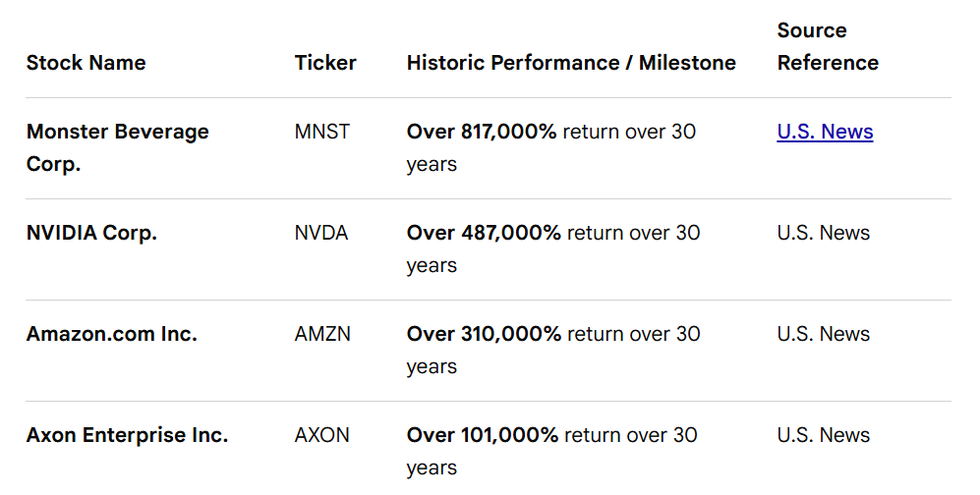
Case Studies: Pre- and Post-Uplisting Short-Term Returns
The following concrete examples highlight how specific companies performed in the exact months surrounding their major exchange debuts:

Marathon Digital(NASDAQ: MARA) Speculative Run-up: During its transition phase from an OTC microcap to a senior exchange, retail hype and crypto-focused momentum caused a 150%+ price spike in the 3 months leading up to structural regulatory approval. Immediate Volatility: Because senior listings require a clean capital profile, the stock experienced massive short-term volatility, popping an additional 30% in its first weeks before facing dilution from secondary capital raises.
Finsight / Riot Platforms(NASDAQ: RIOT) The Hype Window: In the 60 days before transitioning its structure to meet senior exchange guidelines, speculative buyers frequently bid the OTC shares up by 70% to 100% purely based on the uplisting intent notices. Post-Listing Exhaustion: While the stock "popped" on day one due to new brokerage apps (like Robinhood) allowing access, the following 90 days saw a 30% retraction as the company executed underwritten public offerings to secure cash reserves.
DeFi Technologies(NASDAQ: DEFT)
The 2025 Campaign: Ahead of its transition to the Nasdaq Capital Market in May 2025, the company used its OTC base to aggressively court retail volume. Visibility Boost: The initial listing announcement yielded a double-digit price pop, but long-term gains were tethered to the broader digital asset cycles.
________________________________________
Anatomy of a Short-Term Uplisting Return Profile
Analyzing these movements reveals a highly repeatable mechanical pattern:
1. The Pre-Listing Phase (T minus 90 Days)
• The Mechanism: Companies file initial intent documents or execute a mandatory reverse split to meet Nasdaq's minimum share price requirements (often $3.00 to $4.00). [1, 2, 3, 4]
• The Return: This is typically where the largest "pop" occurs. Low-float OTC shares are easily squeezed upward by retail investors front-running the institutional transition, often netting 40% to 150% gains before the actual migration day.
2. The Day-One Launch Window
• The Mechanism: The ticker symbols are mapped to major electronic brokerages that do not support OTC trading.
• The Return: A brief, high-volume opening spike occurs as a completely new demographic of retail investors can suddenly execute buy orders. [1]
3. The Post-Listing Dilution Phase (T plus 30 to 90 Days) [1]
• The Mechanism: Under Nasdaq's amended enforcement rules, uplisting companies utilizing an underwritten public offering must satisfy a strict Minimum Value of Unrestricted Publicly Held Shares (MVUPHS) threshold—typically generating $5 million to $8 million in clean offering proceeds. [1]
• The Return: To clear this hurdle, companies must issue fresh blocks of stock. Consequently, within 90 days of listing, the stock often sheds 20% to 40% of its initial pop due to this new market dilution. [1]

So, if you’re ready, then here’s exactly the timeline that the CEO just told me…
Magnets for Electric motors: 20x stronger than the same weight
Rare Earths are in every single electronic devise that we use.
US faces two choices…
Either stockpile rare earth elements…
Or pay 9x premiums to acquire current companies (USA Rare Earths)

It all starts with the precious resource that they control…
Which is called “rare earth ionic absorption clay.”
Problem
Race Earth Demand/China Dominance
Cannot Afford to Lose: No Second Place
No choice but to control Rare Earth Elements
Those who DO control Rare Earth elements (China) hate us. China plays hard ball.
We need it. We don’t currently have it.
Results: Buying Rare Earth Companies at 9x valuations (Elephant Hunting)

5 Re-Rating Triggers
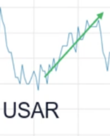
China Hard Ball Trigger: September of 2025, doubled in 2 weeks when Trump started fighting with China over Rare Earth. Value of this company can increate with any future fight. Why? More favorable to US. If China eliminates Rare Earth to the US. This company could 10x. they hold one of the only major deposits outside of China.
We know that exploration Companies Don’t’ Start Making Money Until They Get Into Production.
Ok fine.
But after taking to CEO, we know that production is starting immediately
That means the stock could explode at any moment.

Like a Phase III FDA drug trial: Drug get approved, stock blasts off. This is the exploration company equivalent.
CEO Call Quotes 7/27/2006
“You can see how much trouble the US is in already”
Lassonde Curve
“Deal I’ve always wanted to do”
“We want our material to go to the US”
“This Stock explodes tomorrow”
Exploration: +100 years of mining life
“Talking to the US Government at the highest levels”
What would make the US Government call you tomorrow and say “Name your price?”
Why nobody knows about this yet? Aussie Company operating in Brazil
GOAL: enough to supply US and Europe
Valuation: Linas Rare Earth: $15 billion market cap (we have twice of what they produce)
Show chart and goal: Where we are now: where we have the potential to go
“Bigger than Linas: 30x where we are now”
“Best Project on the Planet”
“we might get taken over”
Holy Trinity: Most metal, best recovery, longest mine life
Actively pursing a NASDAQ listing : debt financing
USA Rare Earth Cera-Verte – private acquisition
CEO: 12 cents up to $1.86
CEO Notes
It's in a large volcano in the middle of Brazil and we've already defined over 220 years of mine life at our initial production rates

We have the largest reserve outside of China.
Meteorics today have the largest rarer resources in the world.
We have 1.5 billion tons, which is more than 200 years of my life.

And we are negotiating with two markets, particularly the US market and the European Union markets, because we know that monopolies are not good for the world.

We have a pilot plant working since December.
The pilot plant we could license the pilot plant in three months.
We build the pilot plant in three months.
We license in three months.
And we are producing some memory from the pilot plant since December last year.
So it's a very, very fast track processing in Brazil right now for projects which are considered strategic for the country.

So we have our environmental service delivered in May 2024.
We had our first preliminary license granted in December 2025.
We launched our installation license in March, 2026.
We got a few inspections in 27 and 28 of May, and we are expecting to have our construction license by September, October, this year.
As soon as we have the installation license granted, we are ready for final investment decision.

For that, we are in deep conversations with both the US government and the European Union.
The picture there was the European Union Commission that went to Brazil a couple of weeks ago.
for a meeting, there was a second business meeting between European Union and the Merkel Su, after the signature of the deal between Merkel Su and European Union.
The guy who was shaking my hand there is the general commissioner of European Union.
In that picture also the director of the Brazilian Development Bank, the director of European Development Financial Institutions and the European Investment Bank.
So that shows how important markets, Western markets have seen the projects.
We are very close to finding the right partner, even if it's US, even if it's European, even if it's both.
And find a project financing solution for us and start building that new market.
We have a letter of interest from the US EXIM Bank, $250 million.
We have Export Finance, Australia, $50 million letter of invitation cited as well.
We are top with DFC, and we are the first one in the list of the Brazilian Development Bank for Project Finacy in the railroad company Brazil.

“Our share price should not be where it is now. So you better get in” – CEO
But rare earth exploration in Brazil has gone bananas, and there's been a lot of success. Now, we're at the forefront of that success, and we are the biggest project in Brazil.

Tensions have cooled, but the AI race is far from over. After weekend trade talks, China agreed to delay rare earth export controls and the U.S. paused plans for new 100% tariffs. Presidents Trump and Xi are expected to meet soon
Source: https://am.jpmorgan.com/us/en/asset-management/adv/insights/market-insights/market-updates/on-the-minds-of-investors/why-are-rare-earth-metals-important/

Short Term Catalyst: Construction permit 2027 start construction, 2028 up and running
Medium Term Catalyst: Nasdaq listing
Long Term Catalyst: Supplying US and Europe with Rare Earth elements

Valuation: Linas Rare Earth: $15 billion market cap (we have

What Re-Rating Means for a Stock

Top triggers:
Upcoming construction permit
Shares should re-rate if this happens. It will be green light for the rest of the project.
Major investors buying shares
Largest rare earth deposit outside China
Shares trading at .2 of Npv. Competitors trading at 1.2 to 1.8 times npv once production begins
At our limit price the upside is 10x within a couple of years and we think you could take your initial investment off the table well before then and FREE RIDE the rest.
Well connected to the government
Trading 40% below its 52-week high
Unknown to most of the world but not for long
In talks with US and EU to help finance mine construction
Expects to be in production in 2028
1 year buildout from approval - time is of the essence
Easy mining process compared to traditional mining means $$ sooner hence the urgency
=========================
The Caldeira Catalyst: Decoding the Financial Blueprint of Meteoric Resources (ASX: MEI)
The global race to secure non-Chinese magnet rare earth elements has forced Western markets to look beyond traditional, capital-intensive hard-rock mines. Sitting at the epicenter of this structural shift is Meteoric Resources NL (ASX: MEI / OTC: METOF), a junior development company advancing its flagship Caldeira Project in Minas Gerais, Brazil.
Caldeira represents one of the world's highest-grade undeveloped rare earth ionic clay deposits. As the company marches toward commercialization, a deep dive into its financial architecture reveals a compelling disconnect between its current market valuation and its future cash-generating potential.
1. The Valuation Gap: Market Cap vs. Post-Revenue Projections
Meteoric Resources currently operates as a pre-revenue exploration and development firm. Consequently, standard backwards-looking financial metrics such as price-to-earnings (P/E) ratios are entirely absent. The true valuation narrative lies in the forward inflection point modeled for late this decade.
Current Valuation
• Share Price: ~A$0.17 to A$0.18
• Market Capitalization: ~A$420 million to A$480 million
• Active Corporate Overhead: Annual net income sits at a deficit of -A$33 million to -A$36 million, driven entirely by Definitive Feasibility Study (DFS) engineering costs, environmental permitting, and corporate administration.
The 2028 Revenue Inflection
Institutional consensus models project that Meteoric will transition out of its development phase and achieve commercial first production by 2028.
• 2028 Projected Revenue: AU$198 million to AU$396 million (during initial production ramp-up).
• 2029 Steady State Revenue: AU$495 million as the mine achieves full operational throughput.

• Implied Forward Valuation: At a current market cap of ~A$450 million, buying the stock today gives investors an implied 2028 Forward P/E ratio of 13x to 14x. Once the 2029 operational expansion is achieved, this entry multiple drops into the single digits—a steep fundamental discount for a strategic mining asset with a multi-decade footprint.
2. Mine Economics: CapEx, OpEx, and the P/NAV Discount
The underlying value of Meteoric is governed by its landmark Pre-Feasibility Study (PFS), which outlines a remarkably low-cost processing design.
Capital and Operating Expenditures
• Initial CapEx: US$450 million. This capital intensity is surprisingly low for a major mining asset, largely because the project skips the massive crushing, milling, and flotation infrastructure required by hard-rock peers. The mine will pull low-cost renewable power directly from Brazil’s domestic hydro, solar, and wind grids.
• Operating Cost (OpEx): US$8.91 per kilogram of Total Rare Earth Oxide (TREO) produced during the first five years (or US$21.80 per kg of NdPr). Costs are kept at the bottom of the global cost curve via "free-dig" surface mining—the soft clays require zero blasting or drilling.
Net Present Value (NPV) and the P/NAV Discount
The Caldeira Project carries an official post-tax Net Present Value (NPV) of US$1.22 billion (approx. A$1.8 billion to A$2.0 billion), with an exceptional Internal Rate of Return (IRR) of 30% and a swift 2.9-year payback period.
In the mining industry, junior developers rarely trade at 100% of their future asset value. They trade at a fraction of their Net Asset Value, known as a Price-to-NAV (P/NAV) multiple:
•PFS-Stage Industry Average: 0.15x to 0.35x NPV.
• Meteoric’s Current Multiple: Trading at roughly 0.25x to 0.27x of its NPV (A$450 million market cap vs. A$1.8 billion asset NPV).
This steep discount reflects the market’s inherent caution regarding funding gaps and execution risk. As Meteoric advances to its Definitive Feasibility Study (DFS) and secures construction permits, this multiple historically "re-rates" upward toward 0.50x–0.60x NPV, before approaching 1.0x once cash flows begin.
3. Structural Profit Margins & Commodity Sensitivity

If the project achieves its baseline operational goals, it is poised to become one of the most profitable rare earth assets globally, driven by a projected ~70% operating mining margin.
Meteoric’s product suite will heavily feature high-value Magnet Rare Earths (Neodymium, Praseodymium, Dysprosium, and Terbium). However, because the company will initially sell a semi-refined Mixed Rare Earth Carbonate (MREC) rather than separated, finished metals, it must yield a minor portion of its gross pricing power to downstream international refiners.
Despite this, the project remains robustly profitable even during cyclical downturns. Its financial baseline is highly sensitive to the global Neodymium-Praseodymium (NdPr) oxide spot price:
[NdPr Price: US$50/kg - Market Lows] ──► Compressed but Highly Profitable Margins
[NdPr Price: US$75/kg - Benchmark] ──► US$2.0 Billion Post-Tax Free Cash Flow
[NdPr Price: US$110/kg - Upside Case] ──► US$2.8 Billion Post-Tax Free Cash Flow
4. Peer Comparison: Meteoric (ASX: MEI) vs. Lynas (ASX: LYC)
To appreciate Meteoric’s risk-reward profile, it must be compared to Lynas Rare Earths (ASX: LYC), the premier Western rare earth producer.
METEORIC (ASX: MEI) LYNAS RARE EARTHS (ASX: LYC)
│ Market Cap: ~A$450 Million │ │ Market Cap: ~A$17.2 Billion │

│ Status: Pre-Revenue Developer │ │ Status: Established Producer │

│ Deposit: Ionic Clay (Surface) │ │ Deposit: Hard Rock (Mt Weld) │

│ P/NAV Multiple: ~0.26x │ │ P/NAV Multiple: >1.0x Premium │

• Valuation Mechanics: Lynas trades at a premium multiple (>1.0x NPV) because it generates over A$1.1 billion in real-time revenue, operating a fully integrated extraction and cracking network across Australia and Malaysia. Meteoric trades at a fractional asset discount (~0.26x NPV) because its wealth remains locked underground until 2028.
• Geological Trade-offs: Lynas operates a premier hard-rock asset. Crushing and treating hard rock requires significant capital and energy, but Lynas captures maximum margins by doing its own chemical separation downstream. Meteoric benefits from vastly simpler, cheaper clay extraction, but must initially stomach the "margin drag" of relying on third-party separation facilities.
5. De-Risking Milestones and Forward Outlook
The massive valuation gap between Meteoric's current share price and its multi-billion-dollar future earnings potential is slowly closing through systematic project de-risking:
• Resource Upgrade: Meteoric upgraded its high-confidence Measured Resources by 246% to 128 million tonnes at an excellent grade of 2,815 ppm TREO. This conversion eliminates geological uncertainty ahead of the upcoming DFS.
• Capital Runway: A strategic AU$40 million private placement has fully funded current pre-development operations, mitigating near-term equity dilution.
• The Path to Production: To unlock its true valuation premium, Meteoric's management must now successfully secure its Environmental Installation License (LI) in Brazil and arrange a non-dilutive project finance package (targeting a 60-70% debt mix via export credit agencies) to cover the US$450 million construction gap.
For investors willing to look past near-term commodity volatility and step into a pre-revenue developer, Meteoric Resources represents a structurally low-cost asset trading at a fraction of its true mathematical net worth.
Meteoric Resources (ASX: MEI) is entering its most critical operational window, with three tier-1 de-risking catalysts scheduled to trigger over the next six months. [1]
Following its recent 246% upgrade in Measured Resources, the company is transitioning from a geological exploration story into a permitted, constructible infrastructure asset. Investors are tracking several pivotal milestones that are expected to drive near-term re-ratings of its P/NAV valuation multiple: [1, 2, 3]
1. Final Pilot Plant Performance Logs (Near-Term)
• The Catalyst: Publication of final metallurgical recovery and purity data from the active Caldeira Project Pilot Plant.
• Why It Matters: The pilot plant has been processing high-grade ore. Final data will prove whether the company can reliably produce its high-purity Mixed Rare Earth Carbonate (MREC) at a commercial scale. This data will feed directly into the final engineering assumptions for the upcoming definitive study. [1, 2, 3]
2. Environmental Installation License (LI) Approval (Expected Q4 2026)
• The Catalyst: The formal review and expected approval of the project's Installation License (LI) by Brazil's state environmental agency (SEMAD). [1]
• Why It Matters: Having already secured federal jurisdiction approvals regarding the absence of radiological risks, the LI is the critical "green light" required to break ground. Historically, junior miners experience an immediate valuation re-rate upon shifting from "permitted in theory" to "cleared for construction." [1]
3. Release of the Definitive Feasibility Study (DFS) (Late 2026)
• The Catalyst: The publication of the highly anticipated Definitive Feasibility Study (DFS).
• Why It Matters: The DFS is the primary de-risking milestone for the entire project. It will replace Pre-Feasibility Study estimates with binding capital expenditure numbers, precise mine sequencing models, and firm operating costs based on the newly upgraded 128-million-tonne Measured Resource base. [1, 2, 3, 4]
4. Project Finance Package & Final Investment Decision (FID) (Late 2026 / Early 2027)
• The Catalyst: Securing the final US$450 million debt-and-equity funding package alongside a formal Final Investment Decision (FID).
• Why It Matters: Management is leveraging existing conditional backing, including a US$50 million letter of support from Export Finance Australia (EFA) and a US$250 million letter from US EXIM. Converting these into binding project finance agreements removes the "funding gap" discount that keeps the stock cheap relative to its underground net worth. [1, 2, 3]
https://wcsecure.weblink.com.au/pdf/MEI/03109817.pdf
CALDEIRA RARE EARTH PROJECT
Delivering light & heavy magnetic rare earth supply to Western markets The most significant and advanced rare earths ionic absorption clay project outside of China
Favorably located in Minas Gerais, the largest mining state in Brazil
Pre-Feasibility Study completed on southern licenses only with scope for northern expansion to support a multi decade operation
Preliminary Environmental Licence received, progressing to Construction Licence.
Pilot Plant commissioned, achieving MREC production and supporting downstream development
CALDEIRA REE PROJECT
SAO PAULO
Developed a skilled team with significant IP associated with finding, recovering and processing Ionic Clay
RARE EARTHS AND WHY WE NEED THEM 4 REE have permanent magnet power
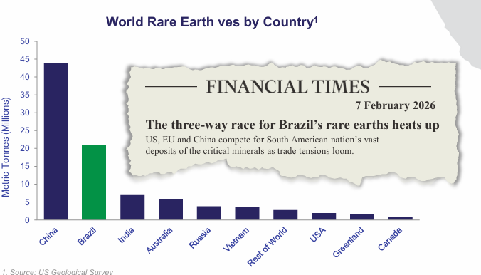
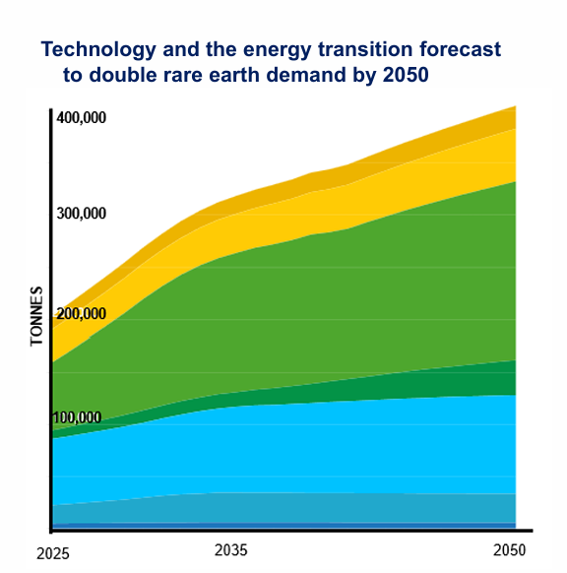

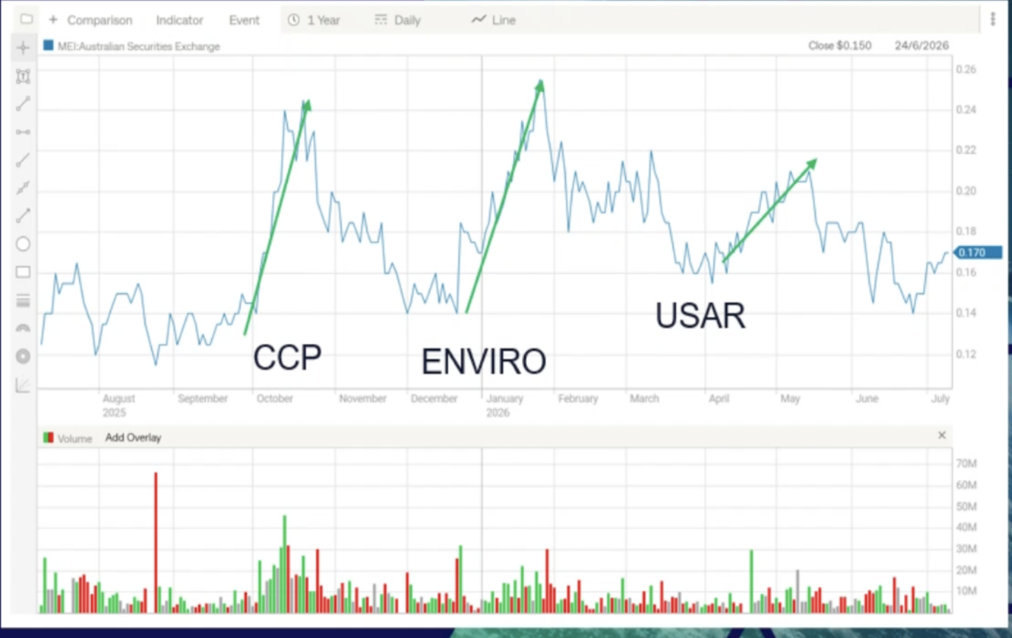

Karim Notes
Why join Monument Trade Advisory?
We’ll give you a direct line to the CEO of the company so we can follow the progress step by step and get the info from the source not some third party
The most exciting 12 cent stock in the world today
Why are billionaires (and millionaires) buying tons of this particular 12 cent rare earth stock

Your 12 cent lotto ticket

The 12 cent millionaire – Could this 12 cent “lotto” be your ticket to a wealthy retirement

If you have 12 cent – you need to buy this stock

The “couch money” play – a 12 cent stock that could change your future

The 12 cent retirement plan – why you need to add 12 cent lotto ticket to your account now!

The 12 cent stock that could change your life

· The 12-Cent Stock Poised to Explode

· Why Smart Investors Are Buying This Overlooked 12-Cent Asset Right Now

· Catch the Next Wave: The Micro-Cap Stock Ready to Surge

· Get in Before Wall Street Notices This 12-Cent Game-Changer

· The Ground-Floor Opportunity Everyone Is Ignoring

· Own the Future Today: Why This Tiny Stock Won’t Stay at 12 cents for long

· The 12-Cent Rare Earth Stock Breaking China’s Supply Chain Monopoly

· Pentagon’s Next Target? The 12-Cent Critical Mineral Play Catching Washington’s Eye

· The Tiny 12-Cent Stock Sitting on the West's Next Mega-Deposit

· Forget Tech Stocks: Buy the 12-Cent Rare Earth Play Powering the next economic boom

· Silicon Valley’s Secret Fuel: Why This 12-Cent Stock Could Skyrocket

· The Rare Earth Penny Stock Poised for a Historic Run

· Ground Floor Glory: Why This 12-Cent Rare Earth Miner Won’t Stay Cheap for Long

· The Ultimate Asymmetric Bet: Turn Pennies Into Fortune With This Critical Mineral Play

Climbing Out of the Valley: How Meteoric Resources is Navigating the Lassonde Curve
In junior mining investment, timing is the difference between generational wealth and a broken portfolio. To master this timing, legendary investor Pierre Lassonde created the Lassonde Curve—a psychological roadmap tracking a resource company’s stock price from exploration to production.
Right now, a rare earth explorer is a textbook example of a company transitioning through the most critical bend on this curve. The company is preparing to climb out of the dreaded "Orphan Period Valley" and ascend the "Production Runway."
text
LASSONDE CURVE & METEORIC RESOURCES
(Peak Hype: 2023)
Discovery Peak
/\
/ \ (WE ARE HERE: Late 2026)
/ \ Orphan Valley Exit
/ \ ★ [MEI.AX] ---> Production Climb
/ \ / /
/ \ / /
/ \______________/ /
Concept The Orphan Valley Cash Flow Realized
Use code with caution.
Phase 1: The Discovery Peak (2022–2023)
The first phase of the Lassonde Curve is driven by pure speculation, adrenaline, and drill results.
· The Setup: In late 2022, the company quired a project in an extinct, heavily weathered volcano.
· The Surge: Drilling revealed a massive, world-class ionic clay deposit. Unlike hard-rock deposits, ionic clays are chemically easy to process, keeping costs incredibly low.
· The Peak: Investors went wild. The stock skyrocketed as the market priced in the sheer scale of the discovery: a multi-billion-tonne deposit rich in magnet rare earths like Dysprosium and Terbium.
Phase 2: The Orphan Valley (2024–Early 2026)
Once the initial drilling hype fades, every junior miner enters the "Orphan Period" (or the Valley of Despair). Retail investors get bored, trading volumes drop, and the stock price drifts downward.
They spent the last two years deep in this valley, doing the unglamorous, heavy lifting required to de-risk a mega-project:
· Pilot Plant Operations: Operating a continuous pilot plant for months to prove the metallurgy worked. · Resource Upgrades: Upgrading their Measured Resources by 246% to 128 million tonnes to prove the ore is securely there.
· Environmental Licensing: Navigating complex permitting laws.
During this phase, the company looked "dead" to casual onlookers, but smart money recognized it as the ultimate discounted accumulation zone.
Phase 3: The Golden Runway (Late 2026 and Beyond)
Now it is breaking out of the valley. The transition from a speculative explorer to an institutional-grade developer is marked by funding, off-take deals, and feasibility studies.

Uplisting from the Over-the-Counter (OTC) markets to the Nasdaq creates a unique, hyper-compressed trading window where prices often swing violently. Historically, the short-term window—comprising the 3 to 6 months before the uplisting date (the anticipation phase) and the 3 months immediately following it (the institutional liquidity phase)—is when the most predictable "pops" and corrections happen.
Comprehensive market studies from platforms like Equifund indicate that roughly 68% of companies enjoy an average price surge of 26% within this six-month surrounding window. However, individual outliers can experience significantly larger multi-hundred percent spikes before reality sets in. [1]

The Genesis: Who They Are
For years, the company operated as a nimble explorer, hunting high-value assets across tier-one mining jurisdictions like Western Australia and Brazil. However, their defining transformation came when they acquired 100% of an ultra-rare geological phenomenon in the southern hemisphere.

Today, they are no longer just an exploration outfit. They have evolved into a vital strategic linchpin for the Western clean energy and defense supply chains.
[ THE METEORIC EVOLUTION ]

[ Legacy Explorer ] -------------> [ Critical Developer ]
Multi-commodity focus Single Focused Objective:
Diverse global targets Building the West's premier
ionic clay rare earths hub

The Mandate: What They Do
At their core, they unlock and deliver the foundational elements of the 21st-century technology economy. They specialize in the discovery, delineation, and imminent production of Ionic Adsorption Clay (IAC) Rare Earth Elements.
Specifically, they mine and process the heavy and light magnet rare earth oxides that the world desperately needs:
- Neodymium (Nd) & Praseodymium (Pr): The core drivers of high-efficiency electric vehicle (EV) motors and wind turbines.
- Dysprosium (Dy) & Terbium (Tb): The ultra-rare heavy additives that allow advanced military, aerospace, and robotic magnets to operate under extreme heat without losing their charge.

The Mechanics: How They Do It Better
[ THE PRODUCTION PIPELINE ]

[ Free-Dig Excavation ] [ Room-Temp Wash ] [ Reforest & Return ]
No Drill-and-Blast Ammonium Sulfate Zero Tailings Dams
Direct Surface Mining Simple Desorption Eco-Friendly Loop
While traditional hard-rock companies spend billions of dollars trying to crush, roast, and chemically blast rare earths out of stubborn granite boulders, this enterprise leverages a unique shortcut gifted by nature:
- Surface Mining Without Blasting: Their resource sits in soft, weathered clay just beneath a thin topsoil layer. Large excavators simply scoop up the material. There are no expensive explosives, no massive crushing circuits, and no deep underground hazards.
- Simple Chemical Desorption: Because the rare earth ions are weakly bonded to the clay surface rather than locked inside crystals, the company washes the clay at room temperature using a mild chemical solution. The rare earths simply "slide off" into a liquid concentrate.
- True Environmental Stewardship: Once the washed clay is filtered, it is completely benign. The company pumps it right back into the open pits, covers it with topsoil, and begins immediate progressive reforestation. They don't build massive, high-risk radioactive tailings dams.

The Ultimate Objective
By securing a gargantuan 1.6-billion-tonne resource footprint, validating their metallurgy through active pilot plant testing, and locking in massive downstream purchasing agreements with tier-one international industrial heavyweights, they are building a direct, non-aligned pipeline from mine site to magnet manufacturer.
They extract the critical material that powers the modern world—cheaper, faster, and cleaner than the competition.

The standard playbook for critical mineral investing is fundamentally broken. For the past decade, institutional capital has chased complex, capital-intensive, hard-rock extraction projects across politically unstable jurisdictions, only to watch timelines slip, capital expenditures balloon, and metallurgical recoveries collapse.
Meanwhile, the macro necessity for the heavy and light magnet rare earth elements—specifically Neodymium (Nd), Praseodymium (Pr), Dysprosium (Dy), and Terbium (Tb)—has evolved from an industrial luxury into a matter of absolute sovereign survival. These four key elements are the foundational building blocks of high-performance permanent magnets, which drive everything from electric vehicle (EV) drivetrains and wind turbine generators to guided missile guidance systems and artificial intelligence data centers.
[ GLOBAL MAGNET REE VALUE CHAIN ]

[ Mining Extraction ] -> [ Chemical Refining ] -> [ Magnet Production ]
(Brazil) (USA / S. Korea) (Global Markets)
- Shallow Ionic Clay - Simple Leaching - High-Performance
- Free-Digging Ore - Low Impurities Permanent Magnets

This tier-one developer has systematically uncoupled itself from typical mining risks by securing a massive, uniquely high-grade ionic clay asset.
Having delivered its definitive technical blueprints and signed binding international industrial frameworks, this company represents the single most compelling, asymmetric risk-reward profile in the critical materials sector today.

1. THE MACRO THESIS: MAGNET REEs AND THE IONIC CLAY PARADIGM
To understand why this specific company is poised to redefine the critical minerals matrix, one must understand the stark divergence between hard-rock (monazite/bayan obo style) deposits and ionic adsorption clay (IAC) deposits.
The Hard-Rock Nightmare
Traditional rare earth mining relies on hard-rock minerals like bastnäsite or monazite. These operations require traditional drill-and-blast methods, massive crushing circuits, high-temperature roasting (>1,000°C), and aggressive acid baking to break the stubborn crystalline structures holding the rare earths. The consequences for investors are clear:
- High upfront capital expenditure (often exceeding $1 billion).
- Prolonged development timelines (typically 7 to 12 years).
- Significant environmental liabilities, notably the creation of radioactive thorium and uranium tailings.
The Ionic Clay Salvation
Ionic clay deposits, by contrast, are a freak occurrence of nature. Over millions of years, intense tropical weathering washes rare earth elements out of underlying granitic rocks and chemically adsorbs them onto the surface of simple clay minerals.
- Free-Digging Overburden: The mineralized zone sits directly below a thin layer of soil. There is no blasting. Excavators simply scoop up the soft clay.
- Low-Temperature Chemical Leaching: Because the elements are bonded electrostatically rather than locked in a crystal lattice, they can be desorbed using a mild chemical wash (such as a simple ammonium sulfate solution) at room temperature.
- Zero Tailings Storage Needed: The washed, chemically inert clay can be immediately returned to the mining pits and remediated with progressive reforestation, removing the multi-million-dollar liability of a tailings dam.
Until recently, true, scalable ionic clay deposits were thought to exist exclusively in southern China and Myanmar. The asset owned by this developer disrupts this status quo completely, presenting a massive, ultra-high-grade ionic clay field situated entirely outside Chinese control.

2. GEOLOGICAL DOMINANCE: UNPACKING THE 1.6 BILLION TONNE MONSTER
In mining, scale brings optionality, but grade pays the bills. This asset delivers an exceptional combination of both, distinguishing it from typical low-grade clay anomalies.
The Global Mineral Resource Estimate (MRE)
The global MRE stands at an extraordinary 1.6 billion tonnes at an average grade of 2,317 parts per million (ppm) Total Rare Earth Oxides (TREO). This makes it the largest defined ionic clay rare earth resource reported anywhere on earth outside of mainland China.
The Measured Resource Quantum Leap
In mining development, the biggest valuation discount occurs when a resource is merely "Inferred" (speculative geology). This developer spent the last 18 months aggressively de-risking this metric via an extensive infill drilling campaign across its southern licenses (specifically the Capão do Mel, Soberbo, and Figueira sectors).
The results were outstanding. The company reported a 246% surge in its highest-confidence "Measured" category, which now stands at 128 million tonnes grading an exceptional 2,815 ppm TREO. When combined with Indicated metrics, the premium core of the deposit sits at 703 million tonnes at 2,617 ppm TREO.
The Strategic Grade Advantage
To put these numbers into context, legacy Chinese ionic clay operations typically mine grades between 500 ppm and 1,000 ppm TREO. This Brazilian project boasts a defined Ore Reserve of 151 million tonnes at a premium grade of 3,524 ppm TREO. This provides a massive buffer against commodity price volatility, ensuring that even during cyclical macro downturns, the high-grade material yields resilient margins.

3. DE-RISKED EXECUTION: VALUING THE DEFINITIVE FEASIBILITY STUDY (DFS)
The single most critical inflection point for a pre-production mining stock is the transition from economic modeling to hard, bankable engineering data. On July 31, 2026, the company officially released its highly anticipated Definitive Feasibility Study (DFS), providing institutional investors with concrete engineering metrics.
Core Technical Pillars of the July 2026 DFS:
- Unrivaled Metallurgical Recovery: Utilizing over six months of continuous, real-world data from its onsite pilot plant, the technical team proved a 71% recovery rate for high-value magnet rare earths. In the clay space, where metallurgical lockups routinely ruin projects, achieving a stable 71% recovery via room-temperature chemical leaching is a major milestone.
- Untapped Resource Optionality: The current multi-decade mine plan outlined in the DFS utilizes less than 20% of the total defined tenure. More than 80% of the broader landholding remains completely unallocated to the initial infrastructure footprint, giving the company decades of organic scale expansion and product life extensions without needing to acquire additional land.
- Infrastructure Advantages: The asset is located close to infrastructure. Unlike remote Australian or Canadian projects requiring billions in greenfield rail, roads, and water pipelines, this site features immediate access to high-voltage power lines, paved highways, skilled local mining labor, and deep-water ports.

4.

With initial capital expenditure projections optimized around US$450 million, the asset features a highly favorable capital-to-value ratio for an open-pit, chemical processing project of this size.

5. GEOPOLITICAL ALIGNMENT & THE OFFTAKE JUGGERNAUT
In the critical minerals sector, downstream users no longer wait for mines to be built; they move upstream to actively secure supply. This developer has built a highly strategic network of global partners that effectively guarantees future commercial viability.
The XXXXX International Strategic Framework
In late July 2026, the company signed a comprehensive Memorandum of Understanding (MoU) with an Asian industrial powerhouse , a transaction that drew ministerial-level attendance from international trade officials.
- Supply Security: Under this framework, XXXXX intends to purchase up to 30% of the total rare earth output from the project for an initial seven-year tenure.
- Value-Chain Integration: This intermediate product will feed directly into XXXXX’s regional separation and refining initiatives, mapping out an integrated mine-to-magnet supply chain completely separate from traditional supply lines.
- Project Financing and Equity: Critically, the agreement details pathways for XXXXX to make a direct equity investment in the developer and secure long-term project financing backed by tier-one policy lenders, including the Export-Import Bank of XXXXX and the XXXXX Trade Insurance Corporation.
The North American Supply Line via Ucore
Complementing its Asian partnership, the developer maintains an active supply framework with U.S.-focused rare metal company. This framework targets the supply of a minimum of 3,000 metric tonnes of Total Rare Earth Oxides (TREO) annually to feed the operations’ downstream commercial separation facility in the United States. This establishes a clean, direct pipeline from mineral discovery in South America to industrial end-users across North America.

6. JURISDICTIONAL ADVANTAGE: WHY BRAZIL WINS
Geopolitics is a key driver in mining success. Operating in modern mining environments means navigating regulatory bottlenecks, local resistance, and environmental red tape.The area the company operates in stands out as one of the world's premier pro-mining mining jurisdictions.
- Streamlined Fast-Track Environmental Permitting: The developer has already successfully secured its foundational Preliminary Environmental Licence (LP). It is currently on track to receive its comprehensive Installation Licence (LI)—the vital regulatory permit required to begin physical mine construction—by Q4 2026.
- 100% Renewable Operational Footprint: Operating in a friendly jurisdiction allows the project to tap into a regional power grid driven by hydro, wind, and solar infrastructure. For Western automotive manufacturers tracking strict Scope 3 supply chain carbon metrics, sourcing rare earths produced via green energy and chemical leaching offers an immediate market advantage over carbon-heavy hard-rock operations.

7. FINANCIAL FOUNDATION AND STRATEGIC TIMELINE
A common pitfall for retail mining investors is buying into cash-strapped explorers that constantly dilute shares just to keep the lights on. This enterprise operates on a much more stable financial foundation:
- Strong Cash Runway: Recent capital raisings were consistently oversubscribed by global institutions and executed smoothly without heavy market discounts, reflecting high institutional confidence in management's execution.
- OTC Market Integration: The August 10, 2026 commencement of trading on the U.S. OTCQB market under ticker broadens access to retail and institutional capital in North America without diluting existing shares or issuing new equity.
Strategic Execution Timeline: 2026–2028

THE INVESTMENT VERDICT: AN ASYMMETRIC VALUE PLAY
The global transition toward electrification, advanced robotics, and defense autonomy is creating a structural supply squeeze in magnet rare earths. The market cannot meet this demand through hard-rock mining alone; it requires scalable, low-cost ionic clay solutions.
This developer offers investors a rare combination of advantages: the world's largest defined ionic clay resource outside of China, a freshly completed bankable DFS, strong strategic backing from Asian and North American industrial groups, and an operational footprint located in a secure mining jurisdiction.
By buying in at a valuation heavily discounted by short-term spot price fluctuations, investors can secure a high-value stake in a critical asset that is essential to the future of Western industrial supply chains.

They own 100% of an ultra-rare geological phenomenon called Ionic Adsorption Clay.
When tropical weathering breaks down granite rocks – the left-over deposits after years of long-term chemical leaching becomes the world's primary source for rare earth elements.
But let me skip all the geological talk and tell it to you straight…
Ionic clay deposits are freak occurrences of nature.
They only occur after millions of years of intense tropical weathering washes rare earth elements out of underlying granitic rocks - and chemically adsorbs them onto the surface of simple clay minerals.
What’s left are ultra-rare heavy additives that allow advanced military, aerospace, and robotic magnets to operate under extreme heat without losing their charge.
This is what’s so important to modern-day technology…
High-performance magnets that do not lose their charge under extreme heat – which is exactly what Ionic Adsorption Clay offers.
So….
While traditional mining companies spend billions of dollars trying to crush, roast, and chemically blast rare earths out of stubborn granite boulders…
Ionic Adsorption Clay offers a unique shortcut gifted by nature…
Surface Mining Without Blasting
The soft, weathered clay just beneath a thin topsoil layer allows excavators to simply scoop up the material.
No expensive explosives
No massive crushing circuits
No deep underground hazards
You simply wash the clay at room temperature using a mild chemical solution – and the rare earths simply "slide off" into a liquid concentrate.
Most companies require an upfront capital expenditure exceeding $1 billion – and a prolonged development timeline between 7 to 12 years – just to access rare earth elements.
But this company will do it at a fraction of the cost…in a faction of the time.
Right now, as you read this…
They’ve secured a gargantuan 1.6-billion-tonne resource footprint…
Making it the largest ionic clay rare earth resource reported anywhere on earth outside of mainland China.
They’re getting set to extract this massive, uniquely high-grade ionic clay asset that’’ help power the modern world— all cheaper, faster, and cleaner than the competition.
That’s why I believe this stock represents the single most compelling risk-reward profile in the entire market today.

