Pro Trader Bryan Bottarelli’s
PROFIT LAUNCH SEQUENCE
Discover a NEW Trading Method... And Get the Chance to Make Up to 500% or More in a Week

SWING TRADER SUMMIT
Discover How to Trade HUGE Market Swings... and Get the Chance to Make Up to 500% or More in a Week

JONATHAN: Hi, I'm Jonathan Roth.
I've been a part of interviews with many of the world's most influential people.
People like the Rev. Franklin Graham, author Salman Rushdie and primatologist Jane Goodall.
But today, I'll be speaking with someone I've wanted to interview for many years.
He's one of the most successful traders of our time, former Chicago Board Options Exchange floor trader Bryan Bottarelli.
Bryan got his start right out of college, trading options in the pits of the CBOE, right in the heart of the tech boom.
And he built his reputation on short-term trades…
With same day gains like 61%, 69%, and 98% …
Even a lightning fast 121% in just one hour and 21 minutes.
But now… he’s doing something no one would expect.
He’s slowing DOWN.
Why?
He’s discovered a way to go for even BIGGER gains… simply by waiting just seven days.
He believes this could be the biggest trading strategy he’s ever uncovered.
And today… Bryan is here with me to blow the lid off his secret to locking in up to 500%... in just one week.
He’ll reveal why it’s PERFECT for a volatile market like this…
And…
For the first time ever…
Bryan will walk us through a special type of trade you can use to profit from the markets' wild swings...
It's a strategy that the world's RICHEST and most successful traders make on a regular basis...
Like Paul Tudor Jones, who made $100 million when the markets fell 20%.
Or Larry Williams, who won an investing championship when he turned $10,000 into $1.1 MILLION in a single year.
Or Dan Zanger, who turned $10,775 into more than $42 million in less than two years.
Today, Bryan will show us the most powerful examples of this trading strategy that can produce 500% or more in a week.
In the next few minutes, we're going to discover...
- The secret to spotting when to make these swing trades... down to the day
- Why a falling market gives MORE opportunities, not fewer
- How it's possible to turn $1,000 into $9,500 in a single week
- What special chart pro traders like Bryan use… and how to active it
Now, let me be clear... you're personally leaving money on the table if you close your browser and leave this video.
So stick around and you'll see how you could collect up to 500% or more in a week.
Bryan, welcome.
INTRODUCING BRYAN BOTTARELLI...
BRYAN: Thank you, Jonathan. I'm excited to share this with our viewers today.
This has been a troubling few months in the markets.
Many investors saw big gains wiped out in weeks or days.
Yet few had any answers.
Go to cash?
Buy Treasurys?
Sell and hope to get back in when everything settles down?
It's hard to know what to do.
But for traders like me, markets like this don't come with worry... or doom and gloom.
Quite the opposite.
For me, markets like these are like manna from heaven.
Because it gives us MORE opportunities to make BIG money.
And for the first time ever, I'm showing our viewers EXACTLY how to trade the markets' sharp swings.
Quant traders and hedge funds have kept what I'm about to show you an industry secret for years...
But I'll give everyone watching the chance to go after 500% or more… in just ONE week…
Using the EASIEST trading method I’ve ever discovered.
From Flipping Burgers to the Floor of the CBOE
JONATHAN: Sounds great, Bryan. And for those who don’t know you, you've done this the hard way your whole life.
Twenty-five years ago you were flipping burgers at McDonald's, watching the clock, making minimum wage.
And then you got an opportunity that changed everything.
You got a shot to trade on the floor of the Chicago Board Options Exchange, right in the middle of the 2000 tech boom.
And you were mentored by some of the top floor traders in the country.
From there you launched your own independent trading research advisory, serving an elite group of traders for well over a decade.
You've been at this for more than twenty years now.
And you've built your reputation on spotting the big opportunities before the crowd sees them.
BRYAN: That's right, Jonathan. And I'll tell you what the floor teaches you that no classroom ever will…
Standing in the Apple computer pit, surrounded by screaming traders...
Learning the strategies Wall Street normally keeps hidden.
It teaches you to read the other side of the trade.
You learn to see when the selling is exhausted… When the guy across from you is out of ammunition…
That's the whole game. Knowing when a move has run out of sellers.
I've spent twenty-five years learning to read that moment.
And traders who can read it collect massive profits in very short periods of time.
JONATHAN: So you’re spoking patterns in the market.
Up 98% the Year the Market Was Cut in Half
BRYAN: Exactly.
Consider the story of fellow trader Jim Simons.
Simons worked with an army of rocket scientists to spot patterns others can't see. They spend their lives mining reams of data to pick stocks.
Bloomberg Businessweek called his quant system "a money printing press."
It's easy to see why...
Since 1988, his Medallion Fund has generated average annual returns of 66% before fees.
His company, Renaissance Technologies, has generated more than $100 billion in trading profits!
In 2008, when the market was devastating regular investors, his fund made a 98% gain.
JONATHAN: A 98% gain... while the overall market lost nearly half its value?
BRYAN: That's right.
And the thing is... the trading strategy I'll show you today was a HUGE piece of his puzzle.
When the market falls, the people who know how to trade it can make an absolute fortune.
Because there's never been a market correction or bear market that has not ended.
In fact, the bigger the drop, the bigger the bounce.
Unfortunately, few regular investors have the tools to profit in a market like this.
But quantitative hedge funds like Renaissance Technologies do.
It's one of the biggest advantages quant funds have.
And believe me, they DO NOT want it getting out.
JONATHAN: I'm sure they don't. Hedge funds make all their money by positioning themselves as the experts.
The 0.01% pay hedge funds to manage their money precisely because they have advantages that others don't.
And the hedge funds make a fortune as a result.
Run-of-the-mill hedge funds charge a fee of 2% on the funds invested, plus a massive 20% on the profits.
Simons' Medallion Fund charges hefty annual management fees of 5% on all assets and as much as 44% on gains.
So it's no surprise that many hedge fund guys become billionaires.
BRYAN: Right.
And you can see why they are so secretive about trading techniques like the one I'm going to share with our audience today.
In fact, The New York Times did an investigation on Simons' Medallion Fund.
It was eye-opening to learn how far hedge funds go to protect their advantages.
As the Times reports, the Medallion Fund "is secretive to the point of paranoia. Employees sign ironclad nondisclosure agreements and are told to avoid media appearances and industry conferences."
Bloomberg says what Medallion trades "remains a secret hidden within its computerized trading system."
And quant fund giant Bridgewater Capital plays its cards just as close to its chest.
The Times reports its trades are a "secret not only to investors but to most of the firm's 1,500 employees. No more than a dozen people have a full sense of how the firm trades."
But I was right there on the floor when those orders came in.
In the pit, with a broker shouting it across the floor at me.
A fund can bury its models all it wants. Somebody still has to fill the order.
And for years, that was me.
So today I'm telling you EXACTLY how to identify trades that could make you up to 500% or more in a week.
What's more, I'll show you why you don't need a giant bank account or a billion-dollar supercomputer to do it.
What I Learned Taking the Other Side of Their Trades
JONATHAN: All right, Bryan. So what is this new strategy of yours all about?
How does it work?
BRYAN: Well, I think we’ve all seen how quickly the stocks recover.
For the past years, I’ve watched stocks get pushed too far in one direction and then snap back the other way.
But…
Knowing it happens is one thing.
Knowing WHEN it’s about to happen is the hard part.
I’m speaking to you today because…
I finally cracked it.
I built something that tells me which stocks are about to swing higher... BEFORE they swing.
Then I trade that swing.
That's why this market is PERFECT for my strategy.
You see the market crash one day... then swing right back up the next.
And I LOVE it when this happens.
JONATHAN: Why's that?
BRYAN: Well, for most people these moves look random.
But with the way I use my system, I can ride these short, fast swings to go after gains of 500% or more within seven days.
To put it simply, I believe there is no better way to grow your wealth today.
JONATHAN: Can you show us?
BRYAN: Absolutely.
I'm going to show you some supercharged swing trades, using recent top examples I picked straight from the market...
Take a look at this candlestick stock chart.
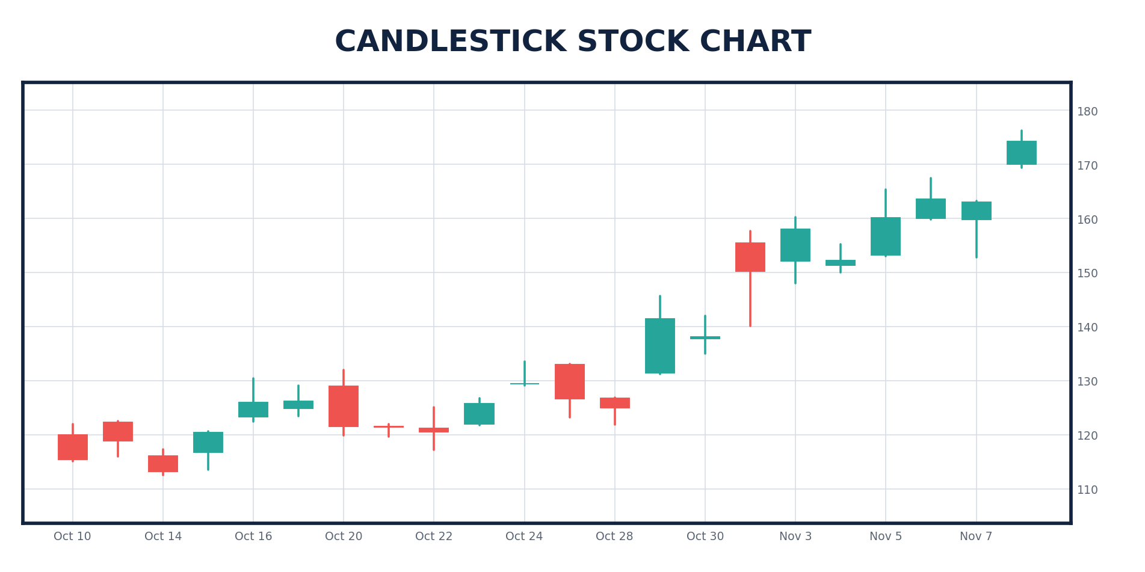
00_generic_candlestick.png
Candlesticks are how professional traders track where a stock is headed next.
What you're seeing here is trading in action.
Each of those bars represents ONE trading day.
The red bars tell you that sellers pushed the stock down for the day...
And the green bars tell you that buyers swung it back up.
What I'm looking for is streaks.
I want to see periods where every day is the same color.
What One of These Trades Actually Looks Like
Let's look back at last September.
Apple experienced one of these streaks.
Look at the candlestick.
See those four straight red bars?
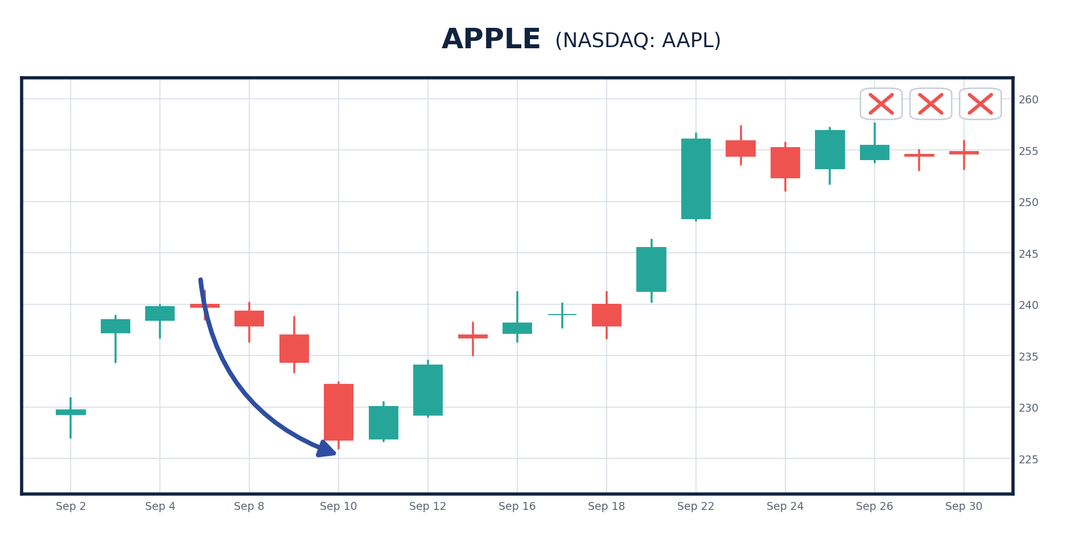
01a_AAPL_step1_down.png
That indicates the sellers are pushing it as low as they possibly can... Four days in a row, in fact.
The stock had become greatly oversold.
Then you see the green bar in the middle?
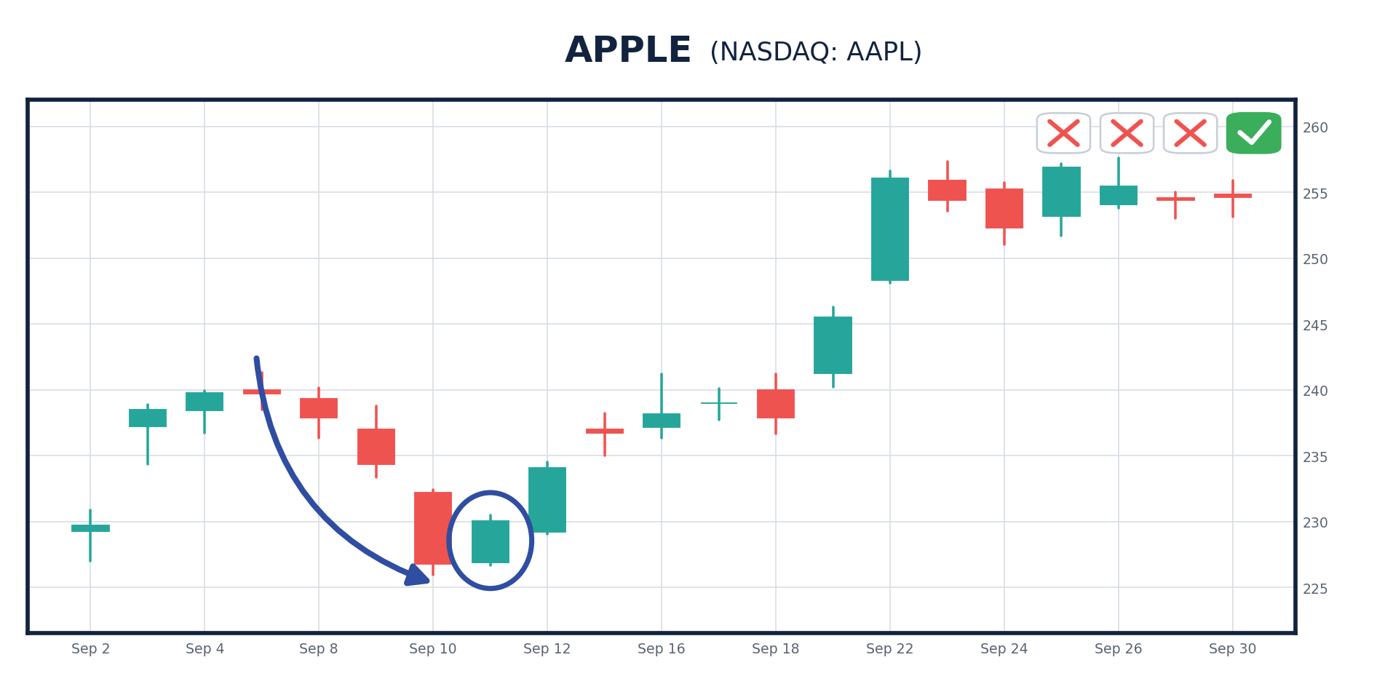
01b_AAPL_step2_reversal.png
That's what I call a "reversal."
It means the buyers are about to swing the stock back in the other direction.
So all you had to do was type in the ticker symbol when you saw the reversal...
Then place a simple short-term trade designed to profit from the swing...
And sure enough... what happened?
The stock swung back up into the green.
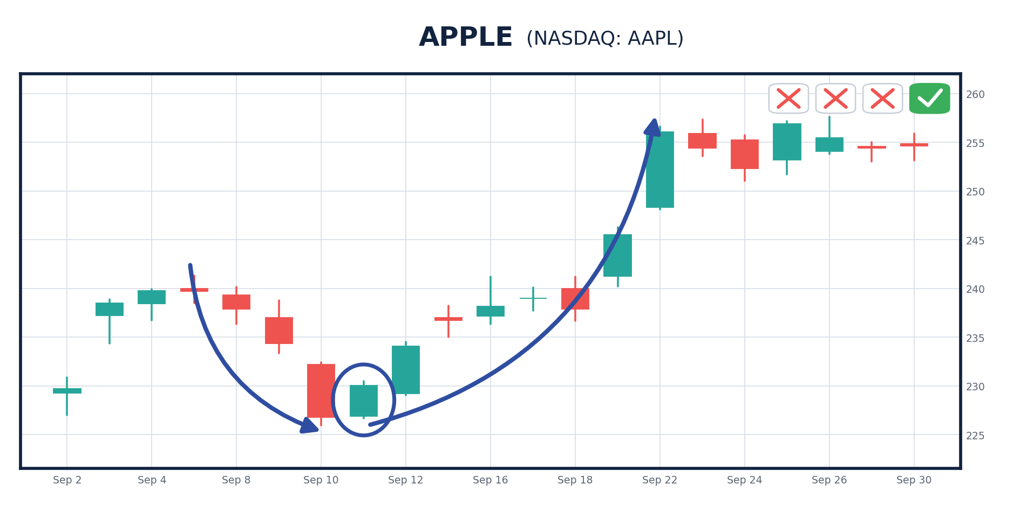
01_AAPL_teaching.png
Here's how it could've looked if you'd placed a trade like this in real time.
(SHOW ON SCREEN)
Type in this symbol... press submit... then you're done for the day.
Play a round of golf with your friends. Spend some time with the family. Go about your life.
And exactly seven trading days later, you could've sold when you saw the swing back up for a 531% gain!
JONATHAN: Wow, that sounds great. Especially the round of golf with friends while I'm making those gains, but can you show me another one, Bryan?
I'm not sure I got it fully on the first example.
BRYAN: No problem.
531% in Four Days on a Stock You Already Own
Here's another big winner...
Tesla.
See the huge streak of red bars?
The sellers were pushing the stock down every day for, let's count them... one, two, three, four, five, six straight sessions!
JONATHAN: It was WAY oversold.
BRYAN: Right.
That created a lot of pressure for the stock to swing back up.
And then...
On Wednesday, November 6, 2024, the reversal hit right here.
This is the moment where the stock flips back from red to green.
So you bet on a rebound in Tesla...
And by the following Monday, you could've sold for a 531% gain!
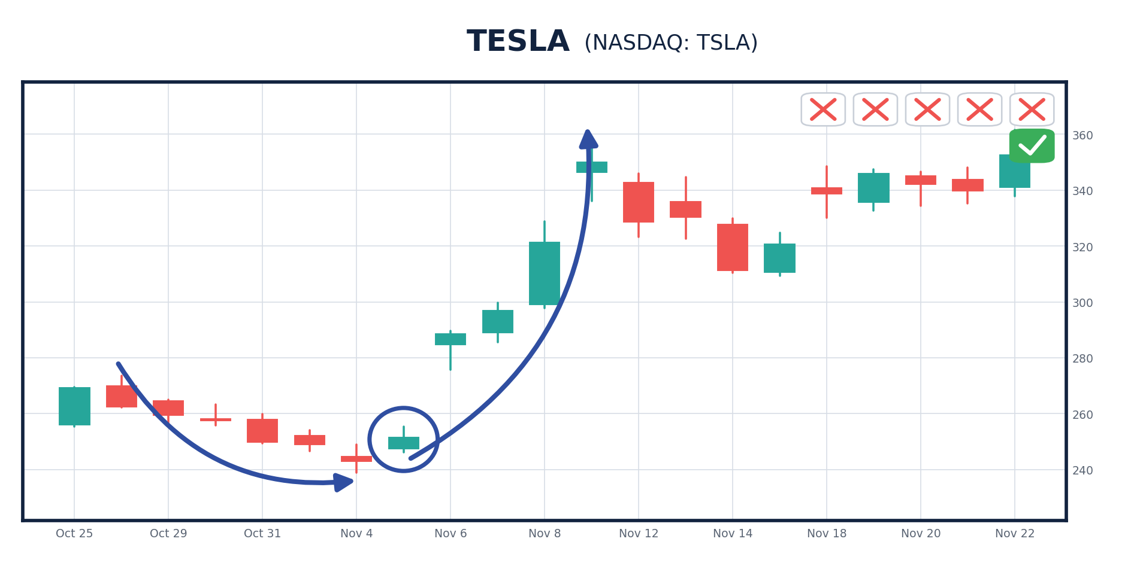
02_TSLA_nov24.png
OK, here's one more.
Looking back to last April, there was another great trade opportunity on Tesla.
You see that, for three days straight, the bars are red.
You know that eventually the reversal will come.
And sure enough, it hits right here on April 23.
The upswing begins when you see that big green bar...
And by making a supercharged trade there... in four trading days, you could have been up 218%.
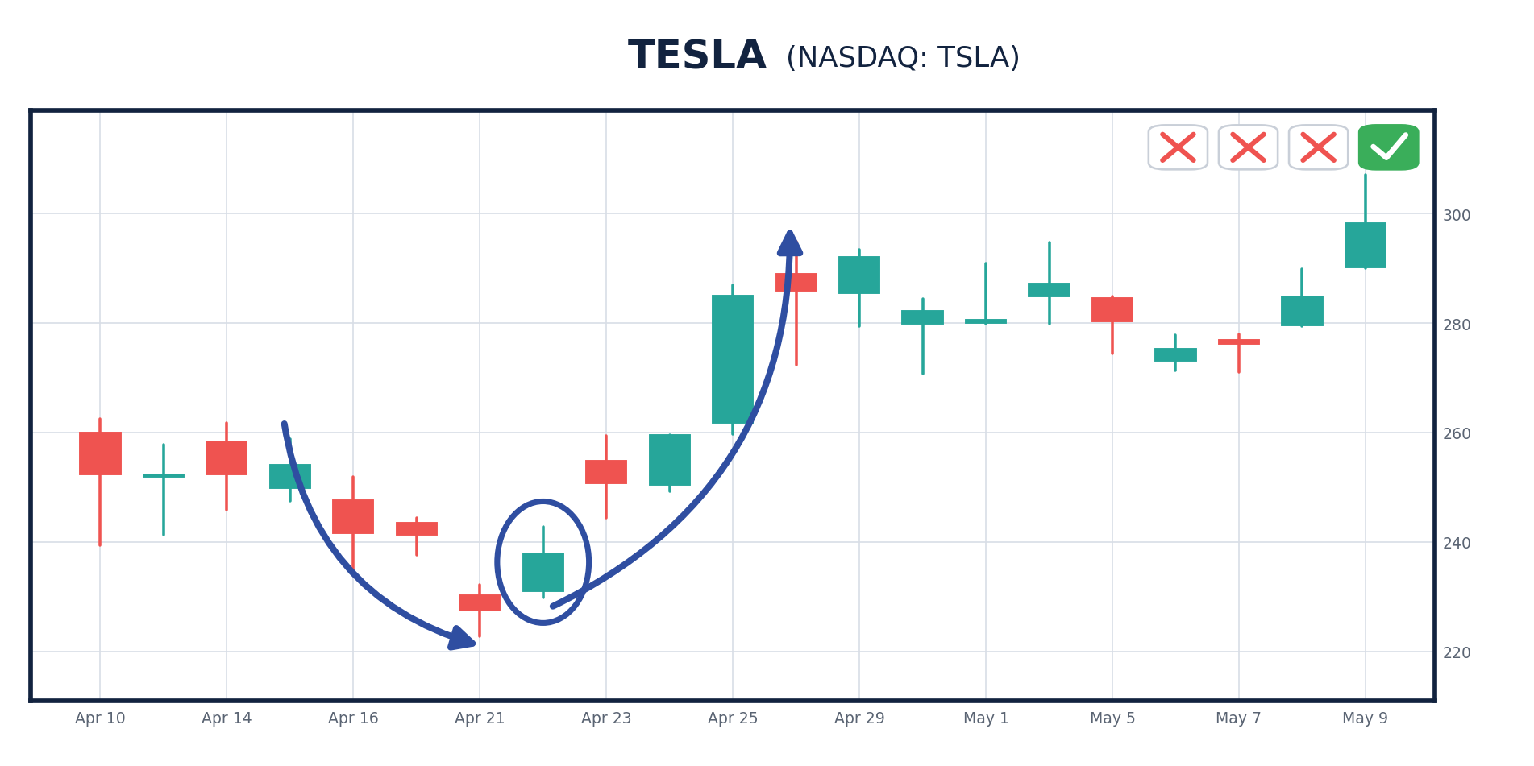
03_TSLA_apr25.png
Looking back at the market, I've found example after example of top trades just like these...
Some of them gaining 500% or more in a week.
JONATHAN: Incredible.
Those are huge gains for just a single trade each week.
Bryan, how do you know when to get out of these trades?
BRYAN: Simple.
I look for another reversal when the streak of green days ends.
When I see that, I know the swing is over.
In a moment, I'll show our viewers the best way to time it.
But here's what I love about swing trading.
This strategy can find winners in ANY market.
I don't worry about whether we are in a bull or bear market.
Instead, I stay completely focused on the individual swings of stock prices.
JONATHAN: But can you really make money in any market?
BRYAN: Absolutely, yes.
This is one of the few strategies PROVEN to work when stocks are rising and when they're falling.
It's not perfect. The market is never 100% predictable.
But research shows this strategy works across the board, in bear markets, bull markets and everything in between. And that can give you a huge advantage.
JONATHAN: So these swing trades hold up in a bear market?
BRYAN: Actually, they can do even better.
In a moment, I'll show you how.
But this is why floor-trained traders don't care whether the market is going up or down.
Once you've perfected this type of swing trading, it becomes irrelevant.
You could wake up tomorrow and the market could be down 300 points... It wouldn't matter... These swing trades can still work.
All you need to do is watch for a big swing in share price... place the trade... and then hopefully close it out for a big gain.
JONATHAN: Can you show us another example?
It Works on the Biggest Names in America
BRYAN: Sure, let's look at a stock everyone knows, Microsoft. Ticker symbol MSFT.
In April of last year, it began to show a perfect swing-trade setup.
Check out the candlestick chart and you'll see exactly what I'm talking about.
You can clearly see the big swing...
Look at all the red bars on one side...
Let’s count them… 1, 2, 3, 4, 5!
The sellers are pushing it down...
But then the reversal hits here.
And it swings right back up to the buyers.
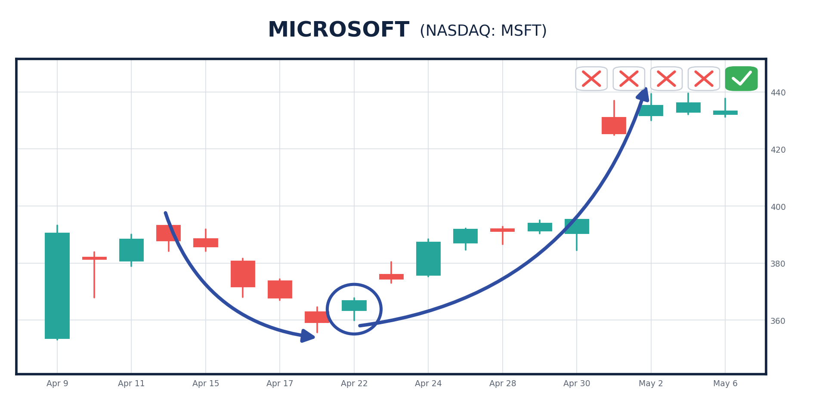
15_MSFT.png
In this case, a simple trade at the reversal would've generated a 516% return in just one week.
How many regular investors do you know who collect MORE than 500% in less than 10 days?
JONATHAN: Hardly any.
BRYAN: That's right.
Of course, there's no crystal ball for the markets, and you might not see triple-digit returns like these all the time.
But this could give you the chance to make more money than many people make in years, in just days!
That's why I'm putting this out in the open...
And exposing these extraordinary opportunities today.
JONATHAN: OK, how does it work? How do you identify when a swing will occur and give you a big profit opportunity?
BRYAN: OK, let's look at an example from a favorite stock of mine, Palantir. Ticker symbol PTLR.
Here's the candlestick chart.
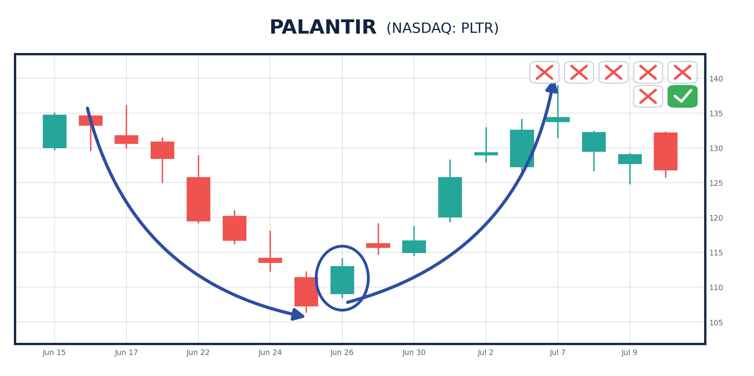
Now, what I'm looking for is a period where the sellers consistently push the stock down for several days straight.
So in this case... what do you see?
JONATHAN: I see seven straight days with red bars.
That means the sellers pushed the stock down for seven straight days, right?
BRYAN: Correct.
And that's unsustainable, especially for a company that size.
So if this was in real time, my scanner would alert me to any stocks that have had at least three red bars in a row.
And then I watch those stocks closely every day.
JONATHAN: You're waiting for the reversal, right?
Because that's the sign that the stock will swing back upward?
BRYAN: Exactly right!
So looking back at this example, the reversal happens right here.
And as you can see, the green bars take over in the swing up.
05_PLTR.png
In this case, investors who spotted this swing could've made 368% in seven trading days!
JONATHAN: So the stock dropped seven days straight… then after the reversal, it swung right back up seven days later.
BRYAN: See how simple it is! It's like Isaac Newton's third law of motion: For every action, there is an equal and opposite reaction.
JONATHAN: But I have a question for you, Bryan.
How do you know that the swing won't reverse again immediately?
How do you know that these swings will last?
So I Had It Tested... 7,218 Times
BRYAN: That's a great question. And I didn't want to guess at the answer, so I had it tested.
We went back 10 years across the Nasdaq 100 and counted every single time this setup appeared.
It appeared 7,218 times.
JONATHAN: Seven thousand.
BRYAN: Seven thousand two hundred and eighteen.
And here's the number that stopped me cold.
Take every stock that had three down days in a row and then closed green. That happened 3,976 times.
In 98% of them, the stock handed you a profit opportunity within seven trading days.
JONATHAN: 98%.
BRYAN: Four down days, 1,888 setups, 98% again.
Five down days, 98%. Six down days, 98%.
Seven down days, 99%.
Eight down days in a row, 58 setups over 10 years... 100%.
Now, it's important to note that nothing is 100% predictable, and all investments carry risk.
But the accuracy of the setup itself is very HIGH.
And it's possible for only one reason.
Wall Street trading nowadays is actually far more predictable than ever before.
And I had a front-row seat when it happened.
JONATHAN: What do you mean?
I Was on the Floor the Day the Machines Showed Up
BRYAN: I was standing on that floor when the machines showed up.
One year the pit is full of people shouting. A few years later, half those people are gone and the orders are coming from a server somewhere.
I watched the human beings get replaced in real time.
And here's what nobody tells you. When the humans left, the market didn't get harder to read.
It got EASIER.
Consider this...
On a typical trading day... 70% of the trades made on Wall Street are actually executed by computers. Not humans.
JONATHAN: I've read the number is even higher on volatile days like we've seen lately.
BRYAN: That's right. On some days, it can reach 90%!
As CNN Business reports, Wall Street's "wild ride isn't driven by nervous portfolio managers, retirees looking at their 401(k) statements, or any other human traders."
Instead, it's computer-driven algorithms that are making the trading decisions.
Forbes reports that "401(k)s have been squandered by the sheer speed of stock market machines... [this] costs regular investors up to $5 billion per year."
The Wall Street Journal says that these firms use "powerful computers to move in and out of markets at lightning speeds."
You've seen it in action...
You saw the fastest bear market in history... and the largest one-day gain in history... all within weeks.
JONATHAN: That sounds a bit scary... that machines are completely in control of the stock market.
BRYAN: Yes, but it's a terrific opportunity for smart traders.
JONATHAN: Why's that?
BRYAN: Because we humans are naturally unpredictable.
We are driven by emotions that can change on a whim.
But machines are completely predictable. Machines don't change their minds. Under the same conditions, they make the exact same decisions... every time.
The computer algorithms are programmed to automatically sell on downward momentum... and buy on upward momentum.
And with more and more people using the same AI models, these trades become more predictable.
JONATHAN: What do you mean?
BRYAN: I mean they quite often move together… it’s the same models looking for the same signals.
So when you see a stock go red, red, red many days in a row, it's because all the machines are trading in lockstep...
When this happens, millions of trades are pushing the stock down...
But then the reversal happens.
All it takes is one upward swing, and suddenly the machines completely alter course.
They, too, swing back to buying instead of selling.
And the days following all go green and the stock SWINGS back upward.
JONATHAN: So this is what you do.
You watch individual stocks closely to see when the computer algorithms will switch from selling to buying...
And you capitalize on that swing?
BRYAN: Yes, and that's exactly what I built my scanner to watch.
It tracks the 100 largest names on the Nasdaq. The most heavily traded, most heavily machine-traded stocks in the world.
So that way, I can track in real time when the computers are switching to buying from selling.
It's incredible how easy it is to predict these movements. And it's wildly effective.
It's almost too easy once you know what you're doing.
Small investors simply don't have access to the sophisticated software to do this sort of swing trading.
Which is a shame...
Because if they did, you'd see regular folks going after 500% or more in a week's time.
Why the Machines Can't Take This Trade From You
JONATHAN: One question, Bryan… wouldn't the computers see this too? How do you have an edge?
BRYAN: Because they're not looking for it, Jonathan. They're causing it.
Those algorithms are built to do one thing. Sell into weakness. Stock goes down, they sell. Goes down again, they sell again.
And every one of those orders loads the spring a little tighter.
JONATHAN: So they're on the other side of your trade.
BRYAN: They're on the other side of my trade, and they can't stop. That's what they were built to do.
Then, one that green bar hits, it releases that spring… and it catapults the stock higher.
JONATHAN: What about the funds that ARE looking for it? The hedge funds like Renaissance you mentioned earlier?
BRYAN: Then you hit the second problem. Size.
We’re putting a few thousand dollars into a one-week trade… maybe a few hundred.
A fund running twenty billion can't.
Even a $1 million trade wouldn’t move their needle.
By the time they've built a position big enough, they've moved the stock and killed the edge they came for.
JONATHAN: So it’s too small for them to bother with.
BRYAN: They’re too big to make these trades. Which is exactly why I slowed down to find it. Everybody's racing to be faster. Nobody thought to slow down.
I believe we're seeing a real breakthrough in trading here.
And I know that if our viewers can collect wins of this magnitude in such a short period of time... it would be a real game changer for many of them.
JONATHAN: I think our audience would appreciate seeing more of these examples.
BRYAN: OK, let's look at another example...
You can clearly see here, there were several big down days.
It's clear with the candlestick because they're red.
But then, in the days after the drop, what do you see?
JONATHAN: A jump higher, all in green.
BRYAN: Exactly.
You see the reversal here. And then the swing higher.
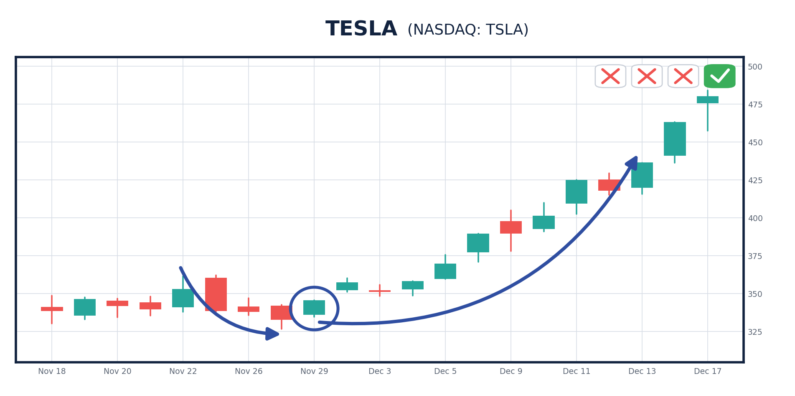
06R_TSLA_dec24.png
On this one, you could've made 487% in just 10 trading days.
Here's another.
This stock was pushed down for three days, one, two, three.
Then you see the reversal here.
And there's the swing back upward. Here savvy investors could've made 308% in 10 trading days.
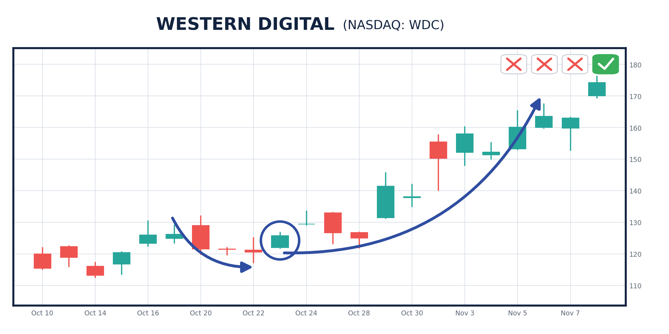
11_WDC_visual.png
Look at one more...
That's a three-day drop. One, two, three.
Then the inevitable swing up. One, two, three, four, five, six days.
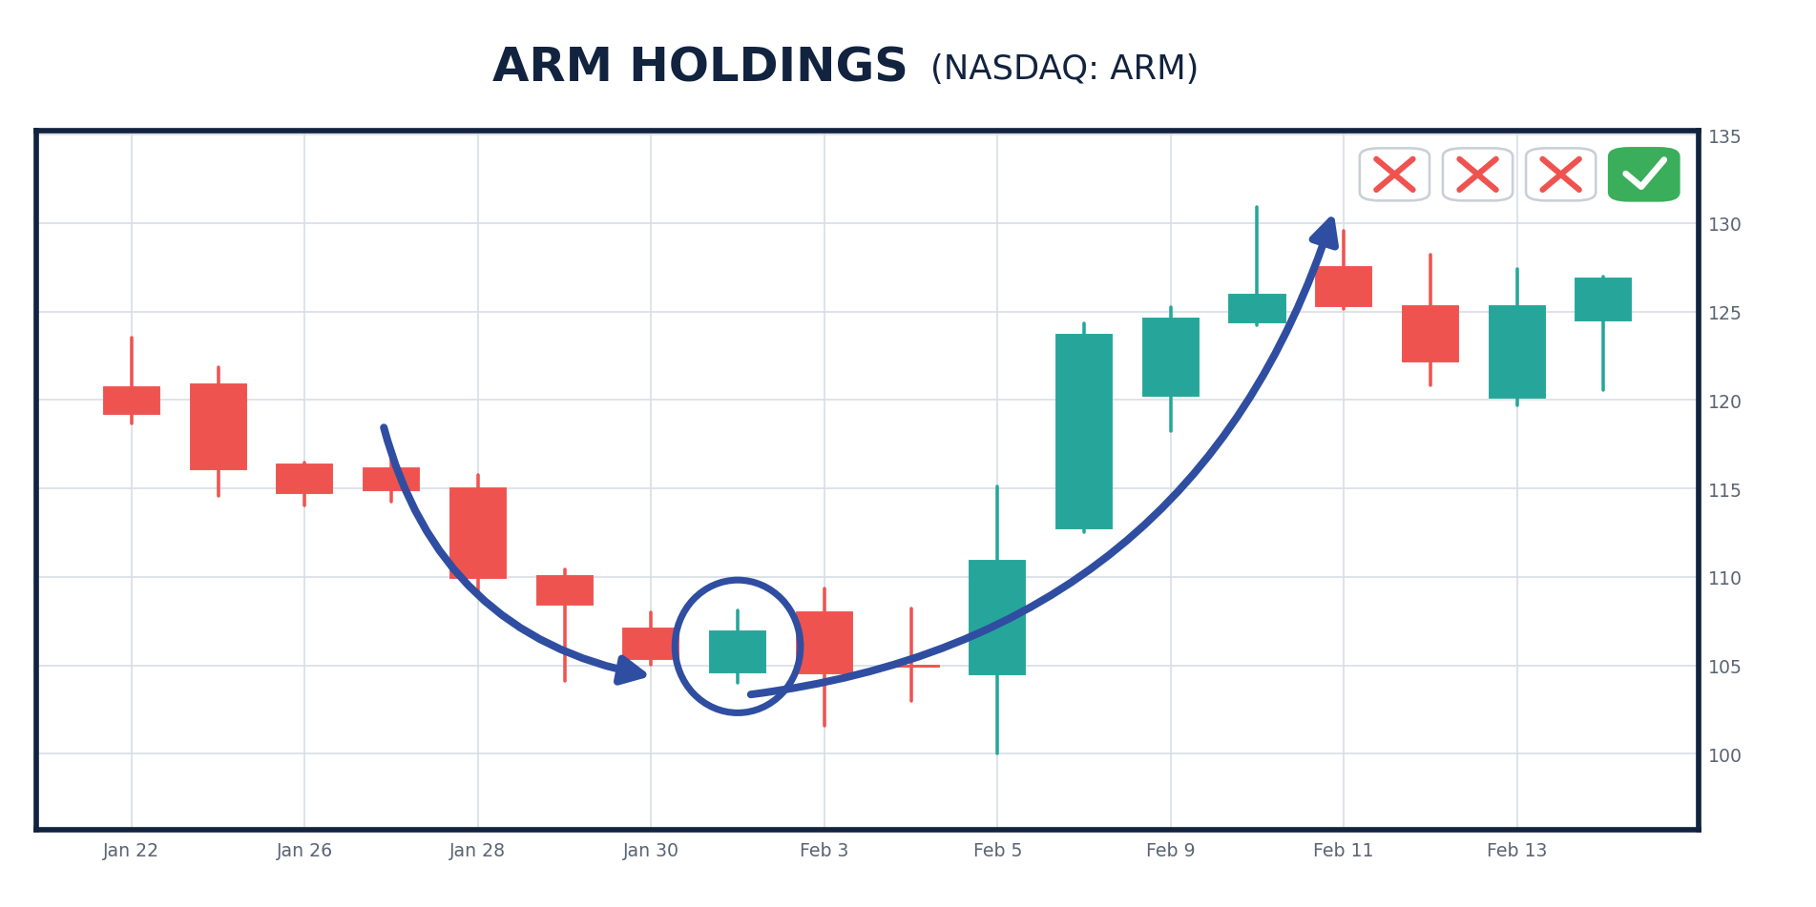
08_ARM.png
And a single trade would've made 260% in six trading days.
What you're seeing here is Wall Street's algorithmic trading in action.
Again, the quants' algorithms are programmed with much of the same software.
They often operate in lockstep.
So when one computing system is selling... most of the others are too.
Then, as the sentiment swings in a positive direction...
The computers trained to recognize this all switch to buying as well.
Most investors wouldn't see this...
But once you've worked with these computers, it's very simple to spot.
JONATHAN: How so?
BRYAN: Because after Wall Street's quant algorithms push a stock lower, it's all but inevitable that you'll see a swing back as those same Wall Street computers push it higher.
Because just like before... when you swing too far in one direction....
JONATHAN: The computers will all swing it back the other way once the reversal hits.
BRYAN: Precisely, Jonathan.
Every Single One Peaked Inside Seven Days
JONATHAN: So how do you know when to sell?
BRYAN: Honestly, that's the easiest part, because the testing answered it for me.
We went back through all 7,218 setups and asked one question. How many days did it take each one to reach its peak?
Every single one of them peaked inside seven trading days.
JONATHAN: All 7,218?
BRYAN: All of them. Not one took longer.
JONATHAN: So how do you know which day to sell on?
BRYAN: You don't need to know. That's the point.
Seven days is the entire window. Get in on the green check, and you are out by day seven no matter what.
Like this...
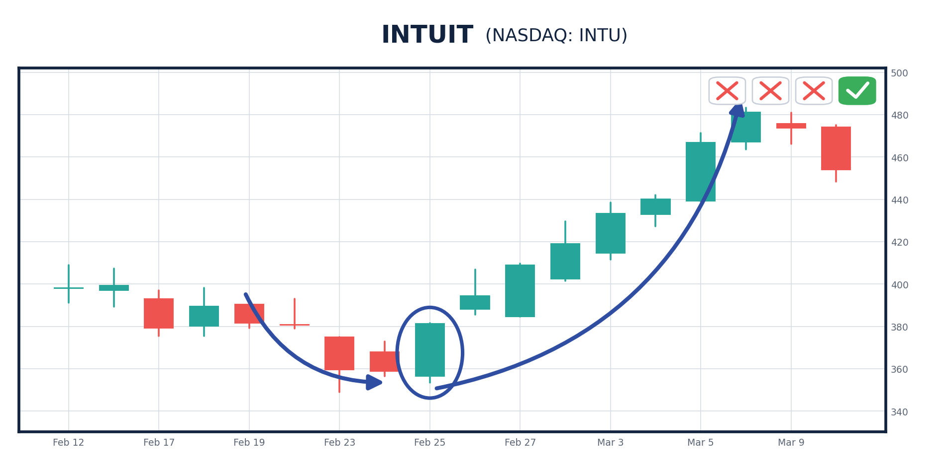
10_INTU_visual.png
JONATHAN: I can see why you’re so excited about this, Bryan.
It seems like if you know how to use these sophisticated computer systems, you have a major edge in the market.
And now you're finally helping regular folks use this to their advantage.
BRYAN: Simply put: These types of supercharged trades can generate extraordinary gains in a short amount of time.
The Biggest Wins I Haven't Shown You Yet
In fact, I haven't even shown you some of the biggest past wins yet.
Like Microchip Technology...
Same pattern. Stock was pushed down for six days... and once the reversal came, it quickly swung right back up.
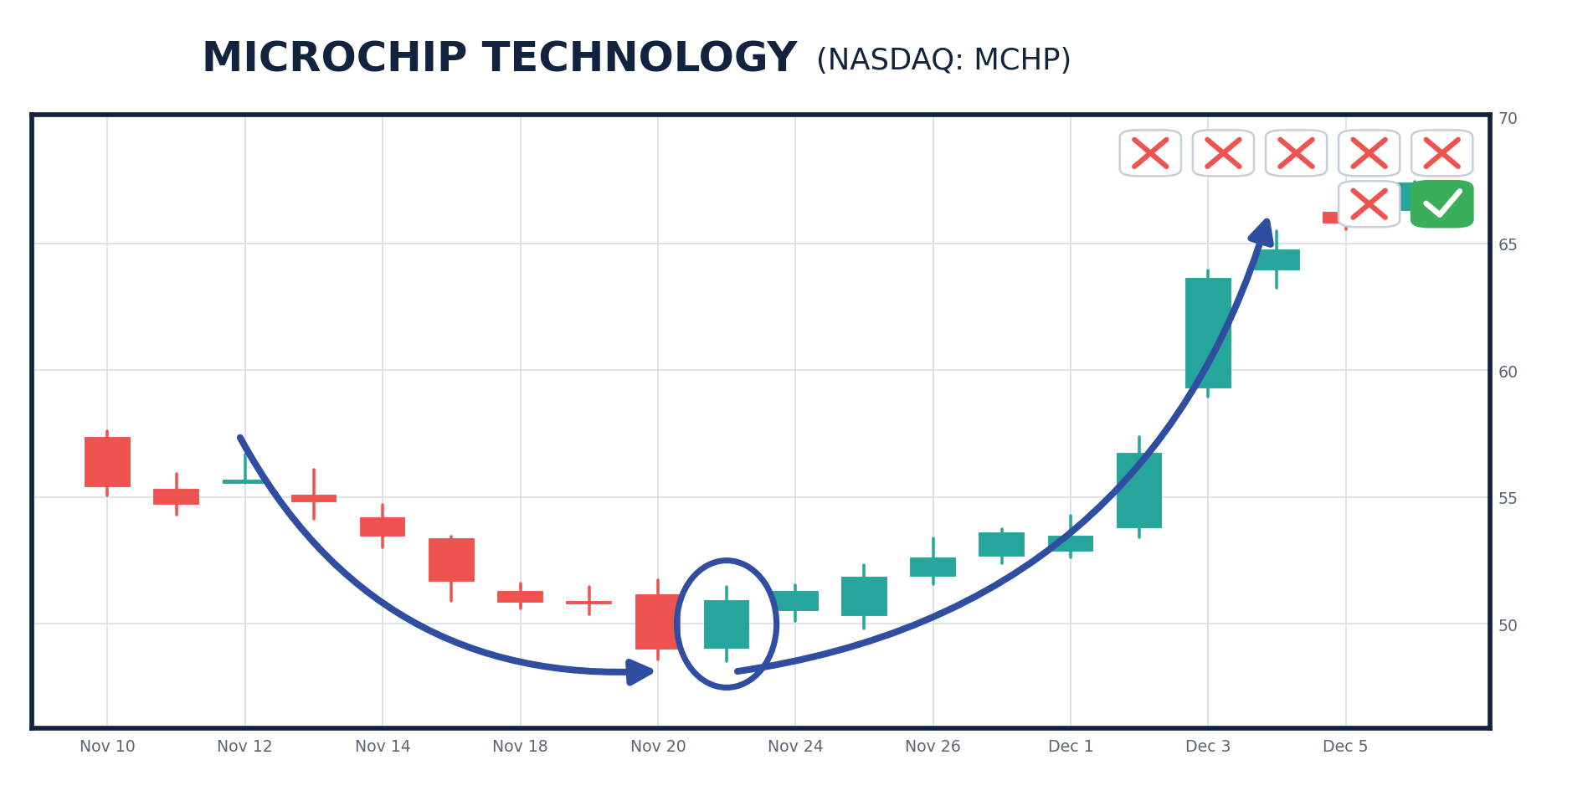
X1_MCHP.png
And a single trade would've handed you a 573% gain in nine trading days!
Or Advanced Micro Devices.
A HUGE swing downward, the stock was pushed down for four days.
So you know once the reversal comes, the upswing could be huge.
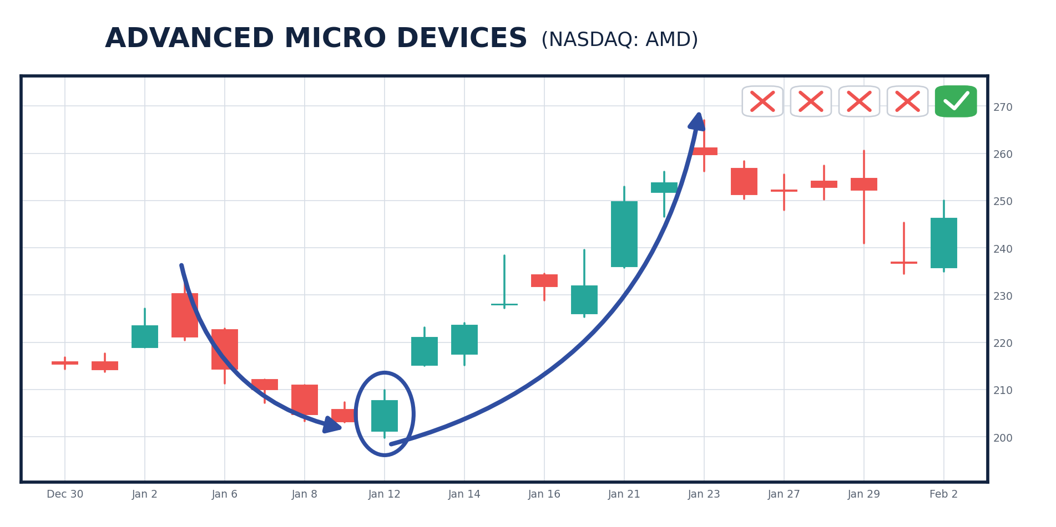
04_AMD_jan26.png
And this is no exception. If you had timed this swing to maximize your gains, this single trade could've handed you a 645% gain!
The folks who have used this type of swing trading strategy have seen their lives completely changed.
Like Gregg S... He's made more than $10 million trading. He said, "My biggest profits are from swing trading."
Today, I'm putting that kind of profit potential in our viewers' hands.
JONATHAN: Look, I know you can spot these... twenty-five years on the CBOE floor and all... but can anyone, even novice investors, spot these?
BRYAN: Jonathan, swing trades are very easy to spot.
If you know how to access the right candlestick charts.
Look at Nebius.
You can clearly see a big downswing in the stock took place at the very end of 2024.
But after that big down swing, you can clearly see the beginning of a reversal.
JONATHAN: That green bar.
BRYAN: Exactly! You're catching on.
Wall Street's money machines are about to swing the stock straight up.
You could've bought that day.
And by placing a single trade that morning, you could've made 341% in nine days.
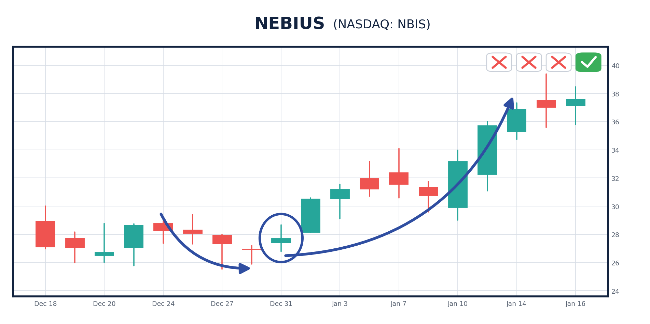
12_NBIS_jan25.png
All we have to do is look for those periods when you get three or more red bars in a row... then make a trade when the reversal hits... and collect a win as the greens take over.
It happens all the time.
Finding These by Hand Is Impossible
JONATHAN: Bryan, there are thousands of stocks trading daily.
How are you able to find the ones where these patterns are forming?
BRYAN: If you tried to do it individually, it would be next to impossible!
You could spend ALL DAY searching stock by stock, and you might not find any!
Even across the 100 biggest names on the Nasdaq, our setup shows up in only a handful of stocks each week.
Most stocks simply trade randomly and don't enter a swing pattern.
For example, here's the type of stock chart where you'll NEVER see the pattern.
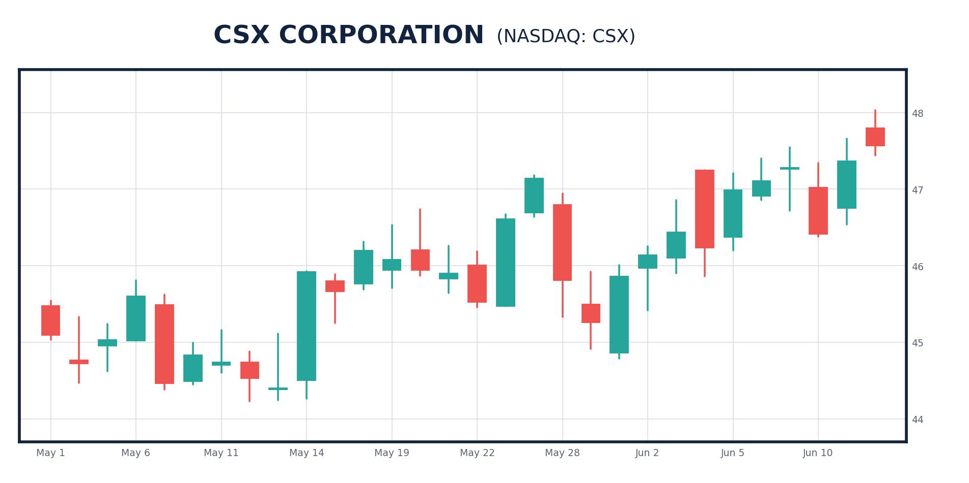
16R_CSX_no_pattern.png
It's all over the place.
There are some up days, some down days.
But it's clear there's no pattern at all.
We DO NOT want to trade those.
And on most days, most of the Nasdaq 100 looks exactly like this.
But with the aid of new technology, I've developed a special way to spot swing patterns as soon as they happen.
JONATHAN: How does it work?
BRYAN: In short, I've built a system that watches the 100 biggest stocks on the Nasdaq and identifies only those companies that have been sold off for several days in a row.
It counts the down days for me.
And it tells me the second one of those streaks ends.
So it's very accurate.
On most days, there are only two or three names that qualify.
But I start watching those very closely for the reversal.
That way I know exactly when the swing upward will begin.
Here are some past examples of what my system looks for.
Swings like...
The one Nebius went through.
It was WAY oversold last October.
You can see it clearly in the chart...
Seven straight days of almost pure red.
When I see that, I am overjoyed.
Then, the reversal hits... and it would have been a chance for a BIG short-term payday.
JONATHAN: And all you had to do was wait for the next big green bar? That's the reversal?
BRYAN: That's it. It tells you exactly when the stock's swinging back up.
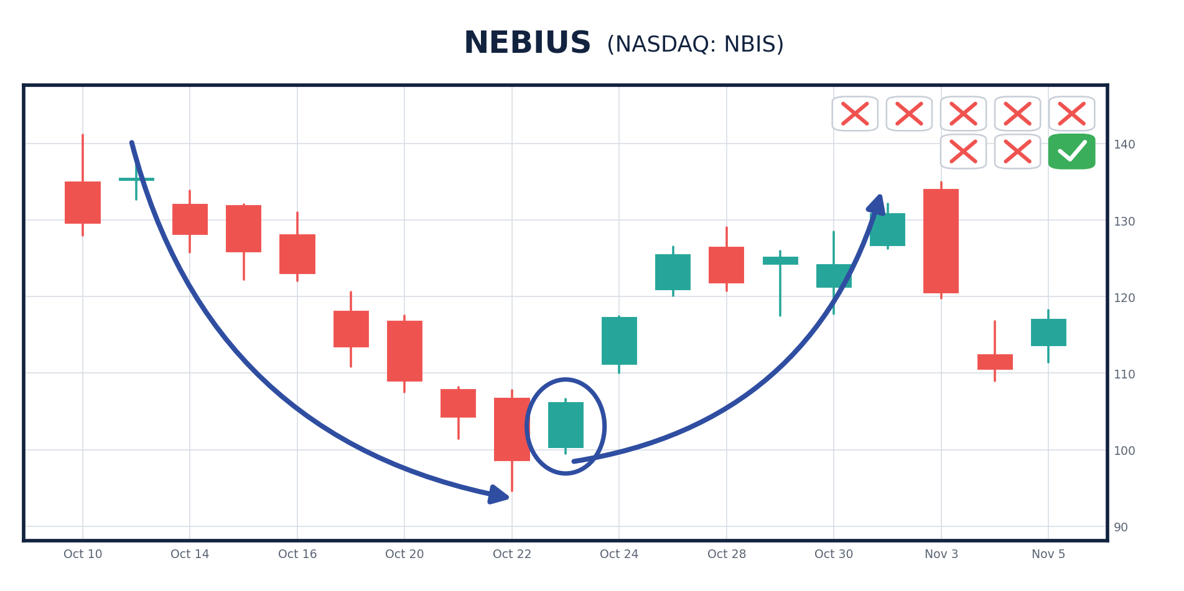
17_NBIS_oct25.png
And in this case, you could've made a 149% gain in six trading days!
JONATHAN: 149%.
You'd more than double your money...
That's incredible.
If our viewers could do that regularly, it would be life-changing.
BRYAN: It is life-changing!
These swing trading techniques have helped traders like Paul Tudor Jones build his hedge fund from a tiny $30,000 startup to a $7.8 billion industry leader.
Jones said, "I have always been a swing trader, meaning that I believe the very best money is to be made at the market turns."
Jim Simons' Renaissance Technologies began to have extraordinary success when it started to focus on identifying reliable and repeatable short-term patterns in the market in 1990.
The result?
Its fund scored a gain of 55.9% in 1990, a dramatic improvement on its 4% loss the previous year.
With this strategy, you no longer have to worry about the broad market, the Fed or GDP growth.
You just trade the predictable swings on individual stocks.
Two Trades. One Morning. More Than 1,200%.
Here's the same pattern again in Broadcom.
You see that big downswing?
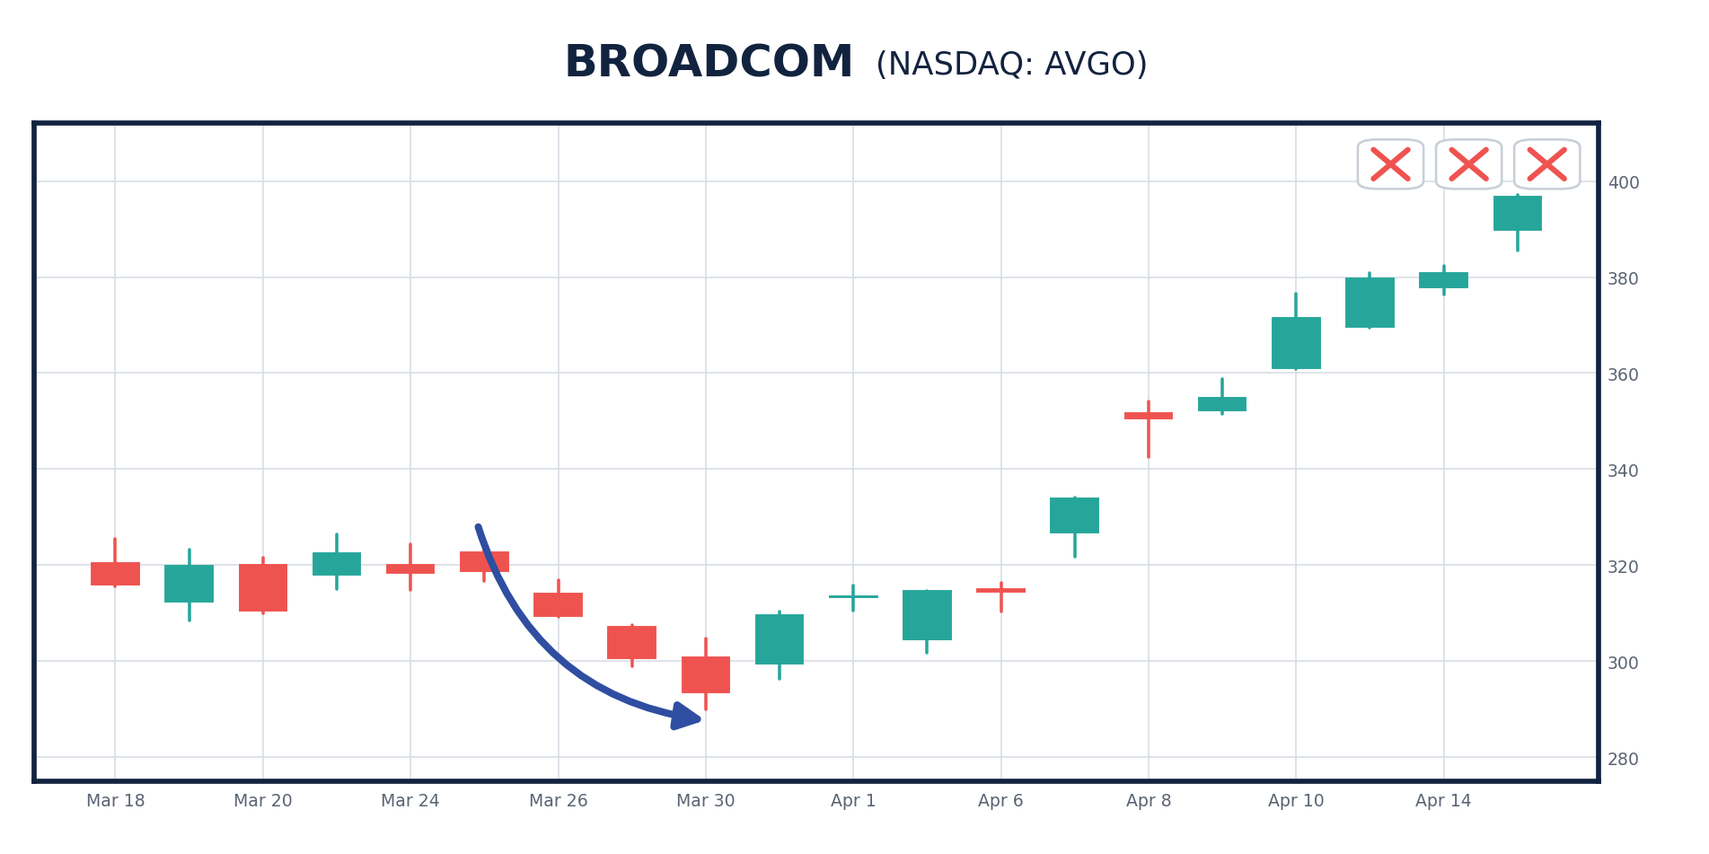
15a_AVGO_downarrow.png
JONATHAN: It's pretty obvious.
BRYAN: What do you think is going to happen?
JONATHAN: The computers will reverse course and it will swing right up?
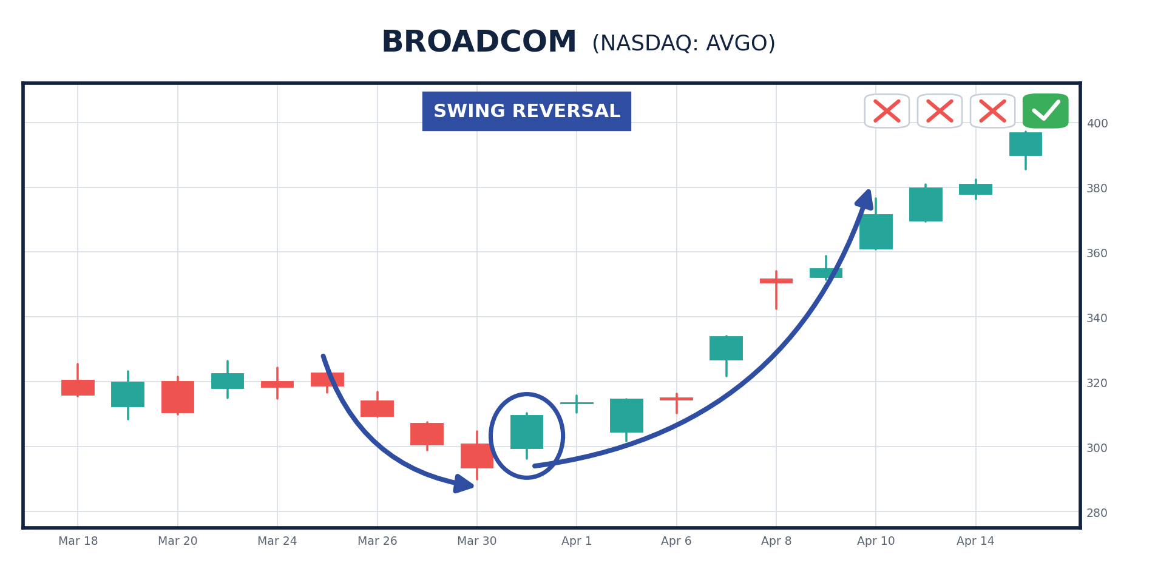
15b_AVGO_reversal.png
BRYAN: Precisely!
It's like a beacon of green here.
And that's when we know the upswing has begun.
That day, you could've placed a simple trade...
And banked an incredible 695% gain in eight trading days!
But, Jonathan, here's what's so great about these swing trades... and why they can build money so quickly...
That same morning, my system flagged another one. CoreWeave...
The pattern is clear as day.
A huge drop in red ...
Then you see a big green bar...
That's the reversal... and then the green bars take over.
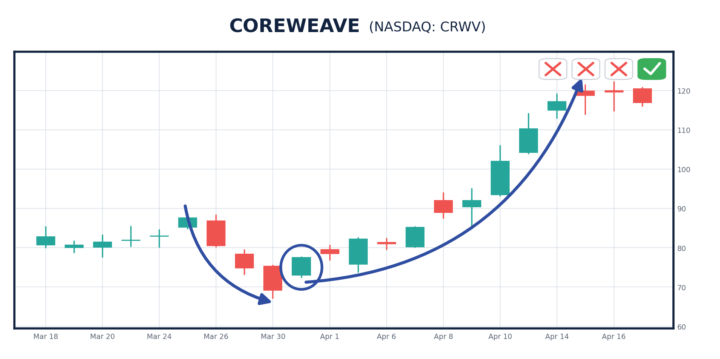
19_CRWV_apr26.png
And in this case, you could've made a 589% gain in 11 trading days!
JONATHAN: OK, Bryan, that's more than 1,200%... on two trades... flagged on the same morning.
BRYAN: Not bad for a couple weeks of work, right?
JONATHAN: Bryan, do trades like this happen all the time?
BRYAN: Jonathan, a gain like 900% is rare, but it does happen.
But that's why I've created this system, so we have the chance to capture the biggest price swings... even up to 1,000%!
I want to show the viewers the full power of swing trades with these past examples.
With these options trades, you can see extraordinary gains.
But the more common wins are what pay the bills. Doubles. Triples. Week after week.
JONATHAN: Heck, I'll take a 100% gain in a week any day!
I'd take 10% per week!
BRYAN: True enough.
I feel the same way. Even 10% per week is incredible.
So if you're not happy with a 100%.. .even 500% gain… in a week, well... then I can’t help you.
JONATHAN: OK, now I have a question for you...
What Happens When the Whole Market Falls Apart
You've shown us that this works in a bull market.
But a lot of people are worried about what happens next.
What does your system do when the whole market is falling apart?
BRYAN: A lot of folks are worried about the stock market. After all, we've seen huge volatility this year.
JONATHAN: And we all know how bad that can be.
Most of our viewers have lived through many of the harshest stock market collapses in recent history.
The dot-com collapse saw the Nasdaq drop 76% in less than three years' time.
And the financial crisis saw the S&P get cut in half.
Some folks are still working back to where they were BEFORE those crashes.
That's why you need a system that doesn't quit on you the moment the market turns.
JONATHAN: That's the main reason hedge funds exist, right...
To figure out ways to make money in all markets?
BRYAN: The No. 1 goal of a hedge fund is to NEVER LOSE MONEY.
That's why in developing my new service, I wanted to be sure we have the best shot to win NO MATTER what happens in the broad markets.
JONATHAN: So what happens to your signals when stocks sell off?
BRYAN: Here's the part nobody expects, Jonathan.
I get MORE of them.
JONATHAN: More?
BRYAN: Think about what my system is actually hunting for.
It doesn't ask what the company does or where the sector's headed.
It's hunting for one thing: a stock the machines have pushed down for several days straight.
So what do you think happens to the number of oversold stocks when the entire market is being sold?
JONATHAN: It goes up.
BRYAN: It goes way up.
Across the last decade, my system averaged 57 setups a month.
But in April of last year, when the market went into a tailspin... it found 102.
Nearly DOUBLE the normal rate.
Through all of 2022, when stocks were grinding lower month after month... 85 a month.
In the fourth quarter of 2018... 81 a month.
JONATHAN: And in a calm year?
BRYAN: Barely above the average.
Look at the biggest months my system has ever had.
December 2022. January 2022. September 2022. December 2018. April of last year.
Every single one of them is a selloff.
JONATHAN: So the worse it gets... the more opportunities you find.
BRYAN: That's exactly right.
Most investors dread a market like that. I've spent my career waiting for it.
Because selling is what BUILDS my setup.
The machines push a stock down three, four, five days in a row... and the harder they push it down, the harder it tends to snap back.
It's Isaac Newton's third law again. For every action, there is an equal and opposite reaction.
JONATHAN: Can you show me?
Three Wins on One Stock... While It FELL 22%
BRYAN: Sure, you'll catch on quickly.
Let's look at MicroStrategy.
Now, this was not a stock going straight up. Quite the opposite.
But my system found it again... and again... and again.
The first setup came in January of last year. Three red bars, then the reversal.
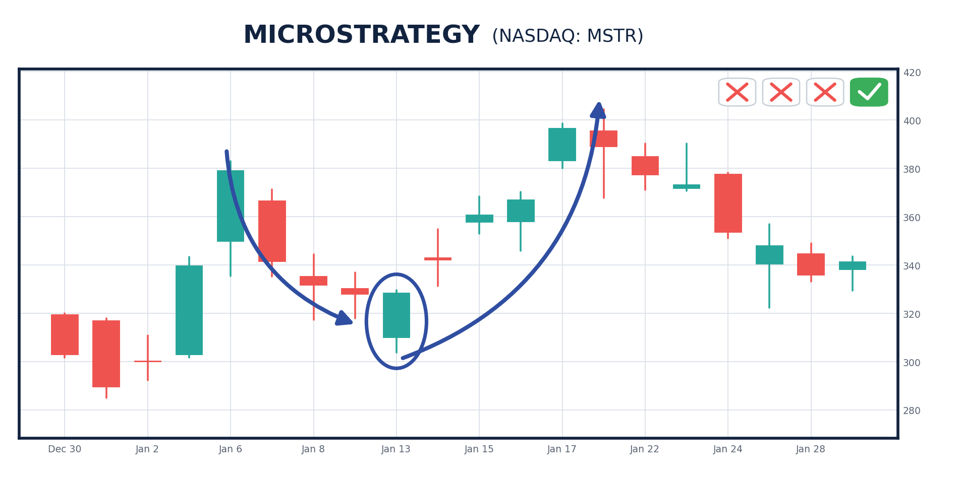
20b_MSTR_jan25.png
Six trading days later, that trade could've handed you 176%.
JONATHAN: On one trade.
BRYAN: One trade, six days.
Then barely six weeks later, the pattern showed up again. Same three red bars. Same reversal.
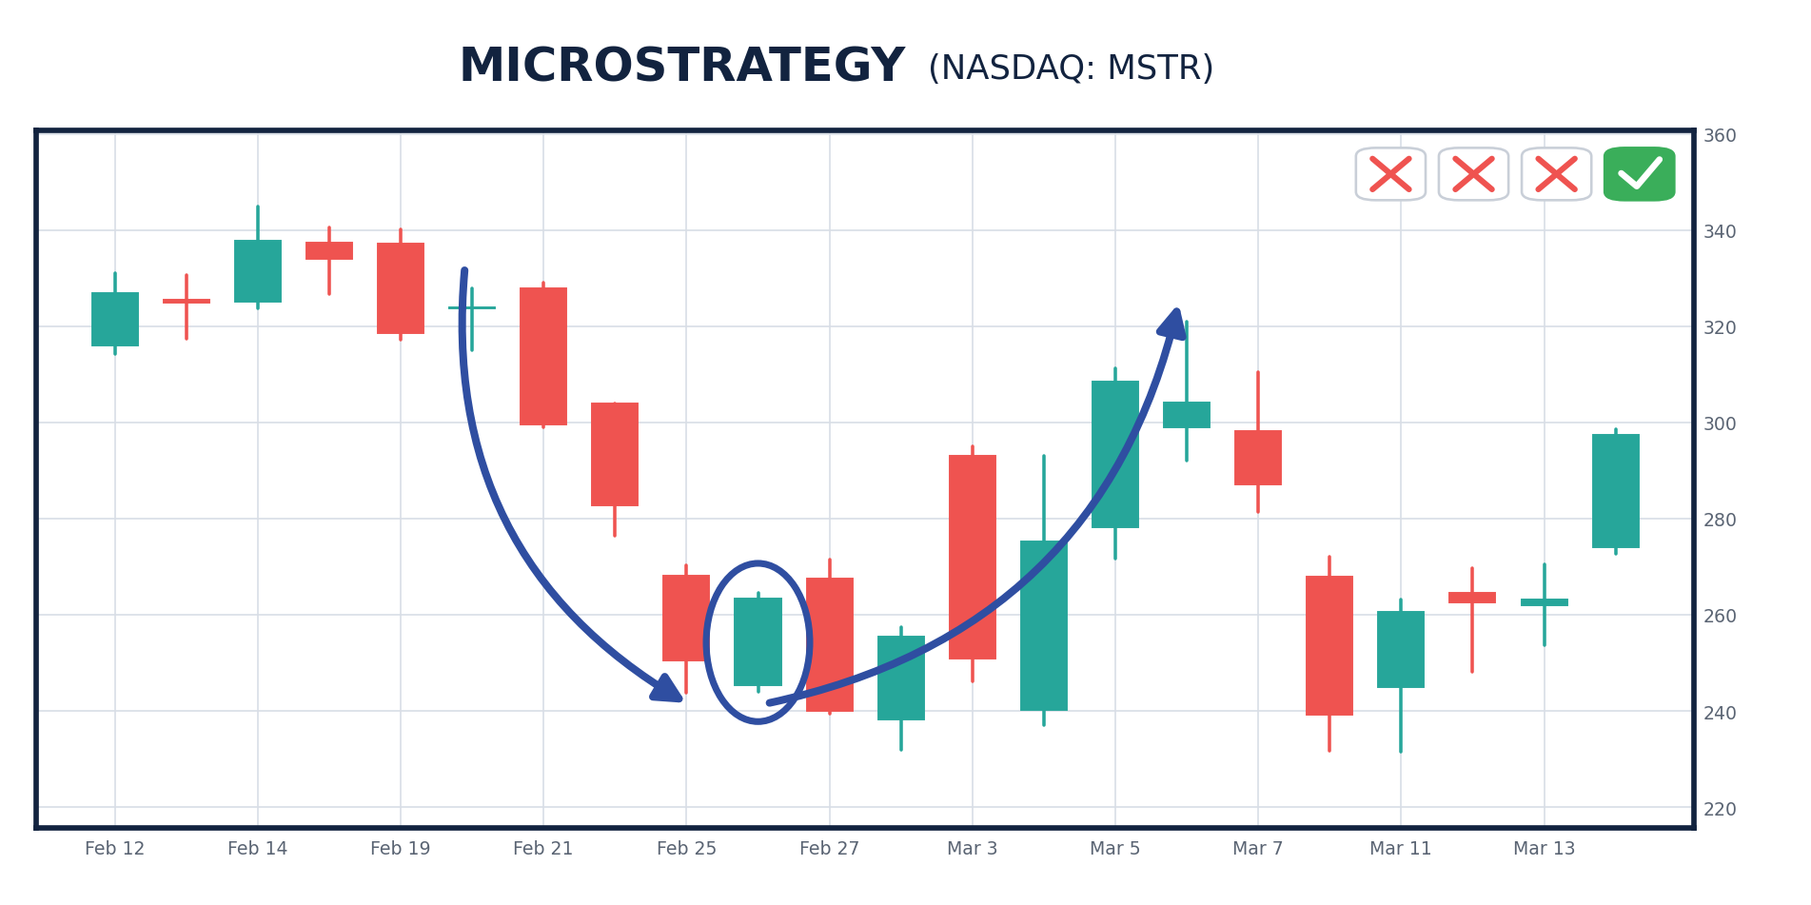
20c_MSTR_feb25.png
Another 197% in six trading days.
And this June, a third time. Eight straight red bars, then the reversal, and 286% in five trading days.
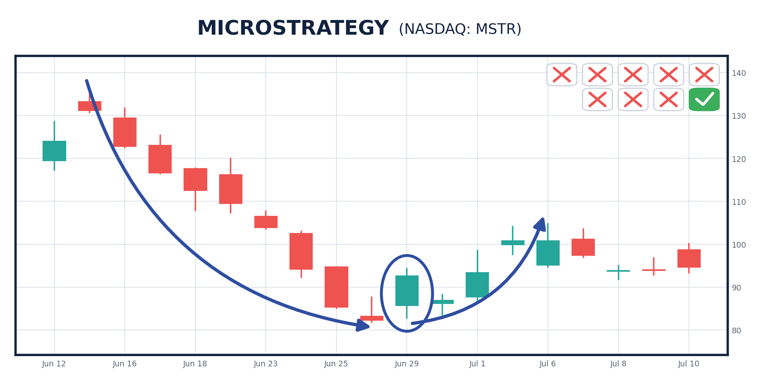
17R_MSTR_jun26.png
JONATHAN: Three separate wins on the same stock.
BRYAN: Here's what I want our viewers to understand.
Between that January trade and that February trade... the stock itself FELL 22%.
JONATHAN: It fell?
BRYAN: It fell.
If you had just tried to buy the stock the regular way during this period, you probably wouldn't have made any money.
But by trading purely on the swings, you had the chance to win twice.
JONATHAN: And it works on stocks going up too?
BRYAN: It sure does. Look at Tesla in the fall of 2024.
The countdown ran through the end of October. Five straight down days... then the streak broke on November 5th.
Four trading days later, that trade was up 531%.
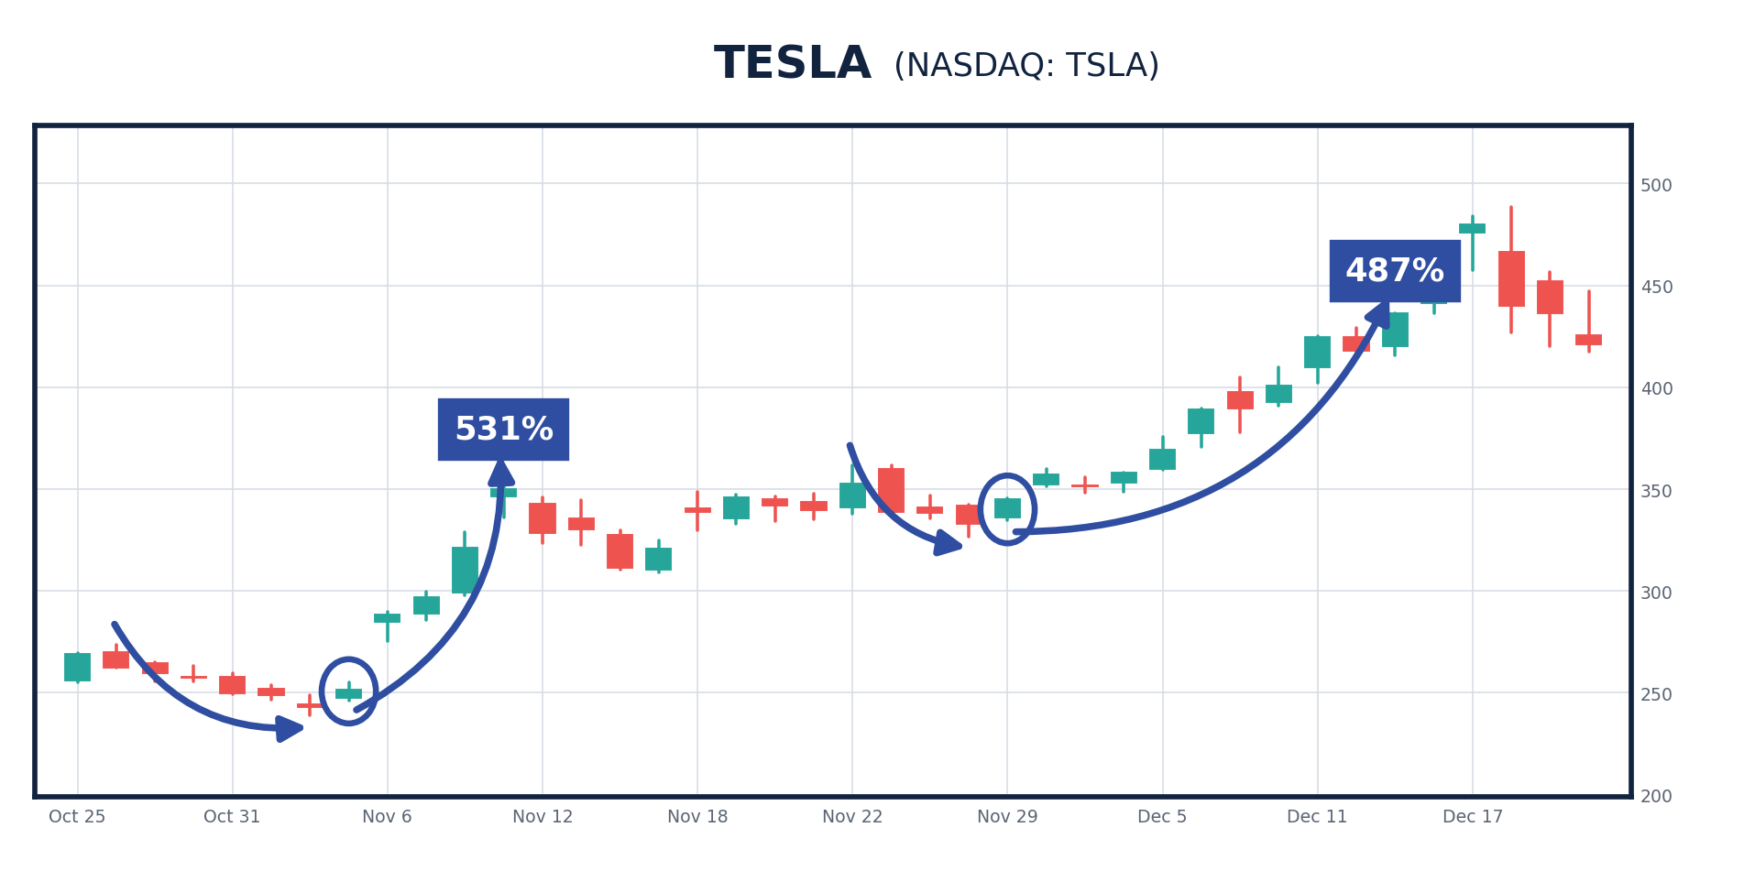
Now look at what happened three weeks after that.
Same stock. Another countdown. Three down days, and the streak broke again on November 29th.
That one went up 487%.
JONATHAN: The same stock. Twice inside a month.
BRYAN: Twice inside a month, and better than 1,000% between the two of them.
That's what I mean when I say I don't need the market to cooperate.
I need the machines to keep doing the one thing they always do.
With the way these computer algorithms work, you'll often see a stock swing from lows to highs over and over again.
That's what I need people to see.
I don't need the stock to go up over the long run.
I don't need the market to cooperate.
I need one thing: a stock the machines have oversold, and a reversal telling me they're about to turn around.
JONATHAN: And that shows up in any market.
BRYAN: That’s right…
$14,000 in Profit From Two Trades
Look at what happened this past April.
On April 1, the very same morning we just looked at, my system flagged Intel too.
Three red bars, then the reversal.
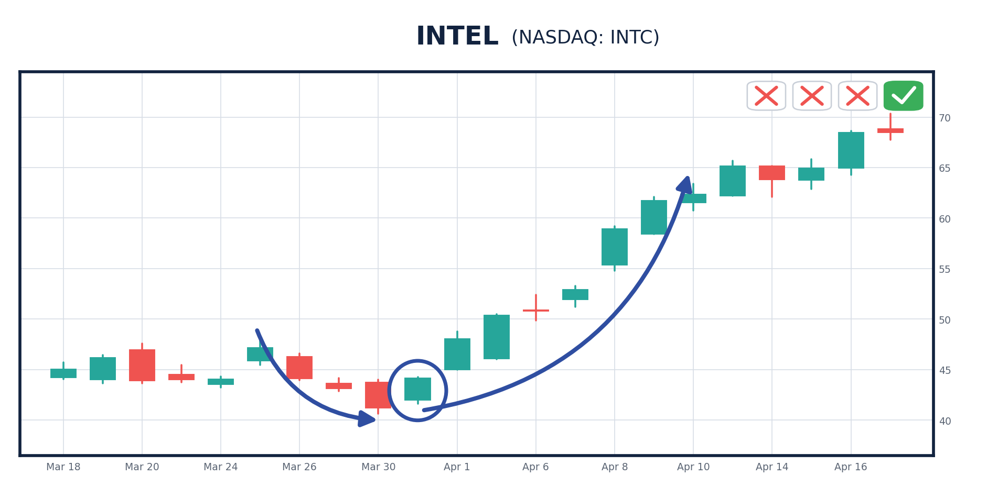
20_INTC_apr26.png
On this one, you could've made 958% in a week, turning a $1,000 investment into $10,580!
Or how about the swing that showed up in CoreWeave last August:
Count them... one, two, three, four, five days it was red!
JONATHAN: When you see so many days in the red in a row, does that indicate the upward swing will be more powerful?
BRYAN: Absolutely.
You had a big reversal here.
Then the green bars take right over!
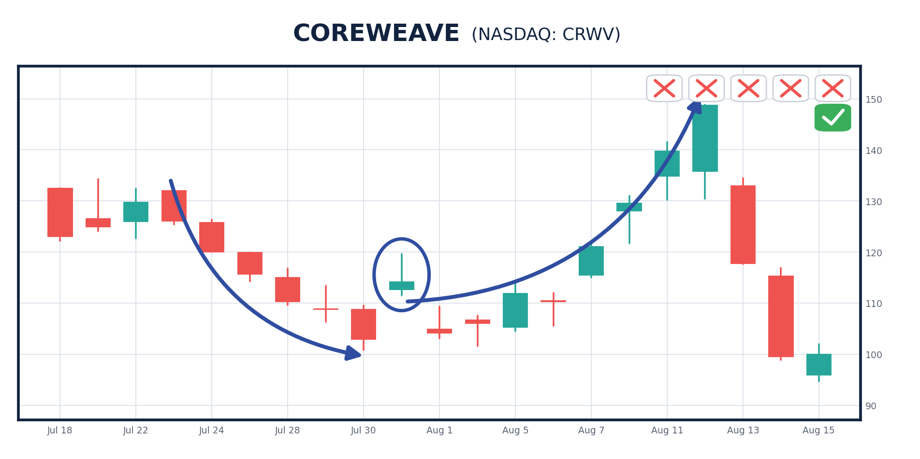
X2_CRWV_aug25.png
With this one, just a single trade could make you 448%, turning $1,000 into $5,480.
JONATHAN: So that's more than $14K in profit in two trades.
Heckuvalotta money when you consider you're starting with just $1,000 in each.
BRYAN: Well, when you're collecting wins of this size in days... you can quickly turn a small amount into some serious money.
Sometimes before the week is even over!
Unfortunately, most people never get high-level, fast-moving trades like these....
The type of trades that can pay out in a week or less.
But today, I want to change that.
And as I said, my system is constantly scanning the market for stocks experiencing big swings.
And after analyzing all the data, I am coming up with at least TWO swing trading opportunities EVERY SINGLE WEEK.
Meaning you could see the chance to double your money twice per week.
The Two Setups I'm Watching Right Now
JONATHAN: Are you watching any stocks currently that are setting up for one of these big swings?
BRYAN: I am.
Right now, I'm looking at TWO perfect setups.
[CHART: two blurred live setups]
And when they hit, I won't be taking them quietly.
Each one is showing a big swing opportunity.
When the reversal hits, it will be an opportunity to go after 500% or more in a week, and perhaps much more.
JONATHAN: So how do the folks watching today get the lowdown on these opportunities?
BRYAN: Well, I have a big announcement to make.
Introducing... The Profit Launch Sequence
BRYAN: For the first time ever, I’m releasing my proprietary trading algorithm to the public.
I call it the Profit Launch Sequence.
This is brand-new. It has never been released, never been sold, and until this morning nobody outside my own desk had ever seen it run.
Starting today, it goes live inside my software platform ProfitSight.
JONATHAN: Can you show us what it actually looks like?
BRYAN: Sure, let’s pull up the screen…
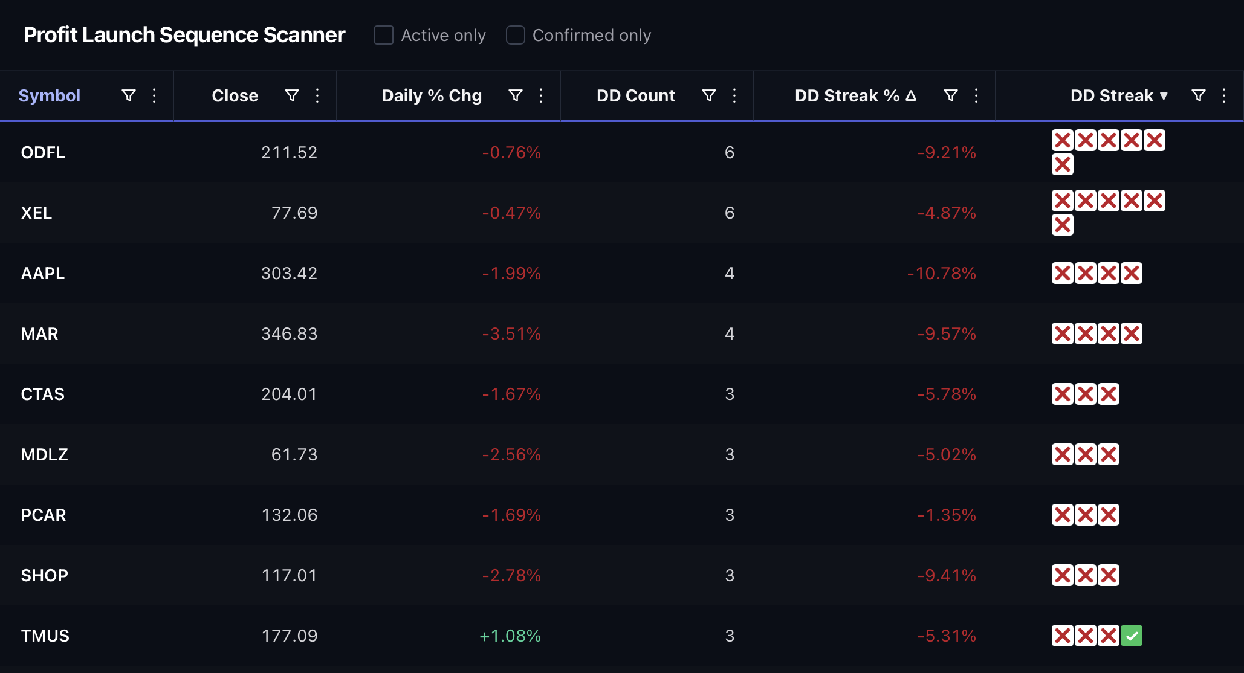
SCANNER_ui.png
Every day, my system hunts the market for the BEST Profit Launch Sequences it can find.
JONATHAN: And all those red X's?
BRYAN: Every red X is a day the sellers won.
One X, one down day. Three X's, three days in a row. Six X's, six.
That's the countdown. And you can watch it build, in real time, before anything happens.
JONATHAN: What's the number beside it?
BRYAN: That's how far the stock has been driven down while the countdown's been running.
Look at Apple there. Four straight down days.
That's the machines leaning on one of the best businesses on earth... and leaning harder every single day they keep at it.
JONATHAN: So what stops it?
BRYAN: One green day.
The stock finally closes higher. The streak breaks. My system flips that row to a green check.
And that check mark is our buy signal.
JONATHAN: Is there one on the screen right now?
BRYAN: You can see it here. You have the red X's... and a green check sitting right beside them.
That countdown just ended…. And it’s time for liftoff!
All you have to do is a make a trade on this stock if you choose… and sell within a week.
And I’ve even made that easy…
If you want to boost your profit with options, my system calculates THREE options trades you can make.
(SHOWS THE OPTIONS AVAILABLE)
JONATHAN: And nobody has to wait on you to email it to them.
BRYAN: You see it the second I see it. Same screen. Same countdown. Same green check.
Nothing is filtered through me first.
Then, if you decide to act, you place a simple trade and enjoy the rest of your day.
Simply sit back and enjoy life.
Play a round of golf or spend time with your family...
Enjoy an afternoon drive, grab your favorite food...
The fact is, you can do what you want, when you want.
The software tracks the clock for you and tells you when the green bar trigger hits.
It's that easy.
JONATHAN: So this is not like some day-trading system where you have to be there 24/7?
BRYAN: Not even close. You might check the screen once a day… then make the trade.
It takes about 10 minutes a week.
JONATHAN: And how often does a green check actually show up?
BRYAN: Over the last 10 years, this setup appeared 7,218 times across those 100 names.
That's roughly two a week.
So if miss one, it doesn't matter. There's another one coming.
JONATHAN:
(TURNS TO CAMERA)
You heard it here first, folks.
This is the FIRST time the Profit Launch Sequence has been released to anyone outside Bryan's own desk.
It is brand-new, and you won't find it anywhere else.
In a minute, you'll see how to claim your spot.
But before we get to that, I wanted to let our viewers see everything else that comes with it.
Everything You Get Today
You see Bryan is truly a teacher.
I mean, giving you the chance to go after 500% or more in a week is a pretty big opportunity as it is.
But as we've seen today, Bryan is NOT a normal stock expert.
And he's about to do something special for our viewers.
BRYAN: That's correct, Jonathan.
I went from a minimum-wage job to the floor of the CBOE and built the career I wanted.
I've spent more than twenty years trading and teaching this... and it's been incredibly exciting.
But it's time to move on to my next adventure.
And I'm excited to say that it's helping folks who want to achieve their dreams.
I will do everything in my power to help them see how to maximize their portfolio and become the investor most people WISH they were.
To start that journey, I want to give you something free when you claim your access to ProfitSight today.
The Profit Launch Sequence Master Class
Obviously, the No. 1 thing you need is a guide showing you how to use the system.
I've just completed it.
It's called The Profit Launch Sequence Master Class.
And it's one of the first things you get today...
You'll be able to access it securely on a password-protected site set up for ONLY ProfitSight owners.
It will give you a complete breakdown of the strategy behind it...
In it, I'll walk you through the screen itself on video. What every column means. What a green check looks like the moment it appears.
I'll show you screenshots explaining exactly where to type everything in, step by step.
And this isn't some class with confusing terms where you need a scientific calculator!
This video series is for ordinary folks who want to learn more about swing trades, fast.
You'll learn how to get a trading account set up, including common mistakes to avoid and step-by-step directions on how to do it correctly...
So you can see how to start pocketing gains immediately.
Plus, if you do have any questions... I have another benefit for you.
Access to the ProfitSight Concierge Team
We have a concierge team available at all times when the markets are open, if you should have any questions about the software.
My team will help you in any way they can.
I wanted to make this as easy as possible for everyone.
So that's why I insisted we have REAL people right here in America available on the phone to ensure you're getting it all right.
I hate when I call a company and get some recorded message... or I have to keep dialing numbers to fight my way through a maze of automation... or I reach some call center in another country.
Our concierge team does NOT have any of those problems.
They'll happily answer any question they can within seconds of your calling them up! And they're some of the friendliest people you'll ever talk to.
So go ahead and add the ProfitSight Concierge Team to your list of benefits.
There's one more bonus I'd like to tack on.
My "Options Quick Start Guide"
I'll explain how to make regular stock trades in the Profit Launch Sequence Master Class.
But honestly, making regular stock trades is like riding a 25-horsepower Prius when you could drive a brand-new 400-horsepower Ferrari!
The fact is real pros don't touch regular stocks.
Yes, 99% of people invest in boring stock shares...
But to get returns like the ones I showed you today, many of the pros use supercharged OPTIONS.
JONATHAN: Why is that?
BRYAN: Because these swings are so predictable... the smart money uses options to reap the biggest profits.
I'll give you five reasons why...
One, you need only a TINY fraction of the cash... Stocks, especially safe blue chips, go for hundreds or thousands of dollars for a single share. But I like to recommend ONLY options that trade for less than $5 per contract. I found many this week that are trading for less than $1 per contract!
So you can invest in these trades with far less cash than buying the regular stocks.
Two, you can make up to 50 times more money on a stock's swing with an option... As we've seen today, my strategy could give you 500% or more in a week. This is ONLY possible with options.
Three, profits can come in a fraction of the time. Most regular stocks take months... or even years... to give you double or triple returns. With options, you can bank a double within a week, if not sooner.
Four, you can do it over and over again.
All the stocks I recommend will have options as well. And with each trade recommendation, I'll walk you through exactly how to make the trade if you decide to invest.
JONATHAN: And you're offering a special training guide on top of that, correct?
BRYAN: Yes, I just finished my "Options Quick Start Guide" as part of the package you will receive as a new ProfitSight member.
In it, you'll find out everything you need to know to see how to profit on options.
Once you understand how to trade options, you'll find it's just as simple as trading stocks... but the profits can be FAR BIGGER.
I've also included screenshots that show you exactly what to input in a brokerage account when one of my swing trades hits.
And in the instruction guide, I'll show you everything you need to know to act on every recommendation I send.
There's one more thing. And honestly, it's the part I'd have wanted most when I was starting out.
And You Won't Be Trading It Alone
BRYAN: Here's the one thing a scanner can't do for you.
It can tell you WHERE. It can't stand next to you while you pull the trigger.
JONATHAN: And that's where a lot of people freeze.
BRYAN: That’s right.
So I'm doing something about it.
Every trade I take off the Profit Launch Sequence, I'm going to take LIVE... inside The War Room.
And everyone who claims unlimited access to ProfitSight today gets a full year in there… for FREE.
JONATHAN: Completely free of charge?
BRYAN: Free of charge… for FULL year of access to the War Room.
JONATHAN: Folks, if you're not familiar...
The War Room is Bryan's live trading room he runs alongside Karim Rahemtulla. They are in there every day the market is open.
When they see ideal trade set ups, they send the trade… and full, easy to follow instructions….
So you can get in immediately.
And then they’ll message you the moment it’s time to close out.
If you can't sit at a screen all day, the alerts come to your phone.
BRYAN: So picture how the two fit together.
Tonight, the Profit Launch Sequence flags a green check on your screen. You watch the countdown end.
Tomorrow morning you walk into The War Room, and there I am, taking that exact trade in real time.
You’ll see exactly the trade I recommend.
You never have to wonder whether you read it right. You can just look over my shoulder until you're ready.
JONATHAN: So you can follow, or you can lead.
BRYAN: Most people start by following. Almost nobody stays there.
We have members posting their own trades in The War Room!
It’s not just a newsletter where you simply follow the alerts.
It’s interactive… it’s FUN… and it’s a community of traders who want to see each other succeed!
JONATHAN: Bryan, what does that actually look like for a member?
BRYAN: I'd rather let them tell you.
Start with George.
He joined us in December of 2019 and the first thing he told the room was, “I’m very new at this.”
Three months later he reported taking $165,000 into peak gains of $2.35 million.
JONATHAN: Three months?
BRYAN: Three months!
Then there’s David. He came in with a $20,000 portfolio in January of 2020. Nine months later it was worth $185,000.
He told me he makes more from his War Room trades than he does from his day job.
And Ken walked in during April of 2020 with no clue what he was doing. Back on the Chicago floor we’d have called a guy like that red meat.
By December he’d taken $150,000 past $300,000.
JONATHAN: What about somebody who just joined?
BRYAN: Mike posted this after one day. “Wow, just made $6,300 on the first day of this service! I paid for my subscription!”
And Edward wrote in after six weeks: “1st $20k day, only been here for 6 weeks! Thanks again Bryan and Karim.”
JONATHAN: And Bryan, I want to make sure nobody missed this…
You’re giving away access to The War Room free of change today.
BRYAN: A full year of it. No extra charge.
JONATHAN:
So to recap everything you'll get as a new member of ProfitSight...
Your Entire ProfitSight Package
*Unlimited access to ProfitSight, including the brand-new Profit Launch Sequence.* The same screen I use. Yours to run whenever you want, for as long as you want.
The Live Countdown Board: Every stock in the Nasdaq 100 currently counting down, ranked by how deep into the sequence it is, updated in real time.
Liftoff Alerts: The instant a countdown ends with a green daily candle, the Profit Launch Sequence flags it. On screen, and by email if you want it that way.
The Seven-Day Trade Clock: The software counts the trading days on every open setup and tells you when day seven arrives, so you never have to track it yourself.
*The Profit Launch Sequence Master Class:* This three-part video series walks you through the new scanner screen by screen. It's super simple, and you can refresh yourself by watching anytime you want.
*The ProfitSight Concierge Service:* This is direct phone access to our team of REAL PEOPLE... available to answer any questions you have about the software.
"Options Quick Start Guide": This comprehensive report will give you full instructions on how to complete options trades so you can supercharge your gains.
A FULL YEAR IN THE WAR ROOM, FREE. Bryan's live trading room, where every Profit Launch Sequence trade he takes goes up in real time. Premarket commentary at 9 a.m., live trade alerts as he takes them, text alerts, the War Room Headquarters library, and 19,000 members you can talk to all day. It has never sold for less than $7,500 a year. You pay nothing for it.
PLUS, the Profit Launch Sequence is not the only system inside ProfitSight.
Your access includes two more, and you get both today...
The Gift Gap Indicator: When a stock gaps 10% or more in a matter of hours, up or down, it leaves a gap on the chart. And most of those gaps get filled. The trick is knowing which ones. We found the trigger: wait until 10% of the gap has been backfilled. Across 10 years and 3,735 gap-down events, targeting the first quarter of the fill produced a 97.11% win rate. 3,627 winners out of 3,735. The average winner took four days, and 80% of them hit target inside two.
Cash Code X: Bryan's team built this one with AI, which is why they've taken to calling it Cash GPT. It hunts for a momentum shift, a fast moving average crossing a slow one, with a second filter layered on top to throw out the false crosses. When both line up, a green arrow appears on the chart. Going back to 2019 across the Nasdaq 100, that arrow has been followed by a winner 70% of the time across 2,769 signals, with an average gain of 24.52% holding the stock for a year. The S&P has averaged 8.4% a year over the last two decades.
BRYAN: So think about what's actually on that screen when you log in.
The Profit Launch Sequence, counting down every oversold name on the Nasdaq 100.
The Gift Gap indicator, flagging every stock that just gapped and is starting to backfill.
And Cash Code X, watching for the green arrow on the ones about to run.
That’s three systems, one login.
And they don't compete with each other. They cover different ground.
The countdown is for the fast trade, in and out inside seven days. The Gift Gap is for the overreaction. Cash Code X is for the stock that's about to go on a run and keep going.
JONATHAN: So whatever the market is doing that week...
BRYAN: Something on that screen is flagging.
Most people will come for the countdown. They stay for the other two.
In short, with all of these benefits, I believe you'll have everything needed to find these setups yourself and act on them.
In a moment, a button will appear below this screen that will give you access to all of this.
JONATHAN: It's an incredible package.
And I have to say, after seeing the results of the top past examples we've looked at today, this is an incredible value.
BRYAN: More than that, it's going to be fun!
I've waited years to be able to share my best swing trade opportunities with people.
There's nothing out there, nothing, that offers more upside potential.
But these highly lucrative, fast-moving swing trades are the ONLY type of opportunities we're going to focus on. You'll never have to wait long to see results.
And we focus ONLY on plays that could hand out gains of 500% or more in a week.
Why I Can't Let Everyone In
Which is why I'm strictly limiting how many people I let in today.
This is a standard practice on any professional desk, for a VERY GOOD reason.
Too much money going into a trade reduces returns.
So I want to keep my service nimble, we want to get in and out quickly.
If I had too many people piling into each opportunity, that could water down the profit potential.
At any given time, we have as many as 500,000 people reading our research at Monument Traders Alliance.
If everyone with an internet connection were running this software on the same 100 stocks, there's no way we'd all be able to buy enough to make big profits.
It's not fair. But that's the reality.
So we can't let everyone in today.
It's going to be a privilege reserved for those who join us today.
JONATHAN: I understand.
And considering you've never opened trade opportunities like this to ANYONE before, I know membership is going to be extremely limited.
And your spots will go very fast.
First come, first served.
But here's the thing...
For those who do get in, the opportunity is going to be huge.
You've never before offered up this kind of research to the public.
It's built on what you learned reading order flow from inside the exchange.
Pretty incredible.
Which is why I'd tell anyone watching to go claim their access to ProfitSight today.
Bryan, you're opening the doors today, correct?
A Special Offer for Everyone Watching Today
BRYAN: That's right.
It’s live RIGHT NOW.
And from there, we'll be targeting our next big weekly wins.
JONATHAN: So, folks, you aren't going to want to miss this.
This is professional-grade software, the kind of tool you won't find outside a trading desk.
I imagine that's quite expensive to run.
BRYAN: It absolutely is.
It costs millions of dollars every year just on technology, staff and research data.
But it's worth it because it's the ONLY way you can find hidden patterns in the market...
Giving you an edge no one else has.
JONATHAN: And that could lead to those big weekly gains we've seen today.
Now, because of the high cost to build and run something like this, I know the retail price is quite high.
BRYAN: I can tell you, it was not easy putting a price on this.
If you handed this money to a professional to manage for you, the standard fee is 2% of the invested capital and 20% of the profits.
For a $200,000 portfolio that grew to $400,000, the cost would be $44,000.
Which, of course, would be worth it to grow your portfolio that quickly.
But what I'm offering you today doesn't cost anywhere close to $40,000.
Because I'm not here to help millionaires become multimillionaires...
I'm here to help regular people see how to unlock the retirement of their dreams.
In fact, we price ProfitSight at $5,000.
And that is not a subscription. That is not a year. That is unlimited access to the software, for as long as you want to use it.
Of course, even at that price, if all goes as I hope, these trade opportunities could pay it off in a very short period.
Consider... you just saw that $1,000 in only two swing trades could have paid out $14,000.
That's nearly three times the retail cost.
But here's the thing...
I wanted to do something special for our viewers today. Especially when you told me you were bringing a full camera crew and making a big show of this.
So instead of $5,000... you can claim unlimited access today for a one-time payment of $2,797.
Not $2,797 a year. Once.
After that it's a $199 annual maintenance fee to keep the data feeds running and the software updated, and that's it.
JONATHAN: Bryan, let me make sure everyone caught that.
They pay one time... and the Profit Launch Sequence is theirs going forward?
BRYAN: Theirs going forward.
And that's the version that comes with the free year in The War Room.
Begin non retail price alt take:
JONATHAN: Why such a big discount?
That seems like a steal for all the work and expense that goes into a system like this.
BRYAN: That's true, Jonathan.
But I want to make this attainable for EVERYONE.
Not just the 0.01% hedge fund clients that I've worked for my entire life.
So I want to make sure the people who join us today get the very best deal.
End non retail price alt take:
BRYAN: Now, because this deal is so good...
And because these spots could be sought after by tens of thousands of viewers today... I have to make one thing clear.
I can't give this away to someone who isn't going to use it.
It's just not fair to take a spot from someone who will actually run the software every night... and hand it to someone who logs in twice and forgets about it.
JONATHAN: Makes sense.
And, Bryan, you told me you have something special planned for the folks who join today.
Take 90 Days. On Us.
BRYAN: I do.
Look, I've just asked people to make a one-time decision. I'm not going to pretend that's a small thing.
So I'm not asking anyone to decide today.
Take a full 90 days with the software.
Run the Profit Launch Sequence every night. Watch the countdowns build. Watch the green checks appear. Sit in The War Room every morning and see how I trade them.
Do all of it.
[GRAPHIC: 90-DAY MONEY-BACK GUARANTEE panel.]
And if at any point in those first 90 days you decide it isn't for you...
Call our concierge team and we'll refund every dollar you paid, minus a 10% processing fee.
One phone call and it's done.
JONATHAN: Bryan, why 90 days specifically?
BRYAN: Because that's long enough to be fair to both of us.
You just saw the numbers. This setup shows up roughly twice a week.
So in 90 days you won't see one or two of these. You'll see something like twenty-five of them play out, start to finish, in front of you.
That's enough to judge it on.
If you've watched twenty-five countdowns run and you still don't want the software, then it isn't the right fit and you should have your money back.
JONATHAN:That's great, Bryan.
I know our viewers are going to really appreciate it.
Now, folks, for those of you who want to be sure to lock in your spot...
We are going to go ahead and open up ProfitSight right now.
Just click on the button that popped up below on your screen.
It says, "Yes, I Want Unlimited Access to ProfitSight!"
Or, if you'd prefer to call right away, you can do so at 888.570.9830 or 410.864.3090.
Remember, this is the first time Bryan has EVER offered something like this.
And I can tell you:
These spots are going to go FAST.
So I would suggest clicking here and claiming your spot immediately.
[ YES, I WANT THESE SWING TRADES NOW! ]
Look, you really have three options here.
Your first option is to do nothing at all.
Maybe continue just investing in mutual funds or ETFs.
If you enjoy waiting years to compound your returns, then that's fine.
You can just keep going with that plan.
But since you've watched this far into our presentation, I'm guessing you're not happy with your current annual returns.
If that's true, then you also have a second option...
You can invest in a quant hedge fund.
But keep in mind... it'll take about $5 million to buy into a good one, if they're taking new clients.
Then you'll pay your fees.
For the Medallion Fund, yearly management fees run as high as 4%... then tack on 44% of your returns as a "performance fee."
For $5 million, that's $200,000 on yearly management fees alone!
Or you have the third option...
Get help from a floor-trained pro like Bryan.
Someone who spent years reading these exact moves from inside the exchange...
Someone who's already put in all the hard work...
So YOU don't have to.
Remember, you could go after 500% or more within a week on a single trade...
Just ask yourself, out of these three options which one is the easiest for you?
Begin campaign alt take:
The choice is yours, but...
You must hurry... because we are only letting in 395 people today.
With this kind of no-brainer offer, I'm pretty sure those 395 spots will be gone quickly... maybe even in the next hour or so.
End campaign alt take:
Begin post campaign alt take:
The choice is yours, but...
You must hurry... because we are only letting in 99 people today.
With this kind of no-brainer offer, I'm pretty sure those 99 spots will be gone quickly... maybe even in the next hour or so.
End post campaign alt take:
Trust me, you DO NOT want to wait too long only to be told we're full.
Go ahead and claim your unlimited access right now by clicking the button below.
[ YES, I WANT UNLIMITED ACCESS TO PROFITSIGHT! ]
And if that's more than you want to spend today... or you're simply not ready to commit to unlimited access... click the second button below for a more affordable option.
Just understand that the free year in The War Room comes with unlimited access only.
[ SHOW ME A MORE AFFORDABLE OPTION ]
Or call XXX.XXX.XXX or XXX.XXX.XXXX.
Thank you for join us today.

